**Website Analytics June 2014**

Website analytics provides insight into who is visiting the website with details of traffic patterns, demographics and technology used. This tool provides the information to create and maintain an effective website.

Analytics are provided on a monthly basis. The following is for the last month.

**Overview**

269,446 individuals visited the site

106,377 visits were made by the individuals above

802,740 pages were viewed during those visits

21% of the visitors were new to the site.

The average number of pages visited on each visit was 2.98.

The average time spent on each page was 3:13.

Most visits came from the following countries:

1. United States
2. Turkey
3. India
4. Canada
5. United Kingdom
6. Germany
7. Australia
8. Philippines
9. Brazil
10. South Korea

People who prefer to view the web with a different language have a setting on their computers that the analytic tool can read. The top five languages preferences that were not a variant of English (US, AU, UK) were:

1. Korean
2. Japanese
3. Spanish
4. C (Catalan or Czech)
5. French

Most visited pages

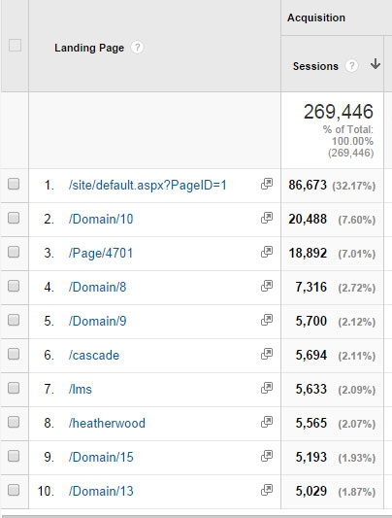

Evergreen Middle

Heatherwood Middle

Everett High

Cascade High

LMS welcome page

Jackson High