**Website Analytics - January**

Website analytics provides insight into who is visiting the website with details of traffic patterns, demographics and technology used. This tool provides the information to create and maintain an effective website.

Analytics are provided on a monthly basis. The following is for the last month.

**Overview**

145,630 individuals visited the site

456, 500 visits were made by the individuals above

1,288,056 pages were viewed during those visits

20% of the visitors were new to the site.

The average number of pages visited on each visit was 3.

The average time spent on each page was 2:46.

Most visits came from the following countries:

1. United States
2. Canada
3. India
4. Germany
5. Philipines

People who prefer to view the web with a different language have a setting on their computers that the analytic tool can read. The top five languages preferences that were not a variant of English (US, AU, UK) were:

1. Spanish
2. Korean
3. Japanese
4. Chinese
5. Romanian

**Page Count**

This shows us how many visits made. Visits represent the number of individual sessions initiated by all the visitors to your site. Of the visitors who only visited once there were 89,727 individual sessions that viewed 273,472 pages. 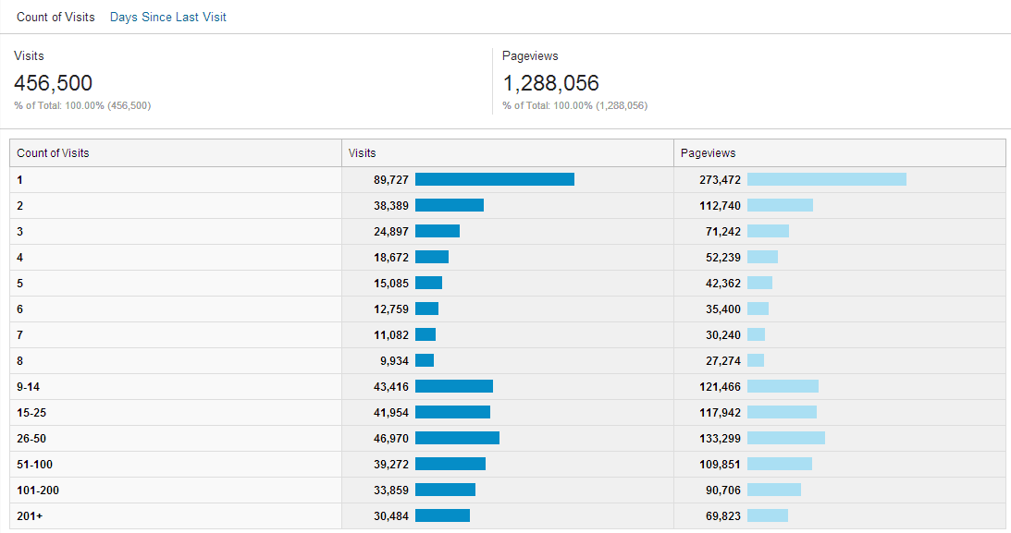

**Page Depth**

This shows the number of pages viewed in a session. In 3,305 session over 20 pages were viewed amounting to 105620 pageviews.

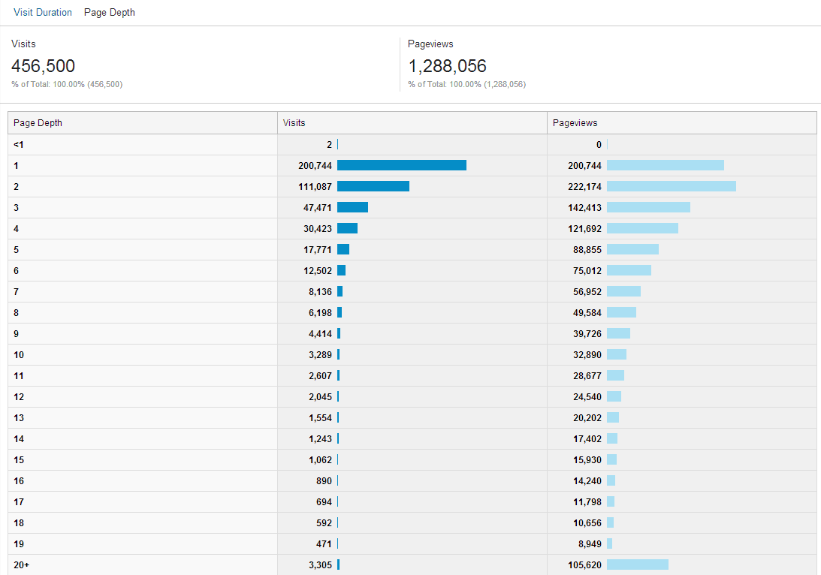

**Browsers**

This data shows that Internet Explorer is still the most popular browser. However, among new visitors Safari was the most popular. This lets us know we need to increase our efforts to make sure that the website can be viewed and functions effectively on Safari

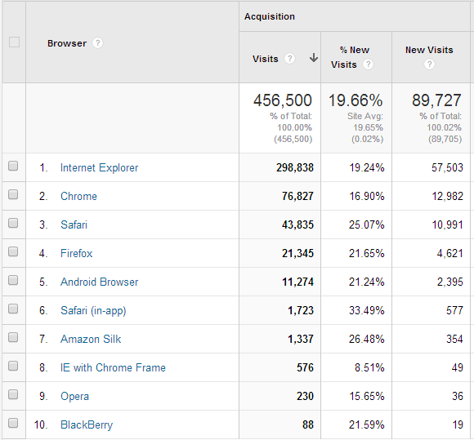

**Traffic**

199,678 users enter directly (meaning they have bookmarked or know the URL they want.)

96,895 were referred by Google

27,647 were referred by Bing

4,824 were referred by heraldnet.com

**Operating Systems**

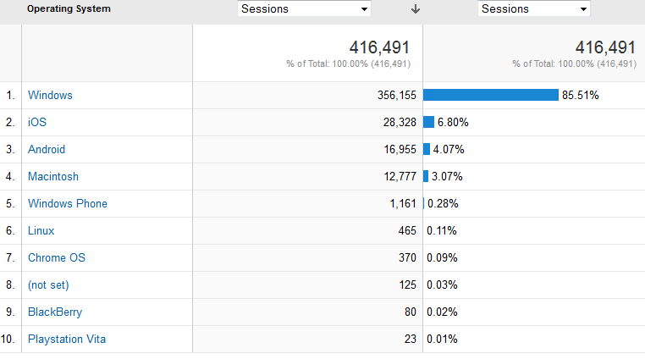

**Screen Resolutions**

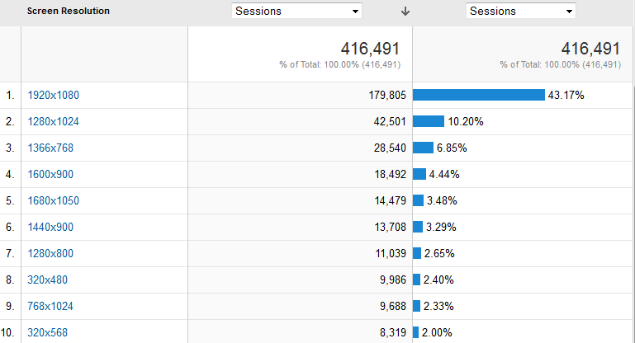

**Devices**

While desktops are still primarily used for accessing the website. Mobileand tablet use is rising, especially with new visitors. Fortunately we made the new website a responsive design so that it functions effectievly on all devices.

**Statistics for all visits to website**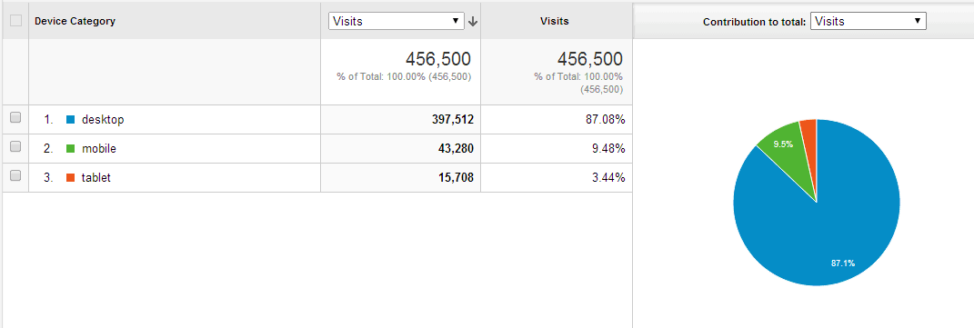

**For new visits to website**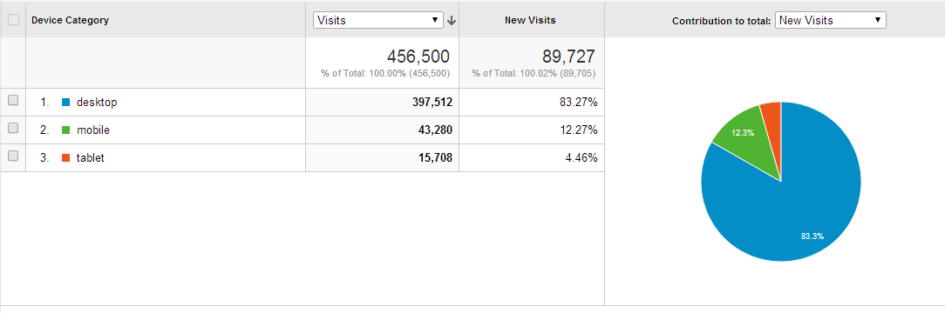

**Mobile Device Info**

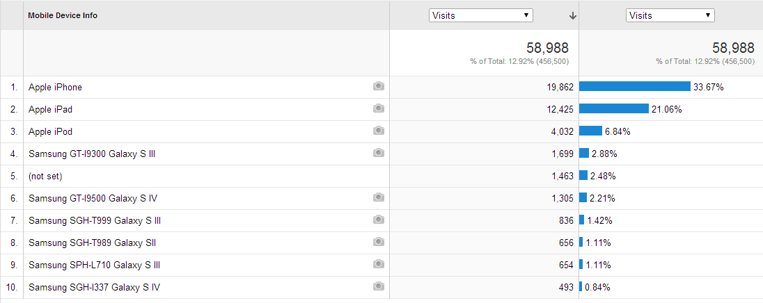

**Service Providers**

This tells us what provider the visitor is using.

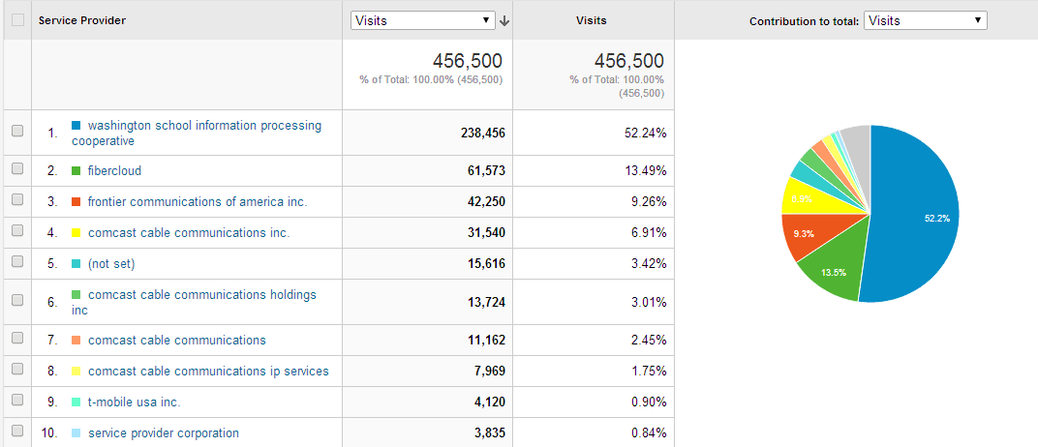

Most visited pages

http://www.everettsd.org/Page/4701 LMS  
http://www.everettsd.org/Domain/10 JHS  
http://www.everettsd.org/Domain/8 CHS  
JHS teacher directory  
myView  
http://www.everettsd.org/Domain/9 EHS  
http://www.everettsd.org/Domain/15 HMS