**Website Analytics April 2017**

Website analytics provides insight into who is visiting the website with details of traffic patterns, demographics and technology used. This tool provides the information to create and maintain an effective website.

Analytics are provided on a monthly basis. The following is for the last month.

**Overview**

174,561 individuals visited the site

432,740 visits were made by the individuals above

1,068,140 pages were viewed during those visits

26.429% of the visitors were new to the site.

The average number of pages visited on each visit was 2.47.

The average time spent on each page was 2:43.

Most visits came from the following countries:

1. United States
2. India
3. Canada
4. Not set
5. Philippines
6. Indonesia
7. United Kingdom
8. Turkey
9. Mexico
10. South Korea
11. Russia

People who prefer to view the web with a different language have a setting on their computers that the analytic tool can read. The top five languages preferences that were not a variant of English (US, AU, UK) were:

1. Spanish
2. Korean
3. Chinese
4. Russian
5. Japanese

**Browsers**

This data shows that Chrome is the most popular browser.

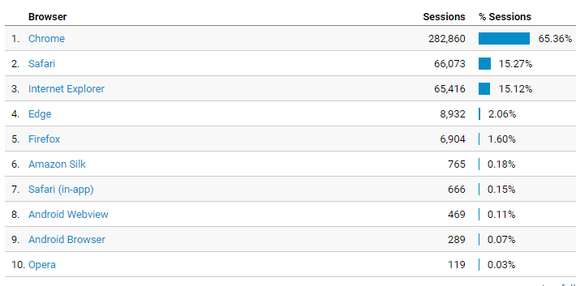

**Operating System**

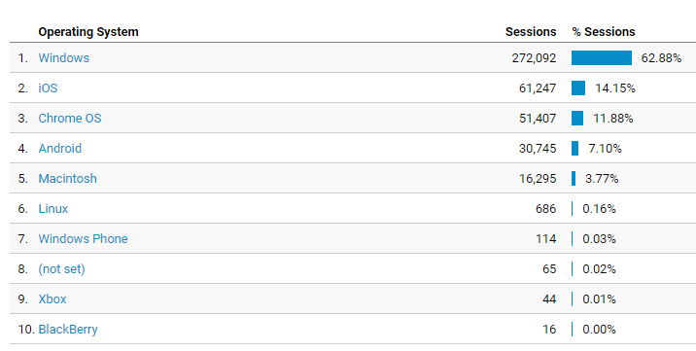

**Service Providers**

This tells us what provider the visitor is using.

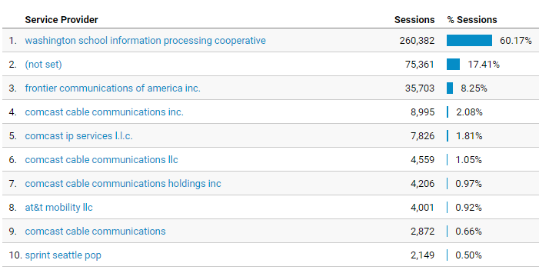

**Mobile Operating Systems** (20% of sessions viewed over Mobile device)

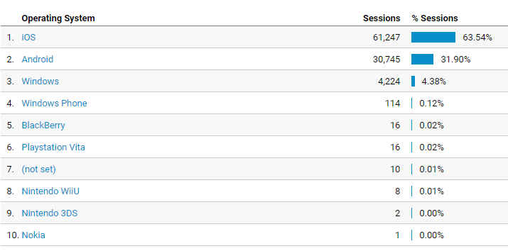

**Overall Screen Resolution**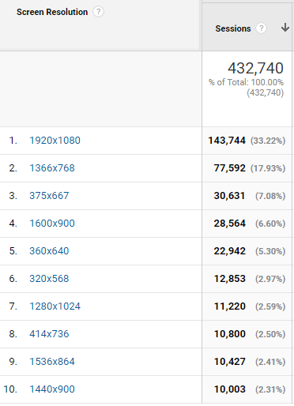

**Mobile Screen Resolution** 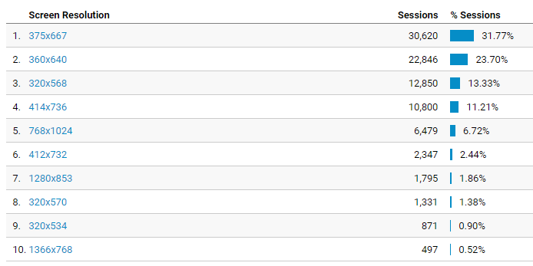

**Mobile Devices**

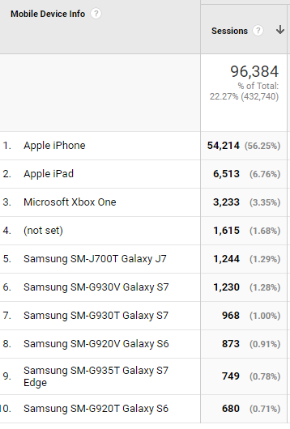

**Device Category**

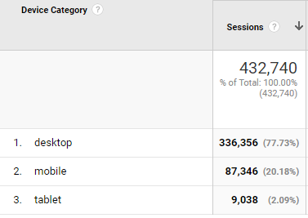

**Most visited pages**

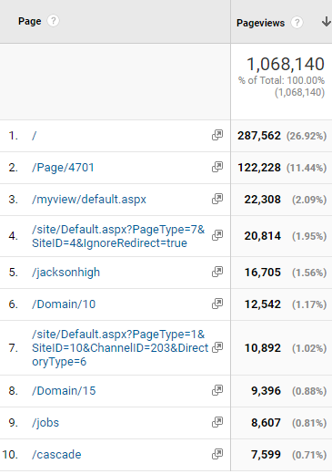

Heatherwood Middle

Everett High

JHS Web Directory

Login page

District home page

LMS welcome page

MyView (must login to see)

Cascade High

Employment

Jackson High