**Website Analytics October 2017**

Website analytics provides insight into who is visiting the website with details of traffic patterns, demographics and technology used. This tool provides the information to create and maintain an effective website.

Analytics are provided on a monthly basis.

**Overview**

353,362 **53,362**individuals visited the site

817,870 visits were made by the individuals above

4,330,528 pages were viewed during those visits

36.71% of the visitors were new to the site.

The average number of pages visited on each visit was 5.29**5.66 5.66**.

The average time spent on each page was 02:45.

Most visits came from the following countries:

1. United States
2. Canada
3. India
4. Philippines
5. Ukraine
6. Japan
7. United Kingdom
8. South Korea
9. Germany
10. Italy

People who prefer to view the web with a different language have a setting on their computers that the analytic tool can read. The top five languages preferences that were not a variant of English (US, AU, UK) were:

1. Spanish
2. Korean
3. Chinese
4. Russian
5. Vietnamese

**Browsers**

This data shows that Chrome is the most popular browser.

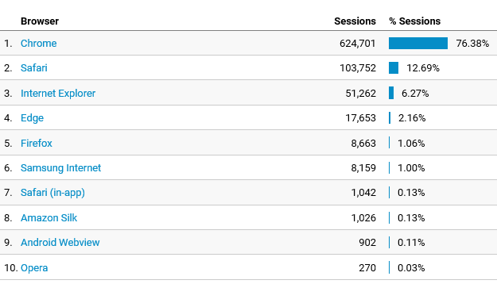

**Operating System**

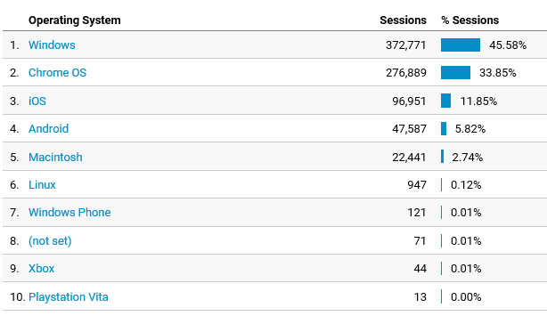

**Service Providers**

This tells us what provider the visitor is using.

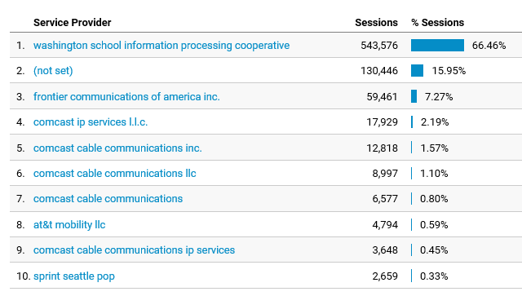

**Mobile Operating Systems**

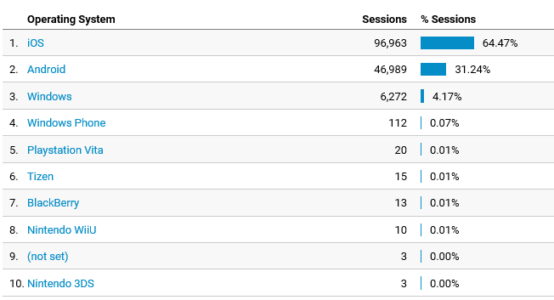

**Overall Screen Resolution**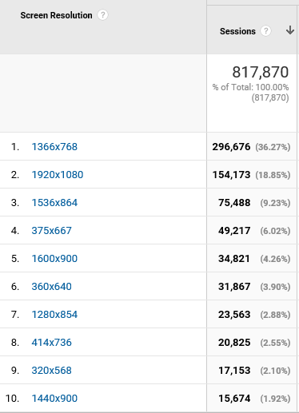

**Mobile Screen Resolution** 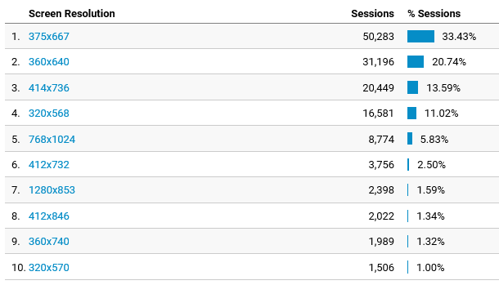

**Mobile Devices**

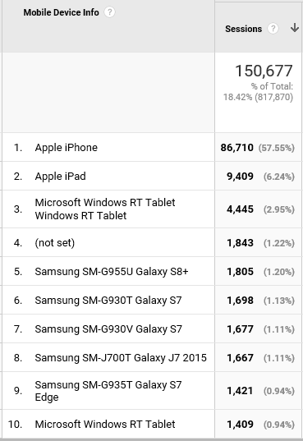

**Device Category**

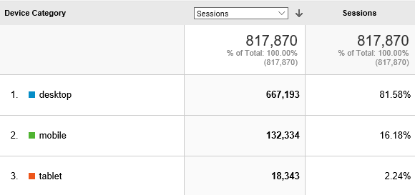

**Most visited pages**

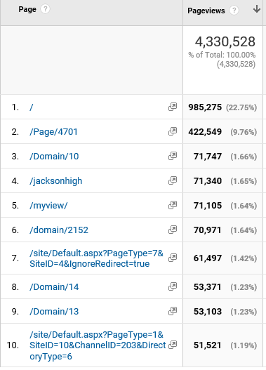

Staff Directory

Evergreen Middle

Gateway Midlle

Login page

Student Tools

MyView (must login to see)

Jackson High

LMS welcome page

District home page

Jackson High