**Website Analytics September 2018**

Website analytics provides insight into who is visiting the website with details of traffic patterns, demographics and technology used. This tool provides the information to create and maintain an effective website.

Analytics are provided on a monthly basis.

**Overview**

262,397 **53,362**individuals visited the site

742,935 visits were made by the individuals above

**1,304,039**2,009,958 pages were viewed during those visits

73.9% of the visitors were new to the site.

The average number of pages visited on each visit was 2.71**5.66 5.66**.

The average time spent on each page was 03:03.

Most visits came from the following countries:

1. United States
2. Canada
3. India
4. Philippines
5. France
6. United Kingdom
7. Turkey
8. Germany
9. South Korea
10. Japan

People who prefer to view the web with a different language have a setting on their computers that the analytic tool can read. The top five languages preferences that were not a variant of English (US, AU, UK) were:

1. Spanish
2. Korean
3. Russian
4. Chinese
5. Vietnamese

**Browsers**

This data shows that Chrome is the most popular browser.

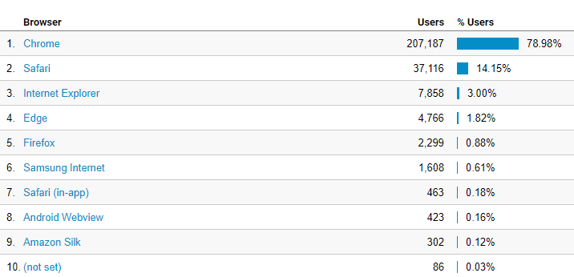

**Operating System**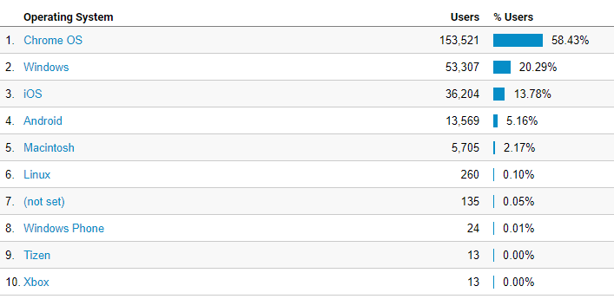

**Service Providers**

This tells us what provider the visitor is using.

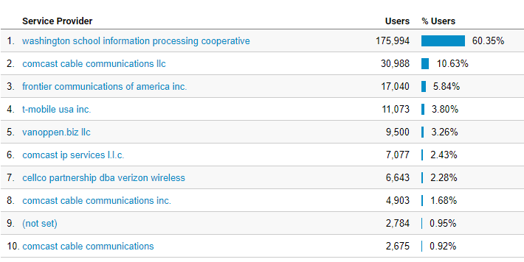

**Referrals** (visits that came to your site from sources outside of the Google search engine)

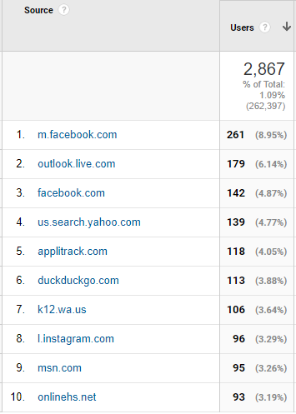

**Mobile Operating Systems**

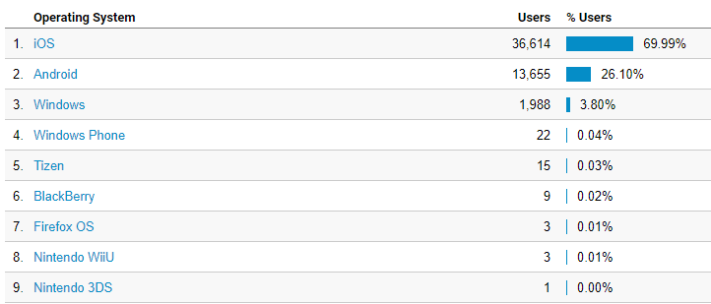

**Overall Screen Resolution**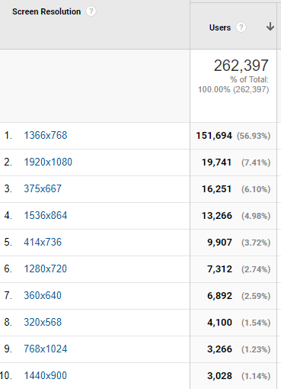

**Mobile Screen Resolution** 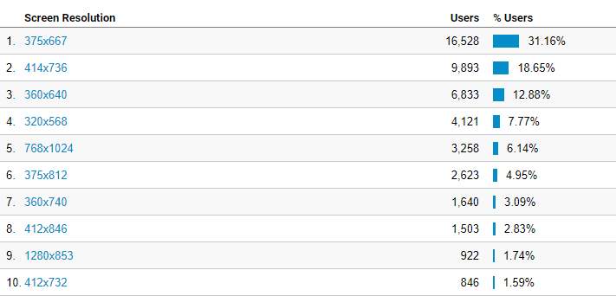

**Mobile Devices**

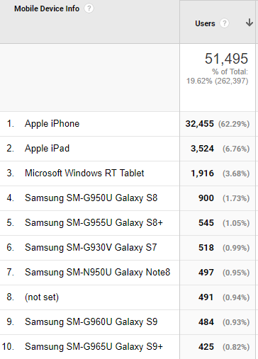

**Device Category**

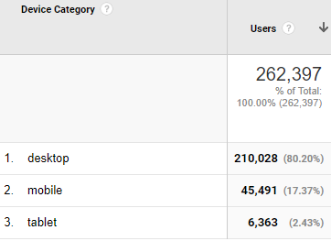

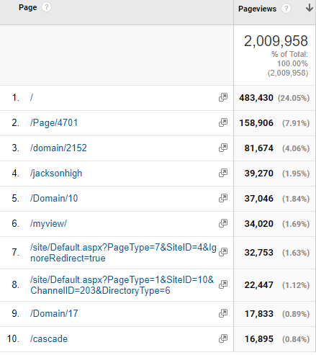**Most visited pages**

Jackson High

District home page

LMS welcome page

Student Tools

Cascade High

MyView (must login to see)

Login page

JHS Web Directory

Cedar Wood Elementary

Cascade High