Issue & Referrals – Admin/Office Screen Shots
Handout #2

Referrals – Part 2

Administrators:  Open in eSchools:  In Menu, open Interventions. | 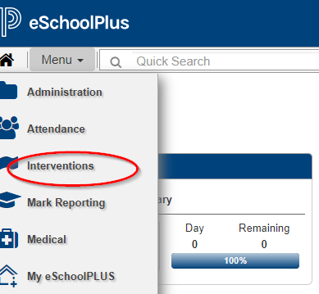
Open Behavior Referrals under Office Section: | 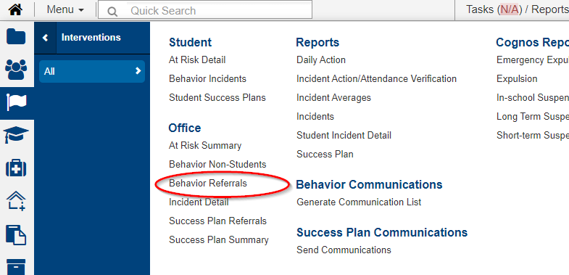
Select the incident  (selecting student brings you to contact information/student data) | 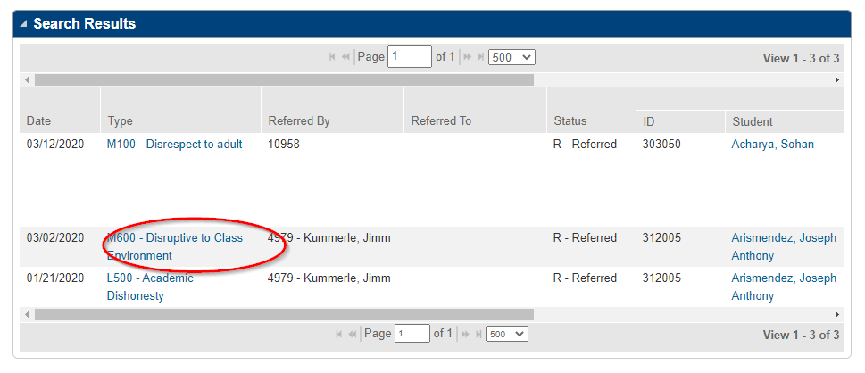
Select the action | 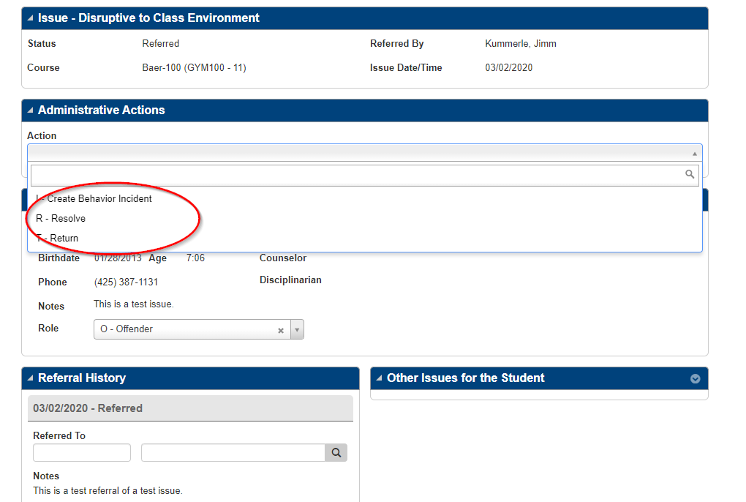
** Resolve or Return | 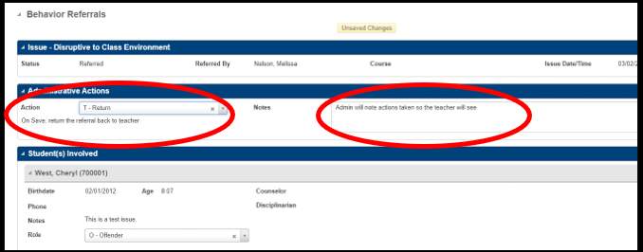
** Create Behavior Incident  - Creating an incident begins the transition to formal discipline with OSPI reporting codes.  - Select an incident code  - HIT SAVE – incident created appears.  - CLICK on Incident Created | 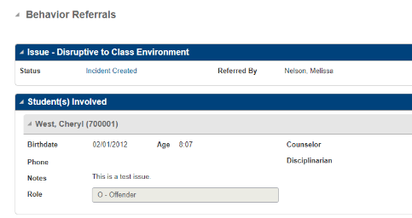  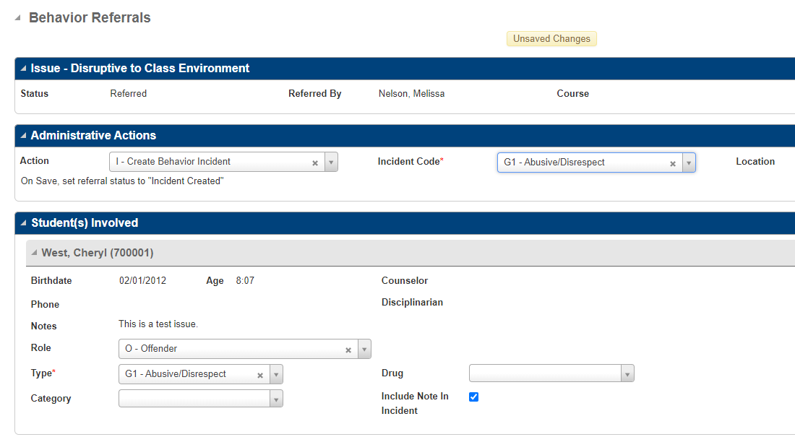
Finish: by entering “discipline” in the typical fashion.  The system will send you to the Behavior Incident Window.  The original description and referring teacher will auto fill. As Admin you can add note in the description if necessary. | 