What if I want a Fine Art as an alternate to an Other Elective?

Because Fine Arts selections happen **first** your Elective class will **NOT** be available to select in the dropdown after choosing “Alternate to this Course” when you are selecting your Fine Arts classes.

You will need to follow the steps below.

### **Fine Arts**

**Step 1**: Put a check next to all **Fine Arts** classes you want, **both** your first choices and alternate choices, including alternates for other electives.

**Step 2:** Next to your **Fine Art** alternate class, click the alternate dropdown and select **“**Alternate to this course:”

**DO NOT select “Alternate this Course” for the alternate to your other Elective. You will do this later.** 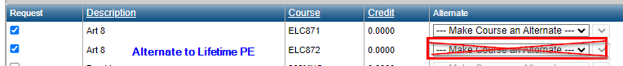

**Step 3:** In the new dropdown that just appeared, select the code for your first-choice **Fine Art** class.

### **Other Electives**

**Step 1**: Put a check next to all **Elective** classes you want, **both** your first choices and alternate choices.

**Step 2:** Next to each **Elective** alternate class, click the alternate dropdown and select **“**Alternate to this course:”

**Step 3:** In the new dropdown that just appeared, select the code for your first-choice **Elective** class.

### **Back to Fine Arts**

**Step 1**: Find the Fine Arts class you checked that you want to be the alternate to your first choice Elective.

**Step 2:** Click the alternate dropdown and select **“**Alternate to this course:”

**Step 3:** In the new dropdown that just appeared, select the name for your first-choice **Elective** class.

