Career Map
7th grade
November

ASCA Standards: C:A2 Develop Employment Readiness, C:B1 Acquire Career Information, C:B2 Identify Career Goals

Purpose:
Students will use the research on their Top Career Pick from November and look at the educational path and different career branches they could pursue.
Materials needed:
Access to computers for each student or part of the class
Fact Gathering sheet from November
Choices After HS preparation Overhead
Potential Earnings Overhead
Career Map worksheet for each student

Lesson
- Start by briefly explaining that every career has a path to get there. Some careers take years of training and or schooling while others do not. Use the “Choices after High School” to discuss the options students have and the requirements they will encounter as they plot their Career Map.
- Show the Potential Earnings overhead and briefly discuss the earning potential (generally) for students who graduate HS, get a degree, etc.
- Have students log onto a computer, or split the class so that some students are using a computer and the rest of the students are engaged in an activity while other students are using computers. Activities for the class could include a backpack organization, reviewing goals and action plans, working on Homework or reading silently (all activities help students be academically prepared and ensure success!)
- Have Students log on to the Internet and go to www.bridges.com. Students should click on WORK at the top of the page and use the Career Zone or Alphabetical list to find information on their “Top Career Pick”. Once they click on the Career and the description pops up have students click on “ Education” on the upper left side of the page, as well as “Salary and Outlook” in order to answer the questions on the Career Map worksheet
- Have students file their Career Map worksheet in their collection folder and transfer to their Portfolio prior to Student Led Conferences.
Choices After High School
Overhead

- Work- finding a job after graduation

- Internship- working for free or reduced wages at a job in order to gain experience for employment (On the Job Training)

- Military- joining a branch of the Armed Forces. Often times the military will help you pay for college.

- 2 year or Community College- A local college that you attend for 2 years. Often time’s students attend a community college and transfer to 4-year college or University. Advantage easier entry requirements and cheaper tuition.

- 4 year College or University- You can earn a Bachelors Degree, a Masters Degree and or a Doctorate at a 4 year College or University

- Other

Potential Earnings
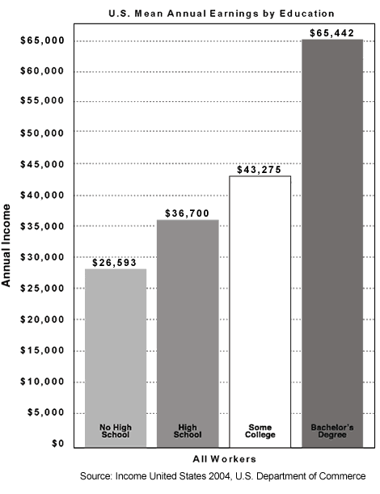

Career Map
Using the information found on www.bridges.com or www.bls.gov/oco/ fill in the following boxes. It might be easier to start at the end and work backwards.

Top Career Pick
Middle School classes that will help me learn the skills I’ll need for this career
*
*
*
*
HS classes that would prepare me for this career
*
*
*
*
*
*
Education required after High School for my Career
- Military
- Trade School
- Community College
- 4 yr college
- other
Best place to live for my career

Salary I expect to make

_____________________________
Careers related to my Top Career Pick:

___________________________

___________________________
What HS Job/Internship or Volunteer experience could I have that might be SIMILAR to my career?

