March 4, 2009

THE HERALD
P.O. Box 930
Everett, WA 98206

ATTN: LEGAL NOTICE DEPARTMENT

The Board of Directors of Everett School District No. 2, Snohomish County, Washington, will hold a special Board meeting on Thursday, March 5, 2009, at 6:30 p.m. in the Board Room of the Educational Service Center, 4730 Colby Avenue, Everett, Washington.

The purpose of the special meeting is to discuss and possibly take action on the selection of the superintendent, and, if appropriate, discuss and possibly take action on the process for negotiating a contract with the superintendent.

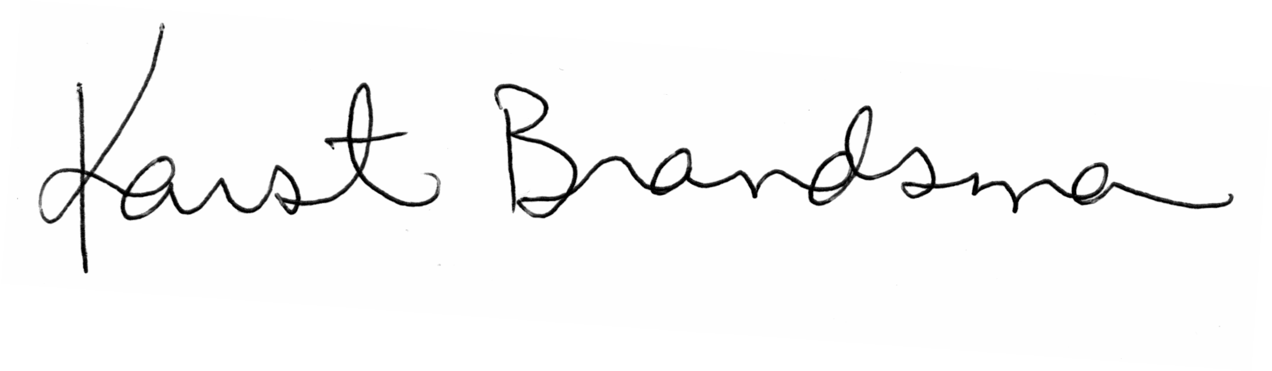
Submitted by:
Karst Brandsma
Interim Superintendent

c: Eric Stevick, The Herald Conor Glassey, The Tribune Carol Andrews
Tim Jarboe, The Herald Kim Eckart, The Seattle Times Ed Petersen
Sarah Koenig, The Enterprise Sue Cooper Karen Madsen
Scott Sunde, Seattle P-I Kristie Dutton Mary Waggoner

P.O. Box 2098 – 4730 Colby Avenue – Everett, Washington 98203

Telephone (425) 385-4016 Fax (425) 385-4002

