You Show
A Mouthful
Paul Jennings

Parents are embarrassing.

Take my dad. Every time a friend comes to stay the night, he does something that makes my face go red. Now don’t get me wrong. He is a terrific dad. I love him but sometimes I think he will never grow up.

He loves practical jokes.

This behavior first started the night Anna came to sleep over.
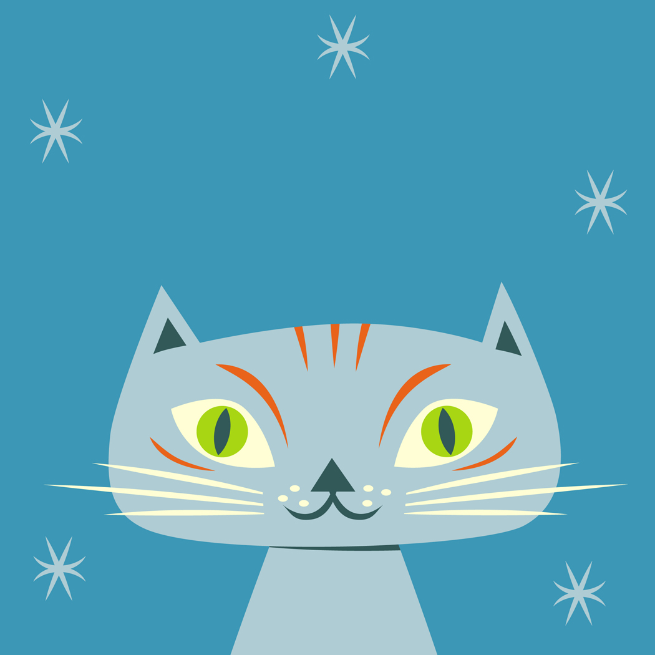
Unknown to me, Dad sneaks into my room and puts Doona, our cat, on the spare bed. Doona loves sleeping on beds. What cat doesn’t?

Next Dad unwraps a little package that he has bought at the magic shop.

Do you know what is in it? Can you believe this? It is a little piece of brown plastic cat poo. Pretend cat poo. Anyway, he puts this piece of cat poo on Anna’s pillow and pulls up the blankets. Then he tiptoes out and closes the door.

I do not know any of this is happening. Anna and I are sitting up late watching videos. We eat chips covered in sauce and drink two whole bottles of Diet Coke.

Finally we decide to go to bed. Anna takes ages and ages cleaning her teeth. She is one of those kids who is into health. She has a thing about germs. She is so clean.

Anyway, she puts on her tracksuit and gets ready for bed. Then she pulls back the blankets. Suddenly she sees the bit of cat’s poo. “Ooh, ooh, ooh,” she screams. “Oh, look, disgusting. Foul. Look what the cat’s done on my pillow.”

Suddenly, Dad bursts into the room. “What’s up, girls?” he says with a silly grin on his face. “What’s all the fuss about?”
Anna is pulling a terrible face. “Look,” she says in horror as she points at the pillow.

Dad goes over and examines the plastic poo. “Don’t let a little thing like that worry you,” he says. He picks up the plastic poo and pops it into his mouth. He gives a grin. “Delicious,” he says through closed lips.

“Aargh,” screams Anna. She rushes over to the window and throws up chips, sauce and Diet Coke. Then she looks at Dad in disgust.

Dad is a bit taken aback at Anna being sick. “It’s okay,” he says, taking the plastic poo out of his mouth. “It’s not real.” Dad gives a laugh and off he goes. And off goes Anna. She decides that she wants to go home to her own house. And I don’t blame her.

“Dad,” I yell after Anna is gone. “I am never speaking to you again.”
“Don’t be such a baby,” he says. “It’s only a little joke.

It’s always the same. Whenever a friend comes over to stay, Dad plays practical jokes. We have fake hands in the trash, exploding drinks, pepper in the food and short-sheeted beds. Some of the kids think it’s great. They wish their dads were like mine.

But I hate it. I just wish he was normal.

He plays tricks on Bianca.
And Yasmin.
And Nga.
And Karla.

None of them go home like Anna. But each time I am so embarrassed.

And now I am worried.

Cynthia is coming to stay. She is the school captain. She is beautiful. She is smart. Everyone wants to be her friend. And now she’s sleeping over at our house.

“Dad,” I say. “No practical jokes. Cynthia is very mature. Her father would never play practical jokes. She might not understand.”

“No worries,” says Dad.

Cynthia arrives, but we do not watch videos. We slave away on our English homework. We plan our speeches for the debate in the morning. We go over our parts in the school play. After all that, we go out and practice shooting baskets, because Cynthia is captain of the basketball team. Every now and then I pop into the bedroom to check for practical jokes. It is best to be on the safe side.

We also do the dishes because Cynthia offers – yes – offers to do it.

Finally it is time for bed. Cynthia changes in the bathroom and then joins me in the bedroom. “The cat’s on my bed,” she says. “But it doesn’t matter. I like cats.” She pulls back the blankets.

And screams. “Aagh. Cat poo. Filthy cat poo on my pillow.” She yells and yells and yells.

Just then Dad bursts into the room with a silly grin on his face. He goes over and looks at the brown object on the pillow. “Don’t let a little thing like that worry you,” he says. He picks it up and pops it into his mouth. But this time he does not grin. His face freezes over.

“Are you looking for this?” I ask.

I hold up the bit of plastic poo that Dad had hidden under the blankets earlier that night.

Dad looks at the cat.
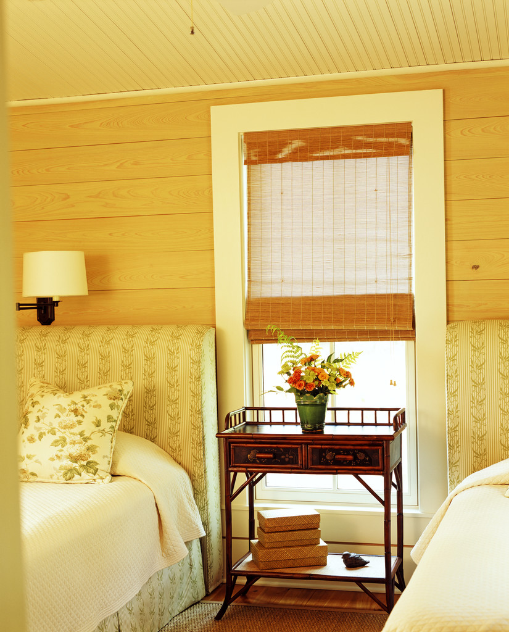
Then he rushes over to the window and is sick.

Cynthia and I laugh like mad.

We do love a good joke.

