Just a Pigeon
By Dennis Brindell Bradin

For Terrence, life seemed a little rough at times – going to high school, pumping gas after school and on Saturdays, and studying late into the night. He often had to tell himself, “You’ve got to keep at it to go to college.”
But now, a Friday, Terrence McCray felt good. He was walking home after work with a paycheck in his pocket.
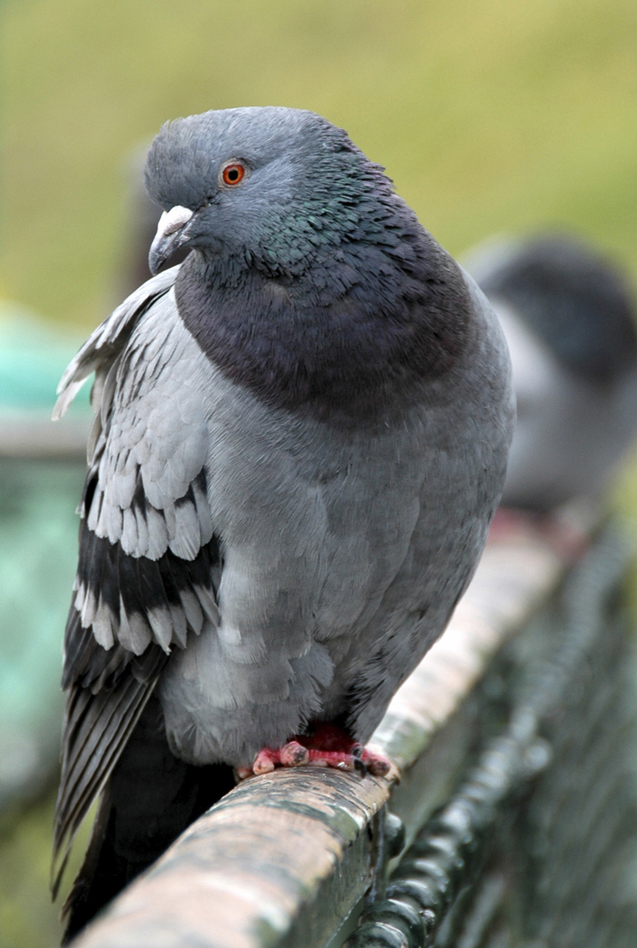
He was thinking about his date the next night with Deborah, when he saw the injured pigeon. It was in the gutter. Several people were hurrying by.

It’s just a pigeon. It’s just a pigeon with a busted wing, he told himself. Some people walk by people. So why should I do anything for a pigeon? But it looked so helpless and scared.

He didn’t want to pick it up, because he knew that pigeons sometimes carry diseases. So he went inside a grocery store and got a paper bag. When he came back outside, he hoped the pigeon would be gone. But it was still there.

“Come on, pigeon,” he said, bending over with the bag. He felt like a fool. Some people had stopped to stare. But he picked up a twig and gently pushed the bird into the bag and carried it to his house.

Terrence’s mother hadn’t gotten angry when she saw the bird. She hardly ever got angry with him. She just said, “You’re good-hearted, Terrence. But you can’t take the burden of the world on your shoulders. You can try to help that bird. But … get it out of my kitchen.”

After dinner, his mother got ready for work. Terrence rushed out and bought some birdseed.
When he got back, his mother was in her nurse’s uniform. She said, “You brought the bird here. So you decide what to do with it.”

Terrence fed the pigeon. Then he put the bird in the shoebox out on the porch.

Later, he could hear the bird cooing sadly. “Maybe I should have left it in the street,” he said to himself. “It will probably die, anyway.”

On Monday, between classes, Terrence looked up “Veterinarians” in the phone book. He got out his cell phone and dialed a number.

“Pigeon?” the doctor said. “Broken wing? I could try to fix it.”
“How much will it cost?” Terrence asked.

“I couldn’t tell. It could be expensive. If I can fix the wing, the bird will have to stay here for awhile. But you would have to pay me all at once.”

After history class, Willie Barnes asked Terrence to shoot baskets in the gym.

“I can’t, Willie,” he said. “See, I found this pigeon with a busted wing. I’ve got to take it to the vet before work.”

“What?” Willie said. “Spending money on a pigeon?”

Thad Lanier had stopped to listen. He stared at Terrence and said, “So many people in this world need help. And you spend money on a pigeon?”
“I saw it in the gutter,” Terrence tried to explain. “I couldn’t help it.”

But Thad had turned and walked off with Willie, shaking his head.

Terrence took the pigeon to the vet. Dr. Landis said, “I’ve got to admit, this is my first pigeon. But I think I can fix its wing. Leave it here and give me a call tomorrow.”

The next day, Terrence called Dr. Landis. He learned that the bird’s wing had been set, and that it was doing well.

Terrence was glad about the bird. But he was worried about the money. Besides that, Thad kept making remarks. One afternoon, just before history class started, Thad went too far.

“Talk about your future leaders!” Thad said. “How about Terrence here? He’s spending his money on a pigeon.”

“A what?” Deborah asked. “Is that why we couldn’t go to the movies, Terrence?”

“Yeah,” Thad said. He found a sick pigeon, and he’s paying for it to get well. Meanwhile, poor people don’t have enough to eat.” Excited by his own voice, Thad added, “Who’s the real pigeon?”
Terrence got out of his seat and rushed at Thad. Just then, the teacher walked in. Terrence didn’t care. He raised his fist. But as he saw Thad’s frightened face, he all of a sudden felt sorry for him. He also knew why he had saved the pigeon.

“It was in trouble,” he said. “It was alive, like us. If you walk past an animal one day, who knows – the next thing you might walk past is a person.”
“What’s all this?” the teacher asked as she came back into the room. “Nothing,” Terrence said.

When Terrence went back to the vet he had plenty of money with him. But he kept hoping that somehow Dr. Landis would say, “Since you’re so kind, you don’t have to pay.”
Dr. Landis took him back to where the animals were kept in cages. There was the pigeon, looking as healthy as any pigeon.

Dr. Landis took it out of the cage. Then they went out through the back door and Dr. Landis set the pigeon down gently on the ground.

Terrence half expected the pigeon to thank them somehow. But it just fluttered its wings and flew up to a window ledge.

Terrence reached for his wallet.
“That will be $40,” Dr. Landis said.

Terrence counted out the money. Then he looked for the pigeon. But it had flown out of sight.

