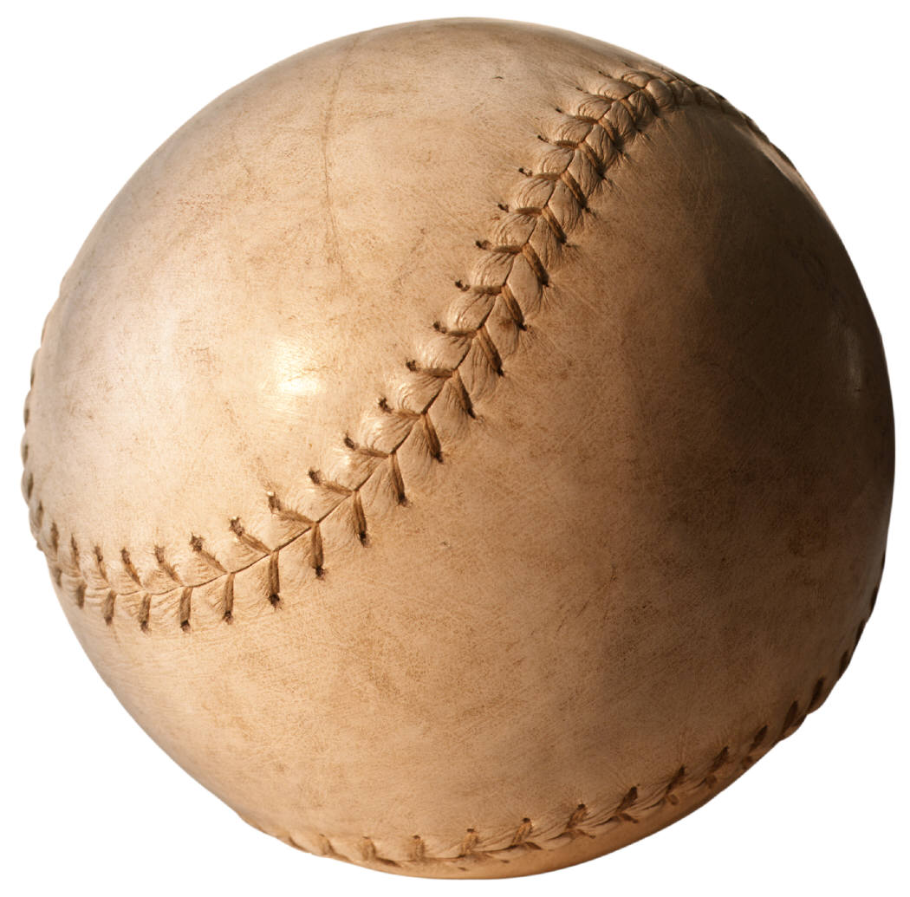

We Do - Explicit
An excerpt from Rickey & Robinson
by John Chalberg

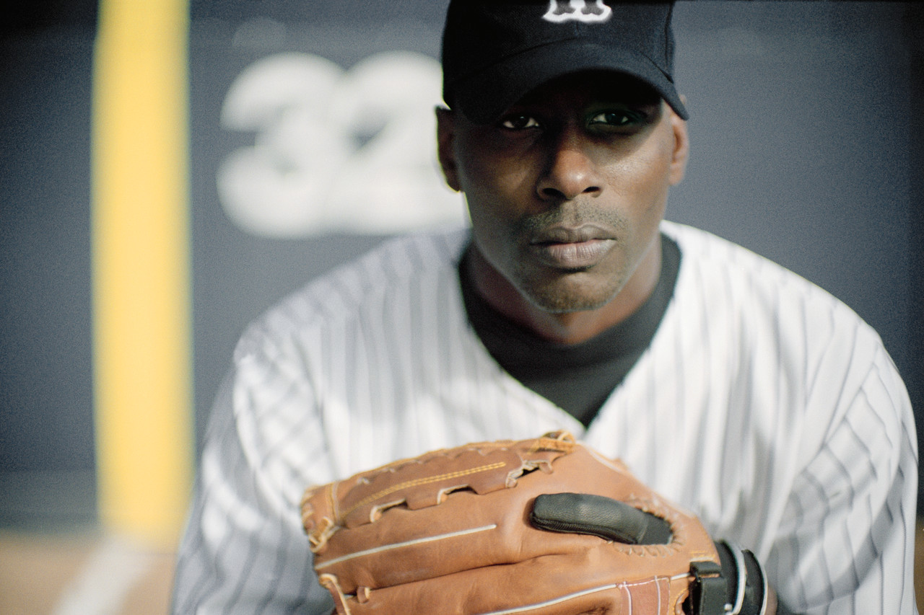
At bat, Robinson quickly learned that one of Branch Rickey’s warnings had to be taken to heart. He also learned that Gene Bensen hadn’t been entirely right: the majors were not necessarily easier, at least not for their lone black player. By the end of May, Robinson had been thrown at-or close to- countless times and hit six times. On each of those half-dozen occasions he could only do what he had promised Rickey he would do: shake off the sting and trot heroically to first base. Though he probably did not know this, that sixth HBP (hit by pitch) tied the individual mark for the whole of the 1946 season. There would be only three more such incidents during the rest of the 1947 season. Did National League pitchers suddenly grow kinder and gentler? Not really: two months of the season was enough to teach them that they didn’t want the explosive Jackie Robinson dancing off first base and charging into second if they could possibly help

