JAMESTOWN

European nations came to the Americas to increase their wealth and broaden their influence over world affairs. The Spanish were among the first Europeans to explore the New World and the first to settle in what is now the United States.
By 1650, however, England had established a dominant presence on the Atlantic coast. The first colony was founded at Jamestown, Virginia, in 1607. Many of the people who settled in the New World came to escape religious persecution. The Pilgrims, founders of Plymouth, Massachusetts, arrived in 1620. In both Virginia and Massachusetts, the colonists flourished with some assistance from Native Americans. New World grains such as corn kept the colonists from starving while, in Virginia, tobacco provided a valuable cash crop. By the early 1700s enslaved Africans made up a growing percentage of the colonial population. By 1770, more than 2 million people lived and worked in Great Britain's 13 North American colonies.
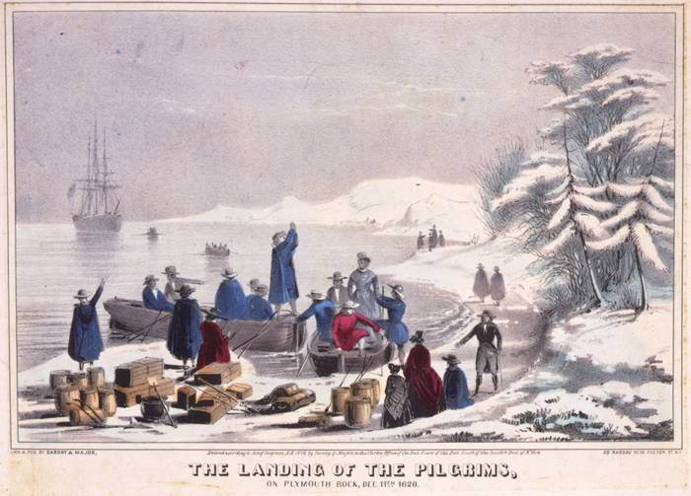
The Pilgrims landing on Plymouth Rock, December 1620

