Elementary Library News-

Woodside Elementary

Woodside students are doing research on the lifecycle of plants and animals. Second and third grade students are using Enchanted Learning to get facts on frogs and will then begin writing an informational paragraph. Fourth and fifth grade students are focusing on the science standards for the life cycle of plants and animals and are doing various web quests and activities to hone in on these skills. Our science table is host to various exoskeletons and shells of animals that molt. Here is a picture of the molted exoskeleton of a tarantula.

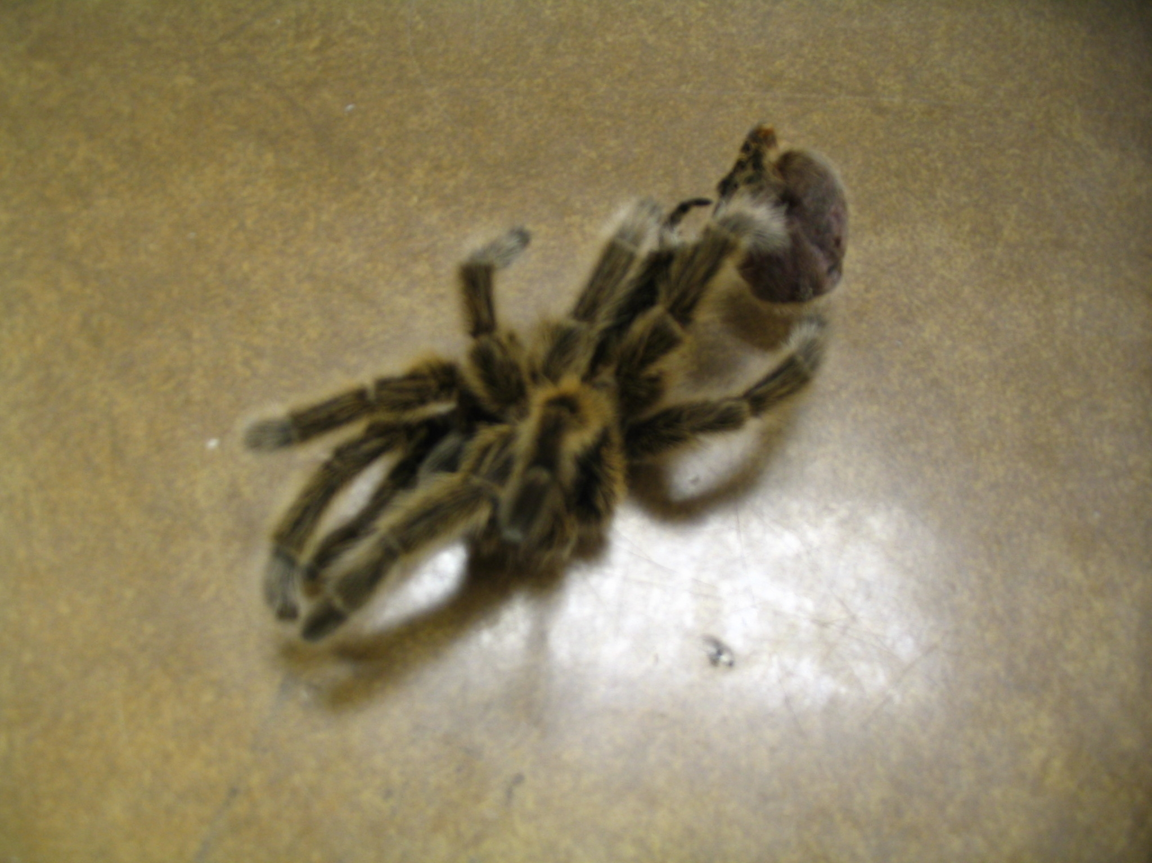

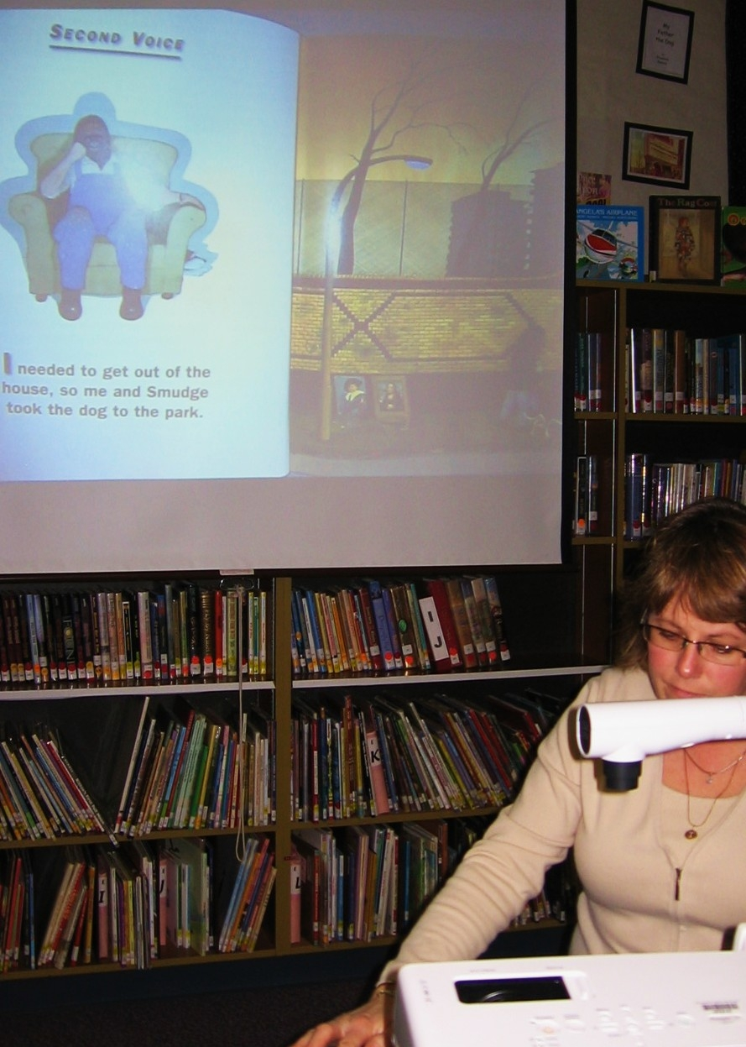

Monroe Elementary

Tracy Stavang, teacher-librarian at James Monroe Elementary, teaches a literacy lesson once a month for each grade level on the literacy skill that is focused on that month.

Ms. Stavang is shown using the book, Voices in the Park by Anthony Brown, to teach inference.

Silver Lake Elementary

Elementary School Monthly Family Reading Nights: PTA sponsored Monthly family reading nights are held in the Silver Lake Elementary School library from 6:30-8:00 p.m. Families can read books in the library and take AR tests. At 7 p.m. volunteer staff read books to the audience based on a monthly theme. Intermission includes snacks for kids in attendance.

