**Creating an Electronic Resume: Microsoft Word**

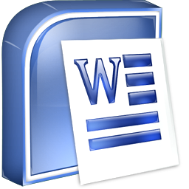



1. Click on the **Start Menu.**



1. In the **Search** area type ***Microsoft Word***.

1. When the search results show in the open window click Microsoft **Word**.
2. 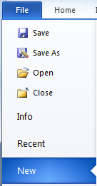When the program opens, click on the **File** tab>**New.**

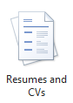

1. 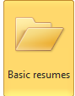In the middle section, scroll down to the bottom & click the icon for **Resumes and CVs** templates.
2. Next, click the folder for **Basic Resumes**.
3. This will allow you to choose from different types of **Chronological, Functional, or Combination** resume templates.

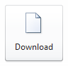

1. Once you have chosen your template click the **download** icon on the right.
2. Make sure you go to **File>Save As…** to title your resume before you start your work.
3. Fill in the template with your information.