**Creating an Electronic Resume: WOIS**



1.  Go to [www.wois.org](http://www.wois.org) & log in to your account.

1. 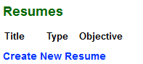From the **Main Menu** *(center)* click **Resume Builder** OR from the **Portfolio** menu *(left)* click on **Resumes.**
2. Click the link to **Create New Resume**.
3. 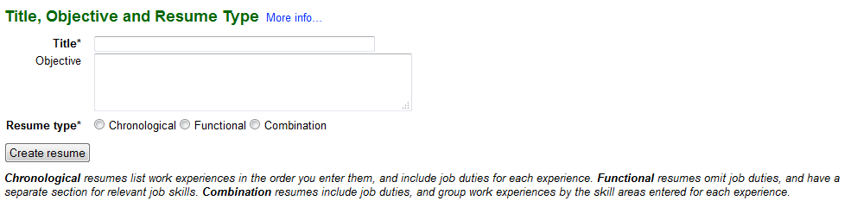Type in a **title** for your resume to help you refer back to it at a later time if you create more than one.
4. Then choose the **resume type** you would like to use.
5. Finally, click **Create Resume** & WOIS will guide you through the process of filling in your information and generating your resume.
6. When you are finished, WOIS will give you the option to **View/Print Resume**.

*\*You can also highlight the text on the page & copy/paste in to a document.*