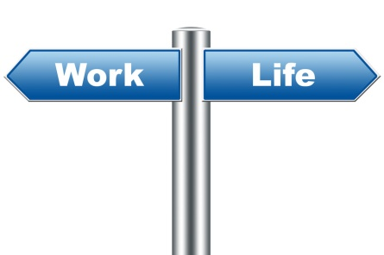

**Interview**

**Learning Outcomes:** **Students will learn and practice the industry standard skills required to apply for employment.**

|  |  |  |  |
| --- | --- | --- | --- |
| **Alignment with Standards:** | **Essential Academic Learning Requirements Grades 9/10 Grade Level Expectations:** This lesson is aligned with Writing 1.5.1 and Educational Technology 1.3.2 and 1.3.3. Students will develop materials in a career-appropriate format. They will locate, analyze, and use information from a national career database.  **Common Core State Standards Grades 11-12:** This lesson is aligned with…College and Career Readiness Standards for Speaking and Listening, Presentation of Knowledge and Ideas 6, Adapt speech to a variety of contexts and tasks, demonstrating a command of formal English when indicated or appropriate.  **American School Counselor Association National Standards:** This lesson is aligned with ASCA Standard C: Students will understand the relationship between personal qualities, education, training and the world of work.C:C1 Acquire Knowledge to Achieve Career Goals, C: C1.3 Identify personal preferences and interests influencing career choice and success.  **21st Century Skills:**   * **Self-direction:** Systematic and comprehensive planning, Self-instruction, Resources, Effective and sustained effort, Self-monitoring and reflection, Results are valuable * **Problem Solving:** Identifying and addressing obstacles, Identifying solutions, Self-evaluation and reflection | | |
| **Materials:** | * **Teacher Lesson** * **Teacher Intro. Power Point presentation** | * **Copies of hand outs:**   *CE Mock Interview Questions and Rubric* | * **Computer/Internet Access** |
| **Implementation:** | * **Ask** students about their prior experiences with interviews. *How many have they experienced? For which positions/jobs? What are their insights in to the process? What went well or not so well in the interview and what did they learn from the process?* * **Present** PowerPoint providing them with more background information for effective interviewing skills. ***(Open file: Teacher_Intro._Interview_Presentation)*** * **Complete** the presentation. ***(*Students will need computers to complete the next part of the lesson)*** * **Discuss** your class process for setting up and participating in **mock interviews.** * **Create** a schedule for interviews and communicate the times to the students. * Students will need to have access to computers in order to **download/save** the interview questions & rubric. * Have students with the list of questions and the rubric. ***(CE Mock Interview Questions and Rubric)*** * **Review** the questions & rubric and have students write enter their responses for each question & **SAVE with their name.** * Once all students are ready, have students pair up & partner practice, scoring each other on the rubric, & providing each other with positive feedback. * When students have completed their **mock interview questions & peer practice** they will need to **UPLOAD** it with their name to the class Moodle site. | | |
| **Additional Resources:** | **Article:**  10 ways intelligent job seekers blow their interviews | | |