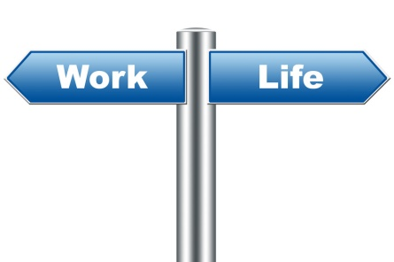

**Personal Multimedia Presentation**

**Learning Outcomes:** **Students will use Prezi to prepare a multimedia presentation about their life experiences. Within the presentation they will detail how life experiences have impacted their skills, strengths, values and/or interests & the effect of these on their future goals/plans.**

|  |  |  |  |
| --- | --- | --- | --- |
| **Alignment with Standards:** | **Essential Academic Learning Requirements Grades 9/10 Grade Level Expectations:** This lesson is aligned with **Writing-** EALR 1: The student understands and uses a writing process. Component 1.5: Publishes text to share with audience. Publishes in formats that are appropriate for specific audiences and purposes. Educational Technology Standard EALR 2-Digital Citizenship, 2.3 Select and Use Applications Use productivity tools and common applications effectively and constructively. 2.3.1 Select and Use Common Applications to create and publish multimedia projects.  **Common Core State Standards Grades 11-12:** This lesson is aligned with College and Career Readiness Standards for Speaking and Listening- Presentation of Knowledge and Ideas 5, Make strategic use of digital media (e.g., textual, graphical, audio, visual, and interactive elements) in presentations to enhance understanding of findings, reasoning, and evidence and to add interest.  **American School Counselor Association National Standards:** This lesson is aligned with ASCA Standard C: Students will understand the relationship of academics to the world of work and to life at home and in the community. A:C1 Relate School to Life Experiences- A:C1.3 Understand the relationship between learning and work A:C1.6 Understand how school success and academic achievement enhance future career and vocational opportunities.  **21st Century Skills:**   * **Self-direction:** Systematic and comprehensive planning, Self-instruction, Resources, Effective and sustained effort, Self-monitoring and reflection, Results are valuable * **Digital Communication:** Electronic environments, Media: Awareness of range of media, Conventions and etiquette in media, Design elements, Responsible behavior * **Problem Solving:** Identifying and addressing obstacles, Identifying solutions, Solving the problem, Self-evaluation and reflection | | |
| **Materials:** | * **Teacher Lesson** | * **Copies of hand outs:**   *Student_MMPres._worksheet_checklist* | * **Computer/Internet Access** |
| **Implementation:** | * **Introduce** the ***learning outcome***of the multimedia presentation. * Students will need the following things to be able to successfully complete their presentation:   + **Download** a copy of the student worksheet (***Student_MMPres._worksheet_checklist*** ) from the class Moodle site and/or provide a hand out.   + **Log in** to WOIS in order to have access to the results of the **Assessments & Exploration Tools** results. *(*Provide students with a copy of the hand out* ***Accessing_Assmts.-Exploration_Results****.)* * **Step 1:** Students will fill in the **student worksheet** collecting the required information for their multimedia presentation. * **Step 2:** Based on the content filled in on the **student worksheet**, students will log in to **Prezi** and begin creating their presentation. * **Step 3:** When their presentation is complete based on the **completion criteria** found on the **student worksheet**, students will set their Prezi to **Autoplay** (<https://prezi.zendesk.com/entries/22433747-Autoplay> **)** and **Copy/Paste** the link on to their **student worksheet** in the space provided. * When students have completed their **student worksheet & multimedia presentation (Prezi)** they will need to **UPLOAD** the document with their name to the class Moodle site**.** | | |
| **Additional Resources:** | **Prezi Log in:** [www.prezi.com](http://www.prezi.com)  **Prezi Manual/FAQ:** <https://prezi.zendesk.com/forums>  **WOIS:** [www.wois.org](http://www.wois.org) | | |