Lesson 12
Job Applications and Interviews
Student Resources
Resource | Description
Student Resource 12.1 | Reading: Applications, Interviews, Cover Letters, and Work Permits
Student Resource 12.2 | Worksheet: Job Ad Terminology
Student Resource 12.3 | Example: Job Application (separate Word file)  Make It Local | If you choose to replace the example with one based in your community, modify this document. Regardless, remove the callout before distributing this file to students.
Student Resource 12.4 | Example: Cover Letter and Resume  Make It Local | If you choose to replace the example with one based in your community, modify these documents. Regardless, remove the callout before distributing this file to students.
Student Resource 12.5 | Worksheet: Preparing to Write a Resume

Student Resource 12.1
Reading: Applications, Interviews, Cover Letters, and Work Permits

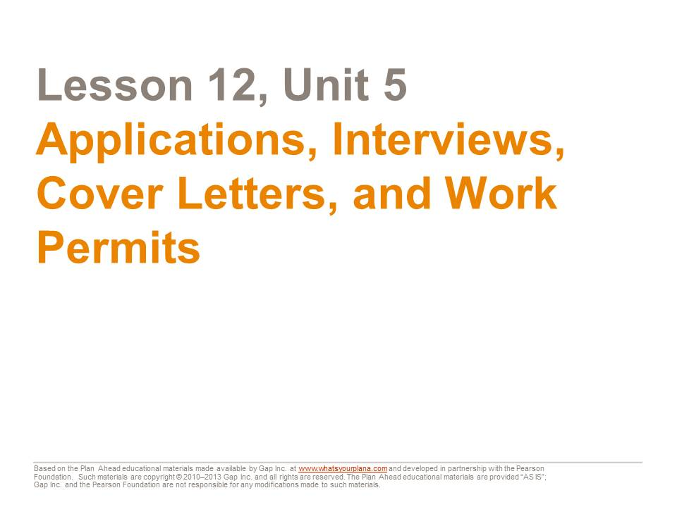
You already know about the power of excellent communication skills to make a good impression on others. Now, as you make plans for college and a future job, it’s also important to know how to present yourself on applications and in interviews. Much of the information and advice here will apply to college admissions. But our main focus is on the job application process.

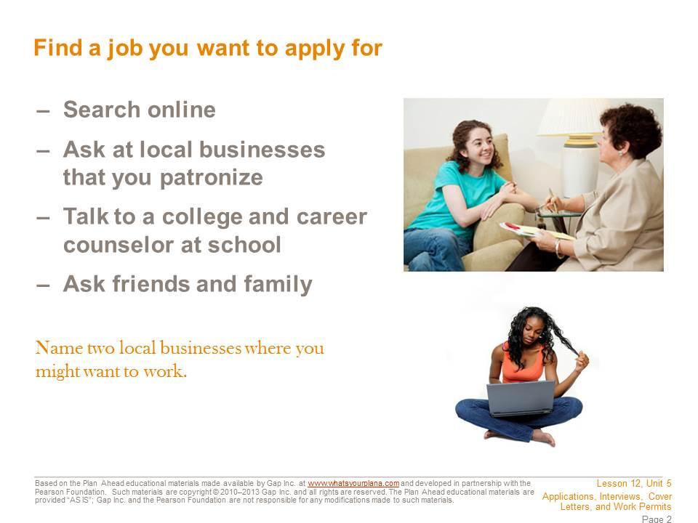

These days, most available jobs are posted online at websites. On a job search website, you can narrow your search geographically—for example, you can search for jobs specifically within a major city or even within a certain neighborhood. Craigslist also has a special section for part-time jobs.
Maybe you already have a potential employer in mind. Some big chains may have local stores in your area, such as coffee bars, grocery stores, or fast-food restaurants. Many of these employers may have applications online that you can fill out.
Many people find jobs by word of mouth. Ask your friends, family members, and neighbors if they know of any job openings. In the business world, this is called networking.
If you’re not sure how to get an application, go to the business and ask in person. Many businesses have applications available; you can take one home to complete and come back another day to return it.

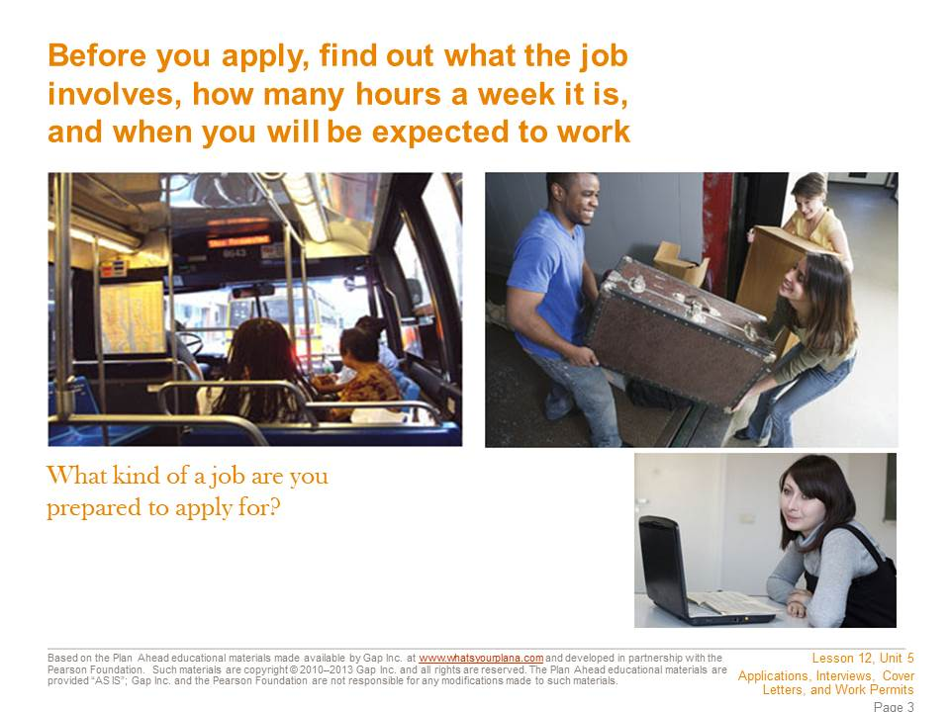
You need to find out some information about a job before you apply for it. Research the company on its website or talk to people who might know something about it. Try to find a job that suits your interests and make sure that you can handle the job requirements.
Do you need to be physically strong? Do you need to be able to use a computer? Will you be serving customers? Also think about scheduling. Can you work around your school schedule? You might want to work at a coffee bar, but if they need people to work the morning shift on weekdays, that job probably won’t work for you except in the summers. Also think about how you will get to work. It might be really fun to get a job at that cool store on the other side of town, but how long will it take you to get there?
As you look for a job, keep these practical considerations in mind.

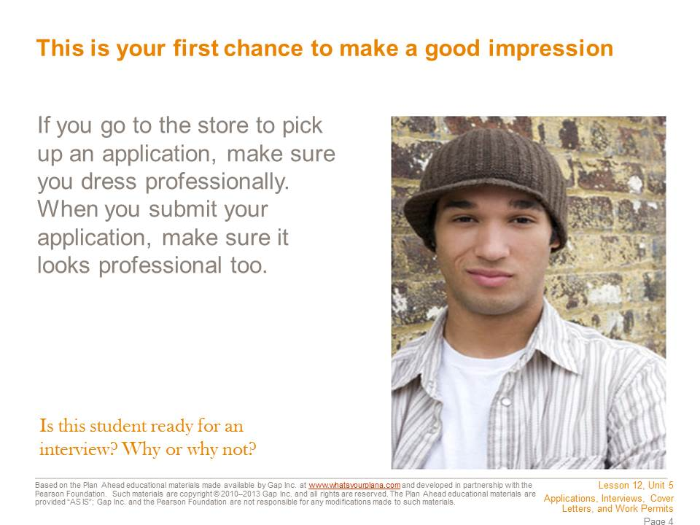

First impressions are very powerful. Even if you’re just submitting an application, you want to look professional. If you are going into a store to pick up an application, dress nicely. That doesn’t mean you need to wear a suit or fancy clothes, but you should wear clothes that will not offend people. For example, this is not the time to wear a t-shirt with profanity on it or a mini-skirt.
You also want your application to look professional. If you are filling out an application by hand, make sure to use blue or black ink. Bright colors and glitter pens are fun to take notes with at school, but they do not look professional on an application. Don’t draw on your application either—no smiley faces next to your signature or hearts dotting the i’s. Neatness is essential: do not turn in a wrinkled application or one that has crossed-out words, and use your easiest-to-read handwriting. Take your time filling it out.

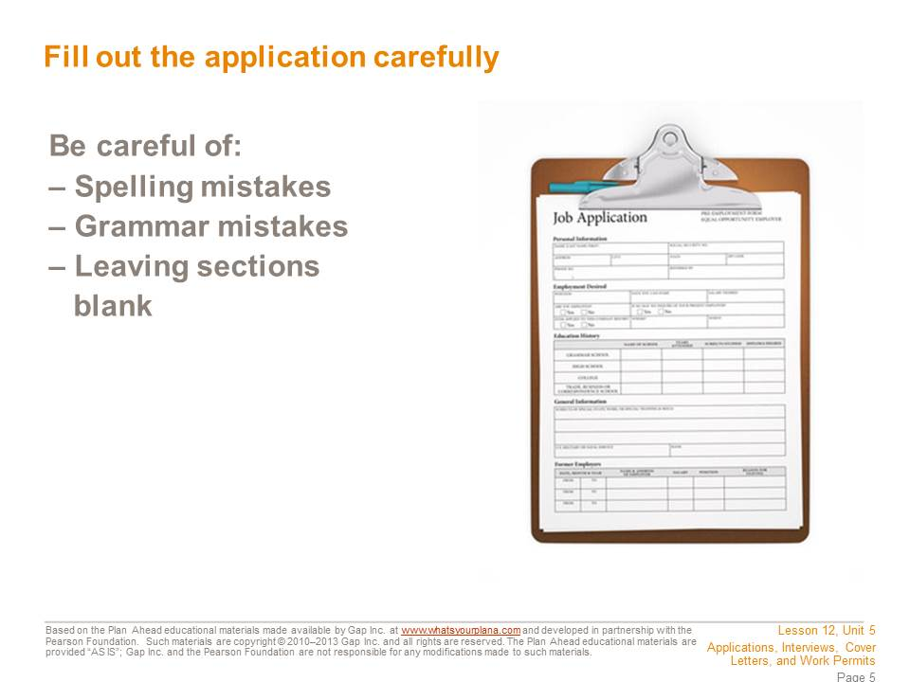
Do your best to avoid making spelling and grammar mistakes. If managers or store owners see a lot of mistakes on your application, they might think you will make mistakes when you’re working.
Don’t leave any sections blank; the manager might think that you didn’t finish the application. Of course there may be sections that you can’t fill out. If this is your first job, you won’t have any “previous employment” to list, and if the application asks about degrees, you don’t have one yet. However, instead of leaving the section blank, you should put “N/A,” which means “not applicable.” That way the manager will understand that you did read the whole application, but just don’t have anything to include in that section. Don’t worry about putting N/A down on a section if you need to; the manager can see that you are just starting out.
If possible, have someone read over your application for you before you turn it in, and make sure you read over the whole thing yourself at least twice. Read it carefully—you don’t want to lose out on a good job because of some careless mistakes.
Many job applications can be filled out online. Before you hit the Send button, however, have someone check your application for mistakes that you didn’t catch. Print a copy of the application to keep for yourself. It will make filling out future applications faster, because you’ve already collected all the information you need.

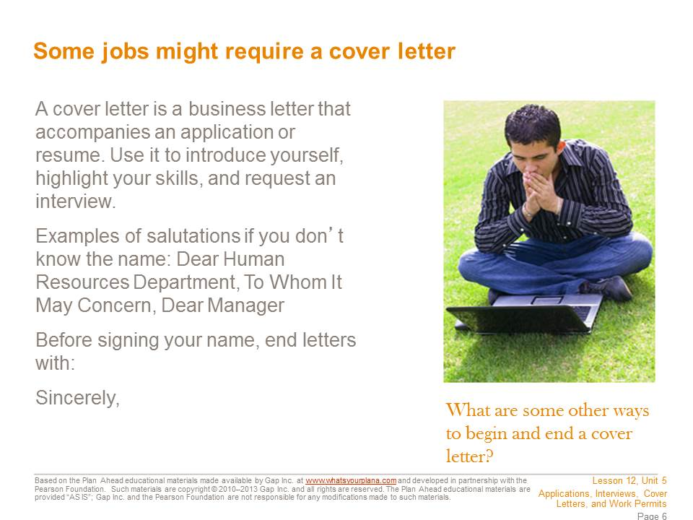

Some employers like to receive a cover letter to have another chance to learn about the potential employee. A cover letter gives you a chance to write about things that might not be on your application. It generally has three parts: an introduction, a summary of your key qualifications, and a request for future action.
In the first section, introduce yourself and explain why you are applying. For example, “I am interested in the position of part-time retail associate that I saw advertised on Jobsforteens.com.”
In the second section, point out why you are a good candidate. For example, “Your ad says that you want someone who is knowledgeable about sports and sports equipment. I have played baseball, lacrosse, and football, and last year I served as the equipment manager for the junior varsity football team at my school.” You also need to make it clear why you want to work at this company. Good reasons? You like its products, you want to have a career in that industry, or you know people who work there and you’ve heard it’s a good job. Bad reasons? It’s the only company hiring, or you think the company will pay you well.
In the third section, you request future action. This generally means that you are asking for an interview. You may want to say something like, “I hope we can discuss this position in the near future,” or “Thank you for considering my application. I look forward to hearing from you soon.”
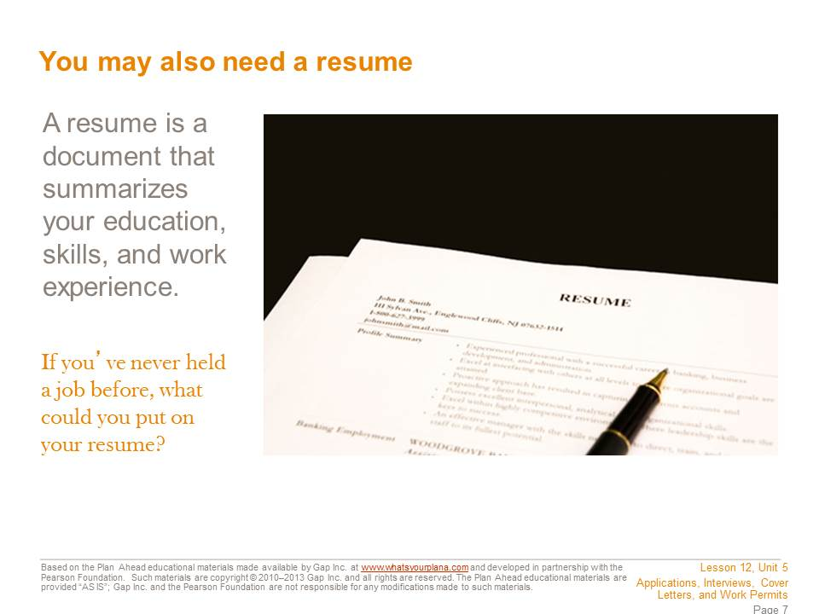
A resume is a written description of your education, skills, and work experience. For work experience, you generally write down the job title, the company you worked for, where it is, when you worked there, and what you did. For example:
- Barista/waiter, Main Street Coffee Company, San Francisco, CA, June–August 2011.
For many adults, the work experience section takes up most of the resume. But what if you’re applying for your first “real” job? First of all, any job you’ve done—babysitting, mowing lawns, or taking care of your neighbor’s cat—can be put on your resume. You might list it as:
- Babysitter, Private Employer, San Francisco, CA, 2008–present
You can also list volunteer experience you may have:
- Kennel Volunteer, San Francisco SPCA, San Francisco, CA 2009–2010
You should list your education, and if you have a good GPA, make sure to mention that. It shows that you are reliable and hardworking. List any awards you’ve received. You can also list extracurricular activities. Finally, you should include a “skills” section that identifies your ability to use the computer, any languages you speak in addition to English, and those all-important “soft skills.” You may wish to mention that you took this course!

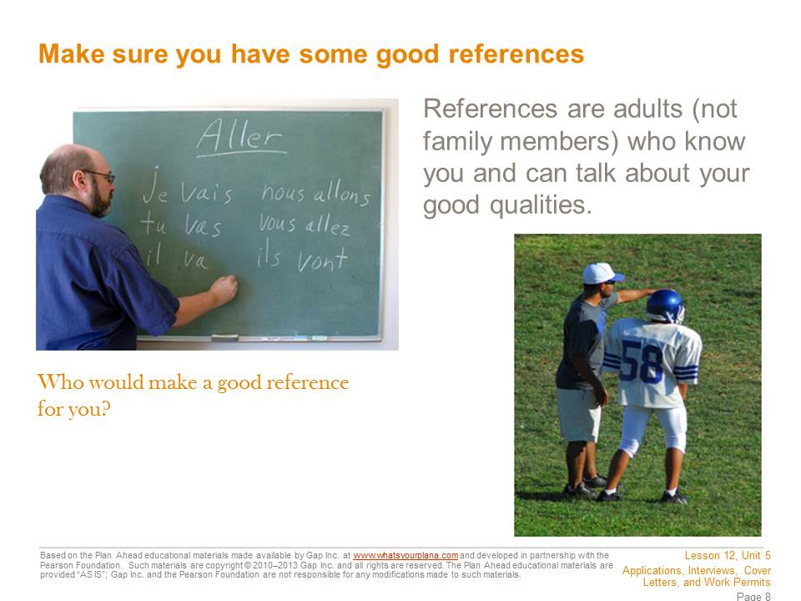
Most companies ask for references. These are people who can talk about what you are like and give potential employers more information about you. Not all employers will ask for references, but it’s good to be prepared.
Your references need to be adults and they can’t be family members. So who can you ask? If you’ve had a job, you can ask your previous employers. If you babysit for your neighbor, she can tell a potential employer if you’re reliable and trustworthy. But maybe you’ve never had a paying job. Don’t worry—for people your age, school has basically been your job. Your teachers can talk about whether or not you show up on time, are reliable, get homework done, etc. Choose one or two teachers you have a good relationship with.
You can also ask adults who work with you on school activities: coaches, band or drama directors, or club moderators. Just like teachers, these people know if you show up on time, do what is asked of you, and are reliable and trustworthy. That’s also true for scout leaders or coaches of local sports teams. If you are involved with a church, a temple, a mosque, or a religious organization, you may also be able to ask people there to vouch for you. And if you do volunteer work, your volunteer supervisor could be a good reference.
You should ask if it’s okay to use someone as a reference before you put that person’s name and information on an application, not after. Make sure you have all of the right information for contacting your reference, too.

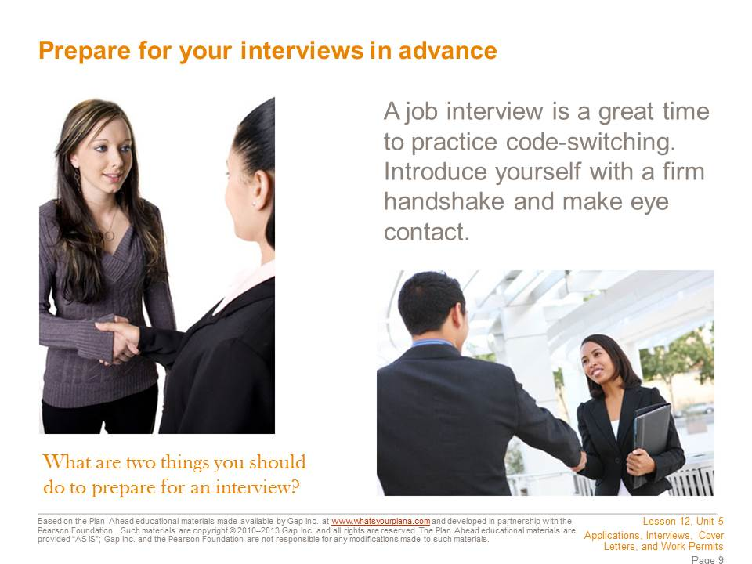

Know how to get to the interview and how long it will take to get there. Leave plenty of time. It’s better to be too early for an interview than to be late. Only a true emergency should cause you to miss an interview. You don’t want to have to say, “Well, my friend was going to give me a ride, but then he had to do something….” Have a back-up plan. Also keep in mind that you may be asked to come back more than once. The employer may want to see if you are reliable and can follow instructions.
If you are going to get a job in an office, wear your most professional-looking clothes. On the other hand, if you are going to work in a restaurant or a store, you probably don’t need to dress up quite as much. Your clothes need to be clean, with no wrinkles, not too baggy, short, or low cut, and nothing with sayings or pictures that might offend people. A nice shirt or blouse and nice pants (not jeans) would be a reasonable outfit. Don’t wear lots of make-up or perfume; some people are allergic to perfume. This is also not the time to have a really unusual hair style.
Bring a couple of pens in case there are other forms you need to fill out. Bring a note pad so you can jot down information. If you have submitted a resume or cover letter, bring copies. Also, be prepared to shake hands with the interviewer and to introduce yourself by your first and last name. To shake hands, extend your right hand (not just your fingertips), fully connect with the other person’s hand, and shake firmly yet gently. An appropriate hand shake only takes a second.

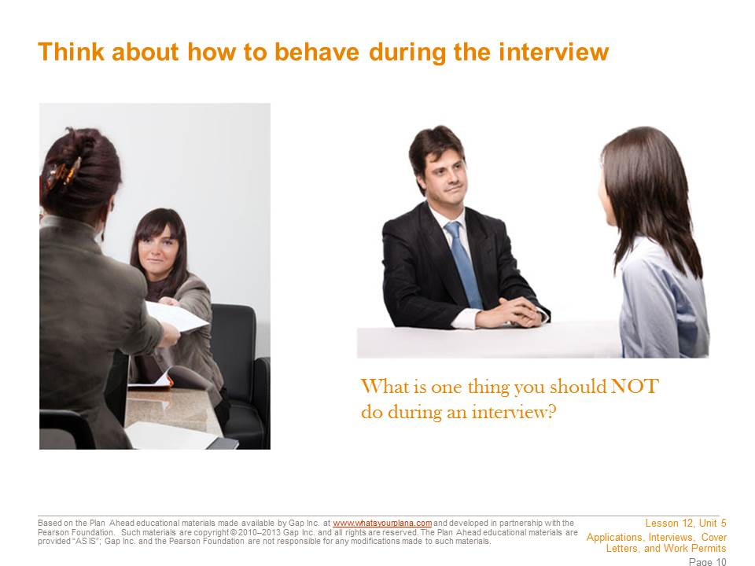

Before you go, think about how you might answer interview questions. Common questions are designed to get to know you, like: “Tell me about yourself,” “What’s your greatest strength? Your greatest weakness?” “Why do you want to work here?”
Practice saying your answers out loud with someone who can give you good feedback. If nobody is around, practice in the mirror.
If you sit down for the interview, sit up straight. Don’t chew gum, bring snacks or drinks with you, or yawn. You might be nervous, but try not to fidget. Listen carefully to the questions, without interrupting. Make sure you give good answers, but stay on topic and keep it brief. For example, if the interviewer asks if you are reliable, you can say that you get good grades or never missed a practice when you were on the volleyball team. Those are all good points. But you shouldn’t say that you get good grades even though you have this one teacher who’s mean or that not only do you show up to practice, but your team made it to state this year…those are not details the interviewer needs to know.
You can prepare some questions of your own; be sure to only ask ones that didn’t get answered already in the course of your conversation. Otherwise it will seem as if you don’t listen well. Remember to turn off your cell phone before the interview.

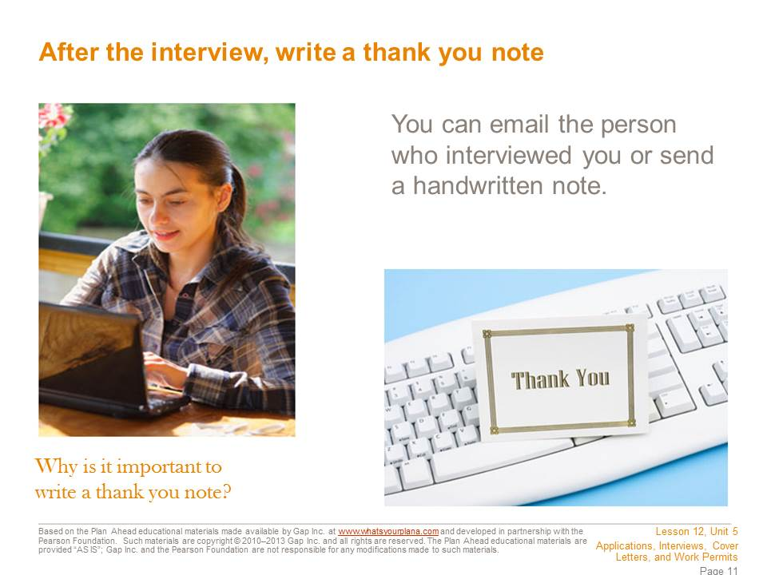

At the end of the interview look the interviewer in the eye, smile, and shake hands again if the interviewer extends his or her hand. Thank the interviewer for taking the time to meet with you. Then, after you get home, write a thank you note or email. If you have been communicating with the interviewer via email, you can send your thank you note that way. Otherwise, write a handwritten note and mail it or personally deliver it.
A thank you note is appropriate, because this person took time out of his or her day to talk to you. Even if the person doesn’t hire you for the job, he or she is helping you learn more about how to do an interview and giving you valuable experience. Sending a thank you note is a great way to impress the interviewer—and to remind the interviewer of what a good candidate you are for the job.

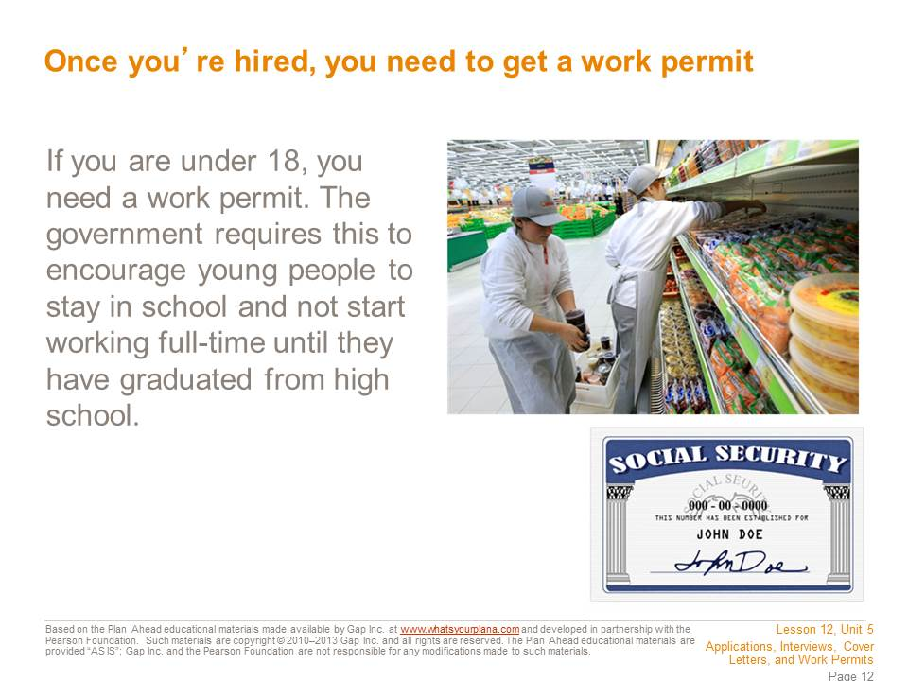

Once an employer agrees to hire you, you can apply for a work permit. You need one because state and federal laws are in place to protect young workers (until the age of 18) from overwork and unsafe conditions, and to ensure that they receive an education.
Your teacher can help you figure out how to obtain a work permit locally.
To obtain a permit, you need to provide the following: a completed application, a social security card, proof of your age (for example, a birth certificate), and proof of school attendance from your school office.



You now have the information you need to apply for a job, internship, or college admission.
If you’ve taken all these steps and you don’t get the job, it’s disappointing—but don’t be discouraged. Everyone has to go through this process more than once, and usually many times, before landing a job. Stay focused, patient, and persistent, and eventually your efforts will yield results.

Student Resource 12.2
Worksheet: Job Ad Terminology
Student Name: _______________________________________________________ Date:___________
Directions: As you read over the job ads, write down any terms you don’t recognize. Then work together with your teacher and classmates to define the terms in your own words. An example is provided.
Term | Definition
Example: Equal Opportunity Employer (EOE) | It means that the employer will hire anybody who’s right for the job without discriminating because of gender, race, or anything else. I think it’s a legal thing—it’s in a lot of ads.
Student Resource 12.4
Example: Cover Letter and Resume

Make It Local | If you choose to replace the example with one based in your community, modify these documents. In any case, remove this callout before distributing.
1300 19th Avenue
San Francisco, CA 94122
(415) 555-1234
hannahishibashi@gmail.com

May 7, 2012

Mr. Jon Ling, Manager
Main Street Pet Supply
1500 Clement Street
San Francisco, CA 94118

Dear Mr. Ling:

In response to your Craigslist posting on May 4, 2012, I would like to be considered for the position of Sales Associate at Main Street Pet Supply.
I am 16 years old and a junior at Thurgood Marshall High School. My teachers think of me as a dependable and hardworking person. I consider myself to be efficient, motivated, and punctual, and I always strive to do my best, whether it’s in school, work, extracurricular activities, or my personal life. I also love animals and currently have two cats and a hamster. For more information about my experience and background, please see my attached resume.
I would like to meet with you to discuss my abilities and how they could benefit Main Street Pet Supply. My family and I have always bought our pet food and other supplies at your store. You have a great selection and the staff is always helpful. I would enjoy being part of your team. Thank you for your time and consideration.

Sincerely,
Hannah Ishibashi
Hannah Ishibashi
HANNAH ISHIBASHI
1300 19th Avenue
San Francisco, CA 94122
(415) 555-1234
hannahishibashi@gmail.com

Education
10th Grade
Thurgood Marshall High School, San Francisco
GPA: 3.5

Awards
Perfect Attendance Award (9th Grade)
Most Improved, Algebra (9th Grade)

Work Experience
Babysitter, Private Employers, San Francisco (2010–2012)
  - Took care of children ages 5–10, including preparing meals and getting ready for bedtime.
Volunteer, Kimochi, Inc., San Francisco (2011)
  - Helped deliver meals to seniors and sell burgers at the Annual Cherry Blossom Festival.

Extracurricular Activities
Band (2011–2012)
Spanish Club (2010–2012)
Theater (2010–2011)

Skills
Languages: basic Japanese and Spanish
Computer: can use both PCs and Macs
Reliable, hardworking, and a good team player
Experienced pet owner: cats (10 years), hamster (1 year), goldfish (3 years)

References
Mr. Prashant Desai, History Teacher (415) 222-3456
Ms. Artemis Bliss, babysitting client (415) 333-1234
Mrs. Kyoko Nishimura, volunteer supervisor (415) 444-5678
Student Resource 12.5
Worksheet: Preparing to Write a Resume
Student Name:_______________________________________________________ Date:___________
Directions: Use this worksheet to help you gather and organize the information you will need to create your resume. Before you begin, read through all of the instructions on this worksheet, and read the assessment criteria at the end of the worksheet to make sure you understand how your final resume will be assessed.
Contact Information
Things to Think About:
- What phone number will you put on your resume? If you give them a cell phone number, make sure your outgoing message is something appropriate, not loud blaring music or you screaming into the phone while your friends are laughing in the background.
- What email address will you put on your resume? Make sure it is an appropriate email address, and make sure that it is one you will check regularly. You don’t want to have someone email you to set up an interview and you don’t respond for days because you don’t bother to look at the email account.
Name
Mailing Address
Phone Number
Email Address

Education
Things to Think About:
- Do you have a good GPA? If so, that can be a good thing to put on your resume. It shows that you are hardworking.
- Do you have any other training that might be helpful for a job? For example, have you taken any classes outside of school or during the summer? Have you taken any classes in school that might help you be a better employee? (HINT: This course!) Any classes you have taken in other languages, any musical instruments or sports you play, or any training you have received, like babysitter training or CPR classes, could be good things to list on your resume, depending on the job you’re applying for.
School Name
School Location
Current Grade Level
Current GPA
Other Education/Training

Awards/Honors/Achievements
Things to Think About:
- Have you gotten any awards? Been on honor roll? Joined an honor society? Earned a “Most Improved” certificate? An award for sportsmanship? Earned your letter in sports? Set a record in a sporting event? Been on a championship team? Write down the details below. Use an extra sheet of paper if necessary.
Award/Honor/Achievement Name | Year Received

Work Experience
Things to Think About:
- What jobs have you held? If you’ve never held a “real” job, have you done any babysitting? Taken care of a neighbor’s pet, watered their plants, or picked up their mail when they were out of town? Ran errands, mowed lawns, tutored another kid in your class, or did some other short-term thing to help someone out and/or earn some money?
- What volunteer work have you done? Was it a one-time thing, like a beach clean-up day? Or an ongoing activity?
- Fill out the chart(s) below. If you run out of space, use an extra sheet of paper.
Job Title
Employer Name and Location
Dates of Employment
Brief Description of Duties

Job Title
Employer Name and Location
Dates of Employment
Brief Description of Duties

Extracurricular Activities
Things to Think About:
- Do you play any sports? When? What level (intramural, frosh/soph, JV, varsity)? Any special achievements?
- Do you do any performing arts activities (band, drama, dance)? When? Any special achievements?
- Have you been on Student Council? In any clubs? When? Any special achievements?
- Have you organized any fundraisers or big events (like a school dance)? When?
Fill out the chart below. Use the comments section to write down special achievements or specific details. If you run out of space, use a separate sheet of paper.

Activity | Year Participated In | Comments

Skills
Things to Think About:
- Do you speak any other languages? How fluently? How do you know the language—because it’s spoken at home? Because you took it in school?
- How good are you at using a computer? How much time do you spend on a computer? Do you use a Mac or a PC? How comfortable are you with email? Doing research on the Internet? Using Word? Excel? PowerPoint? Do you know any other programs? Do you know anything about how to maintain a computer or fix it if it breaks?
- Do you have any other special skills that might be interesting to an employer? For example, if you are trying to get a job in a store that sells musical instruments, the employer would want to know if you play an instrument, sing, or can read music. If you are trying to get a job in a craft store, the employer might like to know if you sew, crochet, or make scrapbooks.
Complete the chart below. Use the comments section to make specific notes about information you might want to include. If you run out of space, use a separate sheet of paper.

Skill | Comments
Example: Good with computers | I use PCs and Macs. I helped my brother rebuild an old PC and I’m teaching myself how to design a web page. I can use Word, Excel, and PowerPoint. I’ve also played around with Photoshop and GarageBand in classes at school.

References
Things to Think About:
- Which adults could you ask to be a reference for you? Former employers? Teachers? Coaches? Volunteer Supervisors? Neighbors? Remember, a relative cannot be a reference.
- You need to get their permission before you list them as a reference. Are these people you can get in touch with easily? If you don’t see them often and don’t have a phone number or email address for them, they’re probably not a good reference option.
- If possible, you should choose people who know you now—getting your third grade teacher to be a reference doesn’t help, unless you still see her in your neighborhood or you babysit her kids or something.
- For each reference, you will need to list his or her contact information. Make sure you can get that information from them—some people may want to give you a specific phone number or email address where it’s easier to reach them.
Remember, you should provide at least three references.
Reference Name
Relationship (How You Know The Person)
Contact Information

Reference Name
Relationship (How You Know The Person)
Contact Information

Reference Name
Relationship (How You Know The Person)
Contact Information

Putting the Resume Together
Once you complete this worksheet, you will have all the information you need to create a resume. But this worksheet isn’t a resume by itself—you have to type it up in the proper format, using the example resume in Student Resource 12.4 to guide you.
Before handing in your final resume, check to make sure it meets or exceeds the following assessment criteria:
- The resume includes full contact information for the job applicant (full name, mailing address, phone number, email address).
- The resume includes accurate information about the job applicant’s education and work experience.
- The resume includes useful information about awards, extracurricular activities, or special skills that an employer might want to know.
- The resume includes contact information for three references.
- The resume is organized and formatted in a way that makes it easy to read and find information.
- The resume is neat and uses proper spelling and grammar.

