Lesson 3
Effective Communication
Student Resources
Resource | Description
Student Resource 3.1 | Reading: The Ride Home
Student Resource 3.2 | Worksheet: Nonverbal Communication Cues
Student Resource 3.3 | Worksheet: Being a Good Listener
Student Resource 3.4 | Reading: Active Listening
Student Resource 3.5 | Reading: Communication Tips
Student Resource 3.6 | Assignment: Communication Comics

Student Resource 3.1
Reading: The Ride Home
Student Name:_______________________________________________________ Date:___________
Directions: Imagine that you need to take the bus to get home from school today. When you get on the bus, it’s very crowded and you’ll have to sit next to a stranger. Read the description of the people you could sit next to. Which person would you choose to sit next to and why? Write “Yes” or “No” for each description. If the answer is yes, explain your reasoning.

A. An old lady with a cane and lots of shopping bags is sitting near the front of the bus. She keeps counting her packages and muttering to herself. If someone walks by her, she grabs her bags and pulls them closer, as if somebody might try to steal them. She is frowning. Her clothes are old and wrinkled.
Would you choose to sit next to this person? ____________________ If yes, explain why:

___________________________________________________________________
___________________________________________________________________
___________________________________________________________________

B. A boy and girl are sitting together; the boy’s arm is around the girl’s shoulders and she’s got her feet up on one of the empty seats. He’s wearing a t-shirt from a local university and her hair is in dreadlocks. She has a bag by her feet with “Save the Planet” on it. They’re totally focused on each other and don’t notice anyone else on the bus. They spend a lot of time kissing and whispering to each other.
Would you choose to sit next to this person? ____________________ If yes, explain why:

___________________________________________________________________
___________________________________________________________________
___________________________________________________________________

C. A middle-aged man in a business suit sits near the middle of the bus. The suit looks expensive, but the knees of his pants are dirty, as if he’s been kneeling on the ground. He is frowning and keeps checking his watch. He is sitting on the edge of the seat like any minute he’s going to jump up and run out the door of the bus. He has a briefcase on his lap and he keeps tapping his fingers on it.
Would you choose to sit next to this person? ____________________ If yes, explain why:

___________________________________________________________________
___________________________________________________________________
___________________________________________________________________

D. A middle-aged woman sits by the window in the middle of the bus. She has her hair in a ponytail and is wearing jeans, running shoes, and a fleece jacket. She is reading a book and does not glance up.
Would you choose to sit next to this person? ____________________ If yes, explain why:

___________________________________________________________________
___________________________________________________________________
___________________________________________________________________

E. Two guys are at the back of the bus. They are sitting close together, talking quietly, but if anybody comes near them, they stop talking. One of them has sunglasses on and keeps his hands in his pockets. The other one is leaning forward; he looks really muscular and has a lot of tattoos.
Would you choose to sit next to this person? ____________________ If yes, explain why:

___________________________________________________________________
___________________________________________________________________
___________________________________________________________________

F. A young woman is sitting near the back of the bus. She has a little boy with her. The woman looks very pregnant; her stomach is huge and her clothes don’t seem to fit right. She is slumped in her seat; she yawns a lot and keeps her eyes closed, except when the little boy starts making noise. Then she shouts at him in an unfamiliar language and points at the seat next to her to try to make him sit down.
Would you choose to sit next to this person? ____________________ If yes, explain why:

___________________________________________________________________
___________________________________________________________________
___________________________________________________________________

G. A teenager is sitting near the middle of the bus. He’s wearing a lot of eye make-up and his hair is dyed two or three different colors; his ears, nose, lip, and eyebrow are all pierced. He’s listening to music on earbud headphones and staring out the window; he looks like he might be singing along to the music, but the bus is too noisy to hear him.
Would you choose to sit next to this person? ____________________ If yes, explain why:

___________________________________________________________________
___________________________________________________________________
___________________________________________________________________

H. At the front of the bus, a little girl is sitting right behind the driver. She seems about seven or eight years old. She wears glasses and has a backpack on the floor at her feet. She is wearing a school uniform that is very neat and well-cared-for. She looks around at the people on the bus and smiles, but if people don’t smile back, she gets embarrassed and stares at the ground.
Would you choose to sit next to this person? ____________________ If yes, explain why:

___________________________________________________________________
___________________________________________________________________
___________________________________________________________________
Student Resource 3.2
Worksheet: Nonverbal Communication Cues
Student Name:_______________________________________________________ Date:___________
Directions: Think about the people on the bus in Student Resource 3.1 and the demonstrations you just saw in class. Then write down examples for each type of cue listed below. Some examples have been provided to get you started.

Facial Expressions | Eye Contact
smiling  frowning | wearing sunglasses so people can’t see their eyes
Hand and Body Movement | Tone of Voice
yawning  hand gestures | how loud someone speaks
Personal Grooming | Clothing
hairstyle  tattoos | length of skirt or dress  pants worn at the waist or sagging lower
Personal Space | Personal “Stuff”
how close together people sit/stand | jewelry  logos or brand names on a purse or a backpack  religious symbols
Student Resource 3.3
Worksheet: Being a Good Listener
Student Name:_______________________________________________________ Date:___________
Directions: Being a good listener doesn’t always come naturally—you have to practice. In the chart below, write down the things a good listener does and doesn’t do so that you have a guide to help you as you work on improving your listening skills. Some examples have been provided.

A Good Listener does… | A Good Listener doesn’t…
- Make eye contact | - Roll her eyes or make insulting or distracting facial expressions
When I’m listening carefully, I… | When I’m not listening, I…
Being a good listener is important if you want to have good friends and do well in school. Why do you think this is true?

Student Resource 3.4
Reading: Active Listening

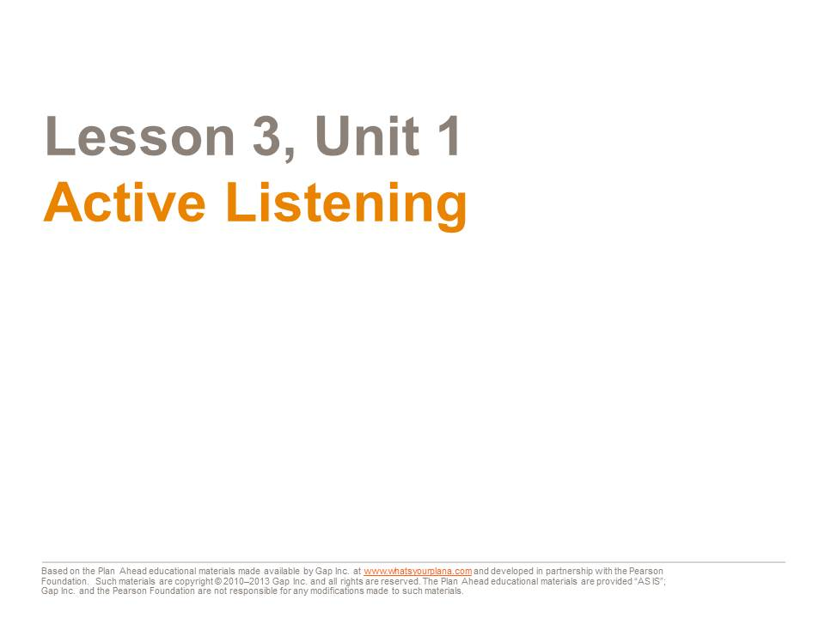
“Active listening” can sound kind of funny. Most of us think of listening as a passive, or non-active, thing to do—we just sit there and let people talk to us. But if we are really trying to hear what the other person is saying, listening can be a very active experience. Let’s look at the four steps to listening actively.

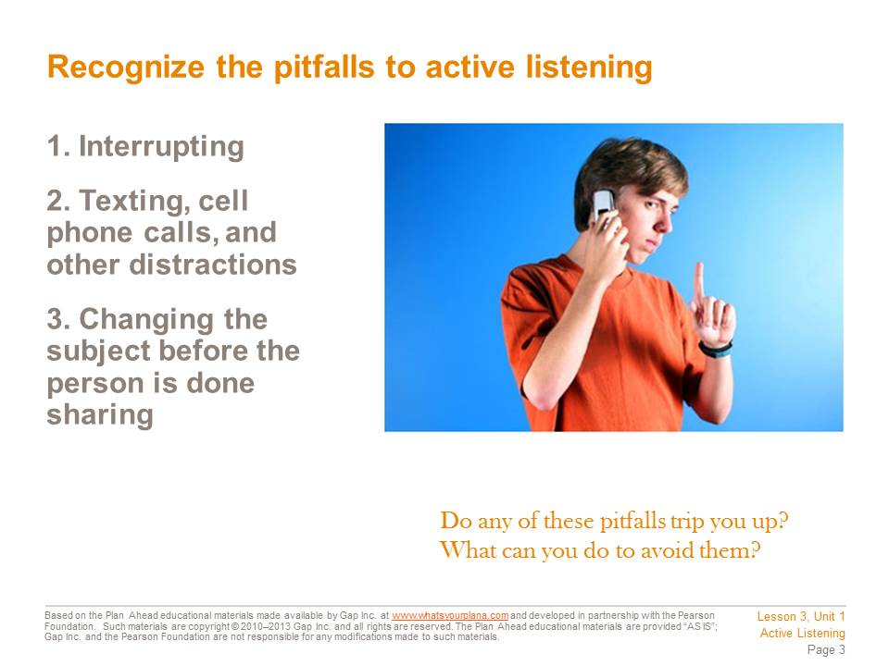

#1 – When you interrupt someone, you’re basically telling him, “What I have to say is more important than what you have to say.”
#2 – You can’t text or use your cell phone while also having a conversation with someone in person. Your attention can’t be in two places at once. You will definitely not catch everything the speaker is saying. If you and your friend want to check and see what time a movie is playing, that’s not the same as ignoring someone while you text.
#3 – If you change the subject too quickly, it’s similar to interrupting someone—you’re basically saying, “Yeah, well, that’s nice, but here’s what I want to talk about and that’s more important.”

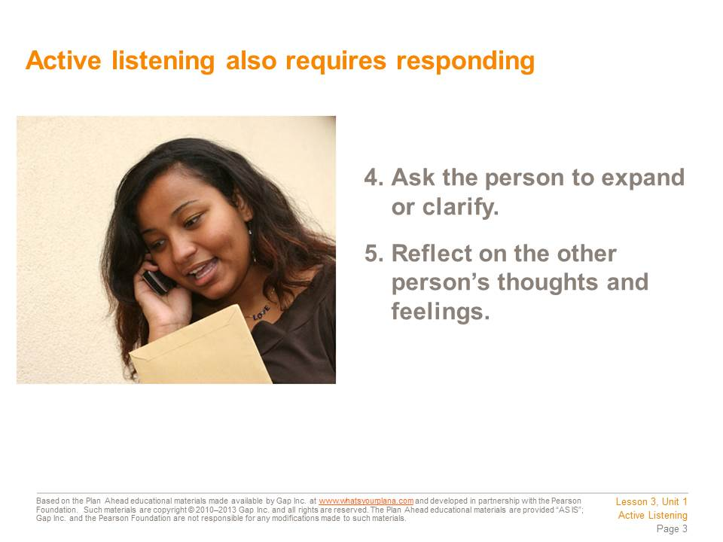

#4 – When the person has paused or finished speaking, ask follow-up questions to make sure you understand. Asking a specific question shows that you’re paying attention. If you ask something vague or general, the speaker may guess that you weren’t really listening. Which of these questions is so general you could ask it without listening?
“What happened at the school dance last night?”
“So where were you when the fight started?”
“What did your Mom say when you told her the bus broke down?”
#5 – Most of the time people don’t just announce how they’re feeling. You have to pay attention to a person’s tone of voice, their body language, and the words they use. But we can all misinterpret or misunderstand a friend’s behavior. Maybe your friend is telling you about how he got a bad grade on an English paper and he sounds really mad. You might say something like, “You sound really mad at Mr. Jimenez. You think his comments on your paper were more sarcastic than helpful, right?” Then your friend knows that you’re listening and can tell you if you understood what he was saying.

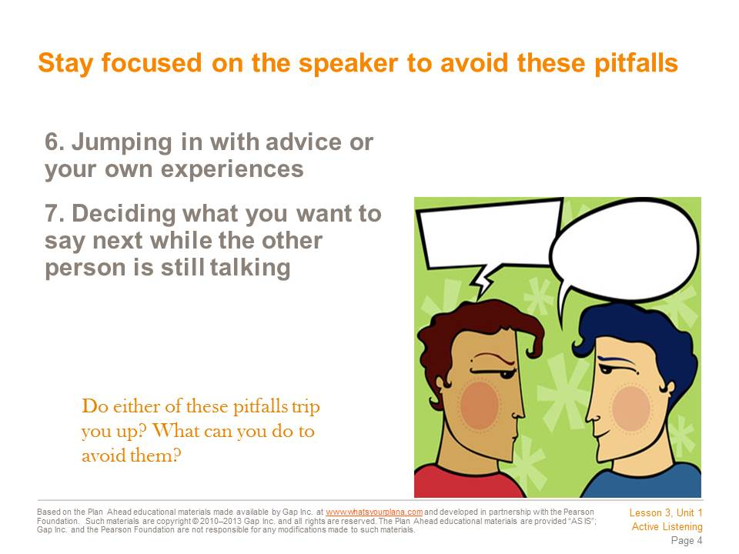

#6 – Have you ever gotten advice that you didn’t ask for? It’s usually pretty irritating. Unless someone asks you for your advice, or you know the person really well, be careful about offering it. Also, don’t start talking about your own experiences—that’s changing the subject. You can make a quick sympathetic comment—“I know, my mom freaked out when I lost my planner, too!”—but keep the focus of the conversation on the other person.
#7 – It’s human nature to think about what you are going to say next. Maybe your friend says something that reminds you of something you wanted to say. That’s understandable. But try to shift your focus back to what your friend is saying. Otherwise, you might miss something important your friend is trying to tell you because you’re distracted by your own thoughts.

Student Resource 3.5
Reading: Communication Tips
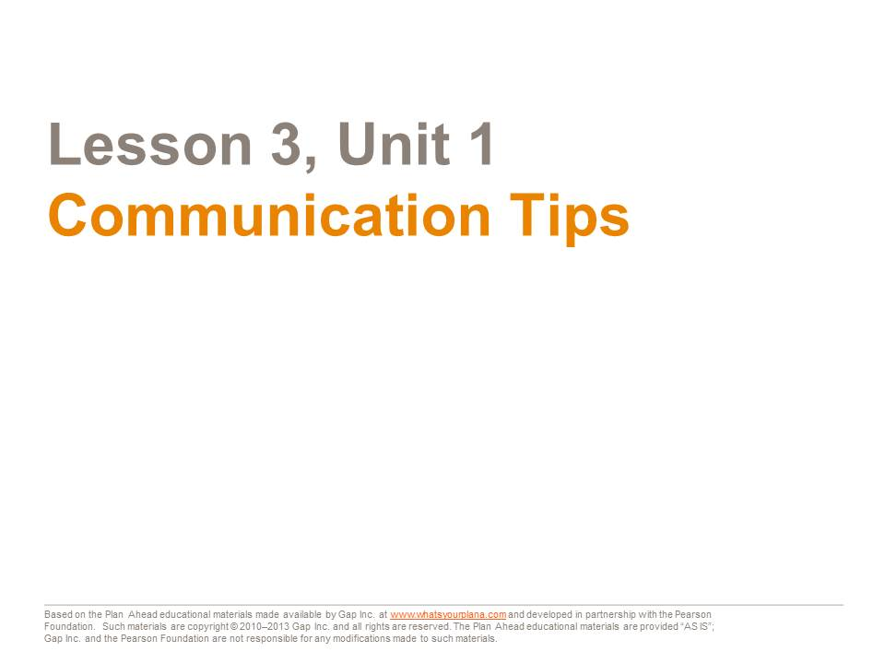

All communication is made up of two parts: the person talking is the “sender.” The person listening is the “receiver.” We’ve already worked on your “receiving,” or listening skills. Today we’re going to look at how you talk—what kind of message you are sending to other people by your words and actions.

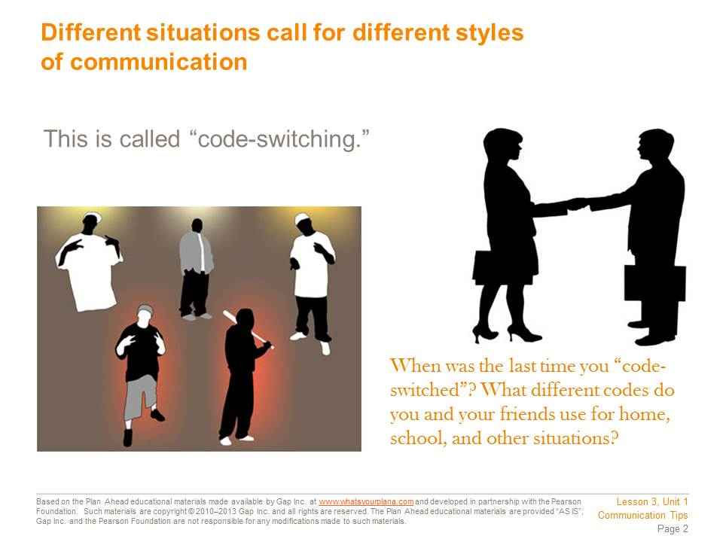

Different situations call for different types of behavior and ways of communicating. Changing how you communicate to suit the circumstances is called “code-switching.” For example, at a basketball game, you might yell or cheer. This is appropriate in that situation. But it would be the wrong thing to do at a funeral.
Here is an example of a different kind of code-switching. Tomas and his family are from the Philippines. Tomas speaks English well, but his parents only speak Tagalog, one of the languages spoken in the Philippines. When Tomas brings his friends over, he has to switch between languages. He will speak in English to his friends, and in Tagalog to his family.
You probably code-switch, too. Everybody uses language differently depending on their circumstances. When you code-switch, you also change your nonverbal communication: your posture, your gestures, your tone of voice all shift to be appropriate to your audience.

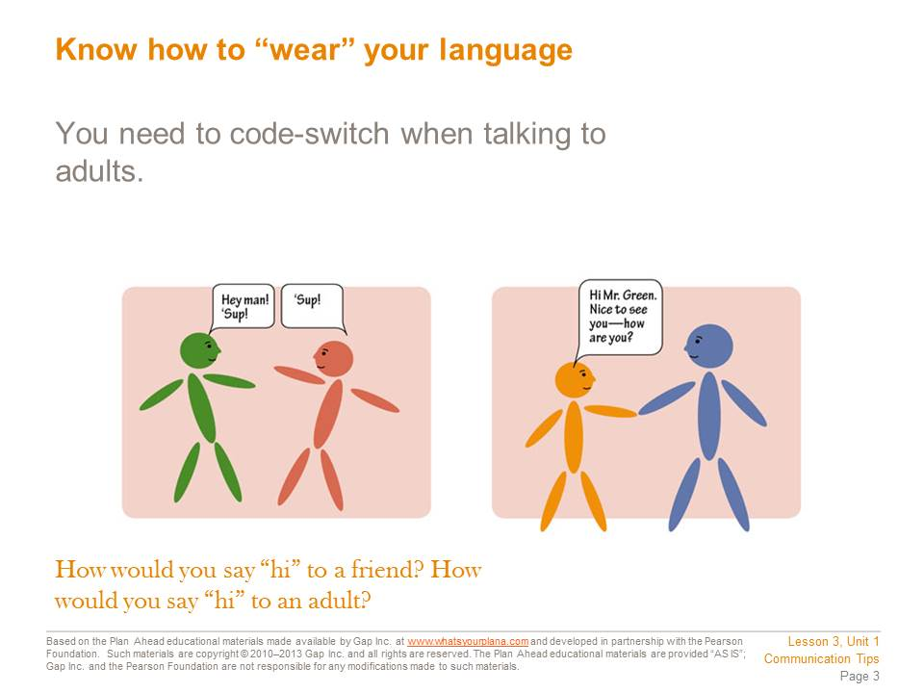

Code-switching helps you to get along with all kinds of people. It also makes a good impression.
To greet a friend, you might say, “Hey” or “Sup?” But those are not good ways to greet an adult such as a teacher, a neighbor, or a boss. In those situations, it’s better to say, “Hello.” If you’ve never met this person before, you could say, “Nice to meet you.”
When you’re leaving, it’s better to say, “Goodbye” or “It was nice to meet you,” instead of “Later,” “Bye,” or “See ya.”
These suggestions are more formal or uptight than how you speak to your friends. That is intentional. When you are speaking to an adult you don’t know very well, your words, tone, and behavior should show respect and politeness. If you get to be friends with someone who is an adult, or if you are speaking to adult family members, you may not need to be so polite. But for adults such as teachers, coaches, or bosses, this is a good way to behave.

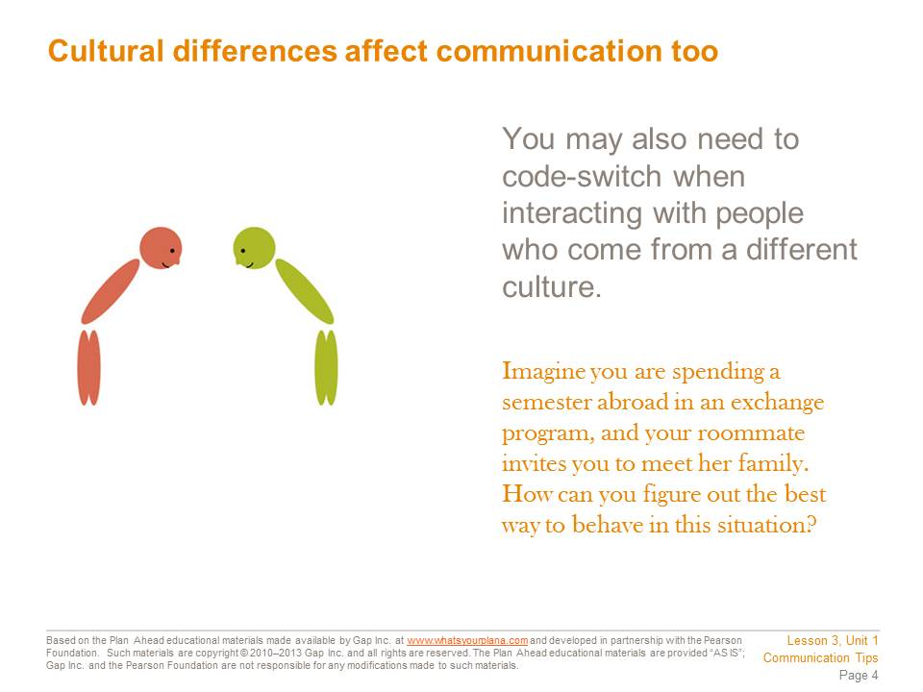

We have been learning about appropriate communication in America. In other countries, good manners can be different from our own. For example in France, it’s rude to eat a sandwich with your fingers. Use a knife and a fork!
Many high school and college students participate in exchange programs. Students from other countries come here to live with an American family, go to an American school, and experience our culture. Every year thousands of American students live with families in other countries too. Colleges are encouraging students to study abroad for a semester because it’s such a great way to learn about cultures different from our own. It’s also an effective way to learn another language.
When you meet people from other cultures, be sensitive to how they might communicate differently. How do you figure out the right way to behave? The best thing to do is pay attention to how everyone else is behaving. If they speak quietly, adjust your tone of voice to match theirs. If everyone is making a special effort to greet the elderly people, you should do the same. If you get good at observing and imitating these behaviors, you can get along with almost anybody.

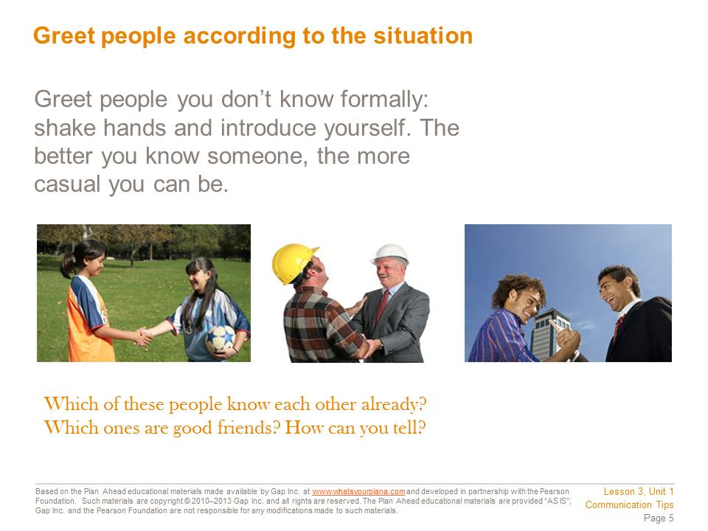

In any country, it’s important to learn how to meet new people properly. Here in the United States, begin with a friendly smile. Look the new person in the eye as you smile. Maybe you’re shy, or maybe you don’t like to smile at strangers. But if you’re looking away or not smiling, you can make a bad impression.
Next, say, “Hello.” Introduce yourself. You can just say, “Hi, I’m (your name).” You will make the other person feel comfortable around you and then you can start a conversation.
If you are introduced to an adult you haven’t met before, smile, say, “Hello,” and shake hands with them. Shaking hands is the typical way that adults interact when they are introduced to each other. They grasp the other person’s hand firmly, with confidence.

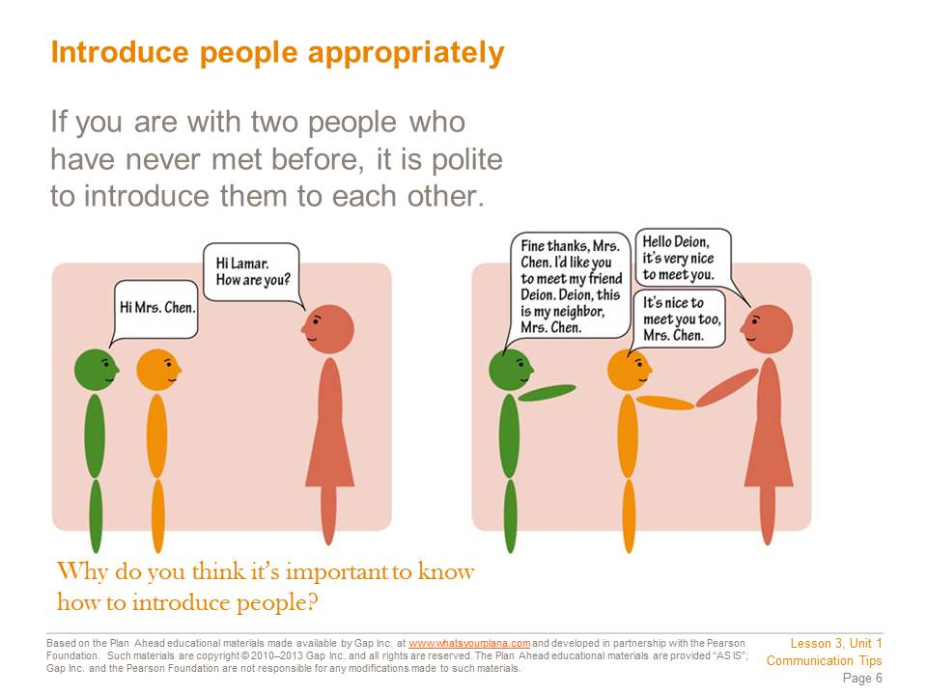

Let’s say you’re touring a college campus with some friends. An elderly neighbor walks by; her granddaughter attends this college. Your friends don’t know your neighbor. What do you do?
It’s polite to introduce two people if you know both of them, but they have never met. If you are introducing someone your age to an adult, introduce the adult first. It is respectful to address the older person first by telling him or her the name of the younger person. So if you are introducing a friend to your elderly neighbor, you would say, “Mrs. Chen, this is my friend, Deion. Deion, this is my neighbor, Mrs. Chen.”
It’s important to know how to introduce people properly. You may not need to do it very often right now, but as you get older you will need to do it much more. Knowing how to introduce your parents, your friends, or your boyfriend or girlfriend to a teacher, a coach, or a boss at a summer job can help you succeed in school and in life.

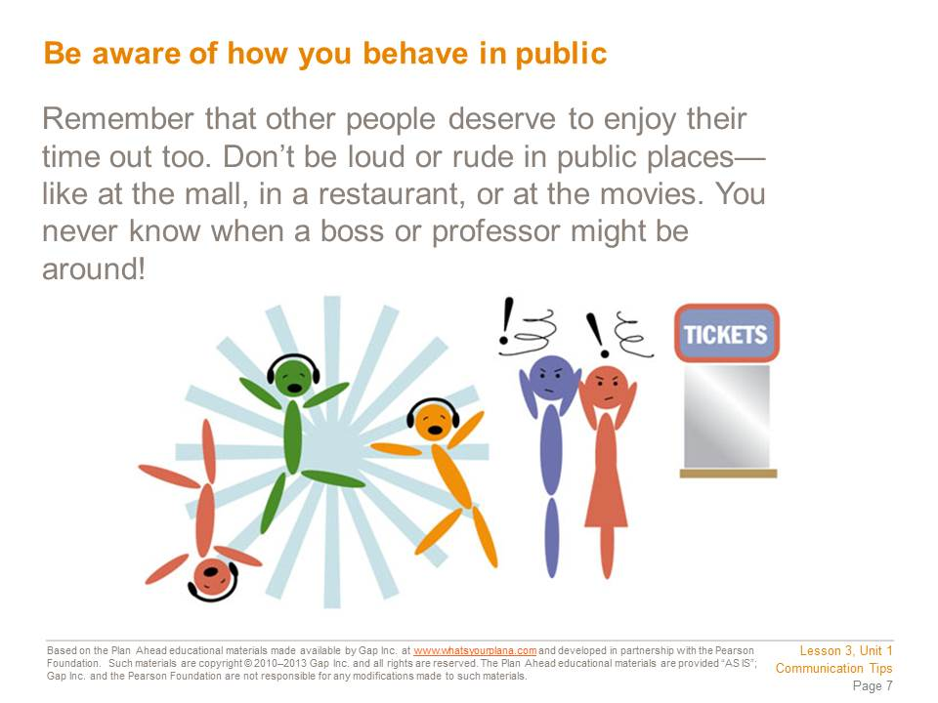
Be aware of your behavior in public. Respect the right of others to be there too. Besides, you never know when being rude will backfire on you. Suppose you go to the mall with your friends. You’re having a good time and being loud. You get angry looks from other people, but you’re having a good time, so you don’t care.
The next day, you have an interview for a summer job. You walk in and find yourself face-to-face with one of the people who was annoyed by your behavior the night before. Oops! So much for that job….
You also need to think about what you post online. Potential employers and college admissions staff will check your Facebook page and any other social networking sites that you use. If these people don’t like what they see, they won’t hire you or admit you to their college.

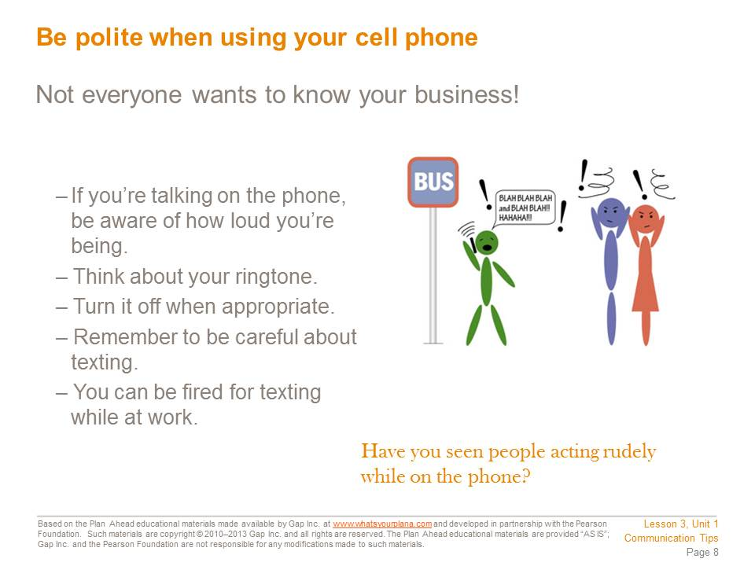
Everywhere you go, you see people talking on their phones and texting. A lot of people don’t seem to know about being polite when they’re on the cell phone. Here are guidelines for good cell phone habits:
Talk quietly if you are in public. Other people don’t want to hear the details of your personal life.
- If you use your cell phone in class, you are disrespecting the teacher. You are also not paying attention, which will bring down your grades.
- Don’t use your cell phone at work unless you are on break. You will get fired if you text or make personal calls on company time.
- Put your phone on “silent” when you’re in the movies or at an event. It’s disrespectful to everyone around you to kill the mood with your cell phone ringing.
- Don’t answer your phone if you are in the middle of talking to someone. It’s like saying, “Whoever is calling me right now is more important than you.”
- Pick a ringtone that won’t offend people if your phone rings in public. You can use your favorite ringtone when you’re at home or with your friends.
- Texting is good to do if you are in a place where you need to be quiet. But don’t text when you’re in a conversation with someone. That’s rude.

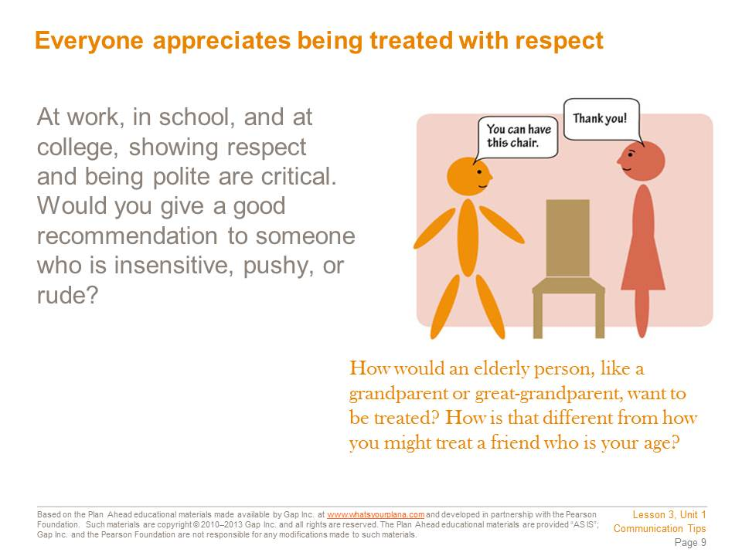
How we treat other people reflects on us. And people form their opinions of you based on how you treat them. This makes sense; why would people think you’re a friend if you only come around when you need a favor or help with something?
In the workplace and at school, how you treat other people is extremely important. If you disrespect your teachers, they will not want to help you out with recommendations for getting a summer job or getting into college.
Treating people with respect is the right thing to do. But it’s also being smart about your future as well.

Student Resource 3.6
Assignment: Communication Comics
Student Name:_______________________________________________________ Date:___________
Directions: On the next three pages are three sets of comics. Each one represents a situation in which people are meeting each other. Your task is to fill in what the people are saying so that they are acting appropriately for that particular situation. You are also going to describe what is happening below each panel.
Use the information below the first panel of each scenario to guide you as you fill in the talk bubbles and the descriptions of what’s happening.

Before handing in your assignment, check to make sure it meets or exceeds the following assessment criteria:
- The conversation between the characters in each scenario shows evidence of an excellent understanding of code-switching.
- The narrative accompanying each panel provides a realistic, natural storyline that matches the visuals and the conversation between the characters.
- The narrative takes the characters’ nonverbal communication into account as appropriate.
- The assignment is neat, legible, and presentable.

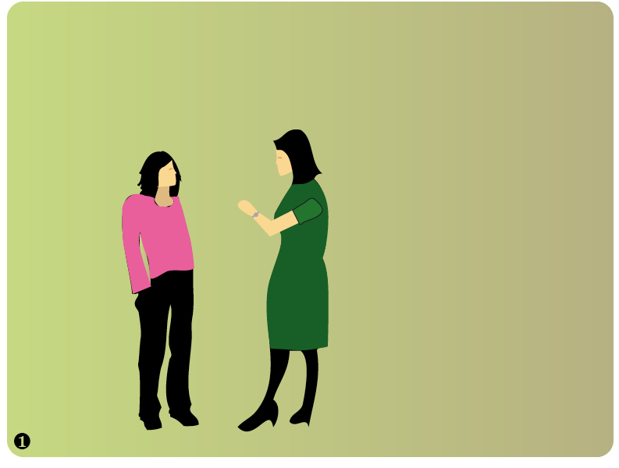
Anitra and her Mom are waiting to meet with the director of admissions for a summer internship program. It is very difficult to get into this program so Anitra wants to make a good impression.

Scenario 1

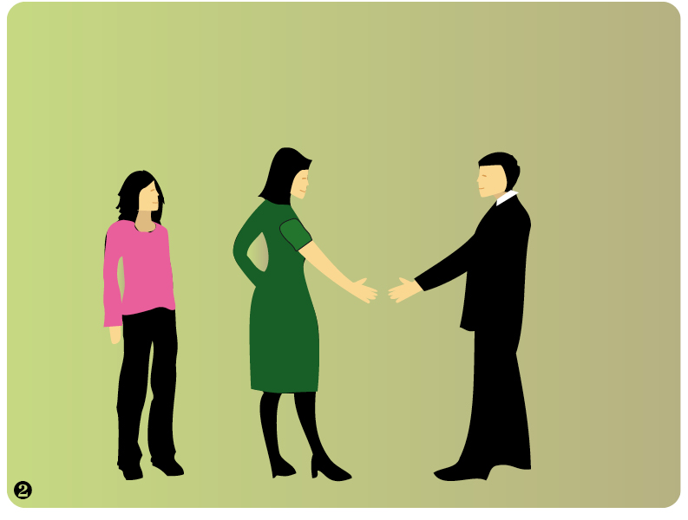

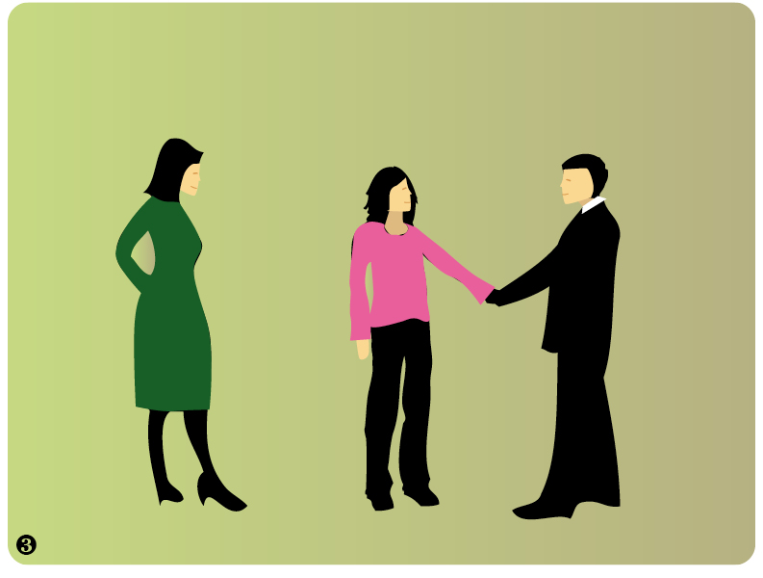

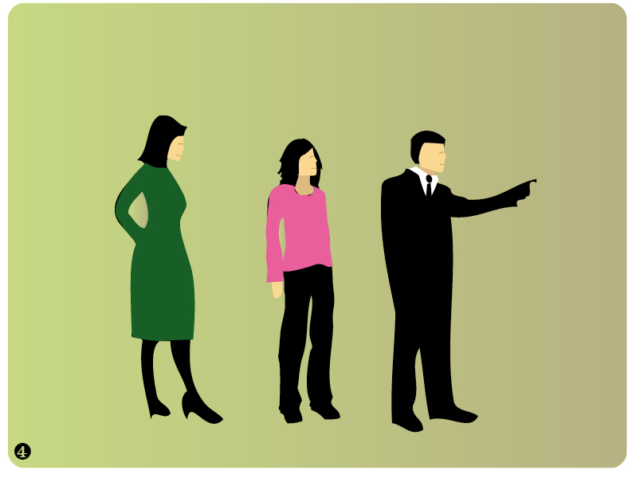

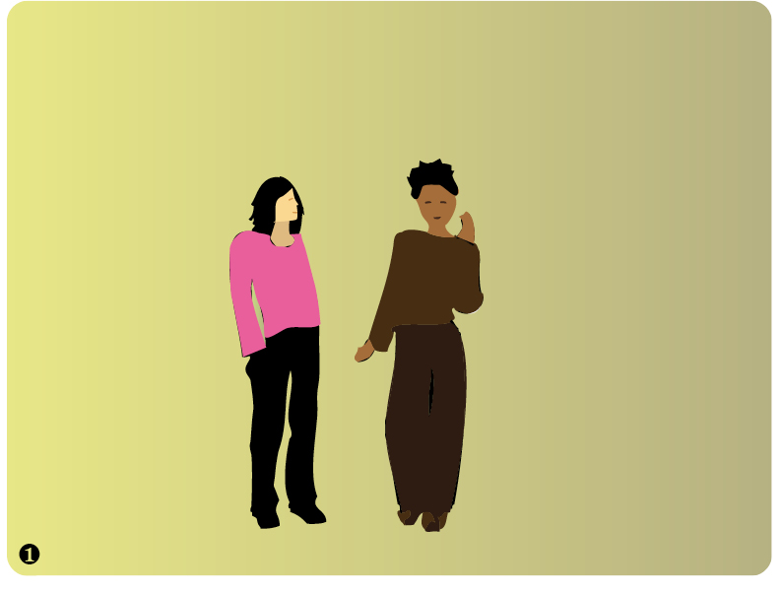
Anitra is chatting with her supervisor Tania. They see Anitra’s boyfriend, Jose. Anitra introduces him to her boss. They decide to all have lunch together.
Scenario 2

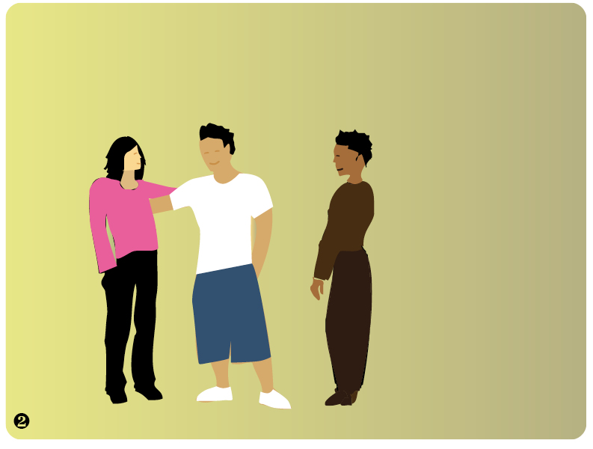

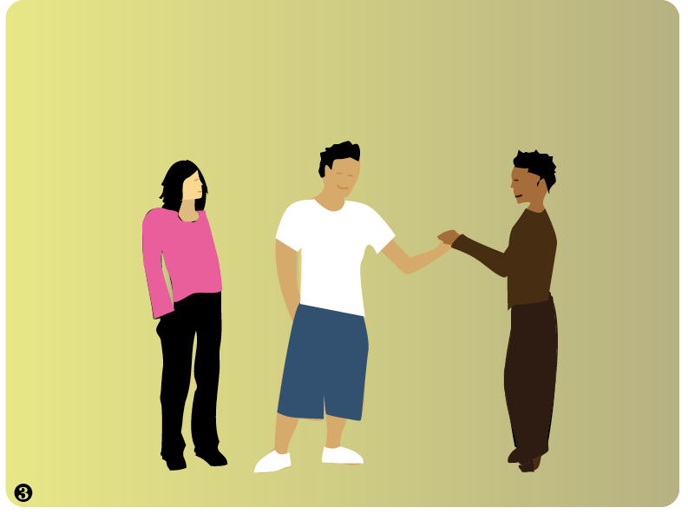

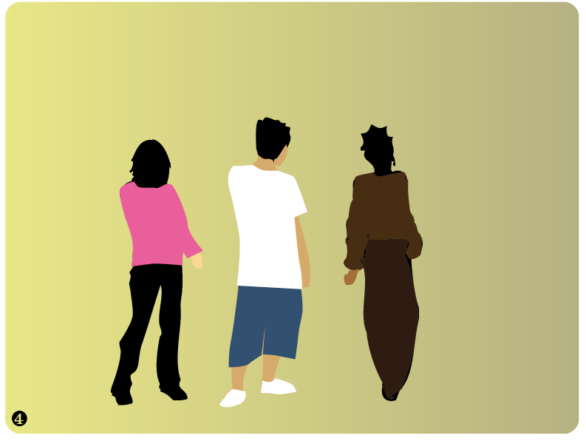
3. Jim is waiting for his Dad to pick him up after school so they can go shopping for school supplies. While Jim waits, his Math teacher, Ms. Gonzales, walks by and stops to say hi.
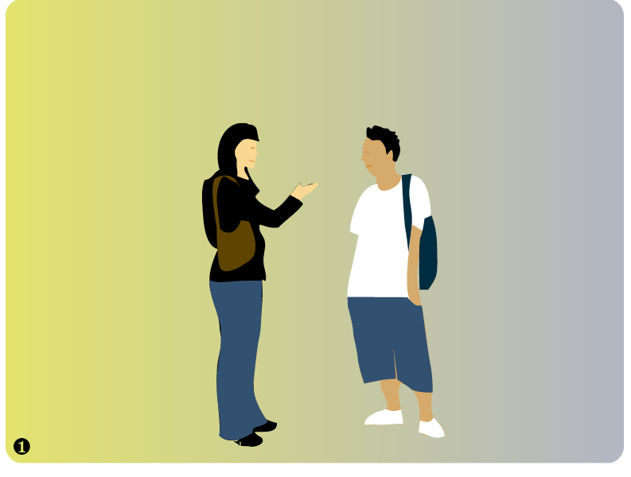
Jim is waiting for his dad to pick him up after school so they can go shopping for school supplies. While Jim waits, his math teacher, Ms. Gonzales, walks by and stops to say hi.

Scenario 3

