Lesson 5
Matching Careers with My Interests, Skills, and Values
Student Resources
Resource | Description
Student Resource 5.1 | Example: Alphabetical Taxonomy
Student Resource 5.2 | Worksheet: Career and Occupation Taxonomy
Student Resource 5.3 | Reading: The 16 Career Clusters
Student Resource 5.4 | Survey: How Am I Smart?
Student Resource 5.5 | Guide: How Am I Smart?
Student Resource 5.6 | Reading: Using Multiple Intelligences
Student Resource 5.7 | Graphic Organizer: Career Recommendations
Student Resource 5.1
Example: Alphabetical Taxonomy
Student Name: _______________________________________________________ Date: ___________
Directions: A taxonomy is a list of related words grouped into categories. You will develop taxonomies in this course to build vocabulary and to see the relationships among important words. Your taxonomies will also be helpful tools for the writing and reading assignments you receive. Below is a taxonomy for the topic of colors, in which the words have been categorized alphabetically.
Can you think of any others? Go ahead and add them into the correct category.

A | aquamarine, amber, azure
B | beige, bronze, burgundy
C | cobalt, chartreuse, cream, crimson
D
E | ecru, emerald
F | fuchsia
G
H
I | indigo, ivory
J | jade
K
L | lavender, lilac
M | magenta, mauve
N | navy blue
O | ochre, olive
P | pink, periwinkle
Q
R
S | scarlet, silver
T | teal, tan, terra-cotta
U | ultramarine
V | violet, vermilion
W
X
Y | yellow
Z
Student Resource 5.2
Worksheet: Career and Occupation Taxonomy
Student Name: _______________________________________________________ Date: ___________
A
B
C
D
E
F
G
H
I
J
K
L
M
N
O
P
Q
R
S
T
U
V
W
X
Y
Z

Student Resource 5.3
Reading: The 16 Career Clusters

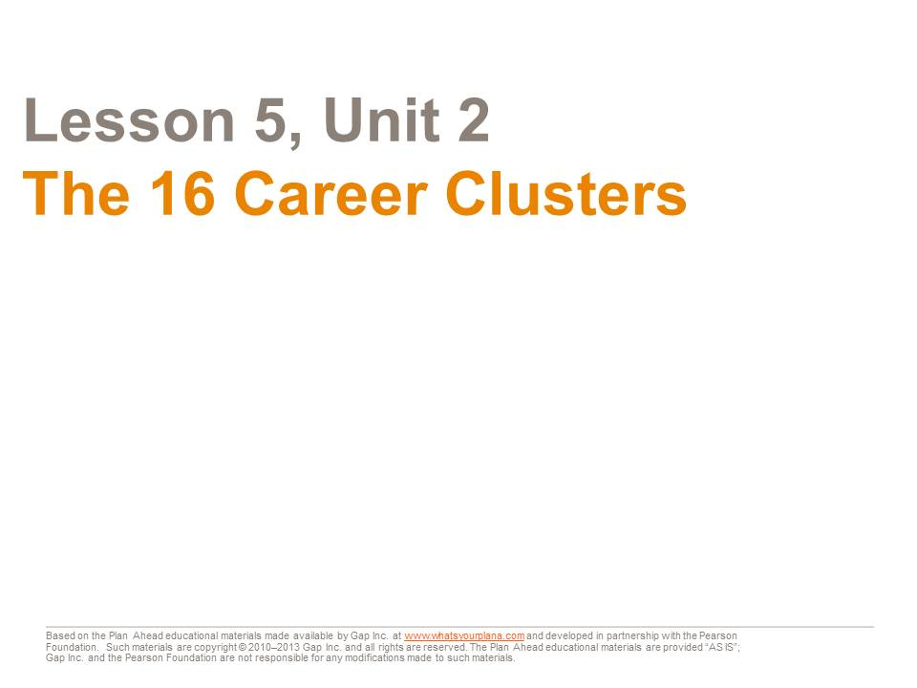
Remember when you were little and you would say, “I want to be a doctor or a firefighter (or a wizard!) when I grow up”? Now that you are older, thinking about which career to pursue may seem overwhelming. There are literally thousands of possible jobs out there.
The career clusters are a helpful tool to start thinking about what kinds of careers might interest you. A career cluster is a group of similar careers based on common factors such as interests and job requirements. The US Department of Education developed 16 career clusters under six career fields as a way for counselors, teachers, and students to organize career planning.
First, get to know a little about each career field.

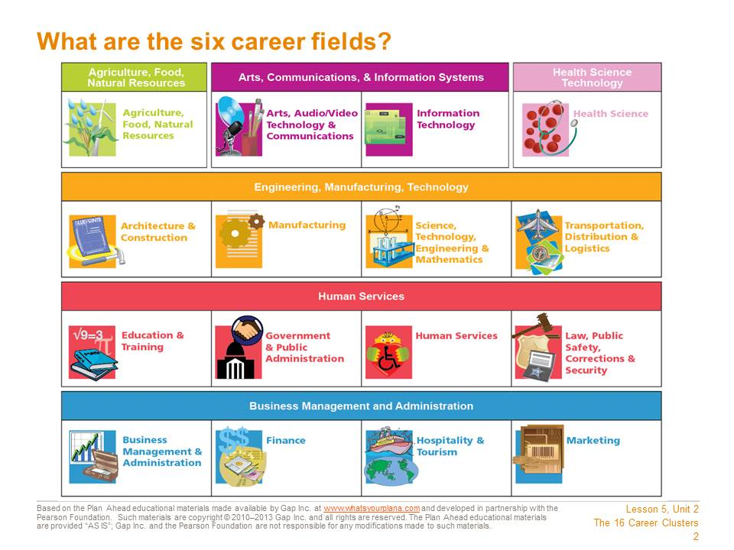
The six career fields are very broad and general. They include:
− Agriculture, Food, Natural Resources
− Arts, Communications, & Information Systems
− Health Science Technology
− Engineering, Manufacturing, Technology
− Human Services
− Business Management and Administration
These fields each include many different kinds of jobs. These are organized into 16 career clusters.
Two of the fields—Agriculture, Food, Natural Resources and Health Science Technology—only contain one career cluster each. Another field, Arts, Communications, & Information Systems, has two clusters. The rest of the fields have four clusters each.

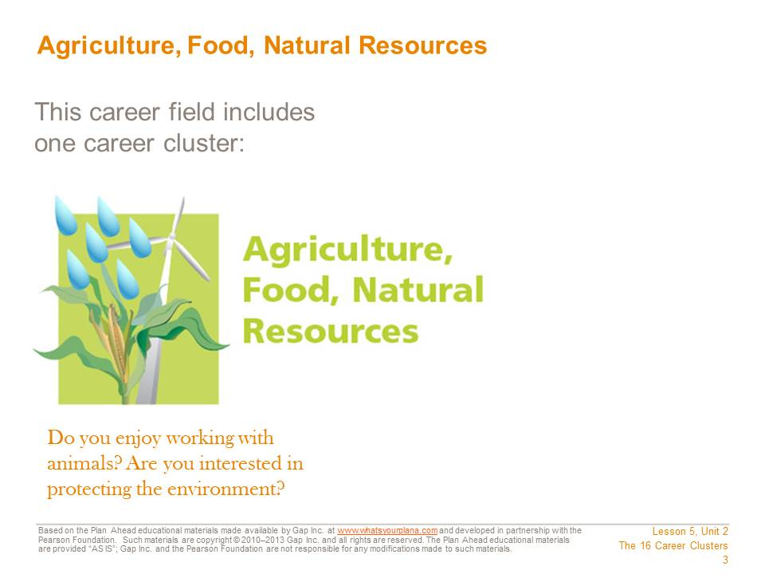
In this career cluster, nature, plants, and animals are the focus. You might produce agricultural goods, such as food, fabrics, or wood. Or, you might work on a farm, a ranch, or a dairy, or at an orchard, a greenhouse, or a plant nursery. You could work in a clinic or a laboratory as a scientist or an engineer doing research related to agriculture or food. Finally, you could also work to conserve natural resources or protect the environment. Jobs that focus on protecting the environment, or “green jobs,” are becoming more and more popular as we look for ways to take better care of the planet. Some of these jobs are about creating renewable energy through solar, wind, and other natural sources of power.

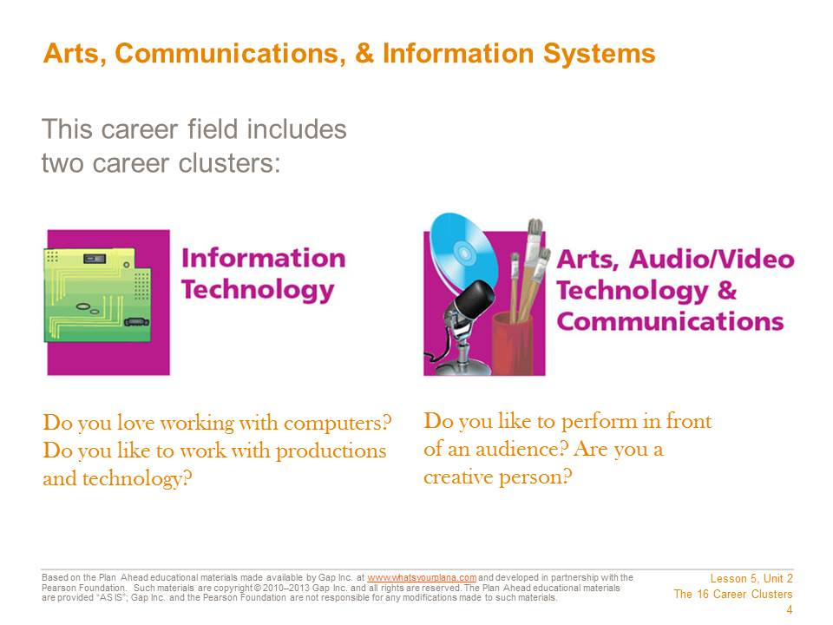
This career field includes these two career clusters: Information Technology and Arts, A/V Technology & Communications.
In Information Technology you would work with computers and software. You might design computer hardware, create software programs, or find ways to make computers run more efficiently. Or you might link workers in several parts of the world using technology, or support others and answer questions about specific software or hardware.
Another area of focus is Arts, Audio/Video Technology & Communications. In this area you might be a performer or an artist. You would be on the stage, acting in a play or performing music in a concert. You might be in front of the camera as an actor in a movie or a television show, or maybe you would work behind the scenes. With this cluster, you might create a painting or write a book. You might also work on film production or magazine, book, or newspaper publishing. Another option might be to use your creative talents with technology and work as an animator, a graphic designer, or a film editor.

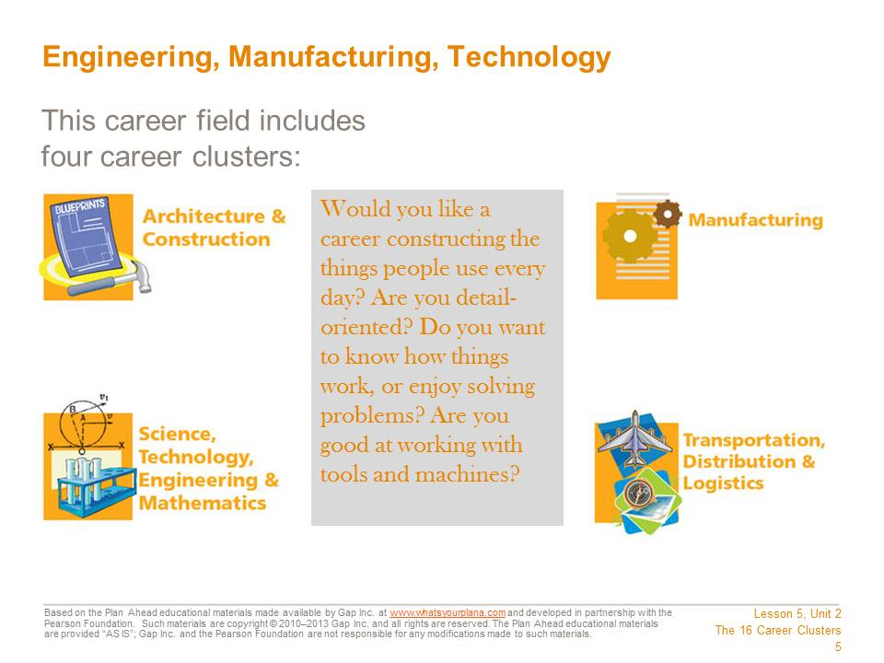
This career field includes these four career clusters:
− Architecture & Construction
− Manufacturing
− Science, Technology, Engineering & Mathematics
− Transportation, Distribution & Logistics
In these career clusters you might construct buildings or make products—anything from household appliances to medical devices, from furniture to tools and systems for businesses and industries. Or you might design new structures or products. Another option would be to install or repair these manufactured products. You might do research to develop new products or systems. Or you could operate the vehicles, the trains, or the planes that deliver the products.

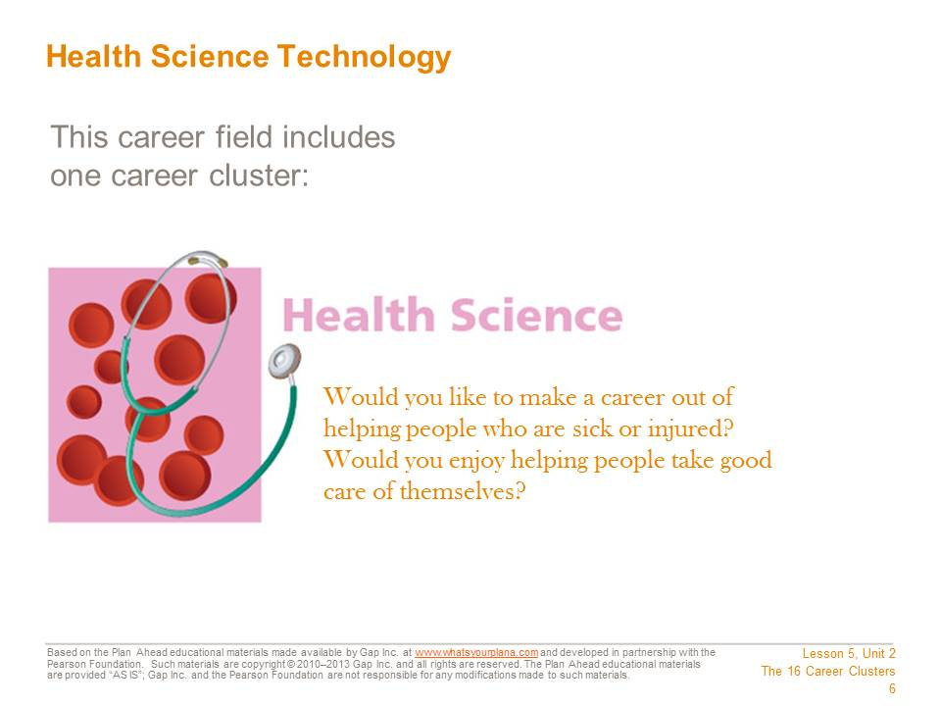
This career field includes the Health Science career cluster. In this career cluster you would identify and treat injuries or diseases, or you might work to keep people healthy. You could work at many different sites. Work may be done in offices, hospitals, or labs, or you might even work on a cruise ship or in a hotel. Doctors, nurses, therapists, and X-ray technicians are examples of jobs in this career field.

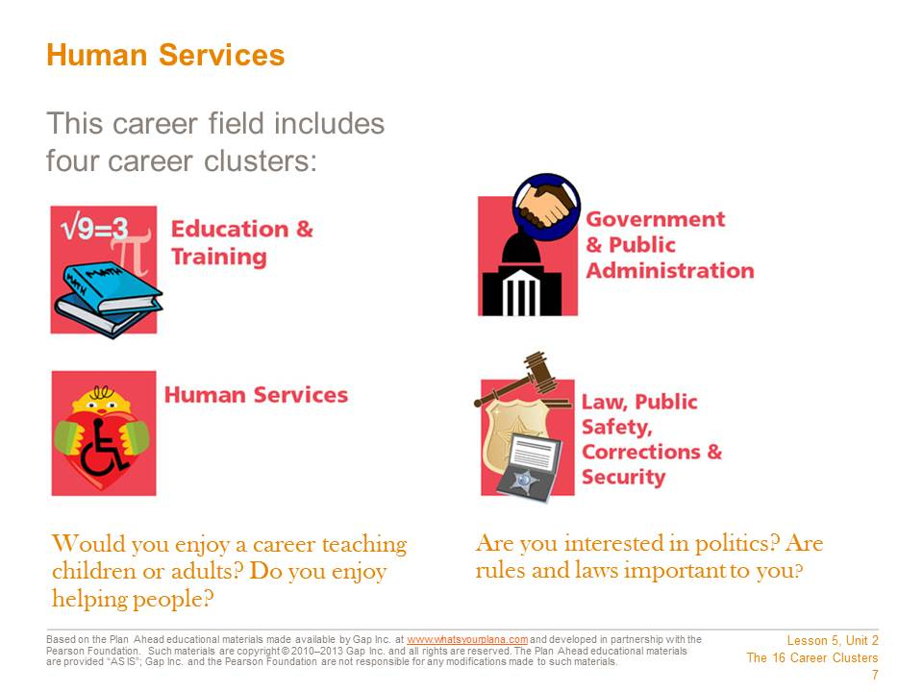
This career field includes four career clusters.
In Education & Training you help young people and adults learn. You may teach in a classroom. You could provide training to employees in a business. In addition, you might support teachers in schools. You could be a counselor, a librarian, or a principal.
In Government & Public Administration you might work in many different places. You might work in your hometown for the city government. Or you might work for your state or federal government. Or you might live in another country and work at an embassy.
You will find many chances to help people in Human Services. You could care for children or the elderly, or take care of disabled people. You might arrange a funeral or help people with money problems.
In Law, Public Safety, Corrections & Security you keep people safe. You might guard people who are in jail or in prison. Or you might defend homes and businesses during fires. Another option is to enforce the law and investigate crimes. You might protect buildings, people, and products. Or you might help people deal with laws.

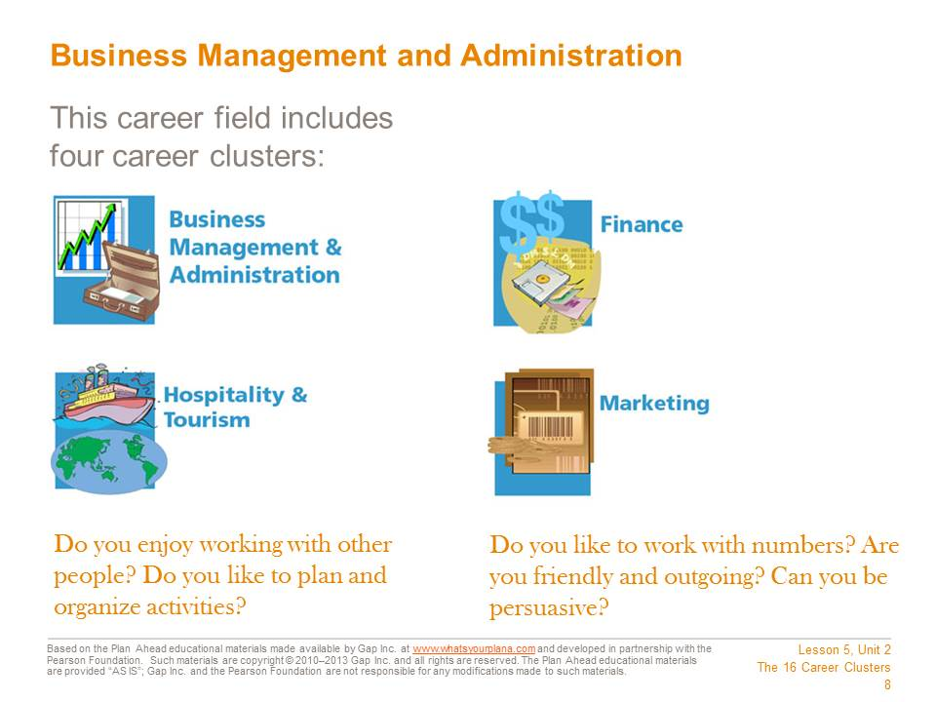
This career field breaks out into four main areas.
In Business Management & Administration you may own, manage, or direct a business. Another option is to keep track of expenses and income. Or you might hire and train the workers.
In Finance you keep track of money. You could keep records. Or you could help people get loans and save money. Another option is to help people buy insurance. You could also run a bank.
In Hospitality & Tourism you help people have fun. You could work in a restaurant, manage one, or own one. Another option is to take care of guests at a hotel. Or you could help people plan trips.
In Marketing you sell products. You might create ads to get customers to buy products through magazines, newspapers, the media, or the Internet. Or you might sell directly to customers.

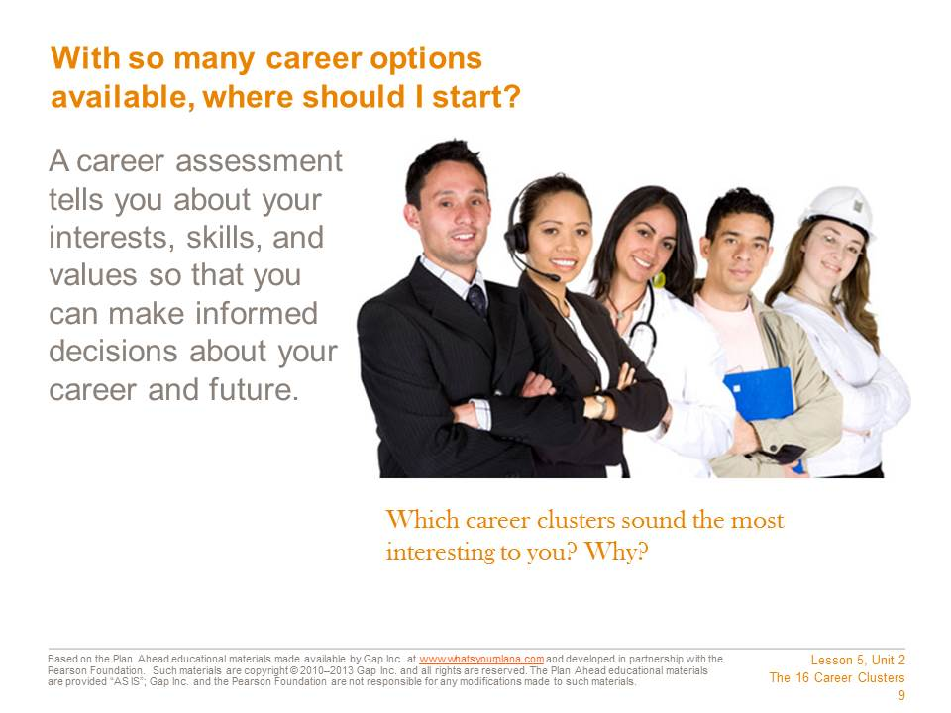
Do some of these career fields and clusters sound more interesting to you than others? To find out which career clusters match your interests, skills, and values, you will take a series of career assessments.

Student Resource 5.4
Survey: How Am I Smart?
Student Name: Date:
Directions: First, read about the Theory of Multiple Intelligences. Then read each statement in the boxes below. Think about whether or not each statement sounds like you—how you think or feel about things or what things come easily to you. If the statement is true, write “T” on the line next to it. If the statement is false, write “F” on the line. If the statement is sometimes true and sometimes false, leave the line blank. At the bottom of each box, write down how many T’s you have.
Remember that this is not a test. There are no right or wrong answers. This is just a tool to help you think about your innate skills and “smarts.” After you have completed the questionnaire, your teacher will give you a sheet to help you interpret your results.
What Is the Theory of Multiple Intelligences?
Dr. Howard Gardner proposed the Theory of Multiple Intelligences. He suggested that there are different ways to be smart. Some types of intelligence show up in a traditional classroom, but other types of intelligence may show up in afterschool activities, when you’re playing sports, or when you’re hanging out with your friends.
This tool will help you evaluate which types of intelligence are your strengths. There are eight different types of intelligence. After you answer the questions, you will be able to learn more about your strongest types of intelligence. This can help you in school, because you’ll understand better what your strengths and weaknesses are, or when choosing a career.

Group A | Group B
_____I enjoy reading all kinds of materials.  _____It is easy for me to explain my ideas to others.  _____Word puzzles like crosswords and jumbles are fun.  _____I keep a journal or write because I enjoy it.  _____I like public speaking and debates.  _____I like listening to speeches and lectures.  _____I would rather follow written directions than a map or diagram. | _____ I can add or multiply in my head.  _____I like to work with calculators and computers.  _____I like to work with numbers and figures.  _____I keep my things neat and orderly.  _____Solving problems comes easily to me.  _____Puzzles requiring logic or reasoning are fun.  _____ I can’t begin an assignment until all my questions are answered.
How many T’s? | How many T’s?

Group C | Group D
_____ I can’t concentrate while listening to music or watching TV.  ____ Life seems empty without music.  _____ I often connect a piece of music with some event in my life.  _____ I like to hum, whistle, and sing in the shower or when I'm alone.  _____ I easily pick up on patterns or rhythms.  _____ Moving to a beat is easy for me.  _____ I enjoy many kinds of music.  _____ Remembering song lyrics (words) is easy for me. | _____ I’d rather draw a map than give someone verbal directions.  _____I always know north from south no matter where I am.  _____I always understand the directions that come with new gadgets or appliances.  _____I can look at an object one way and see it sideways or backwards just as easily.  _____ I enjoy creating art.  _____ I remember well by using graphic organizers.  _____ I can remember things using mental pictures.  _____ I am good at reading maps.
How many T’s? | How many T’s?

Group E | Group F
_____ I pick up new dance steps fast.  _____Learning how to ride a bike or skateboard, or learning how to rollerblade, was easy.  _____My sense of balance and coordination is good.  _____ I enjoy making things with my hands.  _____ Sitting still for long periods of time is difficult for me.  _____ I enjoy outdoor games and sports.  _____ I like working with tools.  _____ I learn by doing. | _____ I’m usually aware of the expression on my face.  _____I stay “in touch” with my moods. I have no trouble identifying them.  _____ I am extremely aware of my moral beliefs, my ideas about “right” and “wrong.”  _____ My attitude affects how I learn.  _____ Working alone can be just as productive as working in a group.  _____ I need to know why I should do something before I agree to do it.  _____ When I believe in something I will give 100% effort to it.  _____ I like to be involved in causes that help others.
How many T’s? | How many T’s?

Group G | Group H
_____ I’m sensitive to the expressions on other people’s faces.  _____I have a good sense of what others think of me.  _____ I learn best by interacting with others.  _____ The more people around me, the better.  _____ Study groups are very productive for me.  _____ I enjoy chatting with people online.  _____ I am a team player.  _____ Clubs and extracurricular activities are fun. | _____ I enjoy categorizing things by common traits.  _____ Environmental issues are important to me.  _____ Hiking and camping are enjoyable activities.  _____ I enjoy working in a garden.  _____ Animals are important in my life.  _____ I think it’s important to recycle.  _____ I spend a great deal of time outdoors.
How many T’s? | How many T’s?

Your Results
In each space below, write down how many T’s you had for that group. Then circle or highlight your highest scoring group or groups.
Group A |  | Group E
Group B |  | Group F
Group C |  | Group G
Group D |  | Group H

Student Resource 5.5
Guide: How Am I Smart?
Directions: After completing the How Am I Smart? survey (Student Resource 5.4), use this guide to help you interpret your results. Remember that everybody has every type of intelligence. For right now, just focus on the one or two types of intelligence that you scored highest on. You can read about the other types of intelligence later on.

Group A: VERBAL-LINGUISTIC INTELLIGENCE
People with strong verbal-linguistic intelligence are good with words. They may be good with words on paper—good writers and effective readers. Or they may be good with the spoken word—good at speaking in public, at sharing their thoughts in a conversation, or at learning from a lecture or speech.
You may enjoy reading, writing poetry and stories, or doing word puzzles like crosswords. You may also like discussing or debating ideas with people and you may be good at telling jokes. You may be very successful in English or Language Arts classes.
People with strong verbal-linguistic intelligence may be successful writers. They could be journalists, advertising writers, screenwriters, or novelists. They may also be editors or proofreaders. People who speak in public like lawyers, comedians, TV and radio newscasters, and sports announcers also need good verbal intelligence. Finally, some people with strong verbal-linguistic intelligence go into research or education that is connected to words by being a speech pathologist, an English professor, or an archivist for a museum.

Group B: LOGICAL-MATHEMATICAL INTELLIGENCE
If you have strong logical-mathematical intelligence, you are probably very good with reasoning things out and solving puzzles. You may be able to recognize patterns, especially patterns within numbers, better than other people. You may be good at solving math problems in your head. You might enjoy doing scientific experiments or analyzing things more than other people.
You may be systematic and organized, and it may be difficult for you to start working on an assignment if you don’t understand the “big picture” or if you don’t have all your questions answered. You may be successful in math or science classes.
People with strong logical-mathematical intelligence may be good at working with computers as a programmer or technician. They may enjoy jobs that require analyzing mathematical data, like working as a statistician, actuary, or a poll taker. People who work in the financial industries, such as bankers, accountants, and stock brokers, also need good mathematical intelligence. Finally, some people with strong logical-mathematical intelligence go into scientific research or medical fields where they can use their strong logic and reasoning skills to solve medical or scientific problems.

Group C: MUSICAL-RHYTHMIC INTELLIGENCE
People with strong musical-rhythmic intelligence are very sensitive to music. You probably are more aware of sounds around you, whether that’s a song on the radio or the tapping of rain on the roof. You can get a song “stuck in your head” very easily and may frequently have a song in your head throughout the day. You may associate a particular song with a specific event that happened in your life—for example, you may remember what song was playing the first time you saw your boyfriend or girlfriend.
You are probably talented with music. You may be able to play an instrument or sing or rap. You have a good “ear” and may be able to imitate people after listening to them. You may be good at dancing because it’s easy for you to hear the beat.
People with strong musical-rhythmic intelligence might choose music for a career. You may be a performer or a technician who helps to record music. You might work for TV or movies, writing the soundtrack or designing the sound effects. You might work as a music therapist, using music to help people, or as a teacher of music. Also, people with a strong musical-rhythmic intelligence may be successful in advertising, because advertising frequently uses music and rhythm in commercials.

Group D: VISUAL-SPATIAL INTELLIGENCE
People with strong visual-spatial intelligence think in pictures and images rather than words. You may be good with understanding diagrams or maps, and you may have a strong ability to picture things in your head. You may be good at jigsaw puzzles or games like chess that require you to picture how moving one piece will affect other pieces. You are probably very aware of shapes, colors, and textures around you. If you are a more “artistic” person, your visual-spatial intelligence may come out through painting, drawing, or sculpting. If you are interested in science or history, you may find yourself more successful at subjects like anatomy, which requires spatial understanding of the human body, or geography, which relies heavily on the use of maps.
People with strong visual-spatial intelligence can pursue many different careers. “Artistic” careers that utilize this intelligence include being an architect, interior designer, photographer, or jewelry or clothing designer. Being a cinematographer and working in the movies is also a good fit, as is working as a graphic designer. For people who are more interested in the sciences, a cartographer (or map maker) and a surgeon both require good visual-spatial intelligence. People who have to navigate, such as professional drivers, tour guides, and airline pilots, also benefit from strong visual-spatial intelligence.

Group E: BODILY-KINESTHETIC INTELLIGENCE
People with strong bodily-kinesthetic intelligence are good at using their body to accomplish tasks. Very talented athletes and dancers usually have this type of intelligence. You may be someone who learns by doing—if your mom wants to teach you how to make a favorite family recipe, you’ll probably learn better by just getting in the kitchen and doing it yourself, rather than by reading the recipe out of a cookbook.
You are probably someone who is very physically active; in fact, it may be uncomfortable for you to sit still for long periods of time. You may be someone who uses body language a lot, or “talks with your hands.” If you watch someone doing a task, you can probably repeat the task fairly well. It may have been easy for you to learn how to ride a bike or skateboard or to learn how to rollerblade. You may also be good at tasks that require you to use your hands, like building things.
People with strong bodily-kinesthetic intelligence frequently work in the field of sports. They may be athletes, coaches, or trainers. They may excel at jobs that require the use of their hands, such as mechanics or builders. They may be gifted at medical careers, working as a physical therapist, doctor, or nurse. Dancers, gymnasts, and circus performers are also very strong in this area, as are models and actors, who have to be able to use their bodies effectively when they are on stage. Finally, many law enforcement people have strong bodily-kinesthetic intelligence. This can help them stay in shape, which is an important part of their job, and can also help them when they have to physically interact with a potential suspect.

Group F: INTRAPERSONAL (UNDERSTANDING YOURSELF) INTELLIGENCE
People with strong intrapersonal intelligence are good at knowing themselves. You may spend time thinking about your life, who you are, and how you react to things. You probably have a good sense of your strengths and weaknesses, and you are probably aware of your inner thoughts and feelings more than other people. Because you know yourself pretty well, you may “screw up” less than other people, because you may be more aware of your own limitations.
You may be a quiet person who is less inclined to talk about some of these things in a group setting. People with strong intrapersonal intelligence are often self-confident and may be “wise beyond their years.” You probably have definite, well-thought-out opinions on almost any issue. You may draw your motivation from within—from your own dreams and goals—rather than looking for outside sources of motivation.
People with strong intrapersonal intelligence seem like they “have it all together,” and other people may frequently turn to them for advice. Because of that, it’s not surprising that many people who are strong in this area become therapists, counselors, or social workers. People with a strong religious faith may combine their faith with this type of intelligence to become a minister or spiritual leader. People with strong intrapersonal intelligence can also be very successful working with the mentally ill or working in some branches of scientific research.

Group G: INTERPERSONAL (UNDERSTANDING OTHER PEOPLE) INTELLIGENCE
If you have strong interpersonal intelligence, you excel at understanding and dealing with other people. You probably enjoy working as part of a team. You may be sensitive to other people’s feelings and eager to help. You probably have a lot of friends. You may be good at talking to people and “drawing out” quiet people by asking them questions.
It may be easier for you to learn through group interaction. If you find that your work on group projects is usually better than your individual work, that can be a sign of strong interpersonal intelligence.
People with strong interpersonal intelligence do very well in careers that require them to interact with a lot of other people. Teachers, politicians, and leaders of companies all need this trait. People who work in sales and customer service also are more successful if they have strong interpersonal intelligence. These types of people may also do well in careers that require bringing people together, such as a social director, activities coordinator, or travel agent. Anthropologists and sociologists benefit from strong interpersonal intelligence, as do arbitrators, consultants, and public relations officers.

Group H: NATURALISTIC INTELLIGENCE
If you have strong naturalistic intelligence, you are in tune with the outside world. You probably love being outdoors and enjoy dealing with plants and animals. You may enjoy studying or observing them and you may be good at classifying or analyzing things you see in nature. You may pay attention to weather patterns or animal behavior more than other people. Taking care of the planet is probably important to you.
People with strong naturalistic intelligence do well in careers that involve plants or animals. This may involve being a veterinarian, farmer, forest ranger, zookeeper, or animal trainer. They might enjoy serving as a conservationists, landscape designer, or florist. They may be successful at careers that involve outdoor activities, such as hiking or camping. If they like science, people with strong naturalistic intelligence may succeed as botanists, horticulturalists, meteorologists, or biologists investigating the world around us. They may also enjoy working for a nonprofit organization that takes care of the planet by replanting trees or protecting animals from pollution.

Student Resource 5.6
Reading: Using Multiple Intelligences
Directions: Use this reading to help you think of ways to use your strengths to help you in school.
Intelligence Type | What to Ask Yourself | How to Use It to Succeed in School
Verbal-Linguistic | How can I use words (spoken or written) to help me? | Write down directions.  Use reading to learn or help you review material.  If you learn better from lecture, consider recording your classes (with the teacher’s permission) or make a “book on tape” of your textbook by reading it into a microphone and then listening to it.
Logical-Mathematical | How can I use numbers, calculations, logic, classifications, or critical thinking? | Take time to get your questions answered and get the “big picture,” so it makes sense to you.  Use a note-taking frame or strategy (like Cornell notes) to help you organize material in a logical way.  Pay attention to timelines, charts, and diagrams in your textbook.
Musical-Rhythmic | How can I bring in music or sound or set key points to a rhythm or melody? | If you need to memorize things, set them to a rhythm or a melody.  Find music that connects to what you are studying (for example, create a “soundtrack” to help you remember the sequence of events in a story).  Pay attention to how sound/music affects your ability to study. If you need quiet, plan to study in a library or use earplugs. If a particular sound or type of music helps you concentrate, take advantage of that—maybe make a “studying” playlist on an MP3 player.
Visual-Spatial | How can I use visual aids, color, art, or drawing? | Use graphic organizers to help you take notes or color code your notes to help you make sense of lots of information.  Look for ways to review or present information using drawings or images (for example, diagrams, posters, or PowerPoint presentations).  Pay attention to illustrations in your textbook or try to create your own illustrations to help you remember key details.
Bodily-Kinesthetic | How can I use my body or hands-on experience? | Create something (like a shadow box or a diorama) to help you review the content.  Use physical movement to help you memorize (for example, counting on your fingers, or tossing a ball in the air while you study).  Look for ways to review or present information in physical ways (for example, by acting out something you learned).
Intrapersonal | How can I connect this to personal feelings or emotions? | Use a journal or similar method to try to relate your personal experiences and ideas to what you are studying.  Take advantage of assignments that allow you to make personal choices (for example, by choosing the topic of your research).  Use your “self-knowledge” to evaluate your work and identify ways you can do better.
Interpersonal | How can I use talking to other people to help me learn? | Think about studying with a partner (but make sure you really study).  Try to “teach” the content to somebody else—a friend, a parent, a sibling. It will help you recognize what you do and don’t understand.  Choose group projects, or try to find ways to discuss what you’re working on with a friend. Maybe you can trade ideas with a classmate, or talk it through with a parent or teacher before you start on a big assignment.
Naturalistic | How can I use nature or natural ideas and images? | Make connections between nature and what you’re studying. For example, how did a country’s weather or geography affect its history? It may help you remember facts about the history more easily.  Study outdoors (if possible). If not, bring nature into your study space—put a nature scene on your computer or have a vase of flowers nearby. It can calm you and help you concentrate better.  If possible, choose assignments or topics that allow you to integrate your love of nature, plants, and animals into your work. For example, if you need to do “service hours,” consider participating in a beach clean-up or volunteering at an animal shelter.

Examples
- Marcus knows that he has strong musical intelligence, but he is weak in linguistic intelligence. That means it may be difficult for him to read and memorize all those dates and places he needs to know for his history test. But once Marcus knows that he has strong musical intelligence, he could set those dates to a rhythm or sing them along with a song—even a simple song, like the ABC song or “Row, Row, Row Your Boat.” By setting those dates and places to music or rhythm, it could make it easier for him to memorize them, which could help him do better on his history test.
- Sofia has strong visual-spatial intelligence, but she has always had a hard time learning vocabulary words in school. Now that she knows she has strong visual-spatial intelligence, she has changed how she studies. She uses a highlighter to color code her notes, making it easier to spot new terms. When she has a lot of new words to learn, she makes special flash cards. In addition to the word and the definition, Alicia also draws a little picture to illustrate what the term means. When she has to remember the word for a test, she tries to remember what picture is connected with the word, and it helps her think of the definition.
- Jada has always been scolded by teachers for being “too chatty” or talking too much in class. She feels like she understands what she’s being taught in school, but her grades don’t always show that. Then Jada learns that she has strong interpersonal intelligence. She realizes that she can use her talkative nature to help her do better in school. Now Jada tries to study with her older brother. He doesn’t like chatting about her boyfriend or her favorite TV shows, but he will talk with her about her science homework or brainstorm ideas before she writes an essay for English class. Discussing things with him helps Jada recognize what she does and does not know, so she can go back and ask the teachers for help. And by talking things over with him before doing her homework, Jada gets her ideas more organized, so the quality of her work improves.

Student Resource 5.7
Graphic Organizer: Career Recommendations
Student Name: Date:
Re-Entering Your Scores
The My Next Move website does not save your scores after you exit the site. But don’t worry! You don’t need to take the Interest Profiler again. That’s why you printed your results. Here are the steps you need to follow to re-enter your scores.
- Return to the My Next Move website (http://www.mynextmove.org/).
- Click “Start” under “Tell Us What You Like to Do.”
- Click “Enter test scores” under “Taken the Interest Profiler Before.”
- Enter your scores from your printed results.
- You will be back at the results page you saw previously.
- Click through the explanation of the Job Zones.
- Select Job Zone 1.
- Click through until you see “Careers that fits your interests and preparation level.”
Reviewing the Job Zones
Complete the chart on the next page, describing one job that is recommended for you from each of the Job Zones. An example is provided.
Job Zone | Example | Zone 1 | Zone 2
Job Title | Secondary School Teacher
What the Job Does | Teaches high school students in public or private school; may specialize in one or more subjects.
Average Salary | $52,200
Training Needed | Bachelor’s or Master’s Degree

Job Zone | Zone 3 | Zone 4 | Zone 5
Job Title
What the Job Does
Average Salary
Training Needed

Before handing in your assignment, check to make sure it meets or exceeds the following assessment criteria:
- The graphic organizer includes accurate information about one job from each job zone.
- The responses clearly demonstrate an understanding of the basic responsibilities of each job.
- The graphic organizer includes a thorough analysis of one specific job and how well it suits the student.
- The analysis utilizes information from all three inventories (interests, multiple intelligences, and values) to evaluate whether or not a job is a good fit.
- All responses are neat and use proper spelling and grammar.

Analysis: Which Career Really Interests Me?
Now you need to choose a career that really interests you. You can choose one from any job zone. If you are choosing to analyze a career that you already wrote about in the “Reviewing the Job Zones” section, you can skip the Basic Information entry on this chart. However, if you are writing about a new career that you have not previously described on this worksheet, you need to include that basic information—the job zone, what the job does, the average salary, and what kind of training is needed.
In order to complete this analysis, you will also need to refer back to the values survey you did in Lesson 4, as well as the multiple intelligences survey you completed earlier in this lesson.
An example is provided to help you get started.
Example:
Job Title | Secondary School Teacher
Basic Information (if not already filled out): Job Zone, What the Job Does, Average Salary, Training Needed | Already filled out.
Personality Description | People who do this job like helping people, teaching, and talking. They value integrity, leadership, and self-control.
Does this personality description fit me? Why or why not? (Look back at your values survey.) | Yes, this fits me. I had high scores in nurturing, leadership, and control.
Skills Description | People who are good at this job need to be able to use the best strategies to reach people—talking to others, explaining things to others, noticing a problem and figuring out the best way to solve it.
Which of these skills am I comfortable with and why? (Look back at your multiple intelligences survey.) | I am good at talking to other people because I had a high score in interpersonal intelligence.
Which of these skills do I still need to develop? | I need to work more on the problem-solving part of this. I get frustrated quickly if I can’t solve a problem, and that sounds like it could make this job harder for me.
Based on this analysis, does this sound like a good fit for me? Why or why not? | So far, it sounds like this is a good fit for me. I have the right personality and some of the skills I need for this job.

Job Title
Basic Information (if not already filled out): Job Zone, What the Job Does, Average Salary, Training Needed
Personality Description
Does this personality description fit me? Why or why not? (Look back at your values survey.)
Skills Description
Which of these skills am I comfortable with and why? (Look back at your multiple intelligences survey.)
Which of these skills do I still need to develop?
Based on this analysis, does this sound like a good fit for me? Why or why not?

