Lesson 9
Graduating from High School
Teacher Resources
Resource | Description
Teacher Resource 9.1 | Guide: High School Dropout Intervention
Teacher Resource 9.2 | Posters: Four Corners Activities
Teacher Resource 9.3 | Interactive Presentation 1 Notes and Instructions: Truancy (includes separate PowerPoint file)  Make It Local | Modify the presentation and presentation notes to reflect truancy laws and policies in your district or community.
Teacher Resource 9.4 | Template: Cornell Notes (separate Word file)
Teacher Resource 9.5 | Interactive Presentation 2 Notes and Instructions: Graduating from High School (includes separate PowerPoint file)  Make It Local | Modify the presentation and presentation notes to reflect graduation requirements, school or district policies, and higher education options in your community.
Teacher Resource 9.6 | Bingo Guide: Graduating from High School  Make It Local | Modify the clues to incorporate terminology from your revised version of the presentation. Remove any terminology that is not appropriate for your school or community.
Teacher Resource 9.7 | Bingo Cards: Graduating from High School (separate Word file)  Make It Local | Modify the cards to incorporate terminology from your revised version of the presentation. Remove any terminology that is not appropriate for your school or community.
Teacher Resource 9.8 | Assessment Criteria: My Four-Year Action Plan  Make It Local | The Assessment Criteria may need updating if the Four-Year Action Plan assignment is modified for your school and community. (Student Resource 9.7)
Teacher Resource 9.9 | Key Vocabulary: Graduating from High School
Teacher Resource 9.10 | Bibliography: Graduating from High School

Teacher Resource 9.1
Guide: High School Dropout Intervention
Background
It is estimated that about 2,500 students drop out of US high schools every day. Truancy is also a serious problem. While most ninth grade students may have no intention of dropping out of high school, they don’t realize the direct connection between cutting class and dropping out. Students who cut class are at risk for becoming truants; 75% of truants do drop out. Read Teacher Resource 9.3, Interactive Presentation 1 Notes and Instructions: Truancy, for important information about handling truancy.
Preparing for This Lesson
Ninth grade is a time of critical importance for dropout prevention. In addition to the other challenges they may face, ninth graders find themselves in a new academic and social environment with complex institutional structures and new expectations. Throughout this lesson, students will be asked to identify challenges, decisions, and consequences related to school and to use their problem-solving skills to list possibilities for helping students stick it out.
In The 6 Most Important Decisions You’ll Ever Make, author Sean Covey addresses a number of obstacles and issues high school students grapple with that influence their resolve to stay in school. Some of these include:
Family Cycles: In some cases, students drop out because everyone else in their families did. Students with no support at home for succeeding in school need even more support and guidance at school to help them break the cycle.
Stress: Almost all students face competition, expectations, and classes or subject areas that are challenging to them. Because stress is a part of life, the earlier students learn the mechanisms to help them cope with stress (e.g., diet, self-care, sleep, exercise, positive relationships), the better they will be able to succeed in adulthood.
Time Management: Many students report not having enough time in the day to get everything done. Focusing on time management and addressing individual time-wasting habits (see Student Resource 2.1, Reading: Planning My Time Effectively, in Lesson 2) help guide students toward positive habits and away from procrastination.
Apathy: Students who are not motivated and don’t feel like trying often feel like victims of a system over which they have no control. Finding a passion to pursue at school, through an elective or co-curricular activity, can empower students and give them a reason to attend when they otherwise might not “love” being at school.
Low Self-Esteem: For some students, the message is, “I’m just not good at school.” Students can build self-esteem by focusing on their strengths. They should also be encouraged to complete extra credit, use available resources (counselors, school tutors, afterschool programs, etc.), and establish good study habits to help boost their grades.
Before you start this lesson, you should be prepared to discuss the strategies and programs in place at your school to promote and support academics, study skills, socialization, and attendance.
Truancy and Dropout Prevention
The students who are most likely to become truants and drop out often show warning signs as early as sixth grade. They may have attendance problems from the very beginning of high school. Lack of parental involvement, substance abuse, poverty, weak basic skills, and low academic achievement are the major factors that contribute to both problems. In this lesson, students explore all of these issues and how to overcome them.
Teacher Resource 9.2
Posters: Four Corners Activities

Use the embedded following images for printing or see the PDF file, L9_4Corners_Posters_2013, for the same graphics as a standalone, printable document.
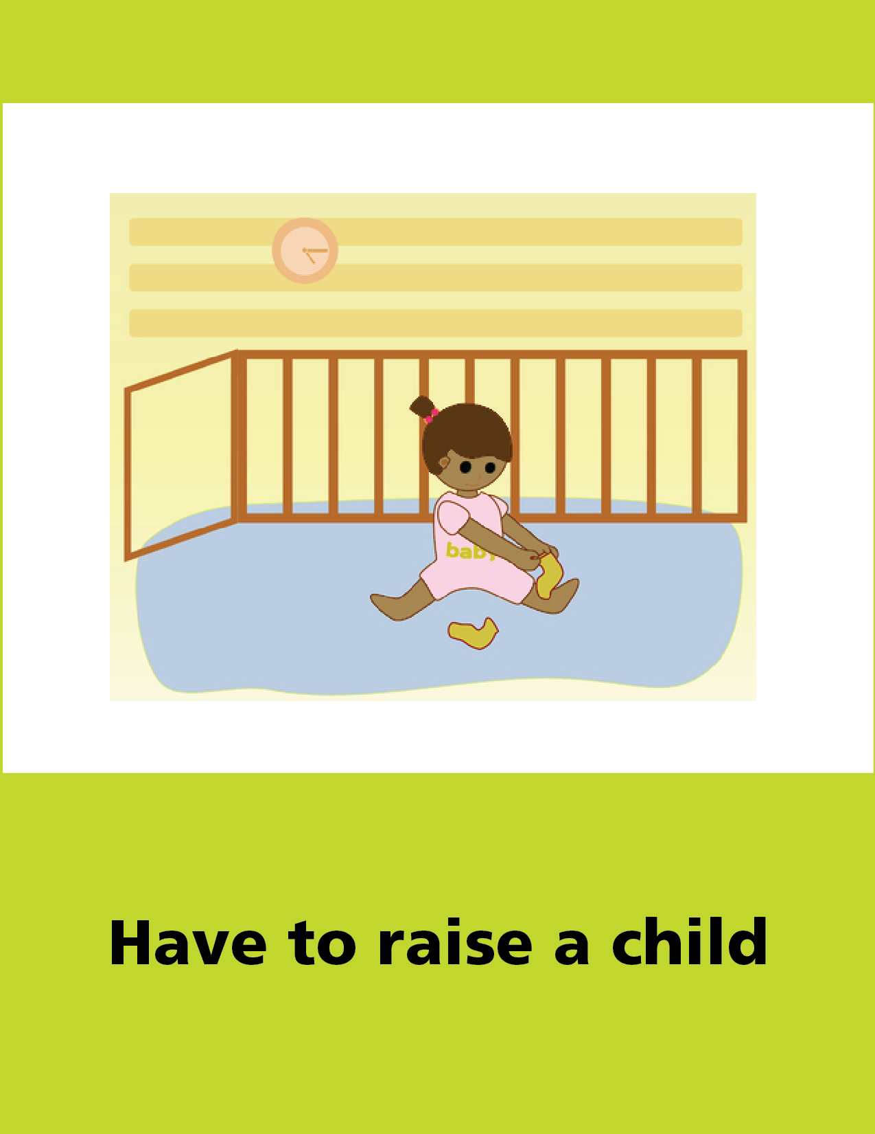
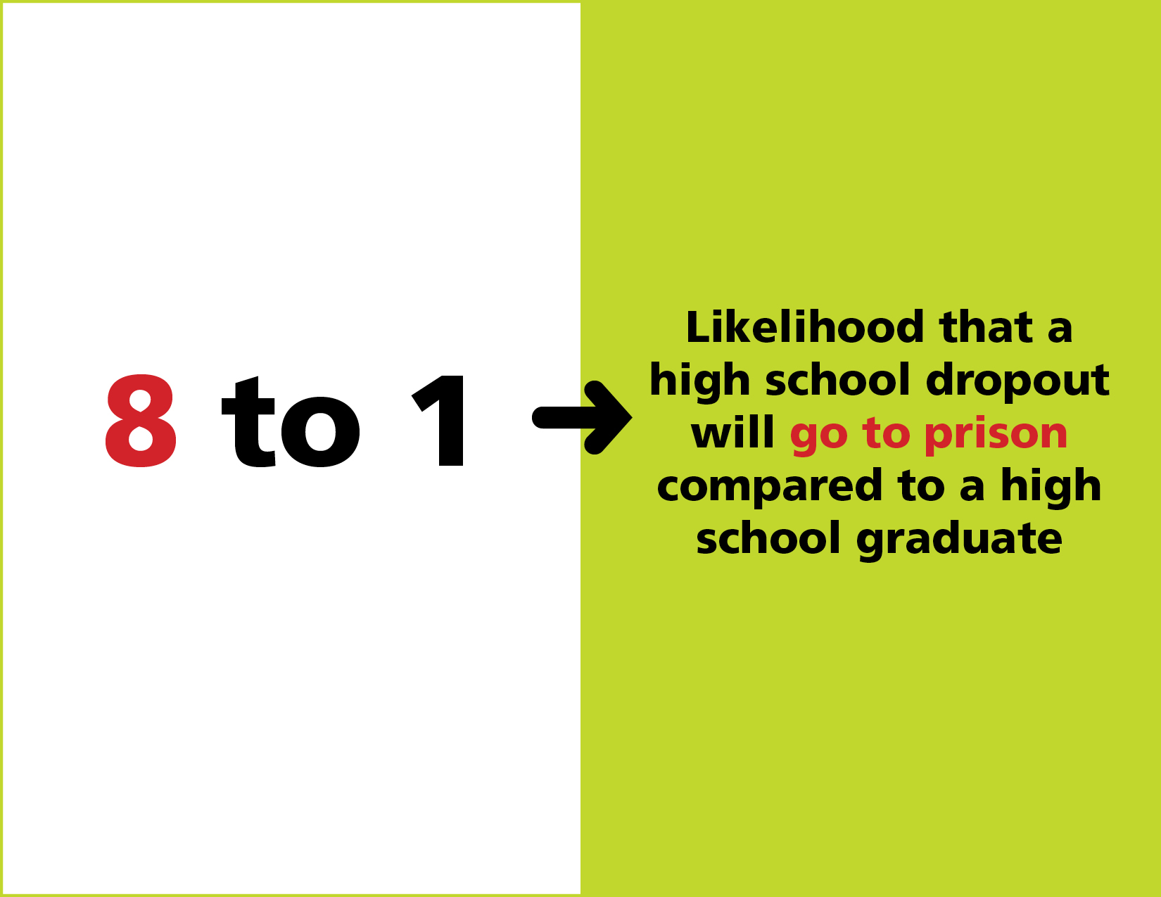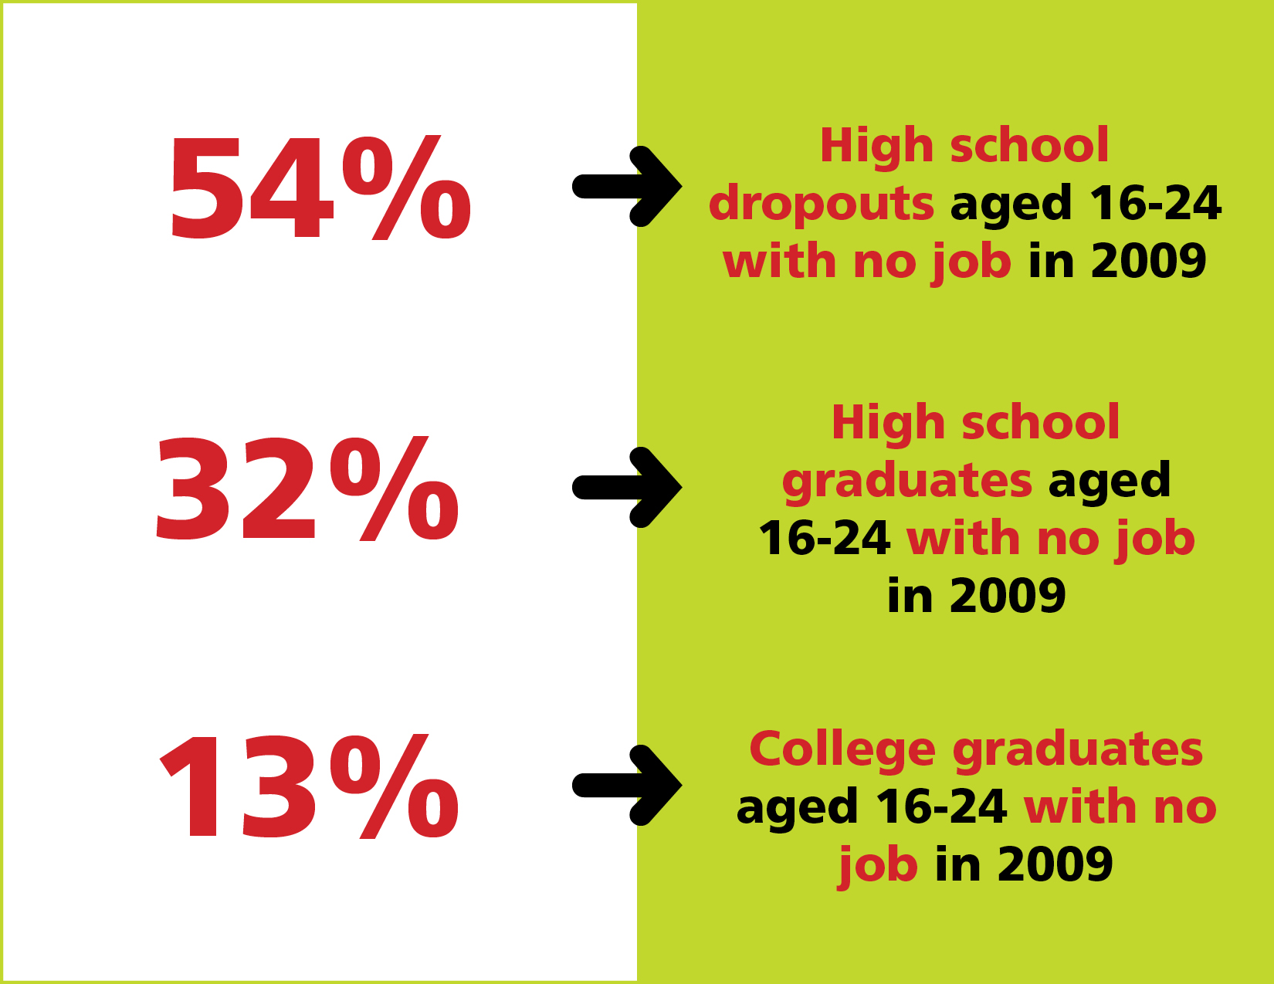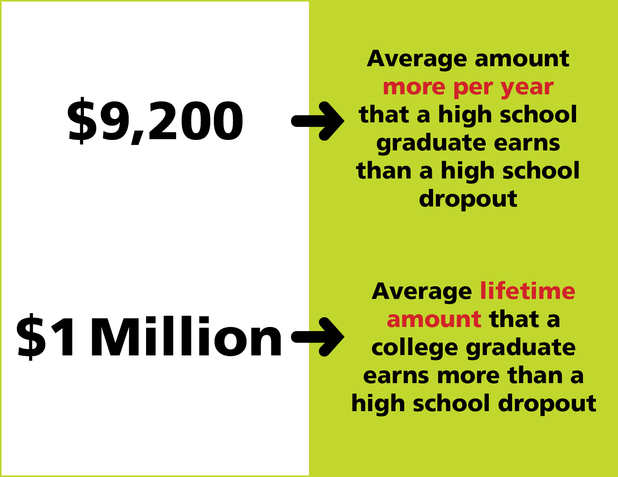
Teacher Resource 9.3
Interactive Presentation 1 Notes and Instructions: Truancy
Before you show this presentation, use any text accompanying each slide to develop presentation notes. Not all slides have text with them. Writing the notes yourself enables you to approach the subject matter in a way that is comfortable to you and engaging for your students. Note the ideas for fully engaging the students that are placed at key points in the “Notes” section.

Make It Local | The separate PowerPoint file will need substantial revision. It includes model content based on information provided by San Francisco Unified School District.
These notes are based on the model version of the presentation. You may need to modify the interactive suggestions based on your adjustments to the presentation content.

 | Presentation notes

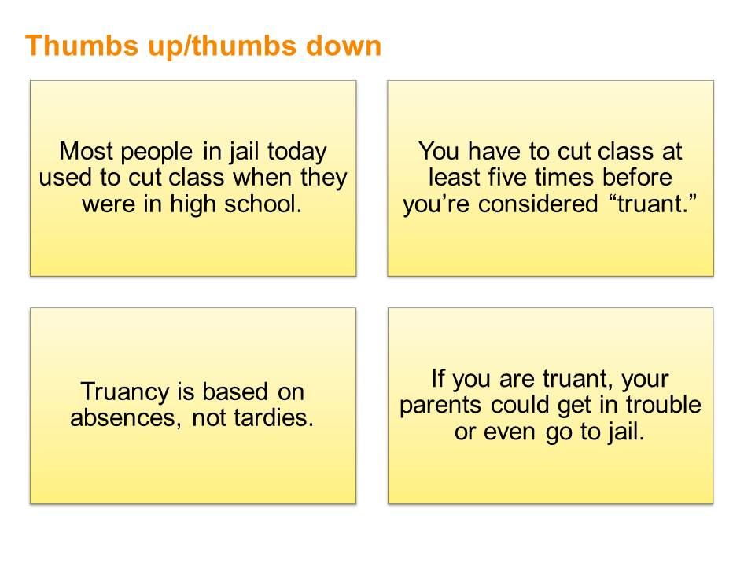  Do you agree or disagree with these statements? | Presentation notes  Call on a volunteer to read the first statement aloud. Then ask students to “vote” on whether they agree or disagree by holding up their arm with a “thumbs up” if they agree or a “thumbs down” if they disagree. If they are not sure, they can hold their thumb sideways or shake it in a “so-so” gesture. Repeat this process until students have “voted” on all four statements.

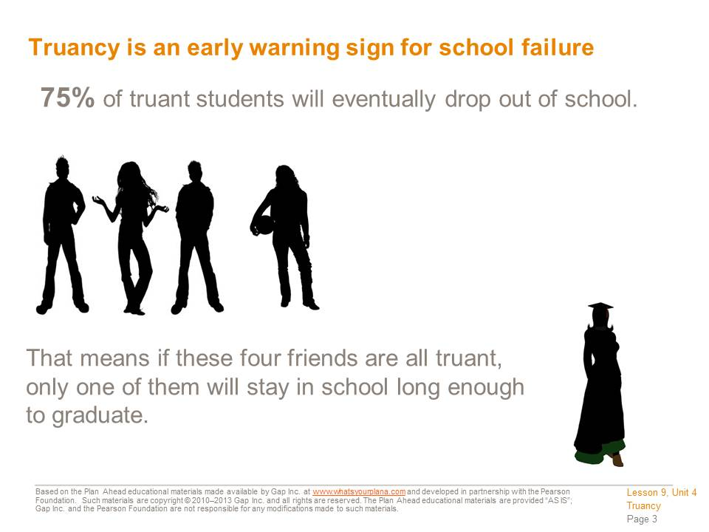 | Presentation notes

  People who are functionally illiterate probably did not stay in school long enough to graduate. People with limited or no literacy skills are more likely to struggle as adults, because they cannot read or write well enough to get a good job. They may also have a hard time finding a place to live or managing their money. All of these things can contribute to criminal behavior. | Presentation notes  Discuss the question on the slide. Help students to recognize the potential link between functional illiteracy and dropping out (someone who already has poor literacy skills may be more likely to drop out, but by dropping out, the person is unlikely to improve his/her literacy skills). Also help students to recognize the potential link between functional illiteracy and criminal behavior, as mentioned in the slide notes.

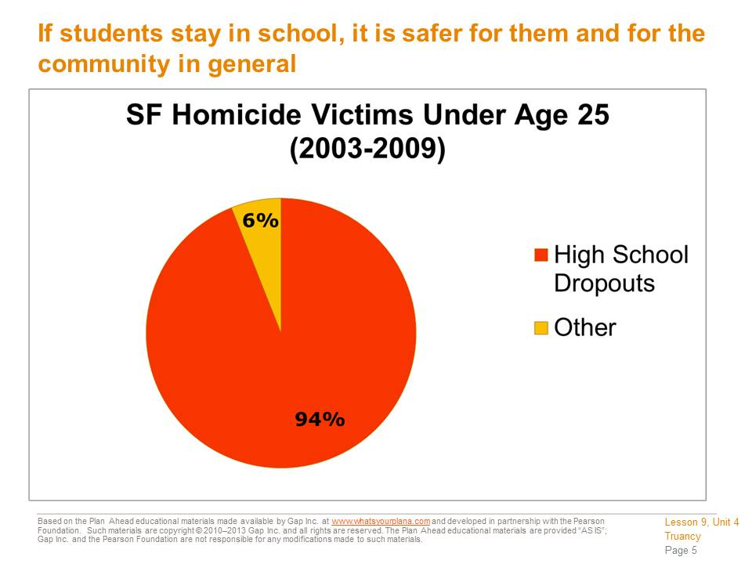  Facts from the San Francisco District Attorney’s Office:  - Between 2003 and 2009, 94% of homicide victims under age 25 were high school dropouts. This means that of all the people younger than 25 who were killed, almost all of them had dropped out of school.  - If 10% more students stayed in school until graduation, the number of murders and assaults in San Francisco would drop by 20%. | Presentation notes  Ask students: are you surprised by the statistics on this slide? Why or why not?  Guide students to recognize that these statistics don’t mean everyone who drops out of school is a bad person or a criminal. Some kids who drop out may get caught in the crossfire, even if they aren’t in a gang or doing anything criminal themselves. On the other hand, some dropouts find themselves joining a gang or participating in criminal behavior because they need money. In either case, the facts clearly demonstrate that students who drop out are at greater personal risk.

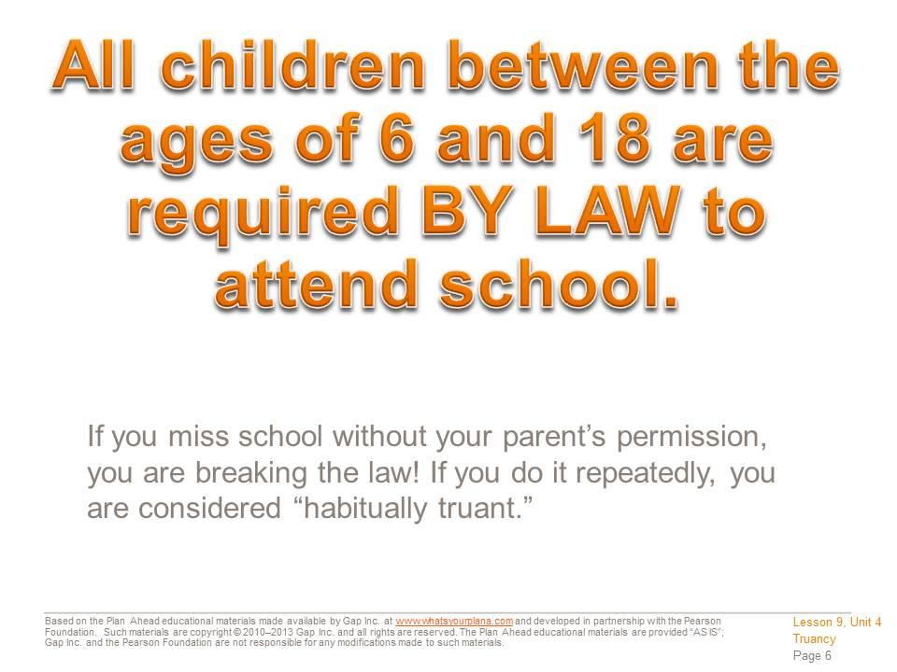 | Presentation notes  Review the concept of “excused absence” vs. “unexcused absence.” For more information, see the “Attendance Guidelines” section of the Student Handbook.  An excused absence is one where you have your parent/guardian’s permission to miss school for a specific reason. Your parent/guardian has to call the school or send a note with you when you come back to class.  Acceptable reasons to miss school include:  - Being sick  - To attend a doctor’s appointment  - To attend a funeral of a close family member  - If you are a parent, to attend an appointment for your child (i.e., doctor’s appointment)  It’s not okay to miss school to babysit, to go shopping, etc., even if your parent gives permission. That is considered an “unexcused” absence.

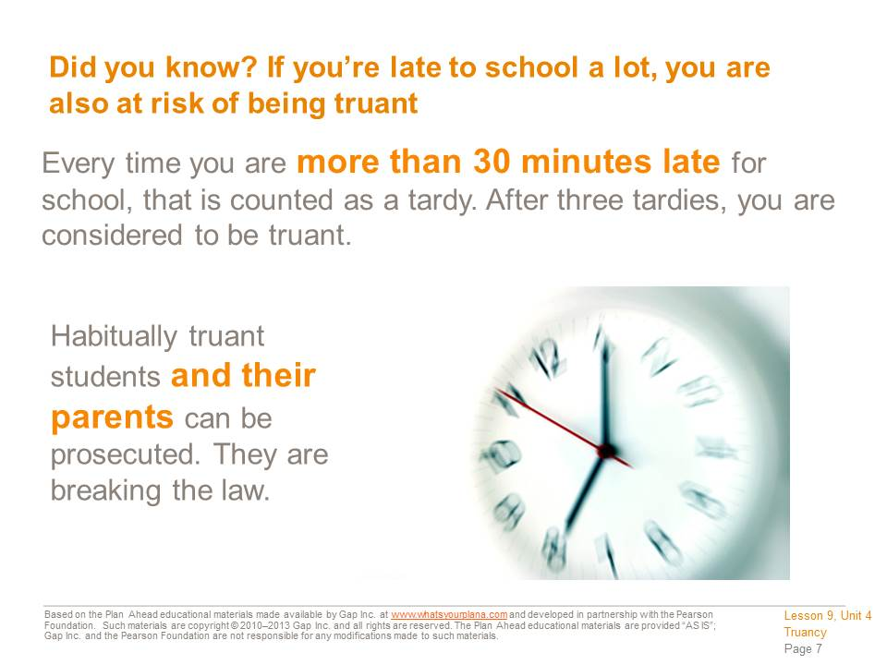 | Presentation notes

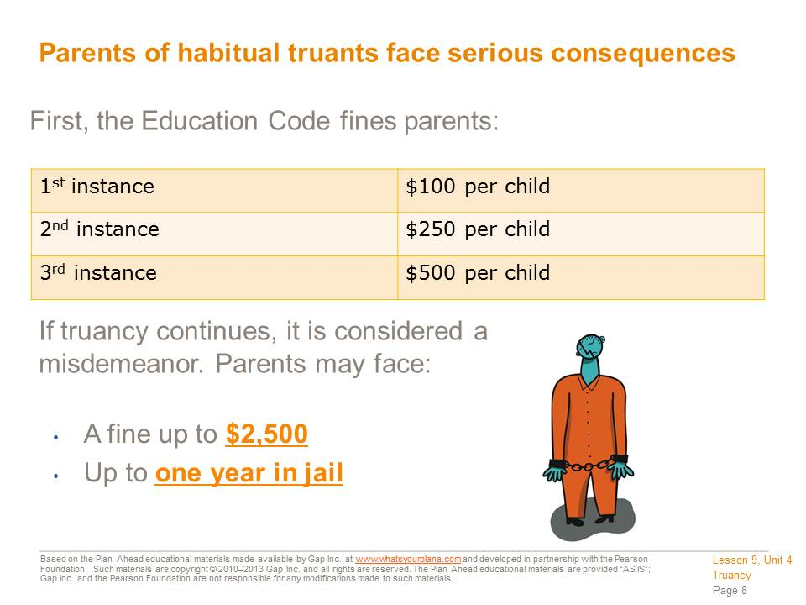 | Presentation notes

 | Presentation notes

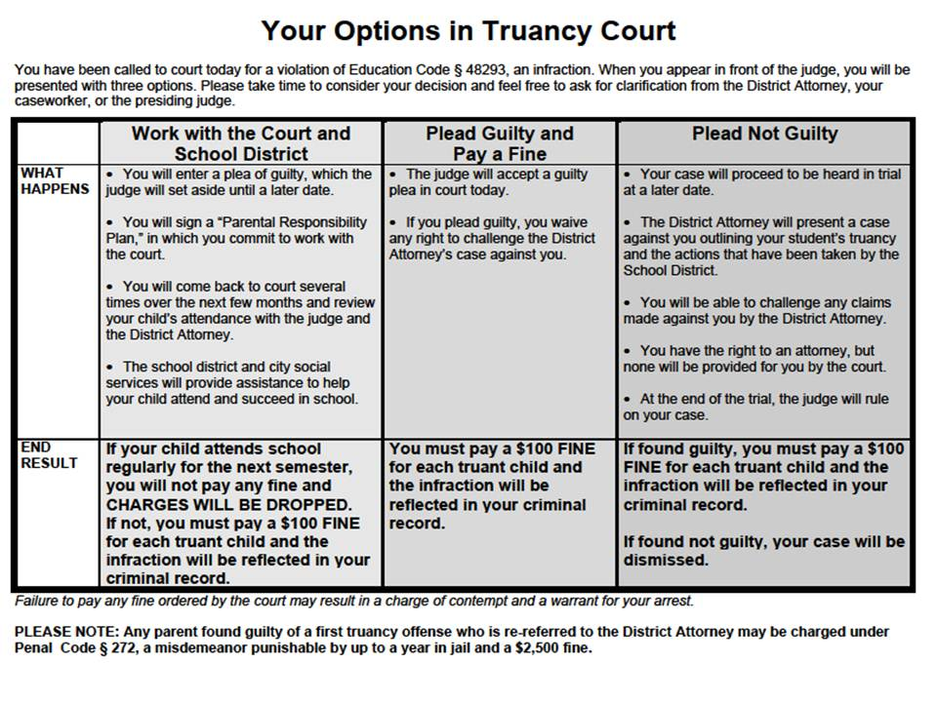  If parents are called to go to Truancy Court for a first offense, they get a sheet that looks like this. | Presentation notes  Give students time to read over the information on the slide. Then discuss the following questions:  If a parent works with the school district and the court, what does she need to do? Answer: Sign a Parental Responsibility Plan and have several meetings to check on the progress of the plan.  What happens if the parent chooses to work with the school district and court, but the student still doesn’t attend school regularly? Answer: Pay a fine; it goes on the parent’s criminal record.  What happens if the parent decides to plead guilty? Answer: Pay a fine; it goes on the parent’s criminal record.  If a parent wants to plead not guilty, what does he need to do? Answer: The parent will go to court. The DA will present the case against the parent. The parent will be able to respond to the case. The parent can have a lawyer if he wants. At the end of the case, the judge will rule.

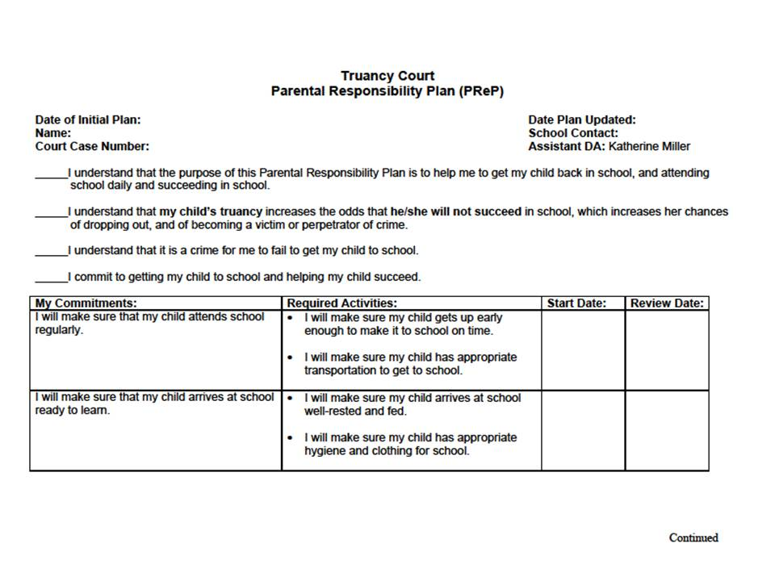  If parents agree to work with the District to solve the problem, they have to complete this Parent Responsibility Plan. The plan has specific goals with “review dates.” The parents have to prove they are meeting these goals by the dates written in the Review Date box. | Presentation notes  Ask students to think back to the three options they saw on the last slide. Which option would use this plan? Answer: Working with the school district and the court.  Ask students: are they surprised by any of the steps on the plan? Help them to recognize that sometimes simple steps (like setting the right time to get up or making sure there’s food for breakfast) can make a big difference.

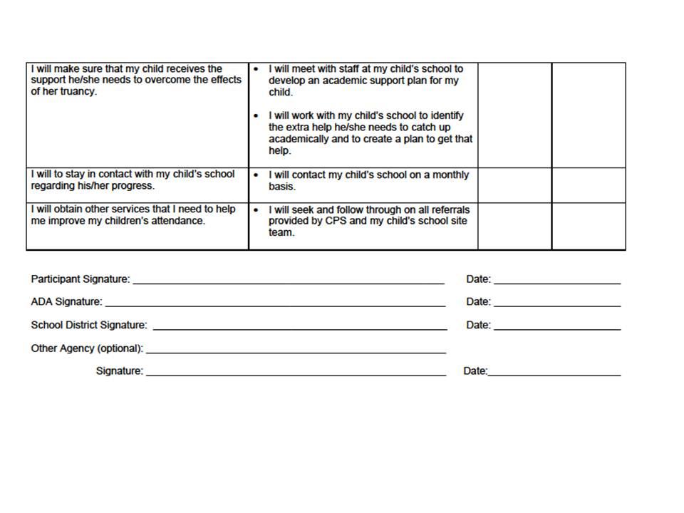  The plan has to be signed off on by an Assistant District Attorney and a representative from the school district, as well as by the parents. In some cases, Child Protective Services or other city agencies may also be involved. | Presentation notes

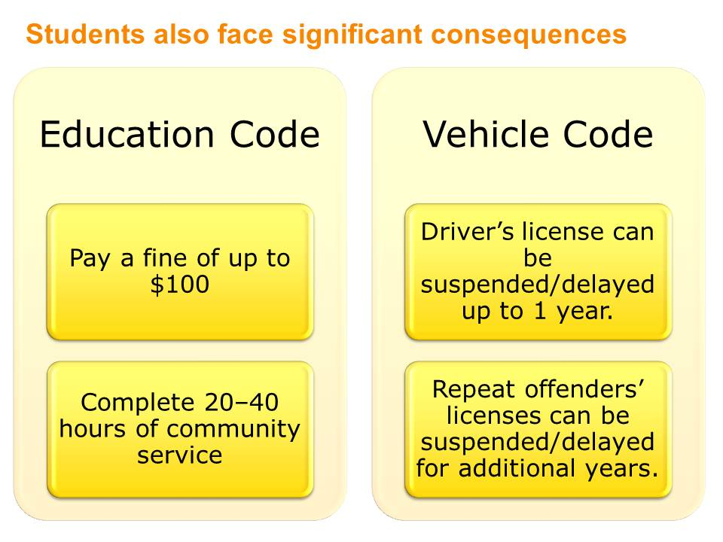  Older students, like you, also bear some responsibility for their truancy. Students can be punished with fines and community service requirements. Truancy can also have an impact on your ability to get a driver’s license, according to the Vehicle Code. | Presentation notes  Point out that so far, the presentation has focused on consequences for parents, but students face their own consequences, since by this time (high school), many students are responsible for getting themselves to school. Discuss the consequences on the slide and ask students: which of these consequences would matter the most to you?

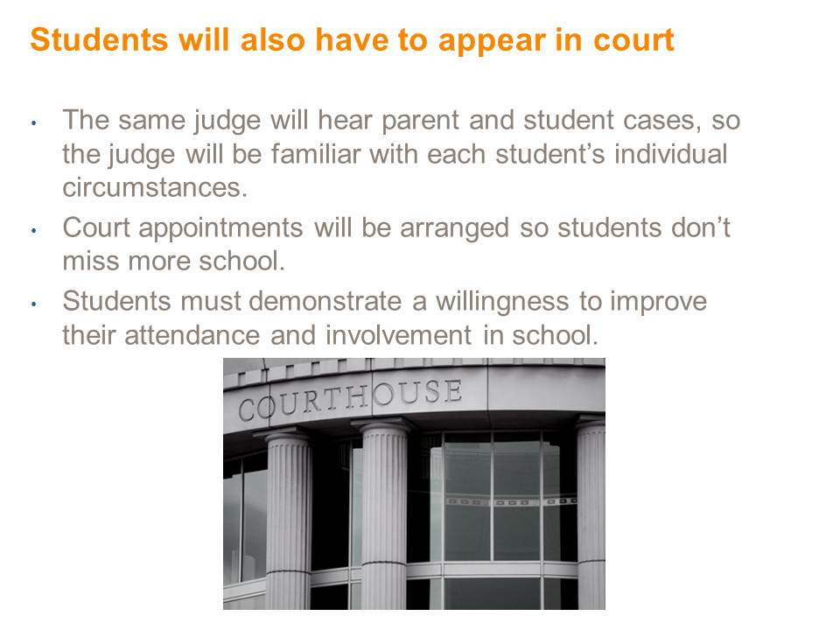 | Presentation notes

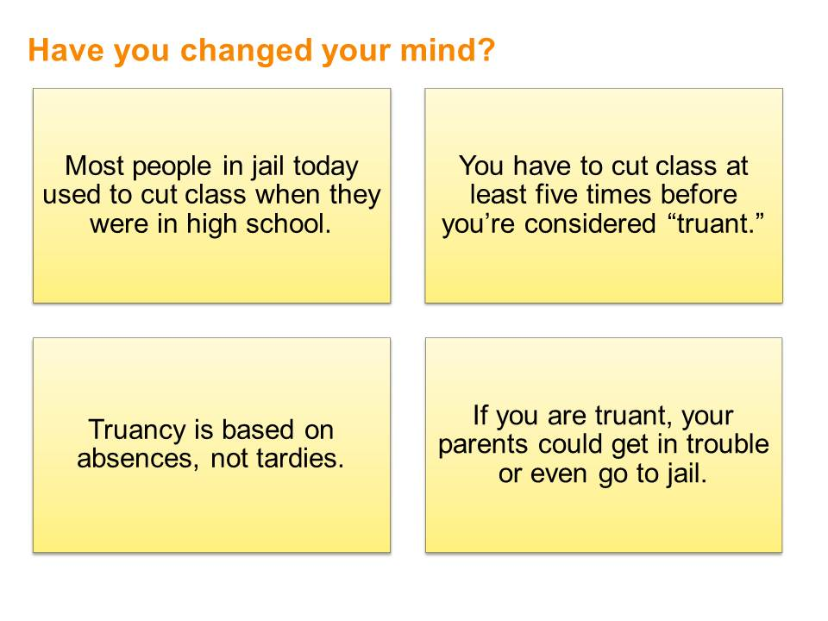  Now that you’ve seen the presentation, do you agree or disagree with these statements? | Presentation notes  Ask students: what did you learn from this presentation? Review the four statements and ask students to re-vote on each of them. Use this as a way to quickly check comprehension by looking for the following results:  - Students should agree with the first statement (Most of the people in jail…).  - Students should disagree with the second statement (Cutting class five times…).  - Students should disagree with the third statement (Based on absences, not tardies…).  - Students should agree with the fourth statement (Parents can get in trouble…).

Teacher Resource 9.5
Interactive Presentation 2 Notes and Instructions: Graduating from High School
Before you show this presentation, use the text accompanying each slide to develop presentation notes. Writing the notes yourself enables you to approach the subject matter in a way that is comfortable to you and engaging for your students. Note the ideas for fully engaging the students that are placed at key points in the “Notes” section.

Make It Local | The separate PowerPoint file will need substantial revision. It includes model content based on information provided by San Francisco Unified School District.
These notes are based on the model version of the presentation. You may need to modify the interactive suggestions based on your adjustments to the presentation content.

  What do you need to do to make sure you graduate?  First, learn about your school’s curriculum and requirements for graduation. Knowing what to expect makes it easier to plan your schedule. Yes, you have parents, teachers, counselors, and others available to support and guide you. Ultimately, though, you are your own best resource. The more you know about the system, the more control you will have over your academic life and your future.  In addition to the requirements presented here, find out about co-curricular activities such as sports and clubs after school. They can make the difference in how you feel about school, even though you don’t earn course credits for participating. You can also explore elective courses in subjects that really interest you. In short, knowing what your school offers can help you to make the most of your high school experience and to take responsibility for your own success! | Presentation notes  Begin by asking students: do you already know any of the requirements for graduation? Students with older siblings, for example, may be aware of some of the course and testing requirements—or they may have out-of-date ideas based on a relative or friend who graduated several years ago. Invite a few volunteers to share what they know. If no students raise their hands, reassure them— that’s why they’re going to see this presentation.  Alternately, if you already know your students’ familiarity with graduation requirements, you could ask for a show of hands of how many students are already involved in a co-curricular activity, and invite them to share which activities they do. Students may have joined a sports team, club activity, school band, or school play because they had friends involved, without realizing that this counts as an activity that can help them stay motivated in high school and as something they can list on college applications.

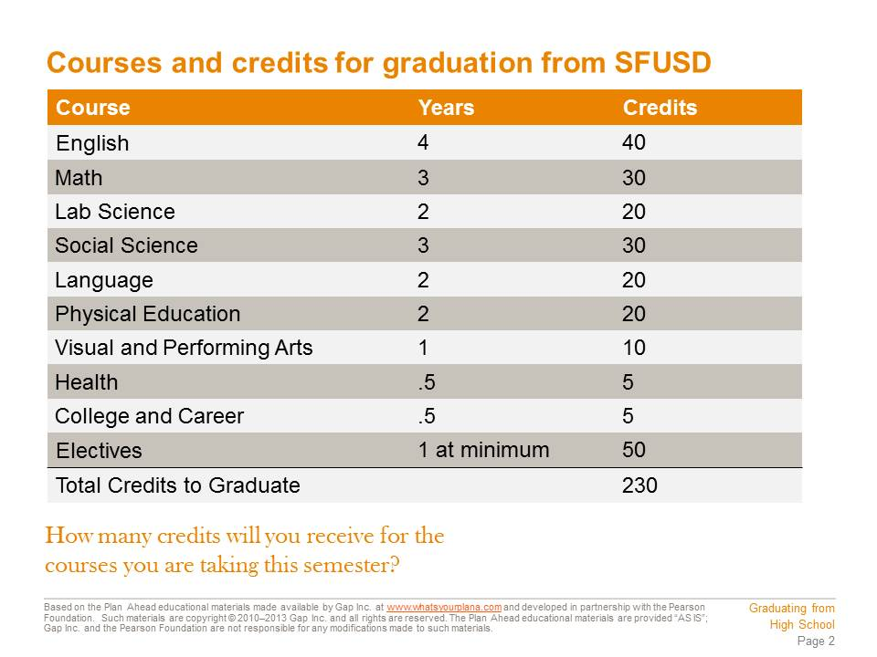  Every high school offers courses that are described in a course listing or booklet. This listing contains all of the departments in your school and what courses, or classes, you can take in each department. Examples of departments are English, Math, Lab Science (like Biology or Chemistry), and History (also called Social Science). You need to take a certain number of courses from each academic department in order to graduate from high school. All high schools in the San Francisco Unified School District have the same graduation requirements.  You can measure your progress towards meeting all of the graduation requirements a couple different ways. One is to see how many credits you’re earning. You have to pass the course with a D or better in order to earn credit for taking the course. Most courses are worth 5 credits per semester; you have to earn a minimum number of credits in each subject area. For example, you will need to take a minimum of four years, or 40 credits, of English courses and three years, or 30 credits, of math. |  | Presentation notes  It is important for students to understand the connection between a course and its department; students may not always recognize where certain courses belong. To help them develop this skill, call on a volunteer to name one course he is taking this semester. Call on a different volunteer to say which department she thinks that course belongs to. Some should be really obvious; some may be less so. Repeat this process a few times. Then ask students: is anyone taking a course and is not sure where it belongs? Guide students to recognize which department each of their current courses belongs to.
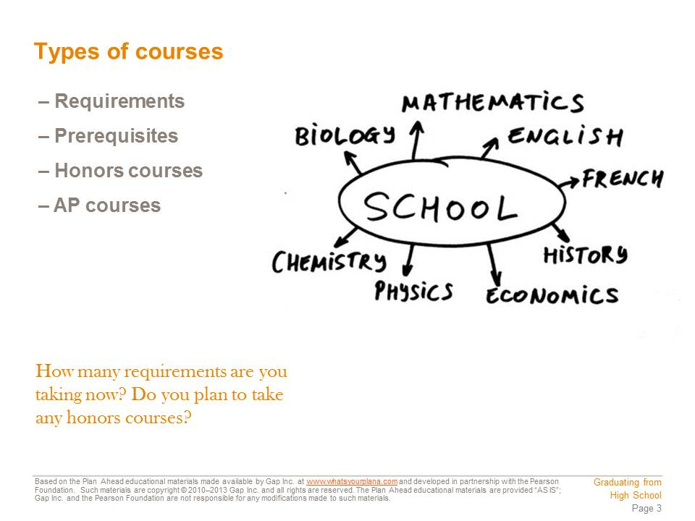  Courses vary in a few important ways.  Requirements are courses you have to take. Often you have to take them in a certain order, or sequence. For example, most students take algebra before they take geometry.  The courses you have to take first are called prerequisites. For example, you have to take two years of a language other than English, such as French. Suppose you don’t know any French. You have to take French 1 before you can take French 2; French 1 is the prerequisite for French 2.  Electives are classes you get to pick. Different schools offer different electives, from environmental science to acting. Electives are a good way to learn about a new subject that you’ve never explored before. To graduate, one of the electives you choose has to be a one-year advanced social studies/history, English, math, science, or visual/performing arts class that is not one of your required courses.  The courses you take in your first two years of high school prepare you for taking more advanced courses in your last two years. Some of these upper-level courses cover more material at a faster pace. These are called honors courses, and you have to get a good grade in the prerequisite course(s) in order to take them. | Presentation notes  Project this slide and then ask students to update their Cornell Notes.  Next, call on volunteers to answer the following questions:  - What is a prerequisite?  - What is an elective?  - What’s the difference between an honors course and a regular course?  Use these questions to check for understanding. You may also wish to point out that this type of information is what students should be including in their Cornell Notes.

  Some courses are so advanced that they are considered college level. These are called Advanced Placement, or AP courses. Colleges and universities look for students who take challenging courses, so you should consider taking honors and AP courses whenever possible.  If you take an AP class, you have the opportunity to take the AP exam. AP exams are national tests that are offered every May. Why would you want to take another big test? If you pass an AP exam with a good enough grade, you can get college credit. That means when you go to college, you will already have some of your college requirements handled. Depending on your score, you might be able to skip some college classes. Some people who take a lot of AP exams in high school and earn good grades on them are actually able to graduate from college faster! That can save you time and money! | Presentation notes  After students review the slide, ask: what are the key factors that make an AP class different from another type of class? Students should be able to recognize the following:  - It’s considered college level.  - It prepares you for the AP test.  - If you get a good grade on the test, you can earn college credit.  If your school has any specific policies about AP courses, make sure to share them with students at this point. (For example, some schools restrict the number of AP classes a student can sign up for simultaneously, or some schools restrict AP classes to juniors or seniors only.)

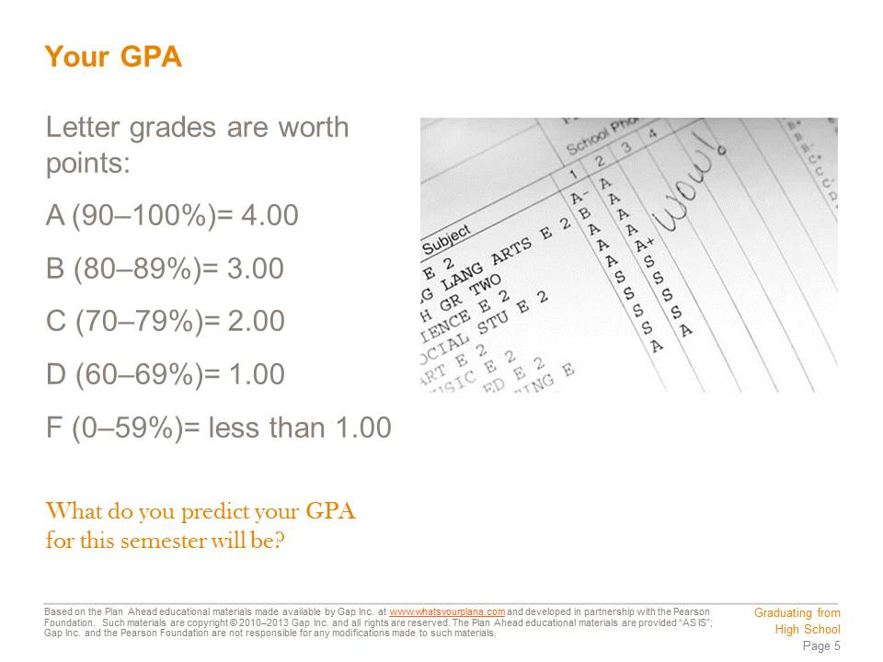  Every semester, you receive a report card showing what grades you got in each of the courses you took. Each letter grade is also assigned a number of points, from 4 to 0. So if you got a B in American History, the number of points you’d receive for that class is 3. These numbers are used to calculate your GPA, or grade point average.  Your GPA is listed on your report card. Schools have different methods for calculating GPAs, but all GPAs represent the same thing: the average of the total points you receive based on your letter grade. For example, a GPA of 2.5 means you are averaging between a B and a C letter grade.  AP courses are graded a little differently, because they are more advanced than a regular course. If you get a B in an AP course, you get 4 points towards your GPA instead of 3. In other words, a B in an AP course is the equivalent of an A in a regular course in that subject area. That’s why some students have a higher GPA than 4.0. | Presentation notes  After students review this slide, take time to demonstrate how they can calculate their GPA using your school’s formula. You may wish to use a hypothetical student with average grades so no real students feel forced to share their GPA.  Also make sure to point out another potential advantage of taking an AP class: the additional point for your GPA.

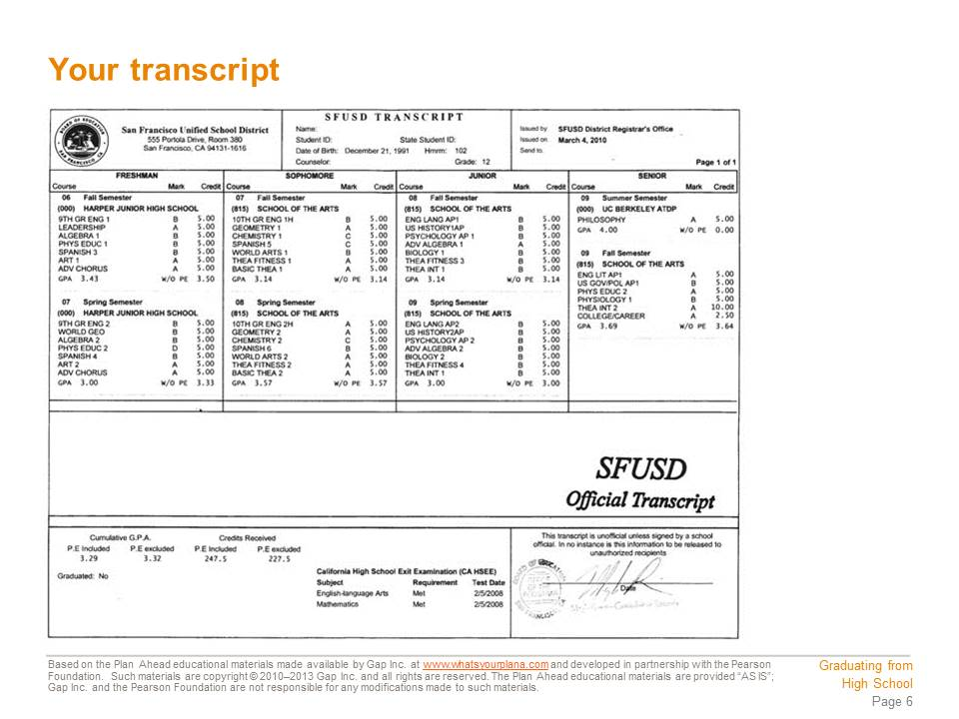  Your school also keeps track of this information for all four years of high school by building a transcript, or an official record of all of your coursework, for you. Transcripts are very important. Any school you attend after you graduate from high school—a university, a community college, a career school, an art school—will look at your transcript when deciding whether or not to admit you.  Transcripts include a lot more information than what courses you took, what grades you got, and your GPA. They show whether a course was a requirement or an elective; whether you took the most courses possible in a semester or whether you took as few as possible; and whether a course is honors or AP. | Presentation notes  Ask students to locate the following information on the transcript:  - Where did this person go to junior high school? (HARPER JR HIGH)  - Where did this person go to high school? (SCHOOL OF THE ARTS)  - What was this person’s cumulative GPA? (3.29)  - When did this person take the CAHSEE? Did this person pass or fail? (2008; PASS)  - Did this person take any AP classes? Name one. (YES—ENGLISH LANGUAGE, ENGLISH LITERATURE, US HISTORY, US GOVERNMENT, PSYCHOLOGY)  - How many years of science has this person taken? (3—CHEMISTRY, BIOLOGY, CURRENTLY IN PHYSIOLOGY)  - How many years of foreign language did this person take? (2—SPANISH)  You may wish to point out that this student is about halfway through his/her senior year at the time of this transcript—there are no spring semester senior year grades on the transcript. Point out that this is the way a transcript looks when it is first sent to a college you are applying to, because you will be applying while you are still finishing your senior year. Emphasize that colleges will also get another version of your transcript after you finish your senior year, so second semester senior year grades still matter to colleges.

  We are very lucky in California because there are so many public colleges and universities to attend. These are grouped into community colleges, California State Universities (CSUs), and the University of California system, or UC system for short.  Every university in the UC and CSU systems expects incoming students to have met certain academic requirements. These include passing a certain number of classes in different subject areas with a grade of C or higher. These are known as the a-g requirements. Completing the a-g requirements helps you become eligible to apply to the UC or CSU system and most other colleges too. For this reason, the requirements to graduate from high school include meeting the a-g requirements.  Images:  http://en.wikipedia.org/wiki/File:University_of_California_Seal.svg  http://en.wikipedia.org/wiki/File:Ucd_silo.jpg | Presentation notes  Give student time to update their Cornell Notes. Ask students: what are the a-g requirements? Suggest that this is something they should have included in their notes.  Ask students if they can name a school in the CSU or UC system. Students may be familiar with the CSU campuses in San Francisco, Sonoma, East Bay, or San Jose. Students may be familiar with UC schools in San Francisco, Berkeley, Davis, Los Angeles, or Santa Barbara.  If you have access to an interactive whiteboard, you may wish to project the following links, which include maps of each system’s campuses:  http://www.calstate.edu/datastore/campus_map.shtml  http://www.universityofcalifornia.edu/campuses/welcome.html

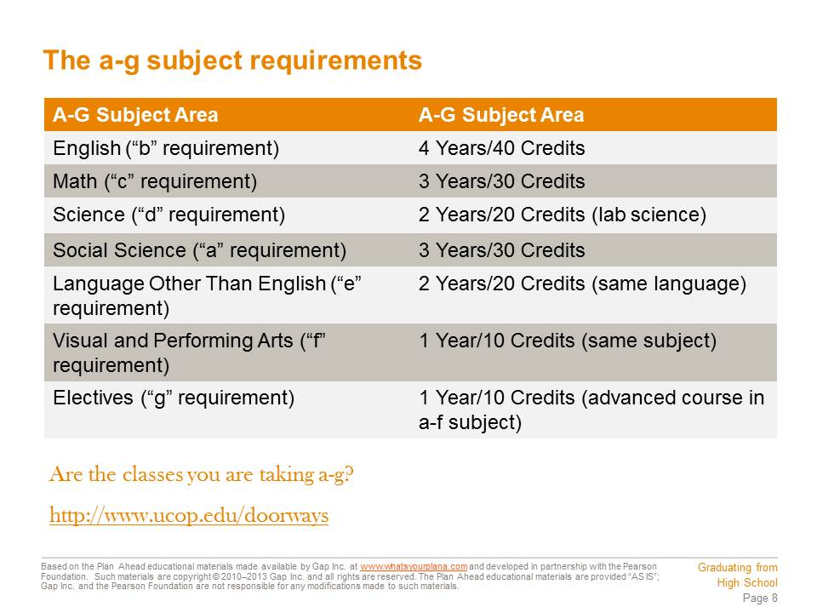  To meet the a-g subject requirements for graduation from a San Francisco high school, you have to earn a certain number of credits in seven different subject areas: social science/history, English, math, lab science, a language other than English, visual and performing arts, and college-prep electives.  The courses you can take at your school that meet the a-g requirements are also listed in your school’s course listings or in material that your teacher will give you.  To earn a-g credit for a course, you have to get a C or better. To graduate, you need a D or better. | Presentation notes  Make a point of emphasizing the difference between getting a good enough grade in a class to graduate (minimum grade: D) and getting a good enough grade to get a-g credit (minimum grade: C). Point out that at this point, students may not know where the want to go to college or what they want to do for a career, so it’s in their best interest to keep their educational options open—that means trying to earn Cs or better in all their courses.

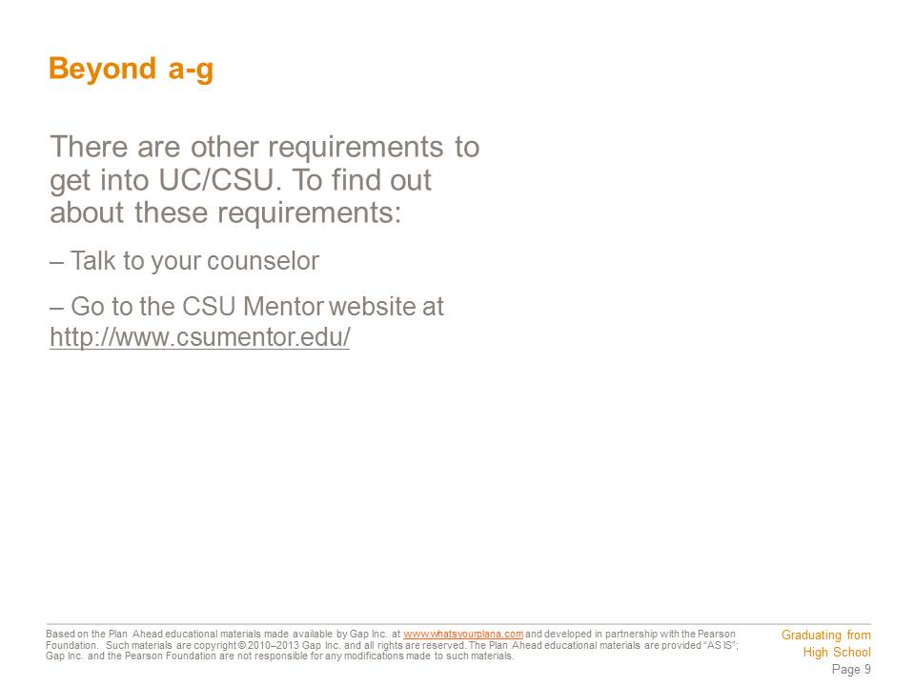 | Presentation notes

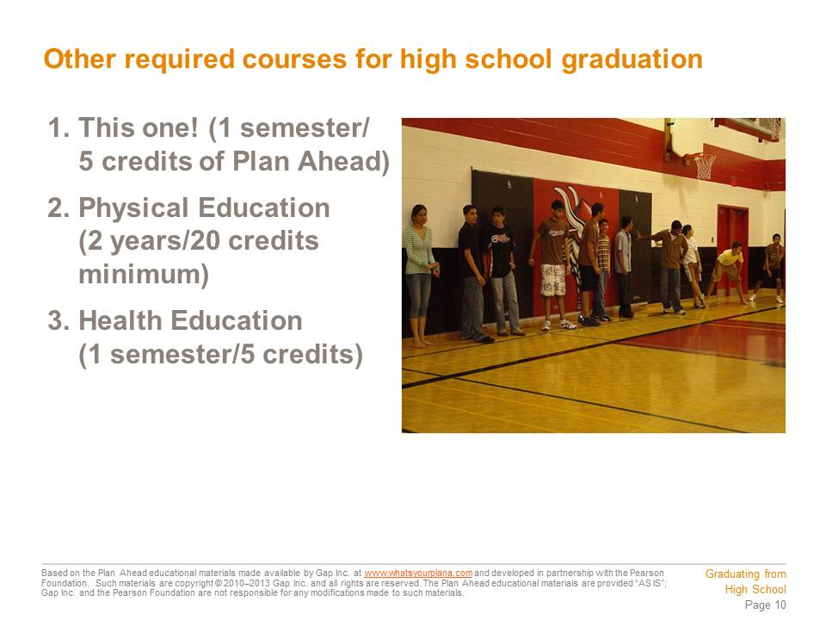  In addition to the a-g requirements, you must take this course. You must also take a semester of health education and a minimum of two years of physical education. California law requires two years of PE, plus a Fitness Test. Students who fail to pass the Fitness Test must retake the test every year until they pass and could be required to take up to four years of physical education. Students who pass the test in 9th grade may choose to take the minimum two years.  Image:  http://commons.wikimedia.org/wiki/File:BrownTown.jpg | Presentation notes  Give students a chance to update their Cornell Notes. Then call on a volunteer to name one of the other requirements mentioned on this slide (the Plan Ahead course, Health Education, 2 years of PE and a fitness test).

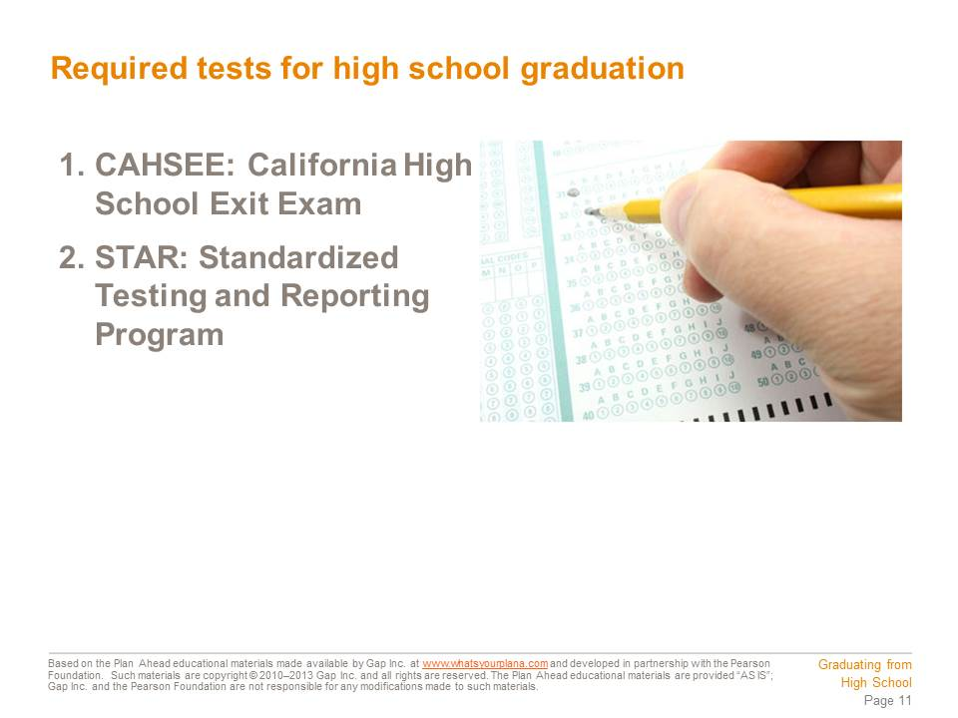  In order to receive a high school diploma, students must pass the California High School Exit Examination (CAHSEE). It’s a state law—all 10th graders take the CAHSEE in the spring semester. If you do not pass either or both parts of the CAHSEE (English Language Arts and Mathematics), you can take the test again in 11th grade and 12th grade.  Another state test is the Standardized Testing and Reporting Program, also known as STAR. The purpose of the STAR program is to measure how well students are learning the knowledge and skills students should have at each grade level in English/language arts, math, social science or history, and science. | Presentation notes  Ask students: what is the CAHSEE? Why is it important? Make sure students understand they must pass this test in order to graduate.

  NOTE TO TEACHER: Fill in this slide with information about the curriculum, pathways/academies, and support programs offered at your school for college and career preparation in 10th, 11th, and 12th grades. | Presentation notes

  It might seem as though there is an awful lot to do in order to graduate from high school. You just take it one step at a time and check in with your teachers and counselor to make sure you’re on track. Use the planning and organization skills that this course is helping you to develop. If you need help, ask for it! Your teachers want you to succeed and will gladly provide the support you need.  Remember: Graduating from high school is worth it! | Presentation notes  Give students time to update their Cornell Notes. Then ask: why is it worth it to graduate from high school?  Student answers may include: because they want a specific job that requires at least a high school diploma, because they want to attend college, etc.  If necessary, remind students of the statistics they saw earlier in this lesson about rates of imprisonment, unemployment, poverty, and lifetime earnings for high school dropouts vs. high school graduates. Emphasize that students can take control of their high school careers right now and set themselves on a path to future success!

Teacher Resource 9.6
Bingo Guide: Graduating from High School

Make It Local | Review the bingo cards (separate Word file) and the bingo clues in this document. Remove any terms that are not applicable to your students and/or community. Replace those terms with words or phrases that are applicable to your students and/or community. Prepare clues for the new terms.

Preparation
To play this game, each student will need a bingo card (see Teacher Resource 9.7) and a set of bingo markers or placeholders. You may use real bingo chips or squares of cardstock for the bingo markers—you might also have students make their own placeholders with scraps of paper.
Bingo Clues
Once students have their bingo cards and placeholders/markers, read the following clues/definitions aloud (in random order) to prompt students to identify each term (students may share answers) and then cover the appropriate term on their bingo cards with a placeholder.
- A course you have to complete first before you can take a course at a higher level. Prerequisite
- The units you earn for each high school course you complete; each course is usually worth 5 per semester. Credits
- California State law requires students to pass this test to graduate, which they take for the first time in tenth grade. CAHSEE
- This number represents the total of points for the letter grades you received divided by the number of classes you took. GPA
- A record of all the classes you have taken and the grades you received for them. Transcript
- The purpose of this test, which you take every year from second to eleventh grade, is to measure if students are at grade level for English/language arts, math, social science/history, and science. STAR
- The sequence of courses in seven subject areas required for high school graduation and for admissions to the University of California system as well as the California State University system. A-g requirements
- You took this type of inventory, which is designed to help you recognize the many different ways that you are smart. Multiple intelligences inventory
- AP stands for: Advanced Placement
- College-level courses offered to high school students to take while they’re in high school. AP courses
- Courses that are challenging and cover material quickly; they require high grades in earlier courses. Honors courses
- Duration of the Health Education course. 1 semester
- A person who works with students to help them select the courses to meet their graduation requirements. Counselor
- Number of credits you will earn for passing the Plan Ahead course. 5
- The university systems that require all entering students to have completed the a-g requirements. University of California and California State University systems
- Number of years of math you have to take to graduate. 3
- The letter grade D is represented by this grade point. 1.00
- The letter grade B is represented by this grade point. 3.00
- Math, English, science, and history are collectively known as: academic subjects
- These are activities that you can take after school, such as sports, music, or clubs. They don’t offer credit and do not take place during classroom time. Co-curricular activities
- You must take at least four years (or 40 credits) of this subject in order to graduate. English
- You have to take two years of PE and pass this test, or you will have to take more PE. Fitness
- The lowest grade you can receive in a course and receive a-g credit. C
- You need to take one year of this “f” requirement. Visual and performing arts

Teacher Resource 9.8
Assessment Criteria: My Four-Year Action Plan

Make It Local | These assessment criteria may require revision, depending on the changes made to the Four-Year Action Plan (Student Resource 9.7). Remove this callout and re-save the file before sharing the criteria sheet with students.

Student Name:______________________________________________________________
Date:_______________________________________________________________________

Using the following criteria, assess whether the student met each one.

 |  | Met | Partially Met | Didn’t Meet
The four-year action plan meets all a-g requirements in a logical order. |  | □ | □ | □
The four-year action plan maps when all other graduation requirements will be met, including required courses and tests, according to a realistic timetable. |  | □ | □ | □
The four-year action plan contains co-curricular activities that show a willingness to participate in a range of activities or a strong commitment to specific activities (such as sports or music). |  | □ | □ | □
The four-year action plan includes college admissions tests, scheduled for the appropriate academic years. |  | □ | □ | □
The four-year action plan is comprehensive, neat, legible, and presentable. |  | □ | □ | □

Additional Comments:
_____________________________________________________________________________
_____________________________________________________________________________
_____________________________________________________________________________
Teacher Resource 9.9
Key Vocabulary: Graduating from High School
These are terms to be introduced or reinforced in this lesson.
Term | Definition
Advanced Placement (AP) courses | College-equivalent courses offered at the high school level; AP courses follow the demanding curriculum established by the College Board and prepare students to take the AP exam and are weighted differently in the student’s GPA.
Advanced Placement (AP) exams | Exams offered for a fee by the College Board in over 30 subject areas. Students who score a 3, 4, or 5 on AP exams may earn college credits depending on individual college policies.
co-curricular activity | Also referred to as extracurricular, those enrichment activities that are not part of the regular school curriculum, do not offer credit, and do not take place during classroom time. Examples include: school clubs and organizations, dances, athletics, publications, community service, etc.
credit | The unit of measurement students receive on their scholarship records/transcripts for completed coursework; a student earns 5 credits for every course completed with a grade of D or better.
elective | A course that can be selected from the school’s curriculum; typically a minimum of one year of electives in an advanced a-f subject is necessary for graduation.
General Educational Development tests (GED) | A group of five subject tests which, when passed, certify that the taker has high school–level academic skills. The GED is sometimes referred to as a General Equivalency Diploma or General Education Diploma.
grade point average (GPA) | The numerical representation of achievement in coursework for a given semester (or cumulatively throughout high school), based on point values assigned to letter grades (e.g., A=4, C=2, F=0) and credits earned for each course. To get the GPA for any semester, multiply each letter grade by the number of credits earned for each subject. Add the total number of points for all of the subjects and divide by the total number of credits earned.
honors course | A course that provides subject acceleration, enrichment opportunities, and increased critical thinking skills to students who seek additional challenges and who meet entrance criteria (e.g., teacher recommendation, grade in previous coursework, test scores). In some cases these courses are weighted differently in the student’s GPA.
pathways | Programs available at a school to help students make the transition from school to college and career (e.g., career academies).
prerequisite | A course that must be completed before one can register for the next level.
requirement | A course that must be taken in order to graduate.
scholarship record | A record of final grades for courses completed or attempted; also known as a transcript. Once a ninth grader has earned a set of final grades for any courses attempted, the District starts a scholarship record for the student.
transcript | The same as a scholarship record; students should conduct a transcript evaluation with a counselor at least twice to determine which courses a student needs to fulfill the graduation requirements.  Note: An “official transcript” is formatted differently and stamped with the original seal of the Registrar.

Teacher Resource 9.10
Bibliography: Graduating from High School
The following sources were used in the preparation of this lesson and may be useful for your reference or as classroom resources. We check and update the URLs annually to ensure that they continue to be useful.
Print
Covey, Sean. The 6 Most Important Decisions You’ll Ever Make. New York: Fireside, 2006.
High School-College-Career Handbook, 2007-2008. San Francisco: San Francisco Unified School District Pupil Services Department, 2007.
Lapan, Richard T. Career Development Across the K-16 Years. Alexandria, VA: American Counseling Association, 2004.
Online
America’s Promise Alliance, http://www.americaspromise.org/ (accessed July 11, 2013).
Bridgeland, John M., John J. Dilulio, Jr., and Karen Burke Morison. “The Silent Epidemic: Perspectives of High School Dropouts.” Civic Enterprises, March 2006, http://www.gatesfoundation.org/united-states/Documents/TheSilentEpidemic3-06FINAL.pdf (accessed July 11, 2013)
“Cities in Crisis: A Special Analytic Report on High School Graduation.” EPE Research Center, April 1, 2008, http://americaspromise.org/~/media/Files/Our%20Work/Dropout%20Prevention/Cities%20in%20Crisis/Cities_In_Crisis_Report_2008.ashx (accessed July 11, 2013).
Dillon, Sam. “Study Finds High Rate of Imprisonment Among Dropouts.” New York Times, October 8, 2009, http://www.nytimes.com/2009/10/09/education/09dropout.html (accessed July 11, 2013).
“New Approaches to Truancy Prevention in Urban Schools.” ERIC Digests, September 2003, http://www.ericdigests.org/2004-2/truancy.html (accessed July 11, 2013).
Pytel, Barbara. “Dropouts Give Reasons: Why Do Students Leave High School Without a Diploma?” Suite101, November 4, 2006, http://educationalissues.suite101.com/article.cfm/dropouts_give_reasons#ixzz0dDQUE8x9 (accessed July 11, 2013).
Thomas, Pierre, and Jack Date. “Students Dropping Out of High School Reaches Epidemic Levels.” ABC News, November 20, 2006, http://abcnews.go.com/TheLaw/story?id=2667532&page=1 (accessed July 11, 2013).
“Webinars: Ninth Grade Transition, Dropout Prevention, Early Warning Systems, English Language Learners.” National High School Center, http://www.betterhighschools.org/webinar/default.aspx (accessed July 11, 2013).

