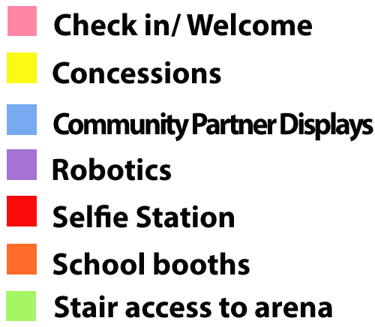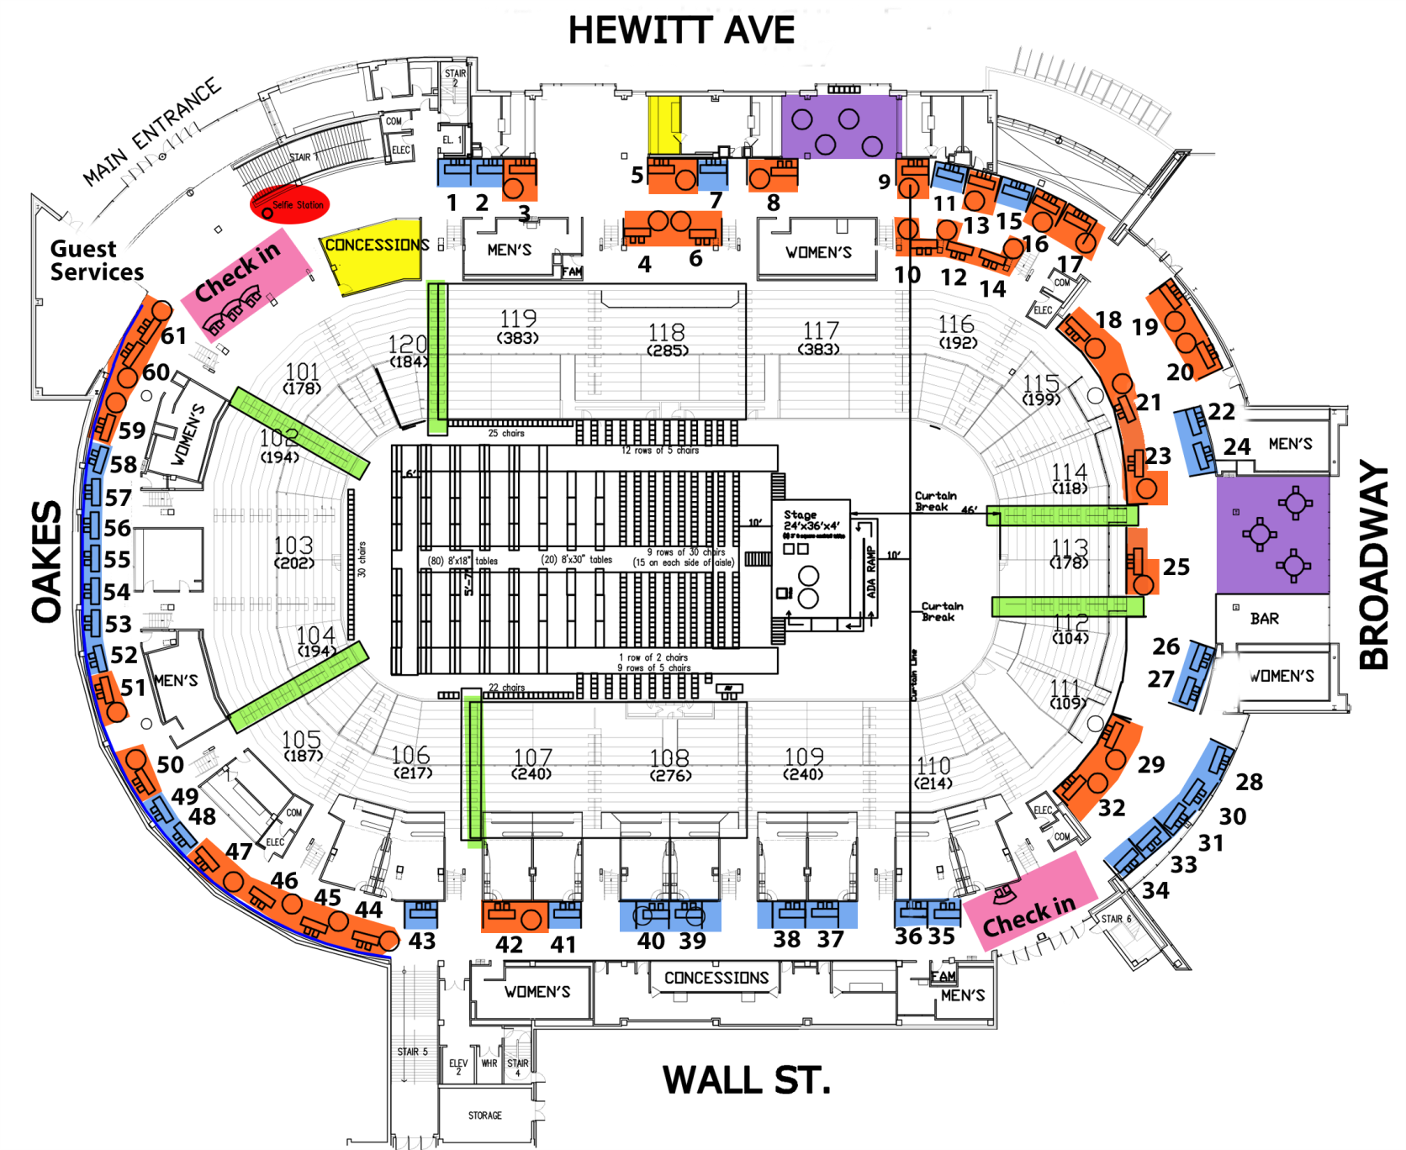

K- Port Gardner Parent Partnership 10

**High Schools**Cascade 19 Everett 51  
H.M. Jackson 32  
Online H 5  
Sequoia 9

Mill Creek 42  
Monroe 21  
Penny Creek 3  
Silver Firs 50  
Silver Lake 23  
View Ridge 44  
Whittier 16  
Woodside 8

**Elementary Schools**Cedar Wood 46  
Emerson 20  
Forest View 18  
Garfield 59  
Hawthorne 4  
Jackson 29  
Jefferson 14  
Lowell 12

**Middle Schools**Eisenhower 25  
Evergreen 17  
Gateway 6   
Heatherwood 45  
North 47

Assistive Technology 13  
Biotechnology 53-55  
Environmental Systems Design 37  
Learning & Information  
 Technology Services 60-61

Robotics 

Absolute Manufacturing 58

Boeing 39-40

Clean Energy Institute 26

Everett Community College 31

Everett Community College AMTEC 28-30

Everett Fire Department 1

Everett Parks & Recreation 27

Hewlett Packard 35

Imagine Children’s Museum 36

PACCAR 2

Providence 24

Reid Middleton, Inc. 43

Sea-Lect Plastics & AJAC 56-57

Snohomish Conservation District 38

Snohomish County PUD 41

Snohomish County Sheriff 33-34

Structural Engineers Association   
of Washington (SEAW) 48-49

US Army 7

UW Plant Biotechnology 52

WSU North Puget Sound 15

COMPETITION

**Community Partners**

**Everett Public Schools**