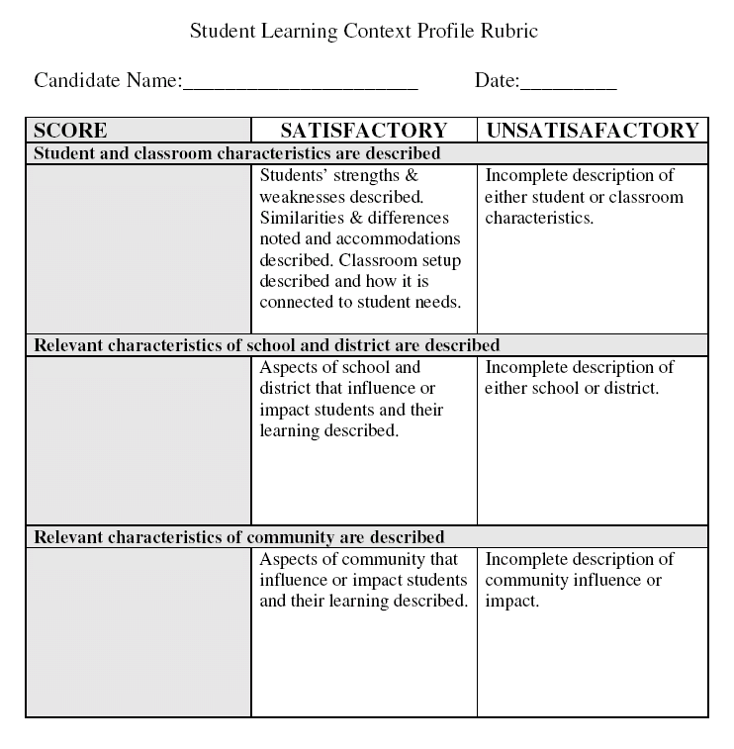
Unsatisfactory |  | Satisfactory
In the Game | Basic | Proficient | Advanced
- Description of context is attempted but key and/or relevant information is missing or unclear  - Context is not connected to teaching and learning | - Description of context is clear but is often only generalizations without clear evidence  - Context is not well connected to teaching and learning | - Description of context is clear and supported with evidence  - Context is connected to challenges for learners but reader must often work to make connections regarding context’s influence on teacher’s actions | - Description of context elaborates the relationship between community, district/school and classroom  - Context is clearly connected to the needs of learners and the response required of teacher to those needs

