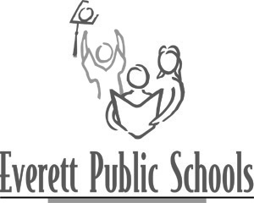

October 2008

Background information:
During school year 2008-09, Everett Public Schools Interim Superintendent Karst Brandsma is the school district’s chief executive. He was named Interim Superintendent by the district’s board of directors and is acting in that capacity through the end of June 2008.

The school board is currently conducting a search for a Superintendent. The board anticipates having a new superintendent hired by spring of 2009 and beginning work on July 1, 2009.

The first step of the board’s superintendent search process is asking for public comment and opinion about the qualities and attributes considered most important in the district’s education leader. To begin the conversations about those qualities, the board has drafted the following list.

The board seeks feedback about these qualities through:
- a series of public meetings as outlined in an October 14, 2008 news release
- a dedicated phone line* where members of the public may leave messages – 425-385-7878
- a dedicated e-mail box* where members of the public may send comments: superintendentsearch@everettsd.org*
- an online survey* launched on October 14, 2008 which will ask those who respond to evaluate the importance of various leadership qualities of a new superintendent

* The phone line, e-mail box and online survey will all be available for your comments until noon on Friday, November 7. The board will use your comments to write a superintendent profile they will use to advertise the position in November, December and early January.

Everett Public Schools Board of Directors’
Draft list of characteristics and attributes for the district’s next superintendent

- First and foremost, a sense of urgency and a passion for educating each child, for improving student achievement among all groups of students and for engaging all families and communities in supporting the success of our students.

- Second, the ability to embrace, support and realize our existing strategic plan and the willingness to respect the work that has been done and is ongoing in the district.

- Third, leadership qualities including:
- vision,
- orientation toward results,
- consensus-building and communication skills, and
- integrity, honesty and trustworthiness.

(next page, please)
Specific skills and qualifications should include:
- experience with strategic planning processes,
- expertise in continually improving our education system,
- ability to establish and develop collaborative relationships with all parents, our diverse community and our staff to educate students,
- respecting and valuing racial and cultural diversity and the ability to communicate effectively with diverse populations,
- developing and engaging high-quality staff and building cohesive high-performing teams,
- willingness to be an active participant in the community on behalf of Everett Public Schools,
- ability to develop and implement effective communication and marketing strategies for our district,
- clear focus on ensuring accountability at all levels, and
- willingness to commit to the position for five years.

