News Release
Everett Public Schools
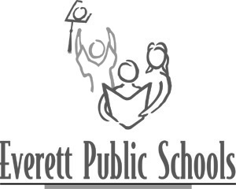
May 8, 2009
For more information:
Mary Waggoner, 425-385-4049

School board sets public budget comment session for June 1

Everett Public Schools’ Board of Directors invites parents, staff and community to visit with them about the school district’s budget challenges. The meeting, organized so that participants will have opportunities for one-on-one conversations with at least one board member, takes place Monday, June 1 from 5 to 7 p.m. at the district’s Educational Service Center at 4730 Colby Ave., Everett.

“Each summer we set a budget for the upcoming school year that relies upon millions of dollars of local and state tax support. This year, Everett, like all districts in the state and nation – like our families and local businesses – is facing a financial challenge unlike any in recent memory,” said Board President Sue Cooper in her invitation to the public. “We hope district citizens will come talk to us about what they value in our schools and what they believe are the budget priorities for next year and into the future.”

Everett School District is faced with cutting more than $7 million from the budget for school year 2009-10.

---end---

