News Release
Everett Public Schools
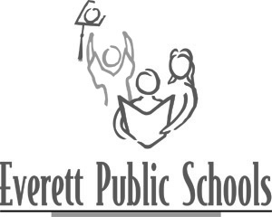
June 3, 2009
For more information:
Mary Waggoner, 425-385-4049
Cynthia Jones, 425-385-6200

Senator Paull Shin to visit Emerson Elementary School on June 8

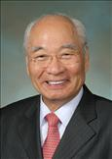
Senator Shin is an advocate for education, and visiting a school to meet children is one of his favorite activities. For students at Emerson Elementary school, Monday, June 8, will begin with a 9:30 a.m. message from Senator Shin about the importance of education and how powerful an education can be for anyone from any background.

Emerson’s music teacher, Lily Fung, contacted the Senator’s office during this winter’s legislative session to extend an invitation for him to visit the school. Fung is a Mukilteo resident which is represented by Shin. He was pleased with the invitation and promised to visit after the session in Olympia ended.

Shin’s education in the United States began when he was adopted during the Korean War by an American GI. Shin first earned a GED and then went on to earn a Master of Public and International Affairs, Master of Arts and finally a Ph.D. from the University of Washington. After 31 years of teaching at the college level, he retired to embrace public service. Senator Shin was elected to the Washington State Senate in 1999. Before that, he served in the House of Representatives from 1993-1994. This session, he is serving as Vice President Pro Tempore which presides over floor action in the absence of the Lieutenant Governor and President Pro Tempore.

Emerson’s principal, Cynthia Jones notes, “Senator Shin has an inspiring life story about overcoming obstacles and the importance of education. Emerson students will benefit from hearing about his experiences learning to speak English and overcoming discrimination, as well as his message that success is possible if you are willing to work hard.”

---end---

