News Release
Everett Public Schools
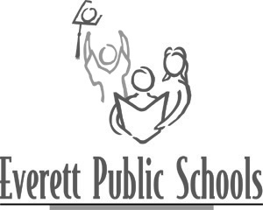
June 4, 2009
For more information:
Mary Waggoner, 425-385-4049
Mary Ann Stine, 425-385-4081

Modeling with Mathematics : A Bridge to Algebra II text considered for new high school math course
A mathematics course that offers students an exciting new perspective on mathematics, Modeling With Mathematics develops algebra concepts through real-life topics such as, business, forensic science , financial literacy and other important real-world examples. This mathematics poses problems real people encounter in their jobs and lives. Mathematical modeling and a data-driven approach to solving functions helps students deepen their mathematical skills and maturity. Modeling With Mathematics: A Bridge To Algebra II has been designed for students who have completed Algebra I or Algebra I and Geometry but need review practice and motivation to succeed in Algebra II. In addition, the course gives students a look ahead to many Algebra II topics.
This course will be offered this upcoming school year for students who need to improve their Algebra II skills prior to enrolling in Algebra II with Trigonometry
This text will be discussed at the June 9 school board meeting and again at the June 23 board meeting. If you are interested in examining this text, please call or e-mail Curriculum and Instruction Director, Mary Ann Stine at 425-385-4081 for an appointment no later than Friday, June 26.
---end---

