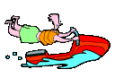
LITERARY ELEMENT --- CHARACTER

CHARACTER | Major or Minor? Why? | Description of the Character | Character’s words, thoughts, and/or actions

