Rainforests

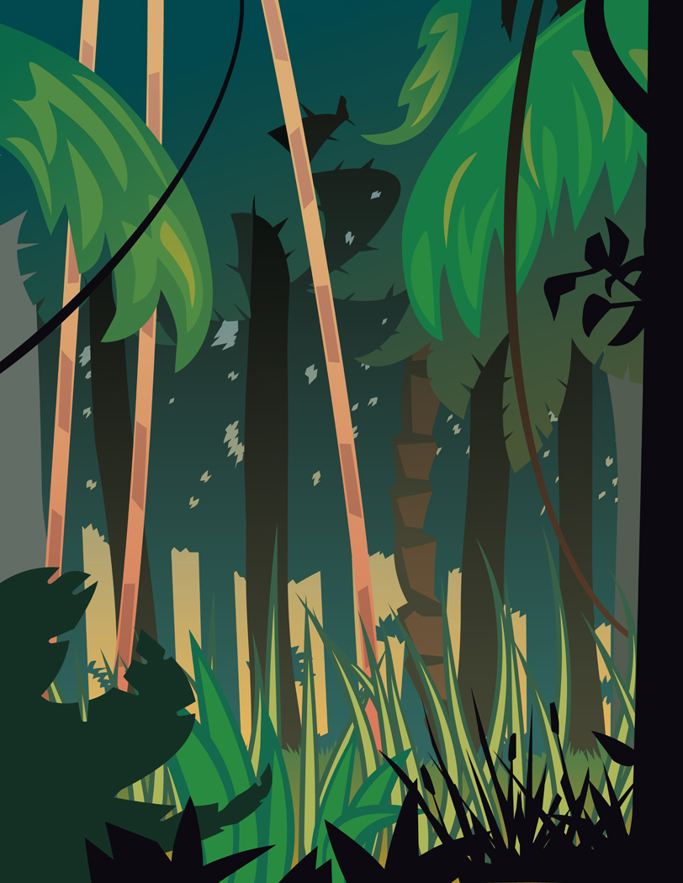
What is a rainforest?
A rainforest is another name for jungle. It grows in places which have plenty of rain, good soil and protection from winds. The trees in rainforests are large and grow so close together that very little light can penetrate through the leaves. The dense cover of foliage formed by the trees is called a canopy. Because of this canopy, rainforests are shady places which make it impossible for grass or small flowering plants to grow. Instead, the ground is covered by fallen leaves, rotting logs, masses of ferns, moss and lichens. Ferns also grow on tree trunks, fighting for space with jungle vines that twist around one another and form loops and swings.

For over one hundred million years, the rainforests have been like a living museum. One can find plants and animals there that have disappeared elsewhere in the world. Due to rapid deforestation, our rainforests are now in danger. The problems of the disappearing rainforests come from loss of trees due to farming, logging, ranching and new development.

What is the author’s purpose for writing the selection? Provide one detail from the selection to support your answer.

