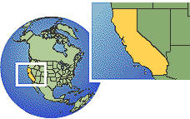
California Attractions
Southern California is known for its tourist attractions and its theme parks. People come from all over the world to get a look at Hollywood, and such things as the "Walk of Fame" where many celebrities’ names are found on gold stars on Hollywood Boulevard. Tourists are also attracted to the area with hopes of catching sight of the movie stars who live in the hills surrounding Los Angeles. Many visitors come to shop in the glamorous shops on Rodeo Drive in Beverly Hills. Among the theme parks that attract visitors are Disneyland in Anaheim, Knott’s Berry Farm, Magic Mountain Amusement Park, and Raging Waters Park. Folks who want to combine tourist attractions and theme parks can visit Universal Studios which offers both.

Giants of the Sea
A humpback whale is breaching – jumping almost clear out of the water and then crashing down in a huge spray of foam. The humpback whale is longer than a big bus and heavier than a trailer truck. Some great whales are even larger. Just the tongue of a blue whale weighs as much an elephant. From tip to tip, the flukes of a great whale are longer than a tall person. Whales are the giant animals of the world.

