Ken Griffey, Jr.
Professional Baseball Player

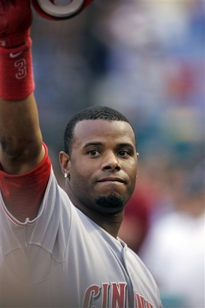
His teammates like to call him "Junior," but Ken Griffey Jr.'s talents are anything but minor. A hard-hitting center fielder for the Seattle Mariners until 2000, Griffey was a significant force behind that team's emergence as an American League division champion. He can dominate on offense or defense, and his engaging personality has brought him widespread fan approval in a time when most major league baseball players are perceived as spoiled and arrogant. Atlanta Journal and Constitution reporter Terence Moore has called Griffey "the Hank Aaron, Willie Mays and Roberto Clemente of our time," and Sports Illustrated correspondent E. M. Swift described Griffey as "the kind of player after whom babies and candy bars are named." In 2000, Griffey dismissed his potential to negotiate an extravagant contract as a free agent and returned instead to Cincinnati to play for his hometown team, the Reds, for a comparatively modest sum of $116.5 million over nine years.
Tagged as a top-level prospect when he was only 17 years old, Griffey joined the major leagues in 1989 at the tender age of 19. Baseball was in his genes: his father, Ken Griffey Sr., was a baseball superstar in his own right and was still an active player when his son joined the American League. The Griffeys have made history as the first father-son tandem to play major league baseball simultaneously.
The same year George Kenneth Griffey Jr. was born, his father signed to play baseball with the Cincinnati Reds organization. The demands of major league baseball are not necessarily compatible with fatherhood. Baseball players travel frequently and pursue their trade at odd hours. They work weekends and evenings. Nevertheless, Griffey recalled in the Chicago Tribune: "My dad was a dad first and a baseball player second." The elder Griffey taught his sons to hit a baseball as soon as they could hold a bat. He took them to Reds batting practice, where they hung out with the likes of Pete Rose, Johnny Bench, and Tony Perez. When the Reds played in the World Series in 1975 and 1976, young Griffey looked on from the best seats in the stadium. "I watched my dad play for years," he told People. "I talked to him every day about the game. There isn't one thing I've seen so far that he hasn't told me about beforehand."
It was talent, and not family connections that enabled Griffey to join Cincinnati's competitive Connie Mack League, a summer amateur program composed mostly of high school graduates. Even though at 16 he was among the very youngest of the players, Griffey was such a success in the league that his team advanced to the Connie Mack World Series--and he hit three home runs in the championship match. He also played high school baseball and was such a good running back with the Moeller High School football team that he was offered a football scholarship to the University of Oklahoma. He turned the scholarship down and made himself available for the 1987 baseball draft. Defending his decision, he told the Chicago Tribune that baseball "is a lot safer and you last longer."
Griffey was the number one pick in major league baseball's 1987 amateur draft. He was chosen by the Seattle Mariners' organization and signed with a $160,000 bonus. In a show of youthful bravado, the 17-year-old player announced that he would make the major leagues within two or three years. No one expected him to live up to that boast--even his father had spent four-and-a-half years on farm teams. Nevertheless, the exuberant Griffey Jr. began his professional career in Bellingham, Washington, batting .320, hitting 14 home runs, and completing 13 steals.
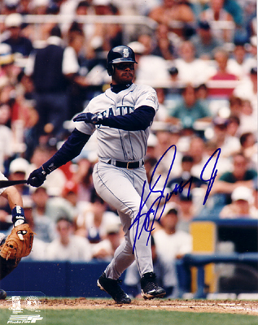
As the 1989 spring training season began, Griffey was determined to find a spot on the Seattle Mariners' roster. Serious and determined, he studied the opposing pitchers, practiced his fielding diligently, and wound up batting .359 with two home runs and 21 runs batted in during spring training games. Sure enough, he earned a place on the team. When he took the field for his first major league game, he was 19--one of the youngest men ever to make the majors.
Griffey put the Mariners on the baseball map in 1990, batting .300 and earning his first of ten consecutive Gold Glove awards. He also became the second youngest player ever to start an All-Star Game. That same season saw both Griffeys playing for the Mariners-- a historic first for baseball that may never be repeated. Griffey Sr. joined the Mariners late in the season after being released by the Reds.
By 1992, the days of father and son playing for the same team were over, and the era of Ken Griffey Jr. had begun. In 1992, Griffey batted .308, hit 27 home runs, and was named Most Valuable Player at the All-Star Game after turning in a three-for-four evening with a home run. He also charmed fans and the media alike with his willingness to grant interviews and his obvious love for baseball.

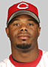
Griffey signed to play for the Mariners through the 1996 season and extended through 2000. He expressed little interest in leaving Seattle until he was offered a contract with the Cincinnati Reds in 2000. Griffey, having moved his wife and children from Seattle to Orlando, Florida, felt eager above all to move closer to both his home and his roots.
Because of his all-around excellent play, he was a perennial participant in the All-Star Game, particularly during the 1990s. Junior has led his league multiple times in hitting categories and was awarded Gold Gloves for his defensive excellence from 1990 to 1999. In 1997, he won the American League Most Valuable Player award, hitting .304, with 56 home runs and 147 runs batted in.
While playing with Seattle, Griffey was a 9-time American League Golden Glove winner, the 1992 All-Star Game MVP, 1997 AL MVP, 1998 ESPY co-winner for Male Athlete of the Year, and was named to the All-Century team in 1999.
On June 24, 2007 in an interview on FSN Northwest, Griffey stated that he would like to end his career as a Seattle Mariner and that he feels that he owes it to the fans of Seattle. “Would I do it? Yeah. I think for the simple reason that this is the place where I grew up and I owe it to the people of Seattle and to myself to retire as a Mariner.”

Selection from- http://www.answers.com/topic/ken-griffey-jr

