News Release
Everett Public Schools
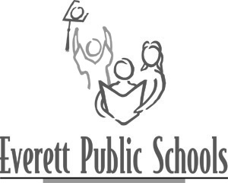
June 18, 2009
For more information:
Mary Waggoner, 425-385-4049

Madison and Silver Lake earn $2,300 for improved student achievement

This week, Madison and Silver Lake elementary schools’ principals, Mark Toland and Mary O’Brien, learned that their work to improve how students are learning is recognized through the No Child Left Behind program and rewarded with $2,335.

Officially called the “Title I, Part A Improvement Award,” the honor and welcome funding lauds the school because they are:
- Title I schools making Adequate Yearly Progress (AYP) for three consecutive years, from school year 2005-06 through 2007-08. (The Title I designation is for schools with a large population of students from low income families.)
- Making improvements and significant gains across subcategories of students – Asian, African American, Hispanic, Native American, Special Education, English Language Learners and Caucasian.

When presenting the awards, Jami Peterson of the Office of Superintendent of Public Instruction said, “It is not often that I have the opportunity to provide a monetary award to our schools for their outstanding efforts in working with our children. I thank you and your entire staff for the great work you have done in supporting your students.”

---end---

