Lesson 2

Planning and Prioritizing

Student Resources
Resource | Description
Student Resource 2.1 | Reading: Planning My Time Effectively
Student Resource 2.2 | Worksheet: Planning My Time Effectively
Student Resource 2.3 | Assignment: My Life So Far
Student Resource 2.4 | Assignment: My Classmate’s Life So Far Interview

Student Resource 2.1

Reading: Planning My Time Effectively

CHARACTERS
Narrator
Ashanti
Cara
Xavier
Miguel

NARRATOR: Ashanti, Cara, Xavier, and Miguel have very different ways of balancing their schoolwork and social lives. In fact, the friends realize just how different their priorities are during a discussion one Monday at lunch.
CARA: (Asks Ashanti) How far have you gotten with your book report for English?
ASHANTI: I haven’t started it yet.
CARA: What? It’s due tomorrow!
ASHANTI: I must work better under pressure. I always wait until the last minute. I’ll probably have to pull an all-nighter tonight.
CARA: I hear you. I really wanted to start this report last weekend, but Susana talked me into going shopping with her. Plus, things are so messed up at Kevin’s house—he’s needed so much attention lately.
XAVIER: Who’s Kevin?
CARA: My boyfriend. You know that Xavier.
XAVIER: (Slapping the side of his head) Whoa! I just remembered that I have a quiz next period! I meant to study last night, but….
MIGUEL: This sounds familiar.
XAVIER: Seriously, I was just going to watch one show and relax a little, but then I watched another, and then another, and I ended up falling asleep with the TV on.
MIGUEL: All this talk is reminding me of the science test this week. I almost forgot to put it in my planner. You guys do remember that we have a science test on Wednesday, right?
(The other three students look at each other and shrug.)
ASHANTI: What’s a planner?

Priorities: Putting First Things First
The students you have just read about represent different ways of managing responsibilities. Author Sean Covey describes them in his book The 7 Habits of Highly Effective Teens. The following table summarizes four main ways of handling priorities:
1. THE PROCRASTINATOR  - Exam is tomorrow  - Late for school  - Project due today  Bottom line: Puts off things to do until they become a crisis. | 2. THE PRIORITIZER  - Essay is due in a week  - Time in schedule for friends, exercise, etc.  - Relaxes after work is done  Bottom line: Looks at everything there is to do and then prioritizes first things first and last things last.
3. THE YES-MAN  - Unimportant phone calls  - Other people’s problems  - Peer pressure  Bottom line: Spends so much time pleasing others that things to do fall to the bottom of the list. | 4. THE SLACKER  - Too much TV  - Excessive video games  - Endless texting or phone calls  Bottom line: Wastes time and doesn’t take responsibility for things that need to get done.

Student Resource 2.2

Worksheet: Planning My Time Effectively
Student Name: _______________________________________________________ Date: ___________
Directions: Based on what you have read in Student Resource 2.1, Reading: Planning My Time Effectively, answer the questions below.
Which type (procrastinator, prioritizer, yes-man, or slacker) would you use to describe each student in the reading, and why?
- Ashanti:
____________________________________________________________________
____________________________________________________________________
____________________________________________________________________
- Xavier:
____________________________________________________________________
____________________________________________________________________
____________________________________________________________________
- Miguel:
____________________________________________________________________
____________________________________________________________________
____________________________________________________________________
- Cara:
____________________________________________________________________
____________________________________________________________________
____________________________________________________________________

Which one of these types do you identify with the most? Why?
____________________________________________________________________
____________________________________________________________________
____________________________________________________________________

Below are Miguel’s plans for Monday and Tuesday. Every time he completes something, he crosses it out. If he needs to do something that is not optional—like take care of his baby brother—he puts an X in the Priority column. He also runs a highlighter through the task so it really sticks out as something he has to remember. But he still needs to decide what to take care of first when it comes to homework. He needs to prioritize.
- If the science test is on Wednesday, where do you think he might make time to study for it? Write in when Miguel could study for the test.
____________________________________________________________________
____________________________________________________________________
____________________________________________________________________

- How would you number his priorities? Write down the order in the Priority column. Don’t forget to look at due dates!
____________________________________________________________________
____________________________________________________________________
____________________________________________________________________
Name: Miguel Week of: September 22
TIME | Priority | MONDAY | Priority | TUESDAY
8 a.m. | X | -drop off Julio at preschool (Mom @ work early)
11 a.m.  Study Hall |  |  |  | -study for geography quiz on Wed.
Noon  lunch |  | -student council meeting at lunch
2:30-4 p.m. | X | -basketball practice after school | X | -basketball practice after school
Evening |  | -geography: map of Peru. Due Friday | X | -babysit Julio 6-8 p.m. (Mom @ conferences)
 |  | -read for Lang. Arts: Othello due Tuesday |  | -science project homework. Due Monday
 |  |  |  | -call Courtney to go over French homework. Due Thursday
 |  | -science homework
Student Resource 2.3

Assignment: My Life So Far
Directions: Before you can plan for the future, it’s important to reflect on where you’ve been and what you’ve experienced. You are going to create a timeline or visual representation of the important events in your life up to this point, so you can “see” how far you have come.
You will be creating your visual representations in the next class period. First, answer the questions below to help you start thinking about the important events in your life.

Questions to Think About

Answer these questions in your notebook for homework:
- Describe your earliest memory.
- Describe a time when you overcame a challenge, either at school or in your personal life.
- Explain something that you are proud of and why.
- What words come to mind when you think about your life right now? Write down at least three ways to describe yourself or your life.
You may use family photographs or other artifacts in your visual representation—as long as they are photos that your family doesn’t mind sharing. As you write the answers to these questions, think about what photos or images you might be able to use to represent the times you’re writing about. If you want to include photos, leave space for them in your visual and put them in when you get home tonight. You need to have your visual finished before class starts tomorrow. Remember: This is an opportunity to practice your planning skills!

Notes and Visual of My Life So Far
Once you have answered your questions, you will use those answers to guide you as you put together your visual representation. On the next page, you will see an example of one student’s answers and her visual representation.
Elena Pangilinan – My Life So Far Questions
#1 – My earliest memory is lying on the floor with my dog, watching TV.
#2 – Math is hard for me. I nearly failed math in 5th grade. Then I got tested and it turns out I have a learning disability for math. I took special classes and they helped me understand it. I also work really hard at it. Now I am passing math.
#3 – I am proud of making the volleyball team. I used to be really bad at it so I practiced all the time. Now my serve is excellent. Maybe I’ll apply for a volleyball scholarship for college.
#4 – Words that describe my life right now: Big sister to Claudia, my little sister who is five. Best friend to Staci. Study hard in high school. Love volleyball.

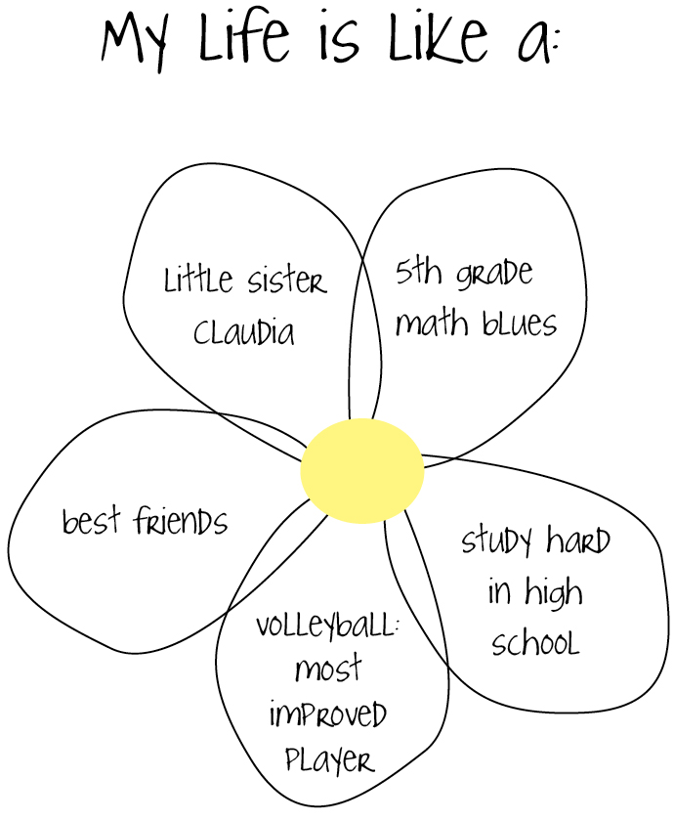

Ideas for Designs
In this section are some other ideas for ways to depict the important times and achievements in your life. Think about which one symbolizes your life so far. You don’t have to use one of these; they are just to get your imagination going.
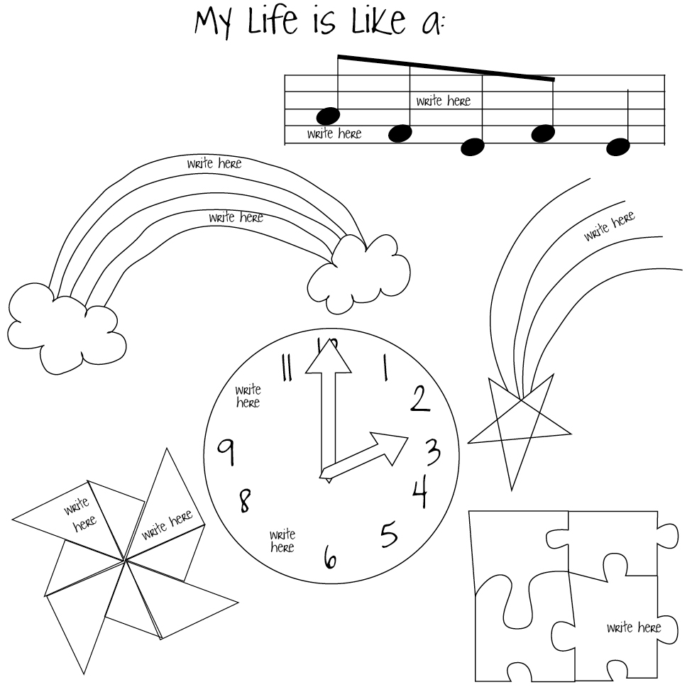

Before handing in your assignment, check to make sure it meets or exceeds the following assessment criteria:
- The visual representation depicts key life experiences and events.
- The visual representation illustrates important information from the student’s notes.
- The visual representation is presented in the form of a timeline or other symbolic depiction.
- The visual representation is neat, legible, and presentable.

Student Resource 2.4

Assignment: My Classmate’s Life So Far Interview
Directions: Now that you have created your visual representation, you are going to interview a classmate about his or her visual.

The Interview

Tips for Interviewing
Look at the visual, but also look at your partner. Pay attention to how your partner looks and sounds—happy? Sad? That can tell you a lot about the events and topics described in the visual.
Listen carefully. That means don’t talk when your partner is talking and pay attention to what your partner has to say.
Take notes, but don’t try to write down every word your partner says.
Ask questions if you don’t understand. Wait until your partner finishes a sentence. Then ask for an explanation.
Check the important points with your partner. Repeat back what you think your partner said in your own words. For example, “It sounds like volleyball is a really important part of your life.” That allows your partner to correct you if you got distracted or wrote something down incorrectly.

Writing Up the Interview
Once you have completed your interview, write a short summary of what you learned about your classmate. Your summary should be at least five sentences long. You should cover all the important points you learned about your partner’s life. The first sentence should talk about the most important thing you learned about your partner, and the sentences should go in order from most important information to least important. An example is provided.

Here is what Elena’s partner, Martin, wrote in his summary:
Elena is really good at volleyball now, but it took her a lot of hard work.
Now she’s so good she might get a college scholarship for playing volleyball.
Elena works very hard in school and got a “B” average last year.
In 5th grade, she found out she had a learning disability, but she studies with her mom and that helps.
Elena is proud that she gets along with her little sister, Claudia, even though she has to babysit her sister a lot.
Elena’s earliest memory is watching TV when she was three years old.

Before handing in your assignment, check to make sure it meets or exceeds the following assessment criteria:
- The interview write-up is at least five sentences long.
- The interview write-up accurately reflects the interviewee’s visual representation.
- The interview write-up demonstrates the interviewer’s ability to listen carefully by presenting ideas or details not found in the interviewee’s visual representation or homework responses.
- The interview write-up is neat and uses proper spelling and grammar.

