Lesson 3
Effective Communication
Teacher Resources
Resource | Description
Teacher Resource 3.1 | Presentation: Active Listening (separate PowerPoint file)
Teacher Resource 3.2 | Interactive Presentation Notes and Instructions: Communication Tips (includes separate PowerPoint file)
Teacher Resource 3.3 | Assessment Criteria: Communication Comics
Teacher Resource 3.4 | Key Vocabulary: Effective Communication
Teacher Resource 3.5 | Bibliography: Effective Communication

Teacher Resource 3.2
Interactive Presentation Notes and Instructions: Communication Tips
1. Before you show this presentation, use the text accompanying each slide to develop presentation notes. Writing the notes yourself enables you to approach the subject matter in a way that is comfortable to you and engaging for your students. Note the ideas for fully engaging the students that are placed at key points in the “Notes” section.
2. Prepare for the first activity that occurs after the 4th slide as follows. Post two sheets of chart paper in the front of the room. On one sheet, list the following people:

Your friend’s grandmother
A classmate
Someone who might give you a summer job
A neighbor who is 5–10 years older than you
On the other sheet of paper, write the following expressions:
I’m sorry to hear that.
That sucks.
Oh no! You poor thing!
That’s terrible news.
3. Prepare for the activity accompanying slide 6 by writing two slips of paper, each with one of the following scenarios:
You are out shopping with your Mom or Dad and you run into your boss from your afterschool job.
You are out with a friend who goes to a different school and you run into one of your teachers.
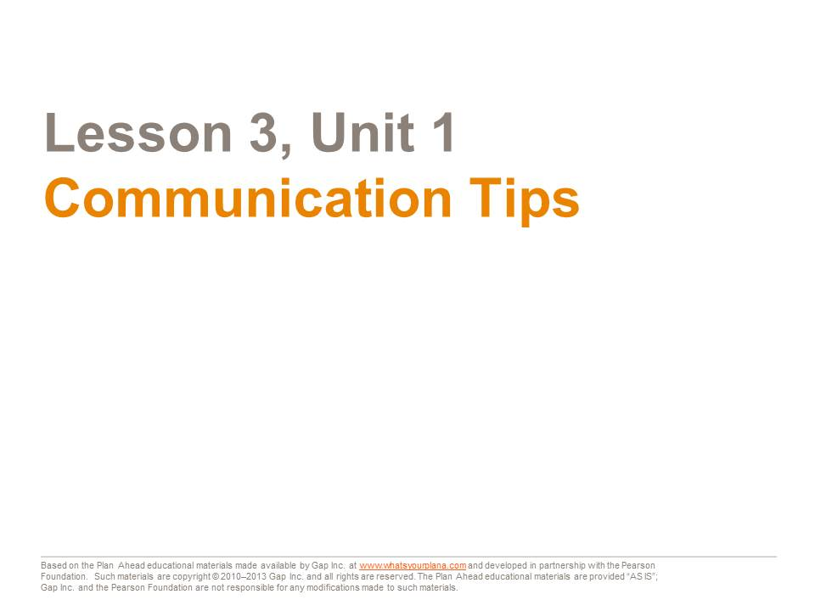  All communication is made up of two parts: the person talking is the “sender.” The person listening is the “receiver.” We’ve already worked on your “receiving,” or listening skills. Today we’re going to look at how you talk—what kind of message you are sending to other people by your words and actions. | Presentation notes
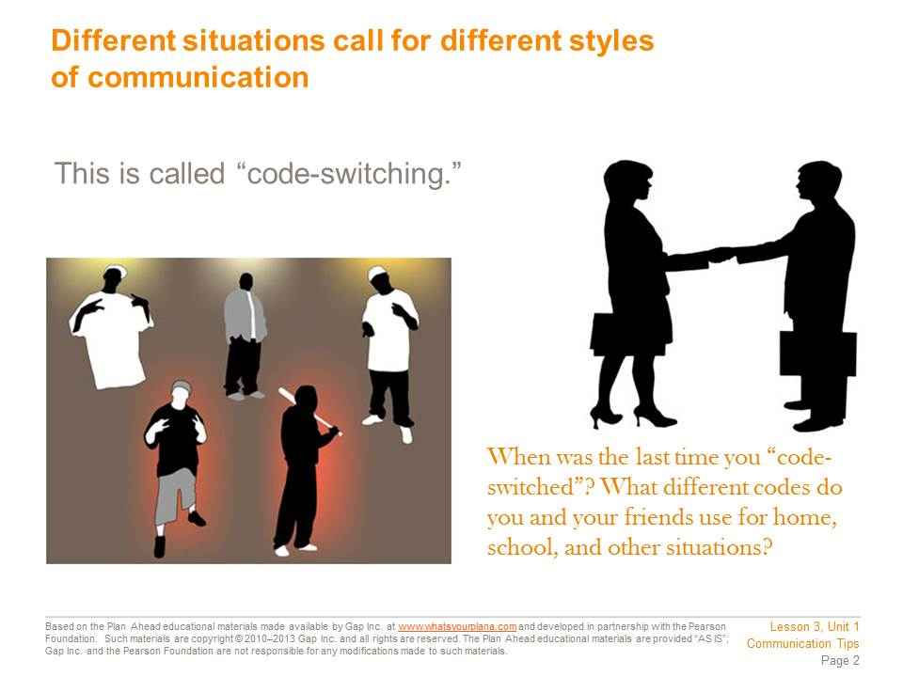  Different situations call for different types of behavior and ways of communicating. Changing how you communicate to suit the circumstances is called “code-switching.” For example, at a basketball game, you might yell or cheer. This is appropriate in that situation. But it would be the wrong thing to do at a funeral.  Here is an example of a different kind of code-switching. Tomas and his family are from the Philippines. Tomas speaks English well, but his parents only speak Tagalog, one of the languages spoken in the Philippines. When Tomas brings his friends over, he has to switch between languages. He will speak in English to his friends, and in Tagalog to his family.  You probably code-switch, too. Everybody uses language differently depending on their circumstances. When you code-switch, you also change your nonverbal communication: your posture, your gestures, your tone of voice all shift to be appropriate to your audience. | Presentation notes
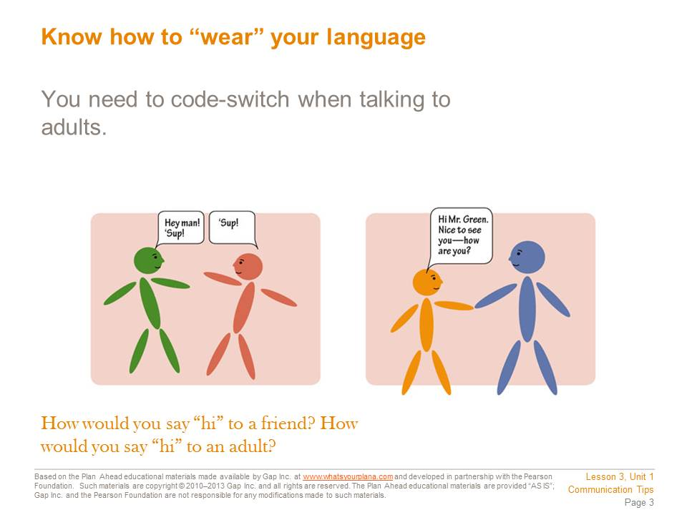  Code-switching helps you to get along with all kinds of people. It also makes a good impression.  To greet a friend, you might say, “Hey” or “Sup?” But those are not good ways to greet an adult such as a teacher, a neighbor, or a boss. In those situations, it’s better to say, “Hello.” If you’ve never met this person before, you could say, “Nice to meet you.”  When you’re leaving, it’s better to say, “Goodbye” or “It was nice to meet you,” instead of “Later,” “Bye,” or “See ya.”  These suggestions are more formal or uptight than how you speak to your friends. That is intentional. When you are speaking to an adult you don’t know very well, your words, tone, and behavior should show respect and politeness. If you get to be friends with someone who is an adult, or if you are speaking to adult family members, you may not need to be so polite. But for adults such as teachers, coaches, or bosses, this is a good way to behave. | Presentation notes  After talking about this slide with students, draw their attention to the chart paper you have prepared. Ask a volunteer to read the expressions of sympathy.  Next, ask the class: If you were going to say something sympathetic to a friend’s grandmother, which of these would you pick to say? Ask students to vote by a show of hands for each expression. They can vote for more than one expression so long as they think it’s appropriate. After the vote, guide students to see that the first and last expressions are most appropriate.  Repeat this process with the other three people. Guide students to recognize that this is code-switching. It may be something they do automatically, without even thinking about it. But if they have difficulty identifying which statements are most appropriate for each person, they may want to work on their code-switching skills.
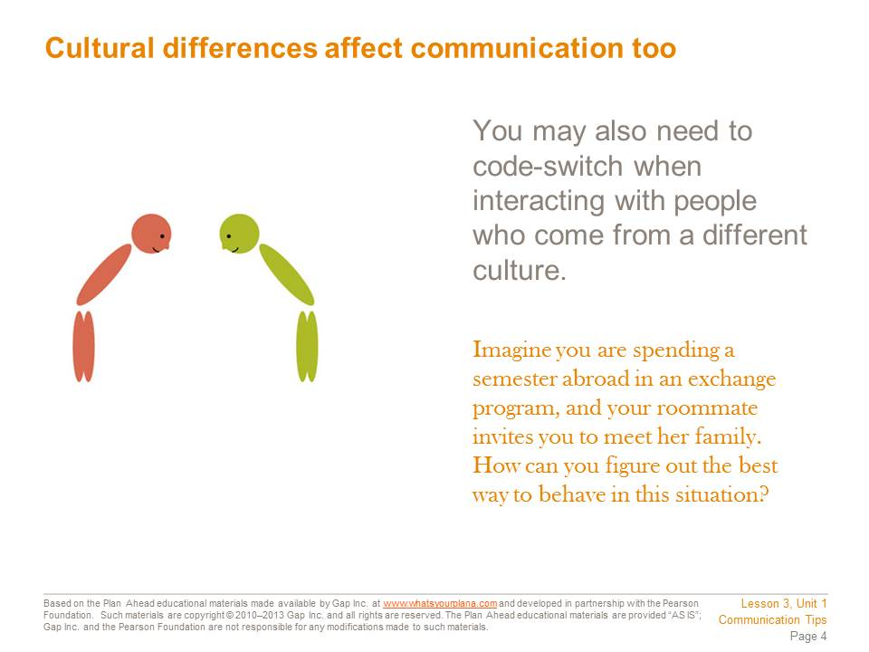  We have been learning about appropriate communication in America. In other countries, good manners can be different from our own. For example in France, it’s rude to eat a sandwich with your fingers. Use a knife and a fork!  Many high school and college students participate in exchange programs. Students from other countries come here to live with an American family, go to an American school, and experience our culture. Every year thousands of American students live with families in other countries too. Colleges are encouraging students to study abroad for a semester because it’s such a great way to learn about cultures different from our own. It’s also an effective way to learn another language.  When you meet people from other cultures, be sensitive to how they might communicate differently. How do you figure out the right way to behave? The best thing to do is pay attention to how everyone else is behaving. If they speak quietly, adjust your tone of voice to match theirs. If everyone is making a special effort to greet the elderly people, you should do the same. If you get good at observing and imitating these behaviors, you can get along with almost anybody. | Presentation notes
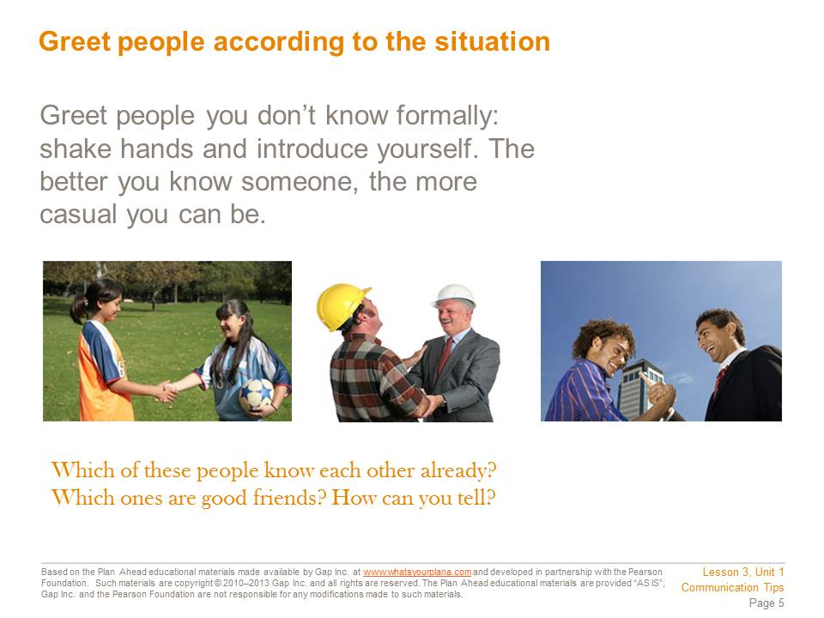  In any country, it’s important to learn how to meet new people properly. Here in the United States, begin with a friendly smile. Look the new person in the eye as you smile. Maybe you’re shy, or maybe you don’t like to smile at strangers. But if you’re looking away or not smiling, you can make a bad impression.  Next, say, “Hello.” Introduce yourself. You can just say, “Hi, I’m (your name).” You will make the other person feel comfortable around you and then you can start a conversation.  If you are introduced to an adult you haven’t met before, smile, say, “Hello,” and shake hands with them. Shaking hands is the typical way that adults interact when they are introduced to each other. They grasp the other person’s hand firmly, with confidence. | Presentation notes  After discussing this slide, call on a student volunteer to demonstrate how you would greet an adult you had not met before (saying hello, introducing yourself, shaking hands).
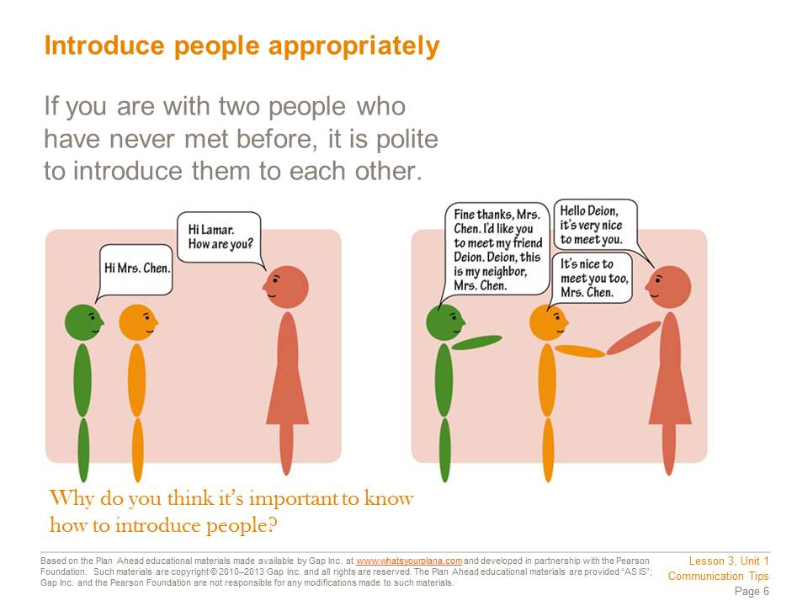  Let’s say you’re touring a college campus with some friends. An elderly neighbor walks by; her granddaughter attends this college. Your friends don’t know your neighbor. What do you do?  It’s polite to introduce two people if you know both of them, but they have never met. If you are introducing someone your age to an adult, introduce the adult first. It is respectful to address the older person first by telling him or her the name of the younger person. So if you are introducing a friend to your elderly neighbor, you would say, “Mrs. Chen, this is my friend, Deion. Deion, this is my neighbor, Mrs. Chen.”  It’s important to know how to introduce people properly. You may not need to do it very often right now, but as you get older you will need to do it much more. Knowing how to introduce your parents, your friends, or your boyfriend or girlfriend to a teacher, a coach, or a boss at a summer job can help you succeed in school and in life. | Presentation notes  Call on three people to read aloud the scene between Lamar, Deion, and Mrs. Chen. Point out how that scene demonstrates appropriate behavior when introducing two people who do not know each other.  Then call up six additional volunteers. Divide them into two groups of three and give each group one of the slips of paper. Give them a minute to decide who will play which part. Then have one group act out their scenario. Ask the rest of the class to give them feedback. Repeat the process with the other group. Clear up any misunderstandings.
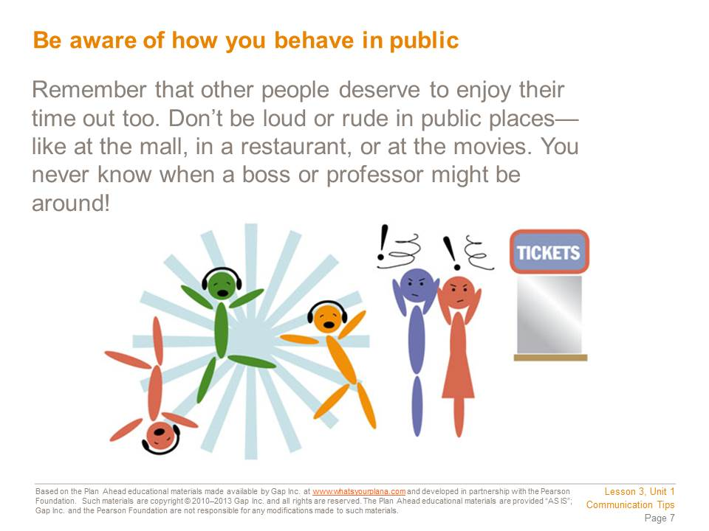  Be aware of your behavior in public. Respect the right of others to be there too. Besides, you never know when being rude will backfire on you. Suppose you go to the mall with your friends. You’re having a good time and being loud. You get angry looks from other people, but you’re having a good time, so you don’t care.  The next day, you have an interview for a summer job. You walk in and find yourself face-to-face with one of the people who was annoyed by your behavior the night before. Oops! So much for that job….  You also need to think about what you post online. Potential employers and college admissions staff will check your Facebook page and any other social networking sites that you use. If these people don’t like what they see, they won’t hire you or admit you to their college. | Presentation notes  Invite students to share: what places is it okay to be loud? What places is it not okay? Guide students to recognize that they need to develop a sensitivity to other people. For example, at a football game, it is acceptable to be loud and cheer. However, it is not appropriate to cheer if somebody has been injured on either team.  If they are playing basketball in the street in the middle of the afternoon, they might be loud. But if they are coming home late at night, they should not be loud, even though it’s the same location. The “rules” about this kind of behavior are really more just about thinking of other people.
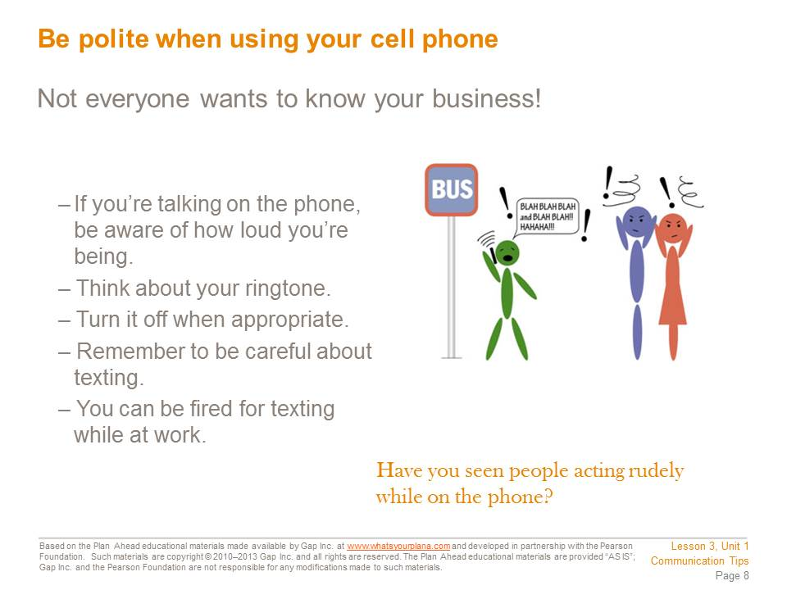  Everywhere you go, you see people talking on their phones and texting. A lot of people don’t seem to know about being polite when they’re on the cell phone. Here are guidelines for good cell phone habits:  Talk quietly if you are in public. Other people don’t want to hear the details of your personal life.  - If you use your cell phone in class, you are disrespecting the teacher. You are also not paying attention, which will bring down your grades.  - Don’t use your cell phone at work unless you are on break. You will get fired if you text or make personal calls on company time.  - Put your phone on “silent” when you’re in the movies or at an event. It’s disrespectful to everyone around you to kill the mood with your cell phone ringing.  - Don’t answer your phone if you are in the middle of talking to someone. It’s like saying, “Whoever is calling me right now is more important than you.”  - Pick a ringtone that won’t offend people if your phone rings in public. You can use your favorite ringtone when you’re at home or with your friends.  - Texting is good to do if you are in a place where you need to be quiet. But don’t text when you’re in a conversation with someone. That’s rude. | Presentation notes  Ask students to respond by a show of hands to the question on Slide 8. If time allows, invite a few volunteers to share their “bad cell phone behavior” horror stories.
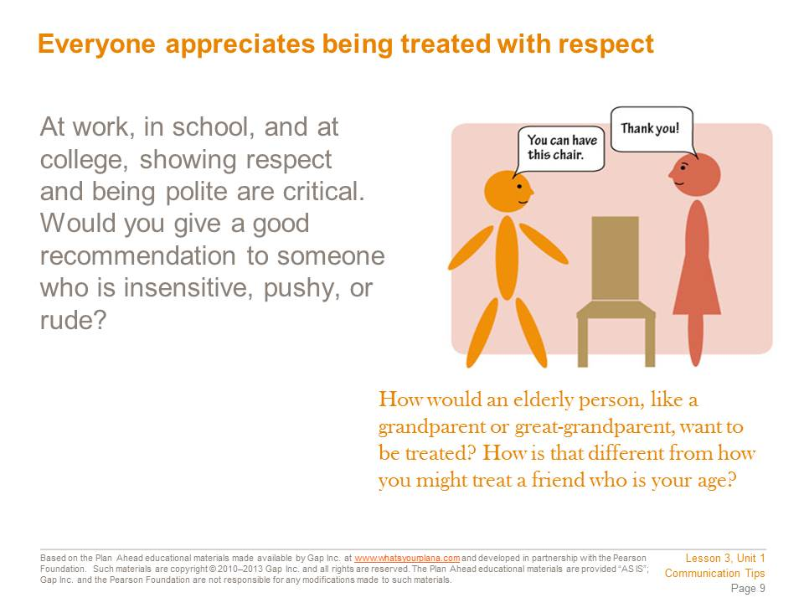  How we treat other people reflects on us. And people form their opinions of you based on how you treat them. This makes sense; why would people think you’re a friend if you only come around when you need a favor or help with something?  In the workplace and at school, how you treat other people is extremely important. If you disrespect your teachers, they will not want to help you out with recommendations for getting a summer job or getting into college.  Treating people with respect is the right thing to do. But it’s also being smart about your future as well. | Presentation notes  Point out that teenagers can feel disrespected by adults. Ask students: how does it feel when someone is disrespectful to you? Invite a few students to share, but stay focused on how they feel rather than on what somebody did to them to disrespect them.  Explain that showing respect is really another way to show that you are thinking about other people. Ask students: imagine that a band that you really love is coming to town. You’re able to get tickets to their concert, but your friend can’t. You go and have a great time and get a t-shirt from the concert. But the next time you see your friend, you might not wear that concert t-shirt. After all, that could make your friend feel bad.  If you are being sensitive to grandparents, teachers, or bosses in your life, you may need to make some changes to how you talk or dress when you are around them. It doesn’t mean that you are wrong to dress a certain way. Instead it means that you are sensitive to differences of opinion and that you show respect by not causing the other person to feel uncomfortable. Invite students to give an example of something they already do to be sensitive to the expectations of adults, or have them make a suggestion of something they could do.
Teacher Resource 3.3
Assessment Criteria: Communication Comics
Student Name:_________________________________________________________________
Date:_________________________________________________________________________

Using the following criteria, assess whether the student met each one.

 |  | Met | Partially Met | Didn’t Meet
The conversation between the characters in each scenario shows evidence of an excellent understanding of code-switching. |  | □ | □ | □
The narrative accompanying each panel provides a realistic, natural storyline that matches the visuals and the conversation between the characters. |  | □ | □ | □
The narrative takes the character’s nonverbal communication into account as appropriate. |  | □ | □ | □
The assignment is neat, legible, and presentable. |  | □ | □ | □

Additional Comments:
________________________________________________________________________________
________________________________________________________________________________
________________________________________________________________________________
________________________________________________________________________________
Teacher Resource 3.4
Key Vocabulary: Effective Communication
These are terms to be introduced or reinforced in this lesson.
Term | Definition
active listening | A learned skill that means accepting responsibility for receiving the same message that the speaker sent, unaffected by your own thoughts or feelings.
code-switching | The use of more than one way of speaking (in language or dialect) in conversation.
I-message | Using the first person to accept responsibility for your reaction to what another has said or done, rather than accusing, assuming, or assigning blame.
pitfall | A hidden or not easily recognized danger or difficulty.

Teacher Resource 3.5
Bibliography: Effective Communication
The following sources were used in the preparation of this lesson and may be useful for your reference or as classroom resources. We check and update the URLs annually to ensure that they continue to be useful.
Print
Covey, Sean. The 7 Habits of Highly Effective Teens. New York: Fireside, 1998.
Downing, Skip. On Course: Strategies for Creating Success in College and in Life, 5th ed. Boston: Houghton Mifflin, 2008.
Packer, Alex J. The How Rude! Handbook of School Manners for Teens. Minneapolis: Free Spirit Publishing, 2004.
Online
“Code-switching.” Wikipedia, http://en.wikipedia.org/wiki/Code-switching (accessed July 12, 2013).
Glater, Jonathan. “To Professor@University.edu Subject: Why It’s All About Me,” New York Times, February 21, 2006, http://www.nytimes.com/2006/02/21/education/21professors.html (accessed July 12, 2013).
Jayson, Sharon. “Tech Creates a Bubble for Kids.” USA Today, June 20, 2006, http://www.usatoday.com/tech/2006-06-19-oblivious-kids_x.htm (accessed July 12, 2013).

