Lesson 11
Skills for a Successful Life
Student Resources
Resource | Description
Student Resource 11.1 | Discussion Prompt: A Good Friend?
Student Resource 11.2 | Worksheet: Scenarios
Student Resource 11.3 | Reading: Are You Stressed?
Student Resource 11.4 | Reading: Managing Stress
Student Resource 11.5 | Worksheet: Preparing a Mission Statement
Student Resource 11.6 | Assignment: My Personal Mission Statement

Student Resource 11.1
Discussion Prompt: A Good Friend?
You sign up to do set design for the school play, even though you’ve never been involved with theater before, because you want to see if you’d like it. You do a lot of the work during rehearsals, and you get to know one of the students, Anna, who is playing a main character. She invites you to go to the café after school and hang out with her and her group. They all seem really nice and interesting. You’re feeling very good about yourself!
One day Anna tells you that you’re invited to the cast party she’s throwing. You’re so excited and you feel that Anna is becoming a real friend. A few days before the cast party, you go with her to her house to pick up some props she’s been working on. You meet her brother. You realize, to your embarrassment, that you know her brother, because he used to date your cousin and he dumped her in a way that was really mean. Her brother recognizes you too and is rude. He frowns when he meets you and doesn’t say anything.
The next day, Anna acts totally different toward you. She avoids you. She also tells you that it turns out only the cast can go to the cast party, not people who did props or costumes or set design. You are very upset. You suspect that she made this new rule up—it’s just that you’re no longer invited. What did you do wrong?
Then you hear other kids talking about how fun the cast party was—including the kids you designed the sets with. You are so upset that you decide to ask her. At first she doesn’t want to say. Then she bites her lip and looks down and starts to cry. She admits that her brother told her not to hang out with you and she didn’t know what to do. She still wants to be friends.
What do you do?

Student Resource 11.2
Worksheet: Scenarios
Student Name: _______________________________________________________ Date:___________
Directions: These scenarios are real-life situations that many teenagers find themselves in. You will work through the practice scenario as a class. Then you will work with a small group to evaluate one of the other scenarios. You will also take notes on the solutions your classmates offer for the other scenarios.
Practice Scenario: The Math Test
Destiny has a big math test tomorrow. She hates math, and she’s barely getting a C- in the class. But the teacher said if she did well on this test, it would really improve her grade. Destiny really wants to get her GPA up, so after dinner, she sits down and opens up her math book. But then her cell phone buzzes. It’s a text message from her friend Erica. There’s a huge party going on later tonight and Erica wants Destiny to go with her. What should Destiny do?

- What might happen if Destiny goes to the party?
___________________________________________________________________
___________________________________________________________________
___________________________________________________________________

- What might happen if Destiny stays home and skips the party?
___________________________________________________________________
___________________________________________________________________
___________________________________________________________________

- If Destiny doesn’t go to the party, what could she say to her friend Erica?
___________________________________________________________________
___________________________________________________________________
___________________________________________________________________

- If Destiny knew about the party earlier, what could she have done about her math test?
___________________________________________________________________
___________________________________________________________________
___________________________________________________________________

- What would you do if you were in this situation?
___________________________________________________________________
___________________________________________________________________
___________________________________________________________________

Scenario 1: Parents Just Don’t Understand
Caleb’s mom is a single parent, raising him and his little brother on her own. He gets along pretty well with his mom—as well as any fifteen-year-old boy ever does. But lately, they’re starting to fight more often. Caleb has always loved music. He taught himself to play his uncle’s old saxophone. When Caleb started high school, he joined the school’s jazz band. He’s made some good friends in the group. His teacher says he’s talented, and maybe if he keeps practicing, he could get a scholarship to go away to a music camp this summer. Some of the older kids in the jazz ensemble are talking about studying music in college, and Caleb thinks that would be the greatest thing ever, just to play music all day long.
Caleb’s mom doesn’t think so, though. Caleb has been asking her to buy him a new saxophone, because his old one barely works, but she keeps making excuses. She says it’s because she doesn’t have the money, but she still has enough for his little brother’s softball uniforms and equipment. And if Caleb talks about studying music in college, she scolds him and tells him he’s wasting his time. She thinks he should be thinking about getting a job that would make him a lot of money, like being a doctor or something. Caleb hates science class, and he thinks that if he could spend his days playing music, he wouldn’t mind if he didn’t have a lot of money.
Now his teacher has given him the paperwork to apply for the music camp. If he gets the scholarship, he wouldn’t have to pay anything to attend. But his mom will have to sign the paperwork for him to apply. What should Caleb do?

- What might happen if Caleb asks his mom to sign the paperwork?
___________________________________________________________________
___________________________________________________________________
___________________________________________________________________

- What might happen if Caleb doesn’t ask his mom to sign the paperwork?
___________________________________________________________________
___________________________________________________________________
___________________________________________________________________

- Caleb could try to forge his mom’s signature on the papers. What would happen if he did that and got caught?
___________________________________________________________________
___________________________________________________________________
___________________________________________________________________

- If Caleb wants to convince his mom to let him apply for the scholarship, what could he say?
___________________________________________________________________
___________________________________________________________________
___________________________________________________________________

- What would you do if you were in this situation?
___________________________________________________________________
___________________________________________________________________
___________________________________________________________________

Scenario 2: Online “Friends” and a Bad Break-Up
Mariah is a popular girl. She has her usual group of friends she hangs out with at school, and even more friends online. On Facebook, she has more than 750 friends, and she loves to spend time chatting with them, seeing the funny stuff they’ve posted, and posting comments on their Walls. Her dad and stepmom don’t like how much time she spends on the computer, but they said as long as her grades are okay, they won’t interfere. Sometimes she tries to show her dad or stepmom a funny video she found on Facebook, but they just tell her not to bother them.
Then one day, Mariah logs on and sees that one of her Facebook friends has posted some pretty awful stuff. He goes to her school, but she doesn’t see him in class or anything because he’s a year older. She sees him sometimes at a party or a basketball game, and her best friend thinks he’s really cute. He usually posts funny stuff, so she looks forward to his posts. Now he seems really angry. She reads the posts on his Wall. It looks like maybe his girlfriend dumped him, and now he’s posting a bunch of stuff about women in general and his ex-girlfriend in particular. Mariah can understand being angry, but these posts seem really unfair. He’s insulting women in general, calling them names and swearing a lot. And he’s posted threatening messages about his ex-girlfriend, saying things about how he’s going to “make her pay” and threatening to post “private” photos of her online for everybody to see. His posts make Mariah really uncomfortable. What should she do?

1. What might happen if Mariah says something to her Facebook friend?
___________________________________________________________________
___________________________________________________________________
___________________________________________________________________

- What might happen if Mariah doesn’t say anything to her Facebook friend?
___________________________________________________________________
___________________________________________________________________
___________________________________________________________________

- What else could Mariah do to address this situation?
___________________________________________________________________
___________________________________________________________________
___________________________________________________________________

- What’s wrong with how Mariah’s friend is acting toward his ex-girlfriend?
___________________________________________________________________
___________________________________________________________________
___________________________________________________________________

- What would you do if you were in this situation?
___________________________________________________________________
___________________________________________________________________
___________________________________________________________________

Scenario 3: Parents vs. Friends
Justin comes from a big, traditional family, with six brothers and sisters. His dad and his two older brothers work construction jobs and love playing football. Justin is the “weird” one in the family. He likes football okay, but he really loves being in the drama club plays. His girlfriend is the one who talked him into trying out for a play, and he’s pretty good. He’s had a couple of leading roles. Even though the rest of his family thinks it’s weird, they always see his plays and cheer for him afterwards.
Normally, Justin’s sister gives him a ride home after play practice. But one day, she was home sick, so his dad and his big brother had to pick him up. Justin’s girlfriend had already left, and he was just hanging out with some of the other drama club members. The drama club is made up of kids who love doing plays, just like him, and Justin is good friends with them. The club is made up of many different types of people. There are guys and girls, kids of every ethnicity, kids with tons of make-up on and rings in their noses and eyebrows, kids who like to wear crazy clothes and dye their hair pink, purple, and flaming orange. Justin doesn’t really think anything about it, but when his dad and brother show up, they seem really uncomfortable with some of the people he’s hanging out with.
On the drive home, Justin gets into a fight with his dad. His dad says the kids in the drama club are “bad people” and Justin shouldn’t hang out with them anymore. Justin says that would mean he’d have to quit the play. His dad says that’s fine, as long as he gets away from “those types of kids.” What should Justin do?

1. What might happen if Justin ignores his dad and stays in the play?
___________________________________________________________________
___________________________________________________________________
___________________________________________________________________

2. What might happen if Justin listens to his dad?
___________________________________________________________________
___________________________________________________________________
___________________________________________________________________

3. If Justin tries to talk to his dad, what could he say?
___________________________________________________________________
___________________________________________________________________
___________________________________________________________________

4. What else could Justin try to do to address this situation?
___________________________________________________________________
___________________________________________________________________
___________________________________________________________________

5. If you were in this situation, what would you do?
___________________________________________________________________
___________________________________________________________________
___________________________________________________________________

Student Resource 11.3
Reading: Are You Stressed?
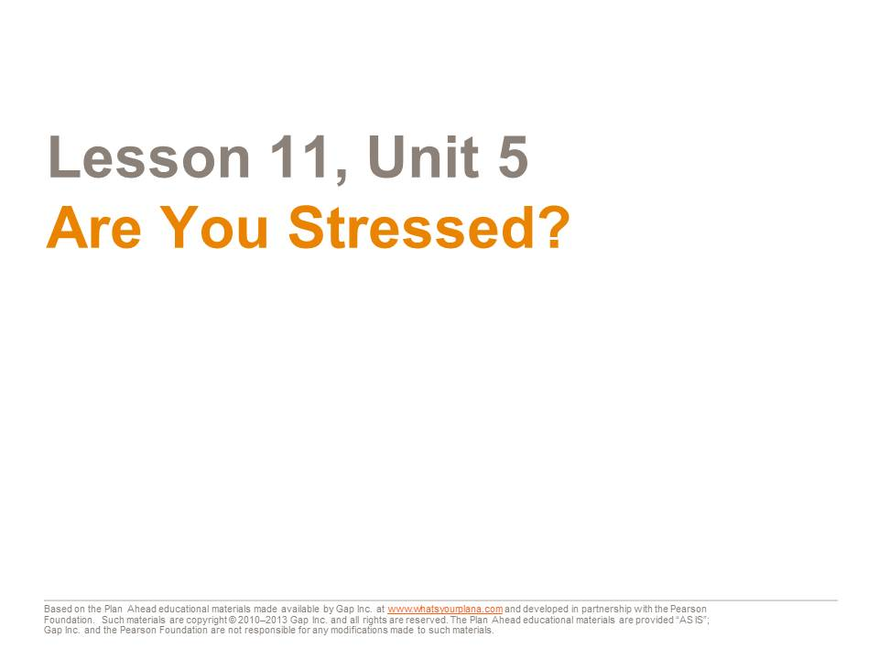

Are you under stress? The answer might surprise you. Sometimes we don’t realize how stressed out we are.

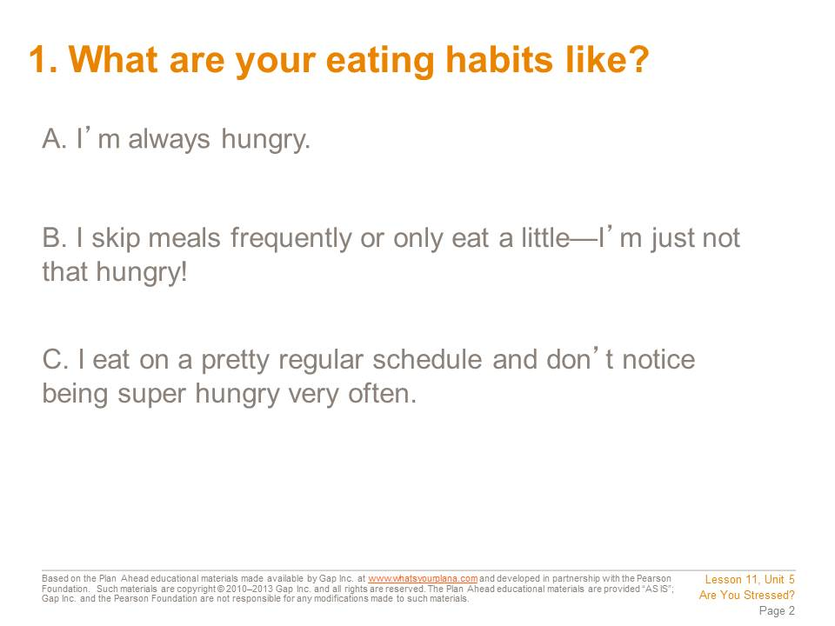

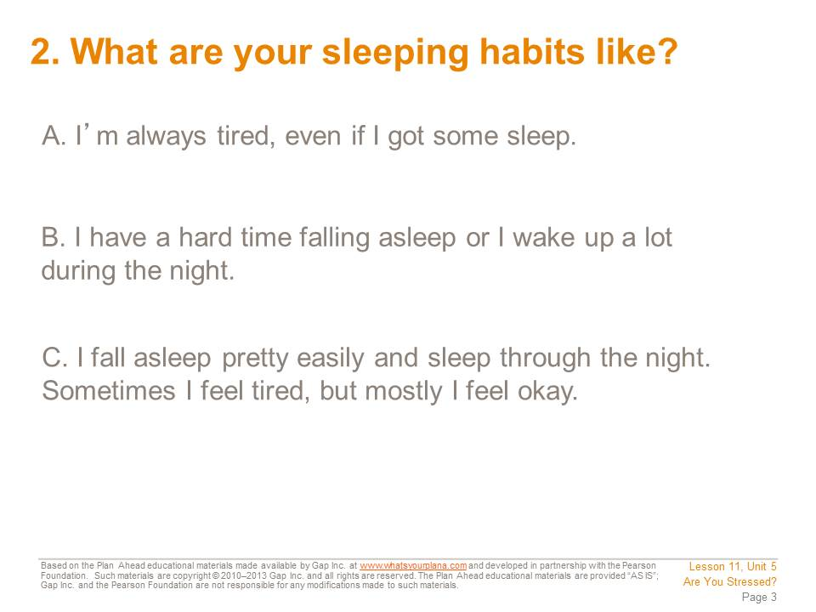

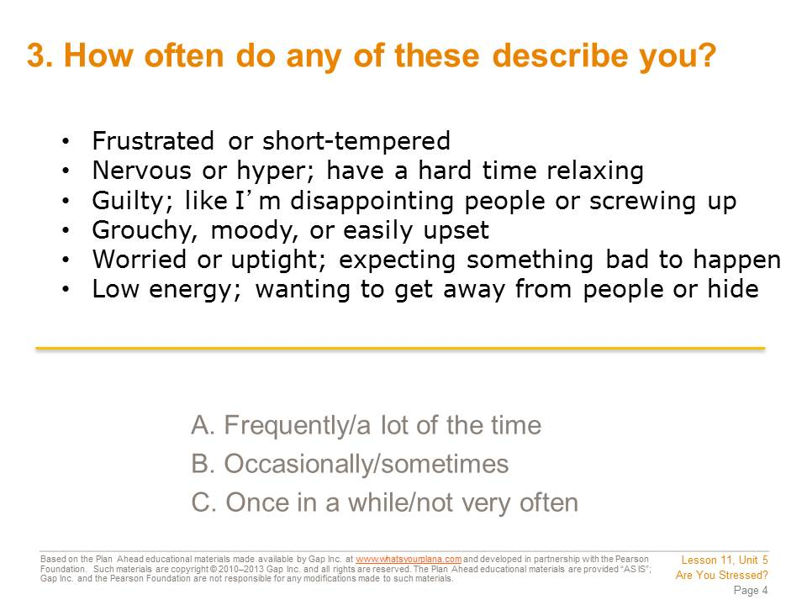

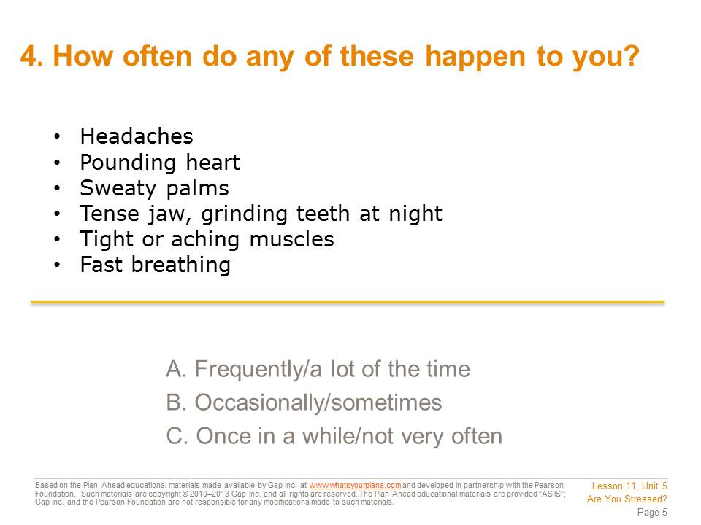

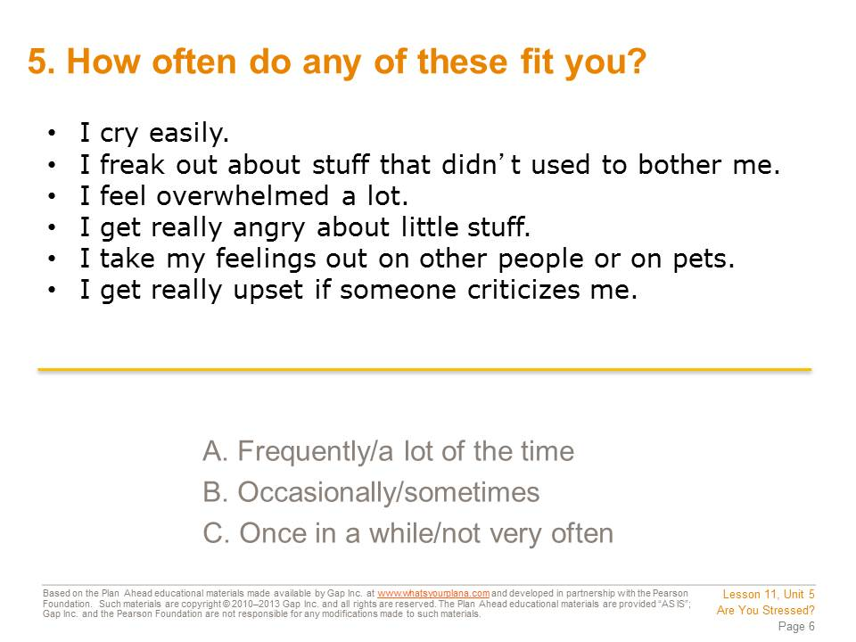

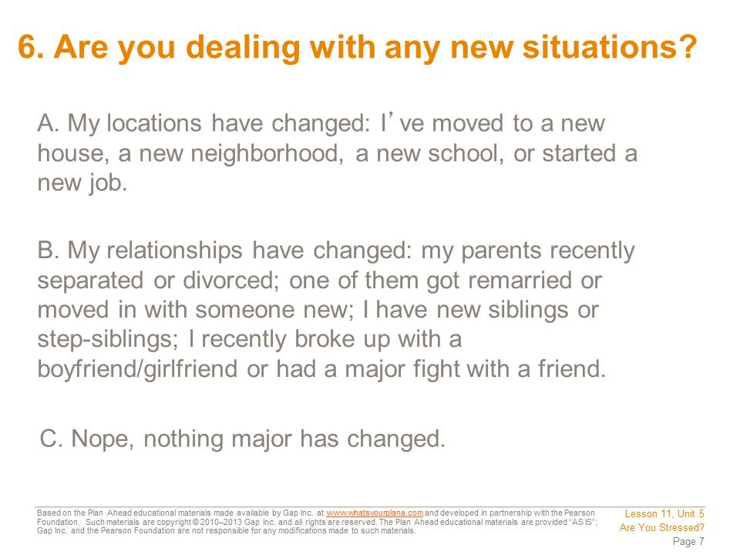

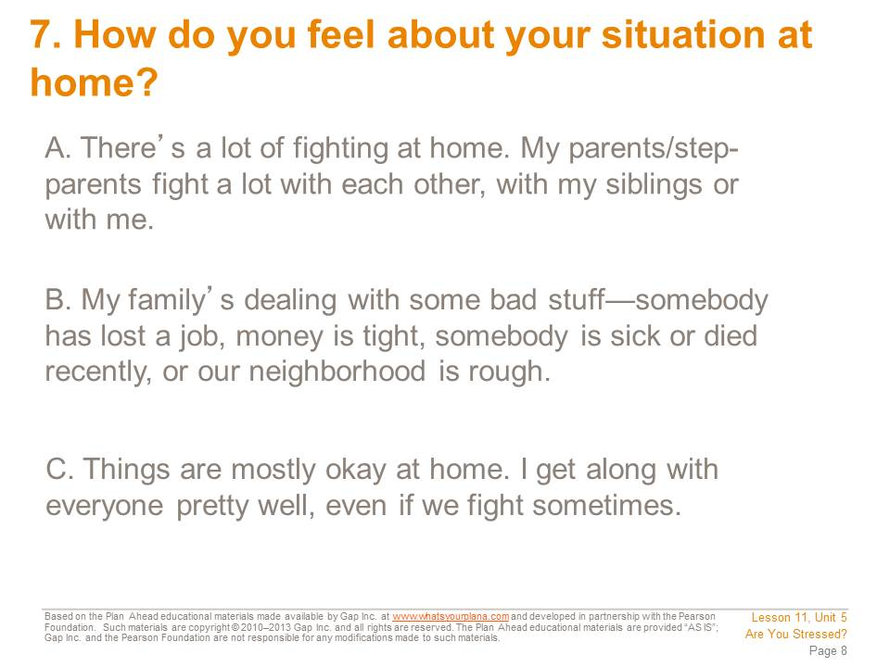

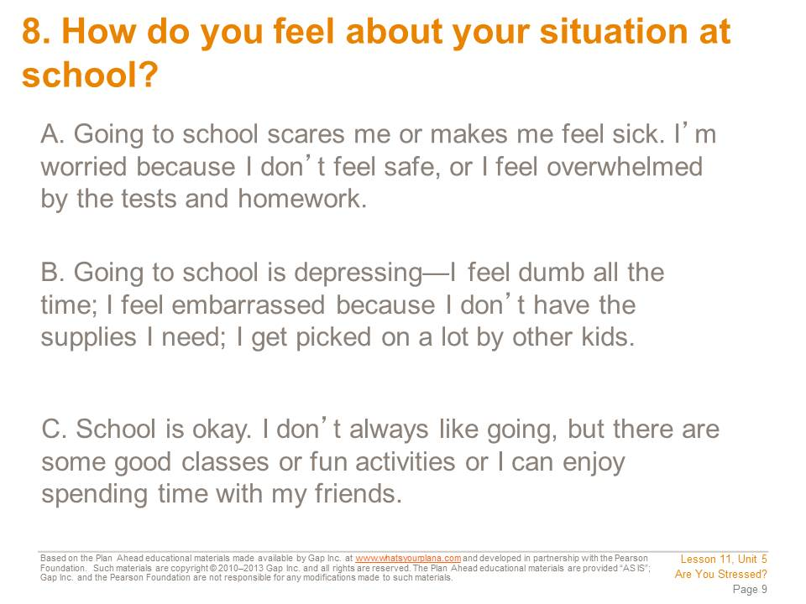

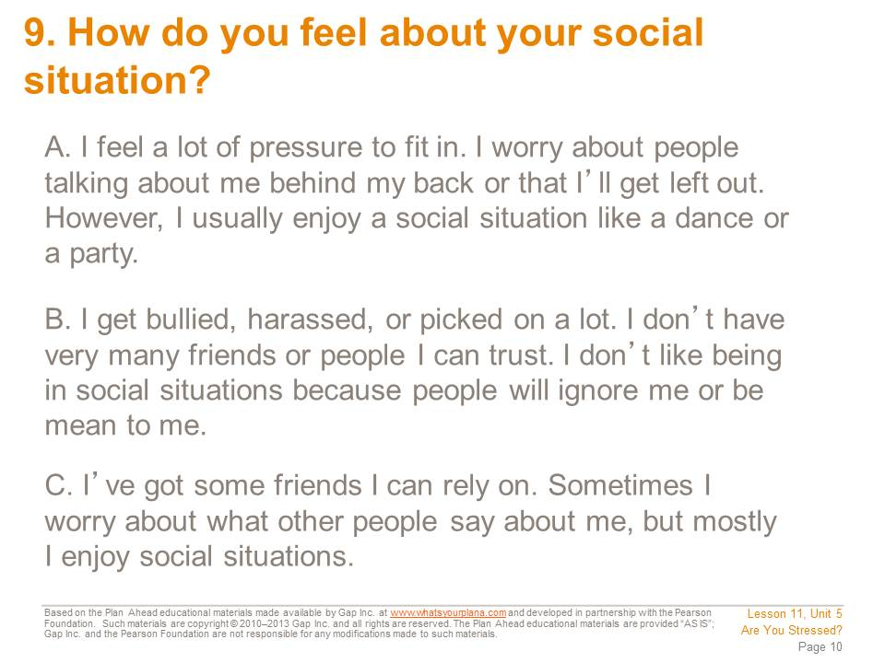

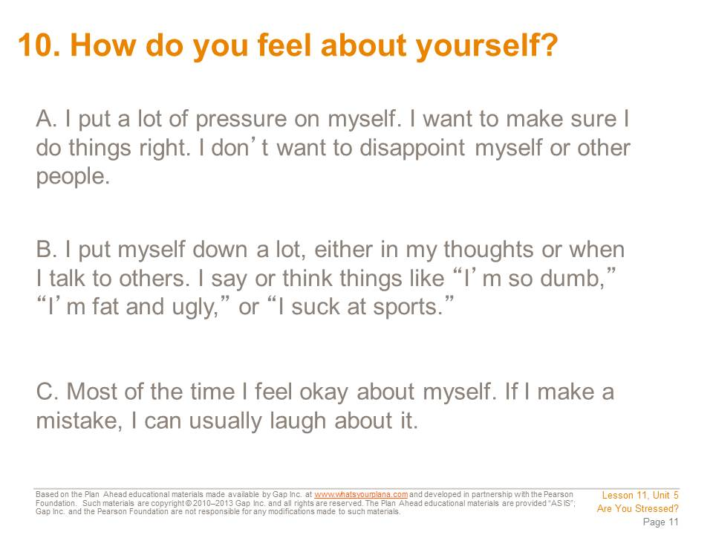

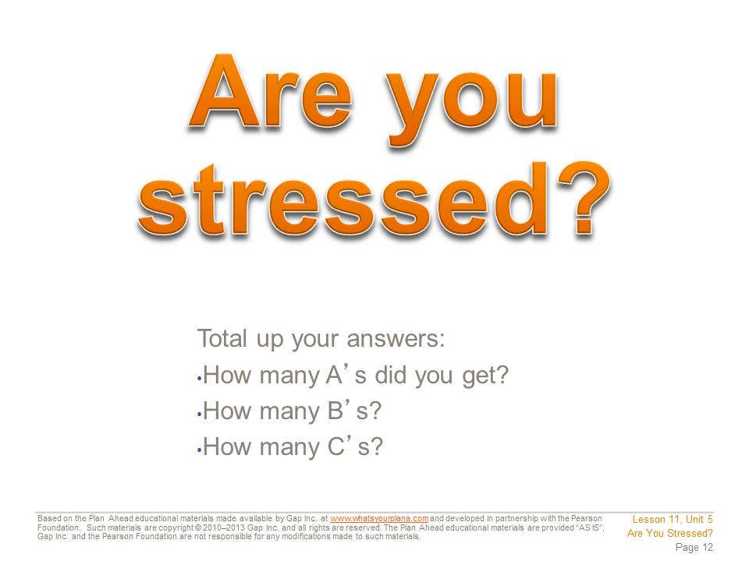

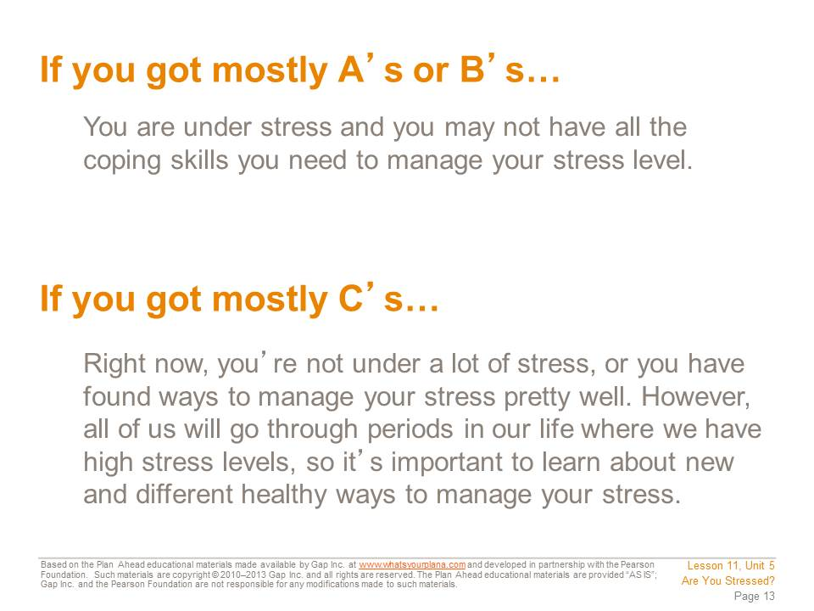

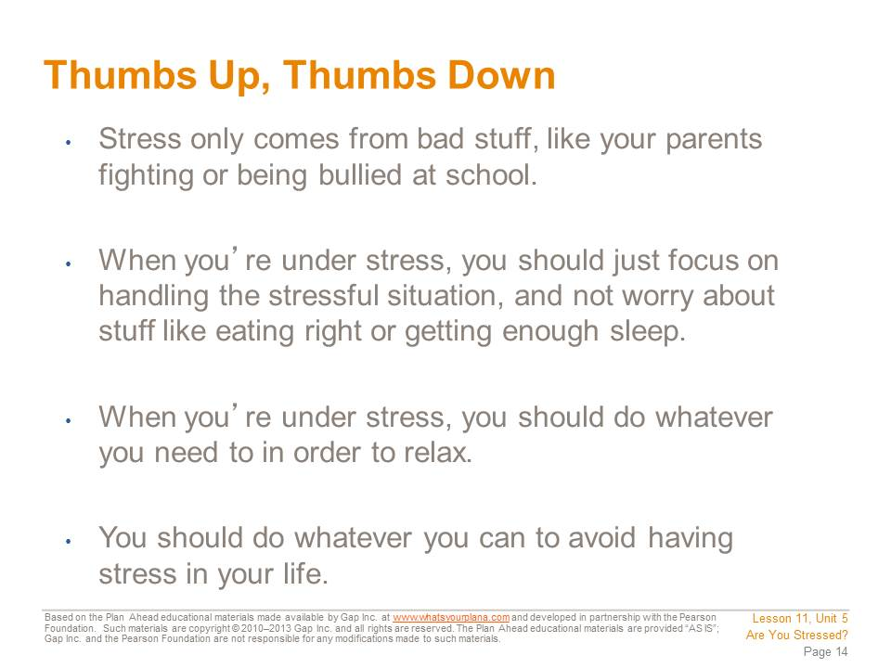

Student Resource 11.4
Reading: Managing Stress
Student Name:_______________________________________________________ Date:___________
Directions: Read each tip below and think about whether or not it’s something that you already do or something you could try to help you handle stress. Answer the questions at the end of each section.
Pay Attention to Signs of Stress
A lot of people think that stress only comes from bad things, like a death in the family or serious financial problems. But positive things could stress you out too. For example, imagine that a few years from now you get a full scholarship to attend a college on the other side of the country. That’s great news! You can go to a good school and it won’t cost you very much money at all! But you’ll be moving across country, living in a new place, meeting new people, and trying hard to do well at your new school. Those things will cause stress, even though they are good things.
You can’t avoid having stress in your life. If you start a new job, move to a new place, get married, have a baby, or buy a house, you will experience stress—even though all of those things are good.
So what can you do? First of all, pay attention to the signs of stress, like those mentioned in the “Are You Stressed?” questionnaire. If you notice that you’re experiencing several of those signs, take time to think about what might be causing you to feel stress.
Check Yourself:
Are you good at recognizing stress in yourself? What parts of your life cause you to feel stressed?
___________________________________________________________________
___________________________________________________________________
___________________________________________________________________

Take Care of Yourself
When you’re under stress, it’s tempting to say “I don’t have time to think about eating right” or “I don’t have time to get a full night’s sleep.” But that’s a mistake. Sure, once in awhile you stay up late to finish a school project or grab food from a fast-food restaurant. But if you do that on a regular basis, it can actually make you feel even more stressed.
Exercise helps you burn off extra energy if you feel anxious or angry. When you exercise, your body releases “feel-good” chemicals called endorphins. So taking the time to exercise can really make you feel better.
Eating right is important, too. Some people skip meals when they’re under stress. A lot of people choose food and drinks that include caffeine—like sodas, energy drinks, or coffee—or sugar, like candy bars. These taste good and give you an immediate rush of energy. But this kind of energy wears off fast. In fact, you can have a sugar crash, which will make it harder to handle stress. Instead of relying on a sugar or caffeine rush, eat to fuel your body. Examples of good healthy snacks are fruit, yogurt, a handful of nuts and raisins, and granola bars. They give you the strength and energy to face your challenges.
Sleeping is another thing that we take for granted when we’re under stress. It can seem as though there’s so much to do that you don’t have time for a good night’s sleep. But when you’re over-tired, even a little problem can feel overwhelming. If you’re feeling stressed and having a hard time making a decision, catch up on your sleep. You’ll realize that you feel calmer and have a better perspective on your problems.
When you’re stressed out, how does it affect your eating and sleeping?
___________________________________________________________________
___________________________________________________________________
___________________________________________________________________

What could you do to get more sleep, more exercise, or eat healthier food while you’re stressed?
___________________________________________________________________
___________________________________________________________________
___________________________________________________________________

Chill Out and Have Fun
When people are under stress, they often miss out on fun activities. But your mind and body need a break from all the tension. Doing something to make yourself laugh—whether that’s hanging out with friends or just watching a funny video on YouTube—can help your mood long after the video is over or your friends have gone home.
Having a hobby or interest can also be a good way to build in some time for fun. If you like movies, make time to catch the latest film. If you enjoy video games, see if you can beat your friends in a multiplayer match. Or just hang out with friends.
Stress can sometimes make people feel overwhelmed or too uptight to enjoy spending time with others. If that’s how you feel, think about something you can do on your own. Listen to music, read a book, work on a puzzle, or try something new and soothing, like yoga or knitting.
Some people, when they’re under stress, figure they’re entitled to do whatever they need to in order to relax. They use their stressed-out state to justify unhealthy habits like smoking, drinking, or using drugs. These are not good ways to manage your stress. They are hard on your body and your mind and can end up making a tough situation much worse. It’s important to look for ways to have fun that are positive. Pursuing a hobby, playing a sport, or taking quiet time by yourself are healthy ways to get a break.

Another way to get a break is to do something nice for another person. Sometimes all of us get caught up in our own personal problems. Those problems can feel huge, like they are the most important thing in the whole world. By taking a step back and helping someone else, you gain some important perspective. Plus, helping other people can make you feel good, which can help your mood. And in some cases, you may be able to do something that helps with the stressful situation. For example, when a major disaster happens, people often like to donate money, volunteer their time, or even give blood. If there is a big natural disaster, all of us will be under stress. By doing something to help people who are really suffering, the rest of us might feel a little better.
What healthy or appropriate things could you do to relax or have fun when you’re stressed?
___________________________________________________________________
___________________________________________________________________
___________________________________________________________________

Let it Out
When you’re under stress, you need to find a way to let out your emotions. You may be feeling sad, angry, overwhelmed, or unable to relax. Venting your emotions can make it easier to follow some of the other suggestions on this list.
One of the best ways to vent is to talk to someone you trust—a friend, a relative, or a teacher. Ideally, find someone who isn’t directly involved in the situation, so he or she can listen and give honest advice. For example, if you’re fighting a lot with your mom, maybe a friend or a teacher can help. But if you’re fighting with your boyfriend or girlfriend, asking his or her sister for advice might not be such a good idea.
If you don’t feel like you can talk to anyone about it, consider writing it down in a journal. Journaling has been shown to really help people work through their feelings and feel better.
Exercise is another great way to vent. Or put on some music and dance!
How would you “vent” if you were in a stressful situation? Would you talk to someone? Write in a journal? Both? Why?
___________________________________________________________________
___________________________________________________________________
___________________________________________________________________

Identify Possible Solutions
This is the last suggestion because it’s not always easy to do. If you are stressed, you might be too tired, emotional, or overwhelmed to be able to think clearly. So first you need to make an effort to take care of yourself. Eat right, get some sleep, and take a break. Only then will you be ready to really consider how to solve your problem.
If your stressful situation involves another person, you may need to talk to them in order to solve it. That talk might be even more stressful. For example, if you’re stressed out by a particular class at school, you might need to talk to the teacher. But if you don’t like the teacher—or you think the teacher doesn’t like you—that will be a difficult conversation. You need to be as calm as possible before you start the conversation. You should also try to use the tools you’ve learned in this course, particularly the listening techniques.
Don’t expect that you will be able to solve every stressful situation. All of us will encounter stress that is beyond our control. An illness, a death in the family, a job loss, a car accident—these things are a part of life, and we can’t always “fix” them. But making a plan to manage a stressful situation can help you find ways to take care of yourself. And some stressful situations can be “fixed.” If you’re stressed out by how much homework you have, there are solutions. You might be able to rearrange your schedule so you have more time for your homework. You might be able to get a friend or parent to help you with some of your work. You might be able to talk to the teacher and get some tips from her about things to do.
This doesn’t mean that you’ll solve your problem immediately. But sometimes, just making progress feels good enough!
Can you identify any potential solutions for a stressful situation you are experiencing right now?
___________________________________________________________________
___________________________________________________________________
___________________________________________________________________

Student Resource 11.5
Worksheet: Preparing a Mission Statement
Student Name:_______________________________________________________ Date:___________
Directions: A mission statement is like a personal declaration of who you are and what you are about. Writing a mission statement helps you to define what’s important to you; what interests, strengths, and skills you have; and what kind of person you aspire to become. Your assignment is to create a personal mission statement that reflects all the important things you have learned about yourself this semester. To help you organize your thoughts, write complete responses to the questions below.
My Values
Look back at the values inventory you did in Lesson 4.Write down your three or four top values from that inventory.
1.
2.
3.
4.
How do these values show up in your life right now? Do you still think that they represent what you care about the most? If they have changed, write down your new values and explain why they have changed.
___________________________________________________________________
___________________________________________________________________
___________________________________________________________________

What can you do to be true to these values in the future?
___________________________________________________________________
___________________________________________________________________
___________________________________________________________________

My Relationships
What are the most important relationships in your life right now? Think about your family, your friends/boyfriend/girlfriend, your classmates or teammates, your teachers, or your coaches.

How are these relationships going right now?
___________________________________________________________________
___________________________________________________________________
___________________________________________________________________

If you think these relationships could be better, what can you do to improve them?
___________________________________________________________________
___________________________________________________________________
___________________________________________________________________

My Goals
Think about everything you’ve learned about yourself in this course so far—what you value, what you are good at, what you are interested in, what careers sound appealing, what kind of school or training you might want or need after high school. Then write down some goals based on this information. Write down at least two goals in each category and how you can achieve it.
Type of Goal | My Goal Is… | How I’ll Achieve It
Example: Career Goal | Become a veterinary assistant | Volunteer at the animal shelter to get experience working with pets
Personal Goal
Personal Goal
School Goal
School Goal
Career Goal
Career Goal

What I’m Grateful For
It’s good to take time to think about the things that are going well in our lives. It’s easy to be grateful for big things—a good grade on a test, scoring the winning points in a game, a chance to do something fun with a friend. But it’s also important to search for the smaller things in our daily lives that we are grateful for—like your mom making your favorite meal for dinner, a chance to watch something good on TV, or the way your dog gets excited whenever you come home.
Knowing what you appreciate about your life is an important part of your mission statement, because it says a lot about who you are and what matters to you. It also implies what you’re willing to make a priority or put time into. For example, if you’re grateful for your mom’s good cooking, then your mission statement can say how you will make sure she knows how much you appreciate her efforts. Or if you love how happy your dog is to see you when you come home, you’re more likely to take him on a good walk, even if the weather is rainy or you’re tired.
Write down three things—big things or little things—that you are grateful for right now.

Student Resource 11.6
Assignment: My Personal Mission Statement
Student Name:_______________________________________________________ Date:___________
Directions: Using Student Resource 11.5 as a guide, write out a clear statement that describes who you are now, who you want to be in the future, and the steps you intend to take to achieve those goals. Read the example statement below. Then write your own mission statement on a separate piece of paper. Before you begin, make sure to review the criteria provided at the end of this sheet so you know how your work will be assessed.
Example Mission Statement
Mission Statement of Daniel Nguyen
My Values
I value novelty. I’m always up for trying something new. I also value creativity. I like thinking of new ways to do stuff or solve problems, especially if it involves computers. A third value is risk taking. All my friends know I’m the one who’ll try out a crazy new trick on my skateboard or be the first in line for the new rollercoaster at the amusement park.
I want to be true to these values going forward, but I need to be smart about it. I want to take “smart” risks, not like that time I broke my arm when I skateboarded down the stairs at school. And I need to figure out how to concentrate on school when it seems boring and not at all creative.
My Relationships
These are the relationships that matter to me right now: my mom, my sister, and my friends. My mom inspires me because she put herself through nursing school and now she works in the emergency room of a hospital. But she always makes time for me and my sister. I need to give her a hug more often. If she bugs me I’ll give myself some time alone instead of snapping at her. I also value my relationship with my sister. She knows me better than anyone. Of course, I value my friends. We’ll always stick by each other.
My Goals
These are my goals: to build my own computer, to get my GPA up around 2.5, and to invent a new computer program—like the next Facebook. I will achieve the goal of building my own computer by saving up paychecks from my summer job at my uncle’s restaurant so that I can buy computer parts. If I can build my computer, I can start teaching myself Linux and HTML 5, which are some of the tools I need to know if I’m going to invent a new computer program.
I will achieve the goal of getting a 2.5 GPA by giving myself a time limit when I play video games and not staying up late playing them. Then I won’t be sleepy during class and I’ll pay better attention. It’s important to bring my grades up, because I’ll need grants and scholarships to be able to go to college, and if I don’t go to college, it will be hard to learn all the stuff I need to invent my computer program.
In order to invent a new computer program I need to learn more about programming. I will go to college and major in computer programming. I might take some business classes, too, so I know how to run a business. If I invent something really successful, like Facebook, I’d need to know how to handle business stuff.
What I’m Grateful For
These are the things I’m grateful for: my mom has made a nice home for us and she takes good care of us. My sister knows how to help us all get along better. Our baseball team is doing pretty well this season, and the computer teacher is helping me build my computer. I’m really a lucky person with a lot to look forward to.

Before handing in your personal mission statement, check to make sure it meets or exceeds the following assessment criteria:
- The mission statement reflects a clear understanding of what the student values.
- The mission statement describes which relationships are important to the student and how the student will strengthen them.
- The mission statement reflects strong self-knowledge by stating what the student appreciates in his or her own life and how the student wants to make changes to improve his or her life.
- The mission statement identifies career-related goals.
- The mission statement is neat and uses proper spelling and grammar.

