Lesson 6
Conducting Effective Online Research
Student Resources
Resource | Description
Student Resource 6.1 | Reading: Using the Internet for Research
Student Resource 6.2 | Worksheet: Using the Internet for Research

Student Resource 6.1
Reading: Using the Internet for Research

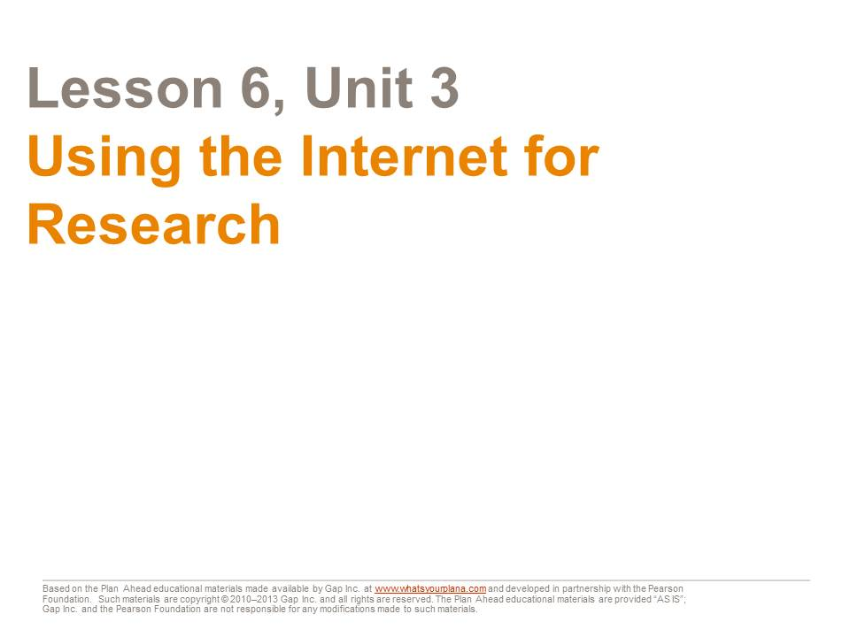
The Internet is a great tool for doing research. But just like any research tool, you need to know how to use it.
Today we’re going to look at:
- How to do an effective Internet search
- How to know if the information you find is trustworthy
- How to keep track of your sources

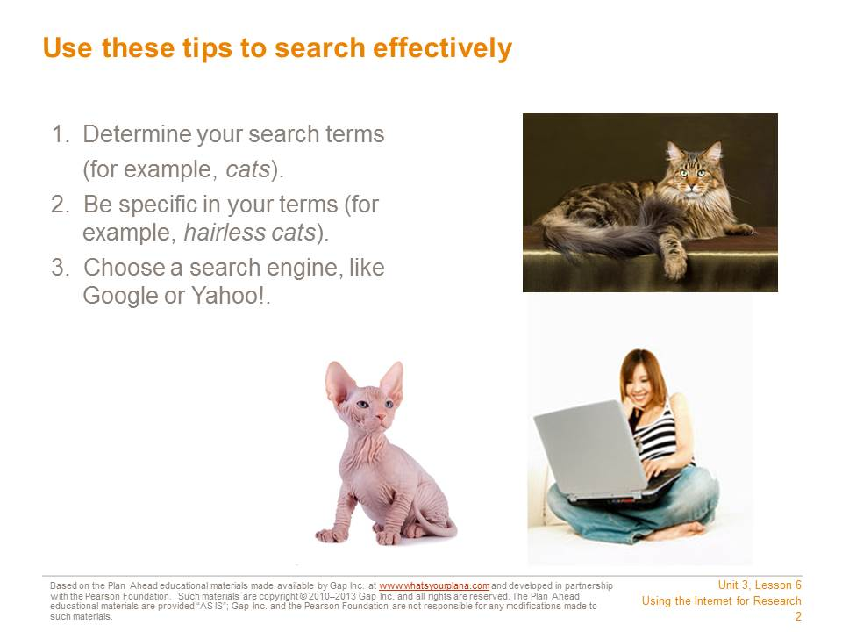

First, decide on your search terms. If you are going to write a report on cats, you will use that word as your main search term. But if you want to write a report on a specific type of cat, you would use that term—for example, hairless cats.
Next, choose a search engine. A search engine is a tool that helps you to find information on the Internet. You can use a regular search engine like Google or Yahoo!.

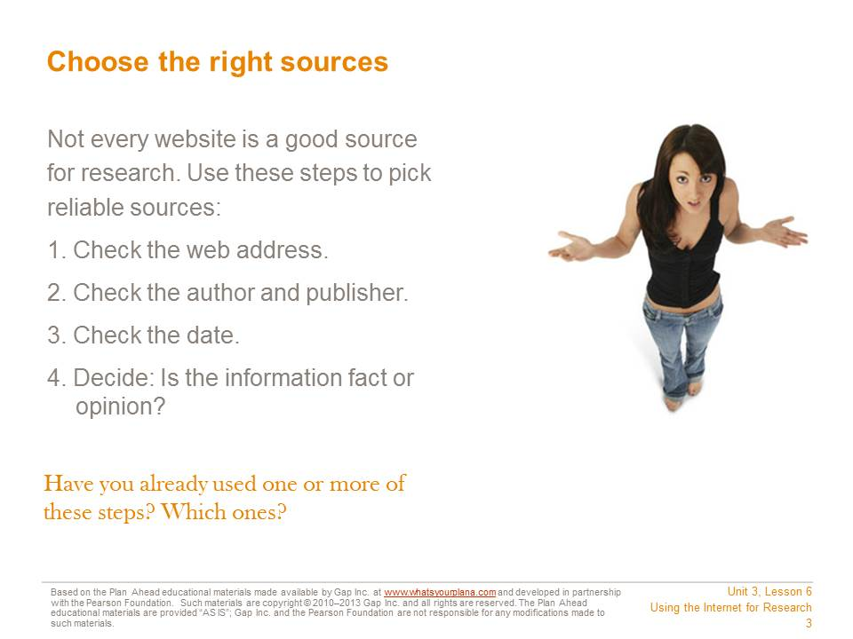

Your search may turn up hundreds or even thousands of results. You have to decide which ones to look at.
You shouldn’t just start with the first result that shows up. There are many sites on the Internet that contain false information. Sometimes the only reason sites show up at the top of the list is that they’ve paid to appear there.
Even worse, there are sites that people use to steal your identity. That means they get information about you so they can pretend to be you. They could get credit cards in your name or even commit crimes, and then people would think you had spent that money or committed those crimes! Be very careful with websites that ask for your name, your email address, or your phone number. You don’t know who can see that information once you plug it in!
There are four steps to make sure that you’re using a reliable source. We will go through each one in detail, so you can feel confident that you’re choosing good sites.

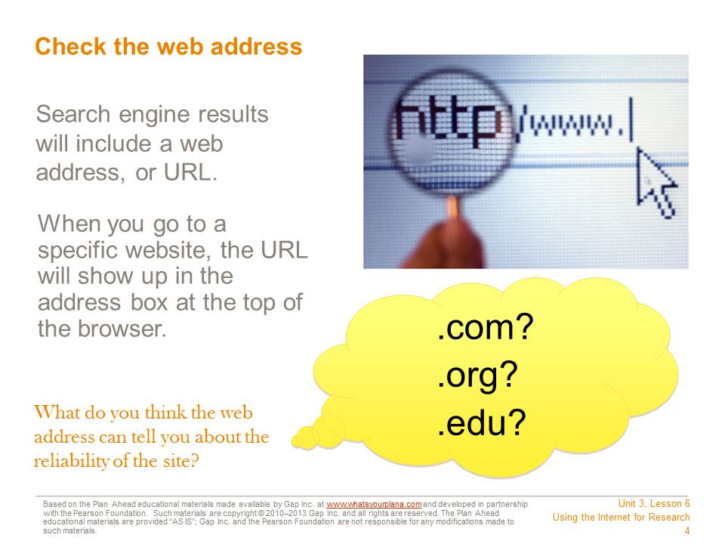

When you use a search engine, the results will include a web address. When you go to a specific site, the address will show up at the top, in the browser.
Web addresses can be long and confusing. They can include lots of numbers, letters, or symbols that mean something to your computer, but don’t mean much to you. That’s okay. The web address can still give you important information.
The web domain can help you recognize where the information comes from. The domain shows up as the last few letters after the period. Here are some of the common ones you see and what they mean:
- .com = company (many newspapers and news magazines are also .com)
- .org = organization (many museums are .org)
- .edu = educational institution (usually a college or a university)
If the address says it comes from a national newspaper, news magazine, museum, a college, or a university, that’s a good first sign.

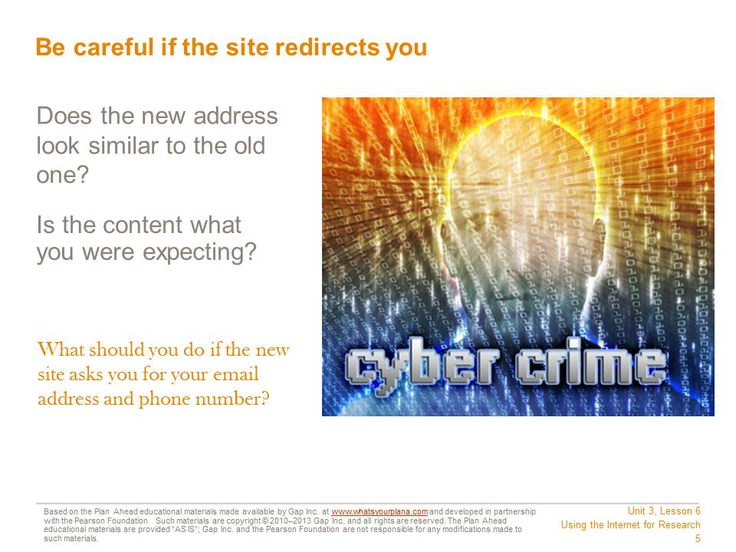
What happens if the site “redirects” you? Sometimes organizations need to move their websites to a new address. If you go to the old link, you may see a message explaining that you will be redirected to a new site.
When the new site loads, check the web address immediately.
- Does it look similar to the old address? Is it still a .com, .org, or .edu?
- Does the content look appropriate? If you were expecting the home page for a museum, is that what you see at the new address? If you expected to see something from a museum and now you see someone’s personal page, or some other page that has nothing to do with museums, don’t use that link! It is no longer reliable.
- You can also check the “About Us” or “About the Company” section to learn more about the site and its sponsor.
Sometimes people make their websites look as though they’re for museums, schools, or other good sources, but they aren’t. Anybody can start up a website claiming to represent a museum, and there are plenty of college professors who run websites that promote their own personal opinions. So you need to look at more than just the web address.

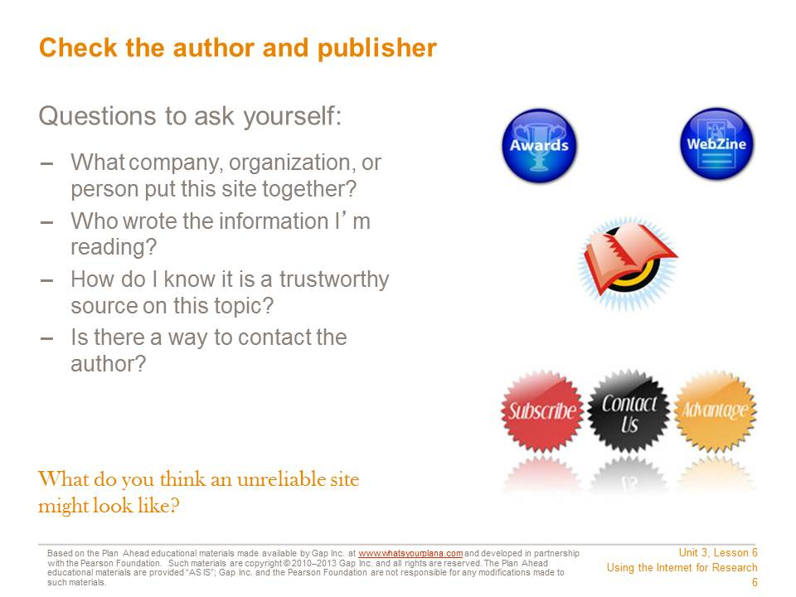
Who is responsible for writing the content on the site? Look for an author’s name. “Webmaster” is not someone’s name; this person puts the information onto the website but doesn’t necessarily write it.
You’re trying to find reputable websites. “Reputable” means that the site has a good reputation; it contains trustworthy information.
Try to identify who created the site—whether it represents a person, a company, or some other kind of organization.
Some websites, like online encyclopedias, may not list their authors. If you have other reasons to trust the website (for example, because it’s one your teacher recommended), you can still use it, but it’s always better to use a site that tells you who its authors are.
One thing you should always do is compare the information you find from different resources. For example, if you are doing research for your history class, compare what each website says with what is in your textbook. A site might have more detailed information than your textbook, which is okay. But if the site says World War II didn’t happen, it’s clearly not a reliable site for you to use.

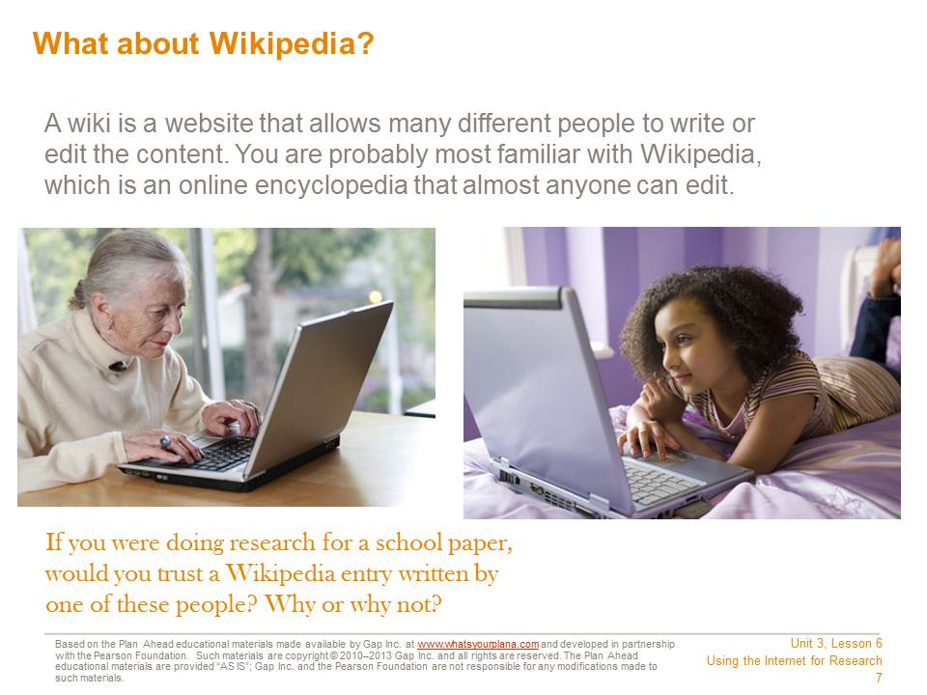
A wiki allows many different people to add content or edit it, so either of the people pictured above could edit the content of a Wikipedia entry. There are advantages and disadvantages to wikis. The advantage is that many different people can contribute. It’s interactive and it benefits from the wisdom and expertise of a wide range of contributors.
However, that can also be a disadvantage. Look at the photographs above. One of these people is younger than you are. She might not know enough about a topic to provide good information. The woman is much older than you are, and she probably does have knowledge and expertise on some topics. But you certainly wouldn’t expect her to know a lot about the latest techno band or the most popular TV show with high schoolers. So when you use a site like Wikipedia, you always need to remember that you might be reading something that a non-expert wrote. It could be incorrect. That’s why some teachers prefer that you not use Wikipedia as a source for assignments.
If you are allowed to use Wikipedia, make sure to double check the information against other sources. Some articles on the site are more accurate than others.

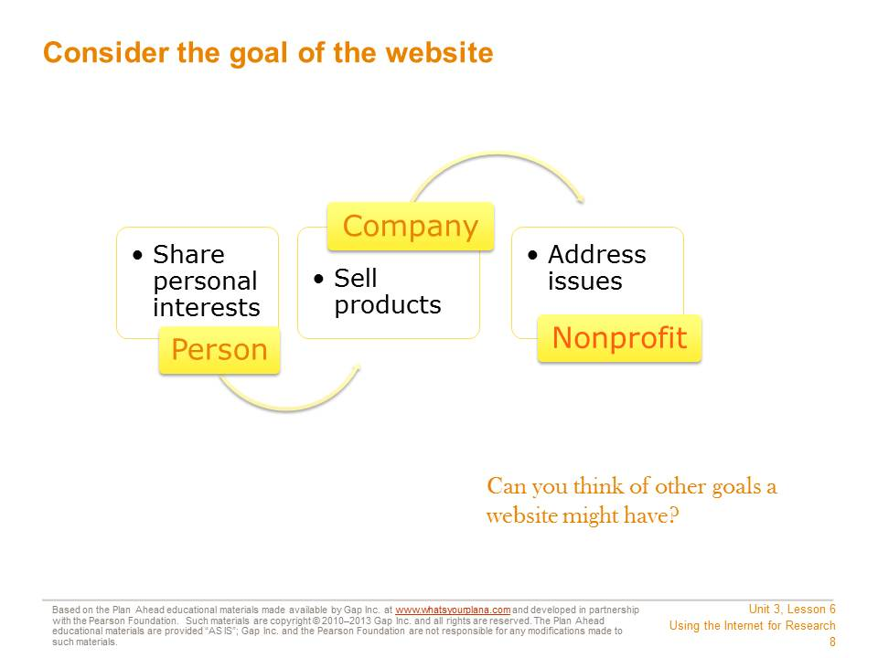

The site’s creators have a goal, a reason they built the site. See if you can identify what the goal is. Usually, a site is built to share information with the general public.
A person might make a site to share her personal interests.
A company usually makes a site to promote its business or products.
An organization, like a nonprofit group, might have a site to talk about the issue or cause the organization addresses.
If people or companies are selling something or just sharing their own opinions, their information may not be trustworthy. A school or a museum might be more reliable. But also keep in mind that there are some schools and museums that have very specific beliefs that most people don’t follow. So it’s important to continue to double check your information against sources you know are reliable, like your textbook.

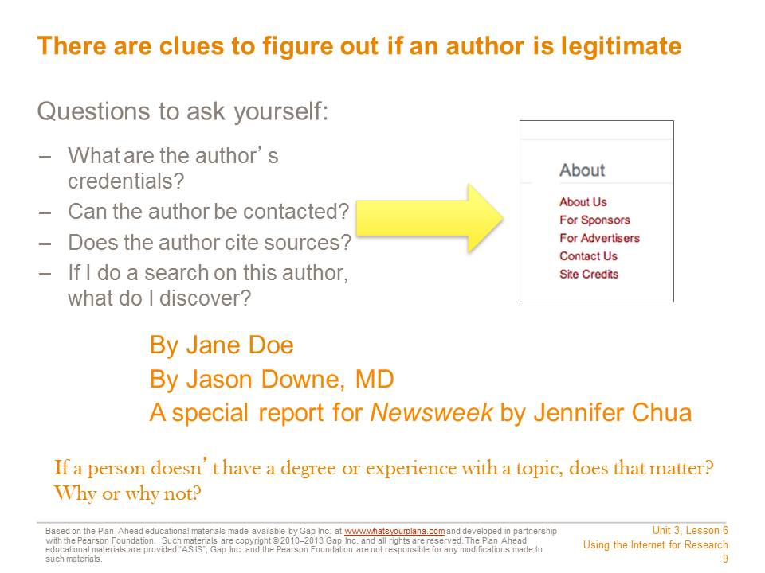

How do you know the author is a trustworthy source on this topic?
- A good source will include the author’s credentials. Is this person an expert on this subject—a college professor in this subject or someone with an important job in this field?
- If the author is a journalist, who is she writing for? If she writes for a reputable magazine or newspaper, then she had to prove that her facts were accurate.
- You can also do a separate search on the author to learn more about him or her.
- Is there a way to contact the author? Journalists and experts frequently include this information, so if people have questions about the article, they know whom to ask.

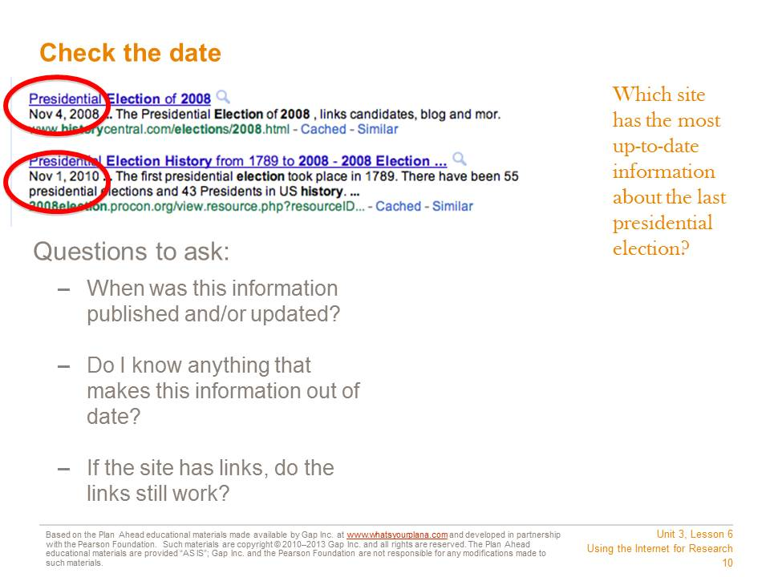

Look for the date when the information was published or updated. It may be at the very top of the page, or down at the bottom by a copyright statement.
Sometimes you will see “Published on” and “Updated on”—that means the information was published on one date and then added to or revised on another date. This often happens with news stories.
What is an acceptable date? In general, look for the newest information available.
If you are researching something that hasn’t changed very much, like a historical event, you can use older information and still feel confident that it’s reliable. For example, what we know about the Roman Empire hasn’t changed much in the last year or two.
But say you’re researching US politics using a website from 2007. That site would say that our country has never had an African American president. If no one has updated this website to include President Obama, then it’s probably not a reliable website.

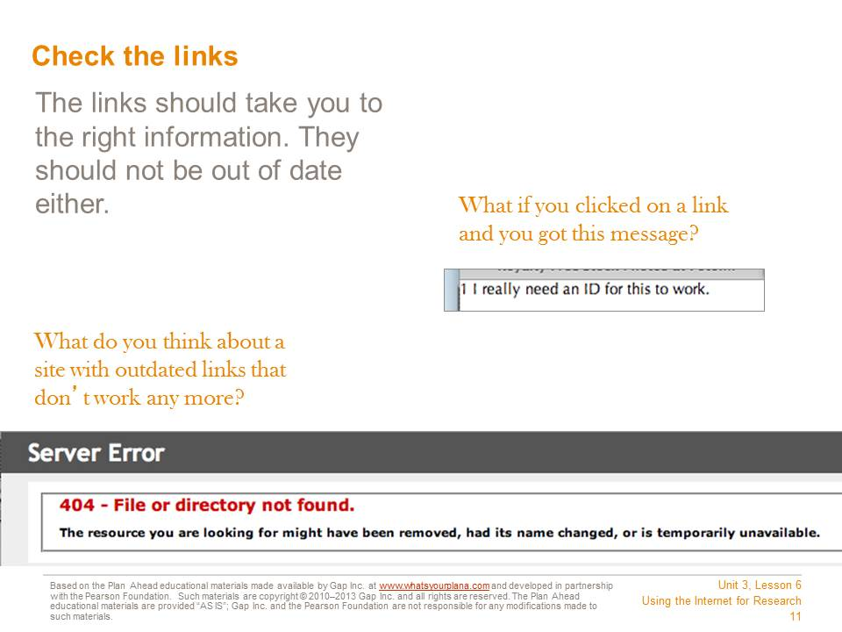

Many sites link to other websites that offer similar information. Try out the links—do they still connect you to the right information? If they don’t work, that is a warning sign. If the people who run the site don’t keep their links up to date, they probably aren’t making sure the rest of their information is up to date either.

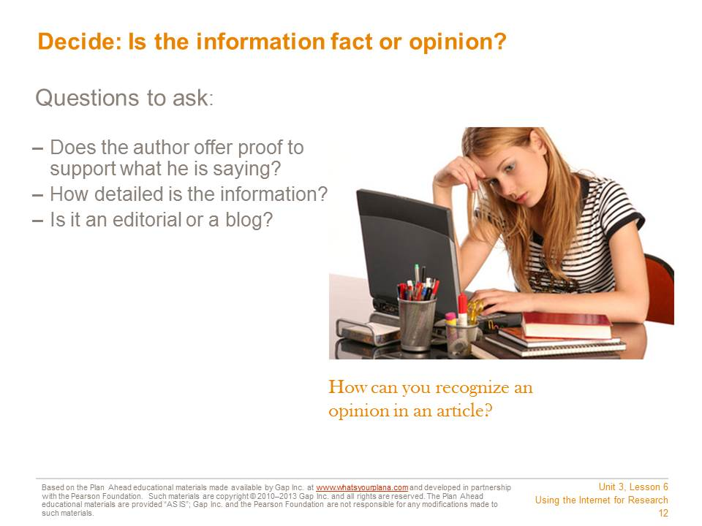

Is the information fact or opinion? If the article includes links to other reputable sites or quotes reputable sources, that’s a good sign. Even if the article you’re reading is an opinion, you can look up the facts being provided and use them for your research.
One sign that the website contains opinions and not facts is if it says things like, “Everyone knows….”
If the article says, “I think…” or “I believe…,” that’s a hint that you’re reading an opinion piece. Also, if the piece is labeled as an “editorial,” that’s another word for an opinion piece. Many blog entries are also opinion pieces, so be careful if you find something on a blog. If you can’t find supporting evidence, don’t use a blog as part of your research.

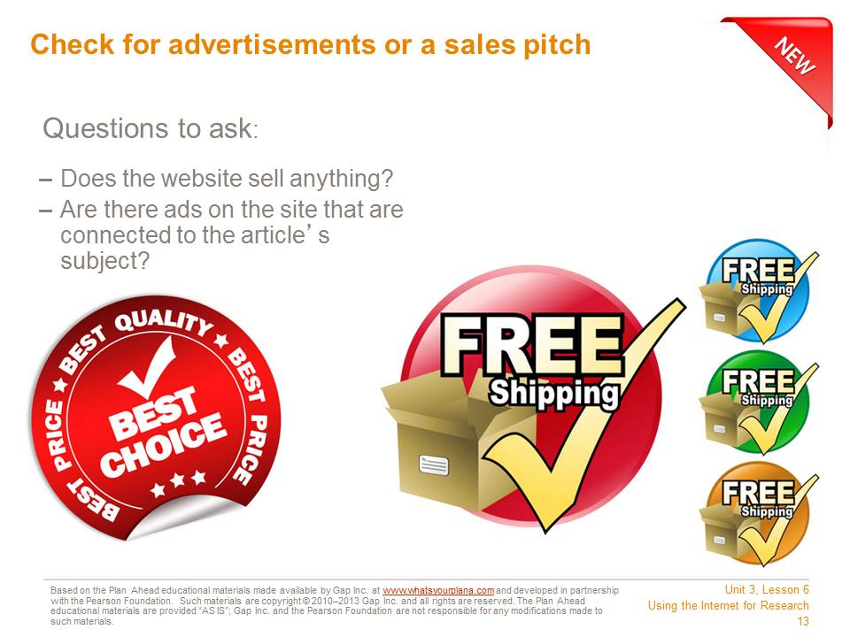

Does the website have ads? If the ads aren’t related to the topic, it just means that this is how the website is getting paid for. But if the ads are for the thing you’re researching, then it makes the whole site suspicious. For example, if you are researching why Vitamin B is a good thing, and the ads are for a company that sells Vitamin B, then you can’t be sure you’re getting the whole story.
If the website is selling something, that might influence what the article says. For example, a veterinarian’s office might have good information on cats. But if the site claims you should only feed your cat a specific type of cat food—which it sells—that’s a warning sign.

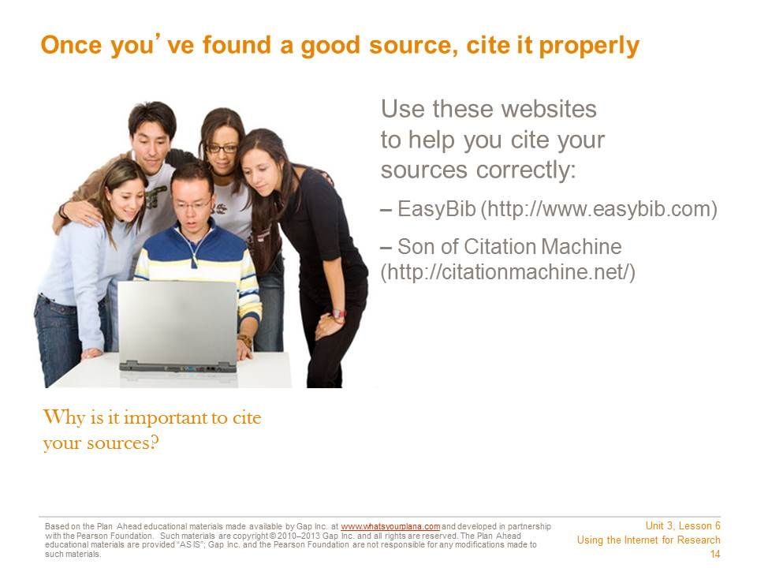
Citing your sources means telling people where you got your information. When you do research, you need to list the books, encyclopedias, and Internet sources you used.
It’s important to cite your sources. It lets your teacher know that you have used good information for your report. When experts do research, they cite their sources so that other people can do the same research if they want to. Any time you use someone else’s words or information, you must cite who and where you got it from.
It’s also illegal not to! You need to give credit to the people who wrote the information. Otherwise it seems as though you wrote it, and that’s called plagiarism.
For each Internet source you use, write down the following information:
- The name of the site and the author (Who made the website? A company? An organization? An individual?)
- The name of the article, if there was a specific article you used
- What day you found the information
- The web address or URL
- The date on which the information was published
Citation generators, such as EasyBib and Son of Citation Machine, can help you put the information in the right format. Different teachers use different formats, so ask your teacher which one is right for your class.
Student Resource 6.2
Worksheet: Using the Internet for Research
Student Name:_______________________________________________________ Date:___________
Directions: Use this sheet to take notes on how to do effective research on the Internet.

How to Search Effectively
Step One:
Step Two:
Step Three:

How to Choose the Right Sources
Step One:
Step Two:
Step Three:
Step Four:

- What should you do if a website asks for personal information like your name, email address, or phone number? What might happen if you submit these things?

- What should you look for in a web address? Why?

- What should you do if a website redirects you to a different site?

- What do you need to know about the author and/or publisher? Why?

- Why does it matter what a site’s goal is?

- Why should you check the site’s date?

- Why is it important to cite your sources?

- What are two websites that help you cite your sources properly?

