Lesson 6
Conducting Effective Online Research
Teacher Resources
Resource | Description
Teacher Resource 6.1 | Guide: Conducting Online Research
Teacher Resource 6.2 | Interactive Presentation Notes and Instructions: Using the Internet for Research (includes separate PowerPoint file)
Teacher Resource 6.3 | Quiz: Using the Internet for Research
Teacher Resource 6.4 | Answer Key: Quiz on Using the Internet for Research
Teacher Resource 6.5 | Key Vocabulary: Conducting Effective Online Research
Teacher Resource 6.6 | Bibliography: Conducting Effective Online Research
Teacher Resource 6.1
Guide: Conducting Online Research
Read each statement below and ask students to vote by a show of hands on whether the statements are true or false.

- True or False? Most sources on the Internet are reliable.
- True or False? If I find a website through a Google search, it’s probably okay to use for a research paper.
- True or False? If a website has expired and sends you to another page, the new site is always fake.
- True or False? If a website has no author, then you should never use it as a source.
- True or False? Any website that says it’s from a university is safe to use.
- True or False? Blogs are always reliable sources of information since they are written by experts.
- True or False? You should only cite the websites you use in your research if you quote them.

Do not share the answers with students until after they have viewed the presentation.
Answer Key
True or False? Most sources on the Internet are reliable. False. There are many reliable sources on the Internet, but there are an equal number of unreliable sources. You need to make sure a source is reliable before you use it.
True or False? If I find a website through a Google search, it’s probably okay to use for a research paper. False. A Google search does not guarantee a site’s reliability. You need to follow the appropriate steps to make sure that a site is accurate and trustworthy.
True or False? If a website has expired and sends you to another page, the new site is always fake. False. Companies sometimes move their websites for legitimate reasons—because they buy a new web address, for example. But some website redirections are tricks to get you to dangerous or unreliable sites, so it’s important to double check.
True or False? If a website has no author, then you should never use it as a source. False. Some online encyclopedias do not list authors, but they are still reliable. You need to follow the appropriate steps to make sure a site is trustworthy, whether it lists an author or not.
True or False? Any website that says it’s from a university is safe to use. False. People can put up a site that claims to be from a university, and some professors put up web pages through their university that promote their personal ideas or opinions.
True or False? Blogs are always reliable sources of information since they are written by experts. False. Blogs are rarely reliable sources because they are designed to express personal opinions. You might use a blog as a source if you are citing people’s opinions, but you shouldn’t trust facts that are presented in a blog unless you can verify them by using other sources.
True or False? You should only cite the websites you use in your research if you quote them. False. You need to cite all the websites you use as research, whether you quote them or not. You are still using information from that source, even if you’re not quoting it.

Teacher Resource 6.2
Interactive Presentation Notes and Instructions: Using the Internet for Research
1. Before you show this presentation, use the text accompanying each slide to develop presentation notes. Writing the notes yourself enables you to approach the subject matter in a way that is comfortable to you and engaging for your students. Note the ideas for fully engaging the students that are placed at key points in the “Notes” section.

2. Make sure to have a book, a newspaper, and a magazine on hand.

3. Determine your preferred citation method or consult with the English/Language Arts department about its preferred method. Once you decide on a form of citation, make arrangements to show an example to the students, either by using one of the online tools (EasyBib or Son of Citation Machine), or by copying the appropriate format onto the board or a sheet of chart paper.

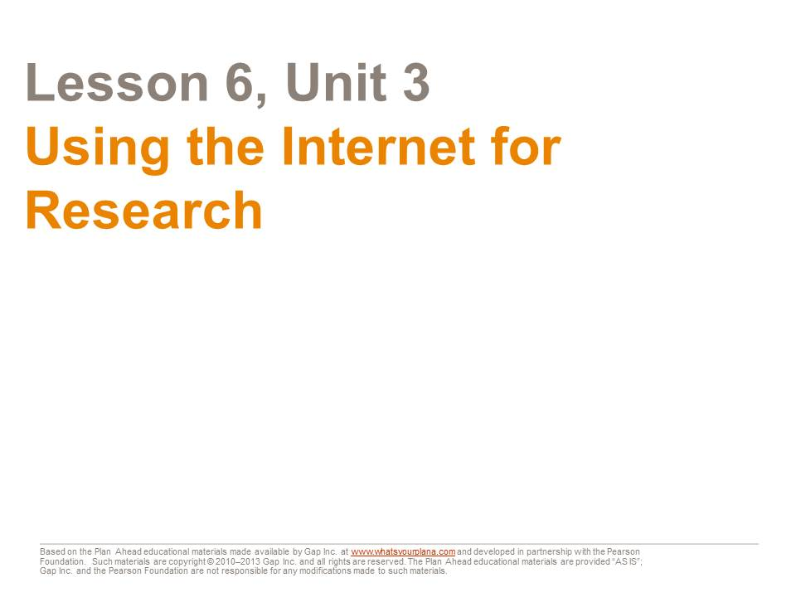  The Internet is a great tool for doing research. But just like any research tool, you need to know how to use it.  Today we’re going to look at:  - How to do an effective Internet search  - How to know if the information you find is trustworthy  - How to keep track of your sources | Presentation notes  Before you show the presentation, let students know that there will be a quiz on the information presented in the next period so they should pay close attention. Point out that students may have done online research before, but they may not have known the best way to do it. They will learn how to do research effectively in this presentation, and that is what they will be tested on—not on their prior experience.

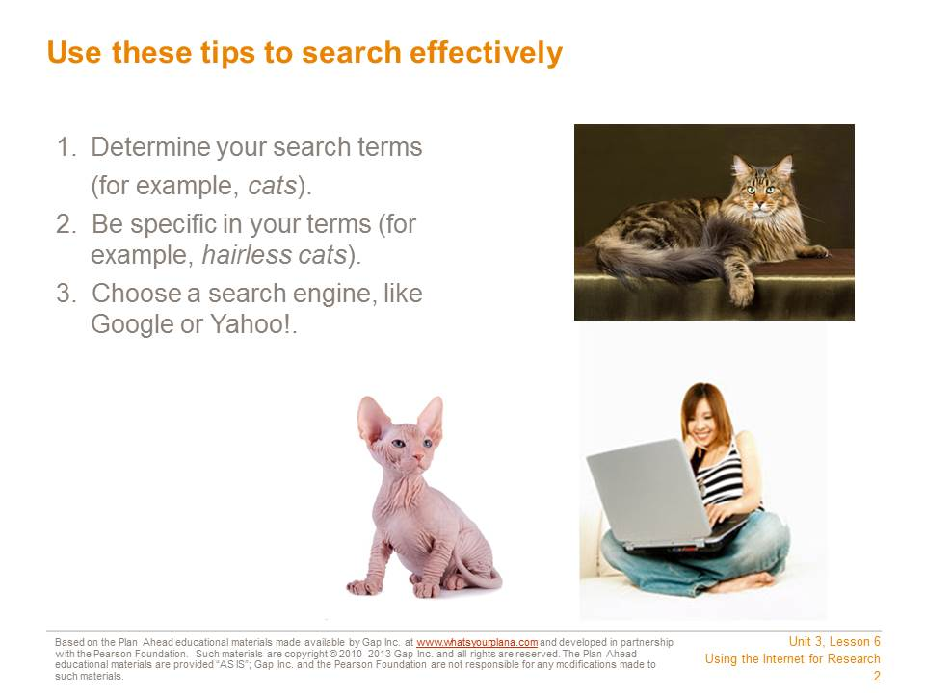  First, decide on your search terms. If you are going to write a report on cats, you will use that word as your main search term. But if you want to write a report on a specific type of cat, you would use that term—for example, hairless cats.  Next, choose a search engine. A search engine is a tool that helps you to find information on the Internet. You can use a regular search engine like Google or Yahoo!. | Presentation notes  After showing this slide, ask students: if you were interested in searching for a summer job, what search terms would you use?  Guide students to recognize that some terms, such as job, summer job, or jobs for high school students, might be too broad and bring up results they aren’t looking for, like full-time jobs for adults. Instead, students could search for their city or neighborhood name + jobs for high school students or for a specific company or store where they might want to work. (Of course there are also sites like Craigslist.)

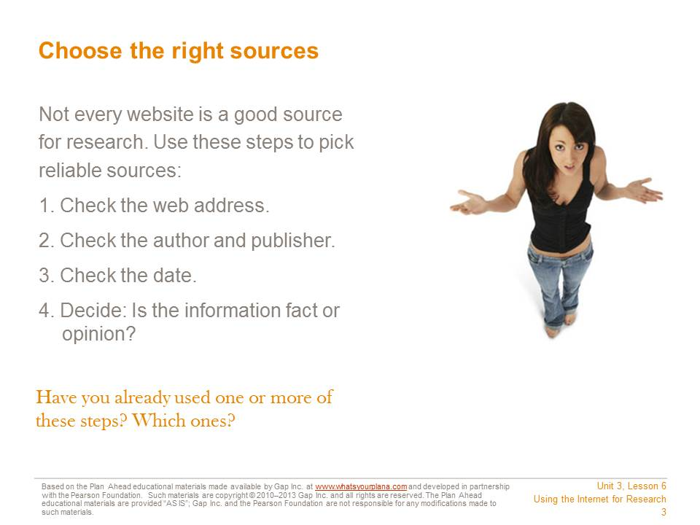  Your search may turn up hundreds or even thousands of results. You have to decide which ones to look at.  You shouldn’t just start with the first result that shows up. There are many sites on the Internet that contain false information. Sometimes the only reason sites show up at the top of the list is that they’ve paid to appear there.  Even worse, there are sites that people use to steal your identity. That means they get information about you so they can pretend to be you. They could get credit cards in your name or even commit crimes, and then people would think you had spent that money or committed those crimes! Be very careful with websites that ask for your name, your email address, or your phone number. You don’t know who can see that information once you plug it in!  There are four steps to make sure that you’re using a reliable source. We will go through each one in detail, so you can feel confident that you’re choosing good sites. | Presentation notes  After students have filled in their worksheets, ask volunteers to paraphrase the process. Then review the importance of being careful about submitting personal information to websites; many students are used to sharing personal data online and will need more explanation.

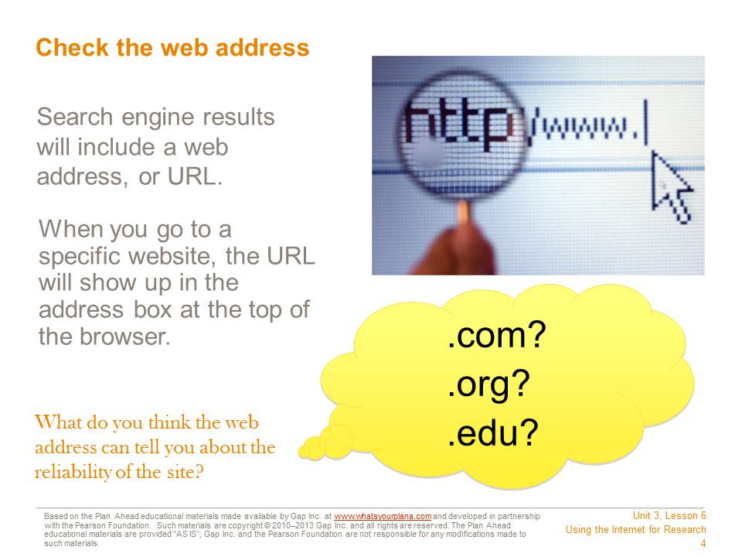  When you use a search engine, the results will include a web address. When you go to a specific site, the address will show up at the top, in the browser.  Web addresses can be long and confusing. They can include lots of numbers, letters, or symbols that mean something to your computer, but don’t mean much to you. That’s okay. The web address can still give you important information.  The web domain can help you recognize where the information comes from. The domain shows up as the last few letters after the period. Here are some of the common ones you see and what they mean:  - .com = company (many newspapers and news magazines are also .com)  - .org = organization (many museums are .org)  - .edu = educational institution (usually a college or a university)  If the address says it comes from a national newspaper, news magazine, museum, a college, or a university, that’s a good first sign. | Presentation notes  After students complete this section of their worksheets, ensure understanding by soliciting responses from a range of students on the following questions:  What would our school district’s web address probably end with? (.edu, because it’s an educational institution)  What do you think Facebook’s web address ends with? (.com, because it’s a company)  What do you think news channel or newspaper websites like CNN or the New York Times end with? (.com, because they are companies)  What do you think the website for the NFL, NBA, or MLB ends with? (.com, because they are businesses)  Can anyone remember what the My Next Move website ends with? (.org, because it’s an organization founded by the US government to help people do research about jobs)

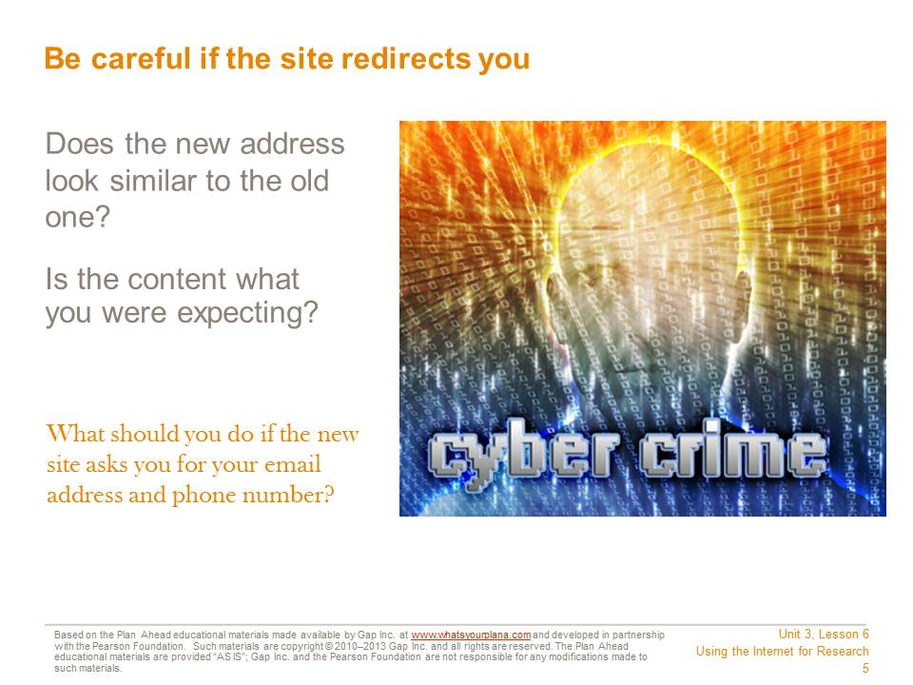  What happens if the site “redirects” you? Sometimes organizations need to move their websites to a new address. If you go to the old link, you may see a message explaining that you will be redirected to a new site.  When the new site loads, check the web address immediately.  - Does it look similar to the old address? Is it still a .com, .org, or .edu?  - Does the content look appropriate? If you were expecting the home page for a museum, is that what you see at the new address? If you expected to see something from a museum and now you see someone’s personal page, or some other page that has nothing to do with museums, don’t use that link! It is no longer reliable.  - You can also check the “About Us” or “About the Company” section to learn more about the site and its sponsor.  Sometimes people make their websites look as though they’re for museums, schools, or other good sources, but they aren’t. Anybody can start up a website claiming to represent a museum, and there are plenty of college professors who run websites that promote their own personal opinions. So you need to look at more than just the web address. | Presentation notes  Ask students: could you go home after school today and start a website? The answer is yes, if they bought a domain name and knew how to set up a web page. They could set up a web page that said they were an expert on a specific topic or claimed to represent a museum or other reputable organization. Nobody has to verify this.  Some people do this for criminal reasons—to steal your identity. Other people do it because they want to convince you about their opinions and they think if their website looks like it’s part of a reputable organization, they can convince you more easily.  Give students time to make notes on their worksheet.

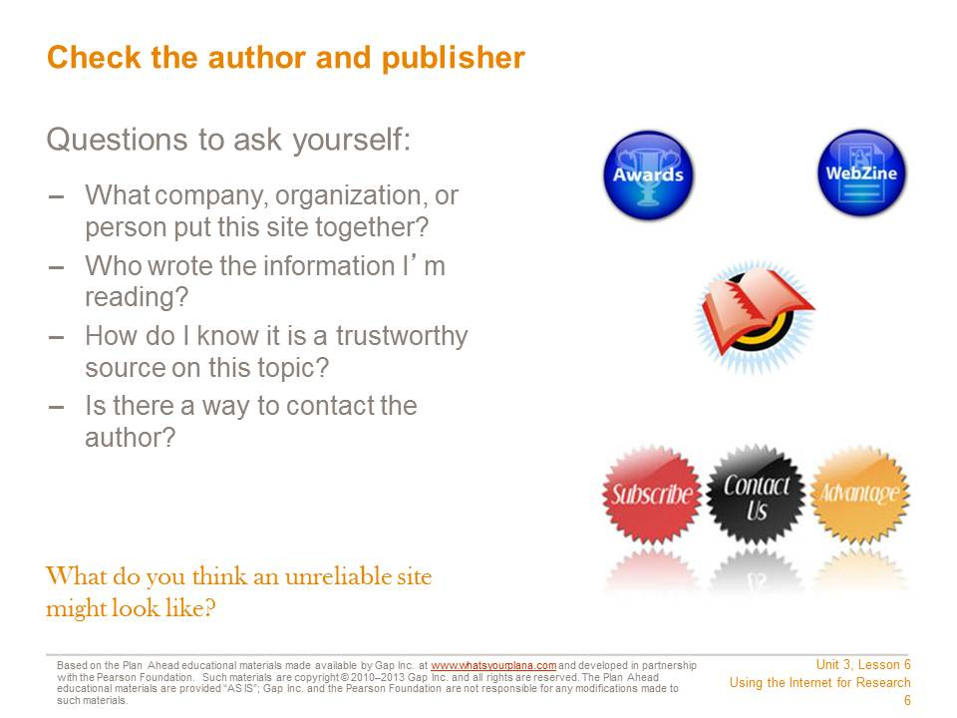  Who is responsible for writing the content on the site? Look for an author’s name. “Webmaster” is not someone’s name; this person puts the information onto the website but doesn’t necessarily write it.  You’re trying to find reputable websites. “Reputable” means that the site has a good reputation; it contains trustworthy information.  Try to identify who created the site—whether it represents a person, a company, or some other kind of organization.  Some websites, like online encyclopedias, may not list their authors. If you have other reasons to trust the website (for example, because it’s one your teacher recommended), you can still use it, but it’s always better to use a site that tells you who its authors are.  One thing you should always do is compare the information you find from different resources. For example, if you are doing research for your history class, compare what each website says with what is in your textbook. A site might have more detailed information than your textbook, which is okay. But if the site says World War II didn’t happen, it’s clearly not a reliable site for you to use. | Presentation notes  Once students fill in this section of their worksheets, point out that the Internet is full of anonymous sources—material that isn’t clearly labeled with an author’s name. This is different from the research materials that most people have used for centuries—books, magazines, and newspapers.  Ask for three student volunteers to come to the front of the room. Give one the book, one the newspaper, and one the magazine. Ask the three students to find the author’s name (for the newspaper and magazine, give them a specific article to search). Students should be able to find the author quickly and easily. Ask students: is it that easy to find the author’s information on the Internet? (Answer: sometimes, but not always)  Explain that the Internet is wonderful because it lets us find information more easily, but it also means we have to be more careful about evaluating the information we find, because anybody can post things online anonymously or they can lie about their qualifications.  Review the importance of comparing information to check a source’s accuracy. Ask students: besides comparing the information to a textbook, how else could you verify a site’s accuracy? Guide students to recognize that this is one reason why it’s important to have multiple sources. If they find articles on five different websites, and four of them say somebody died in 1937 and the fifth one says the person died in 1947, they can probably determine which date is the correct one.

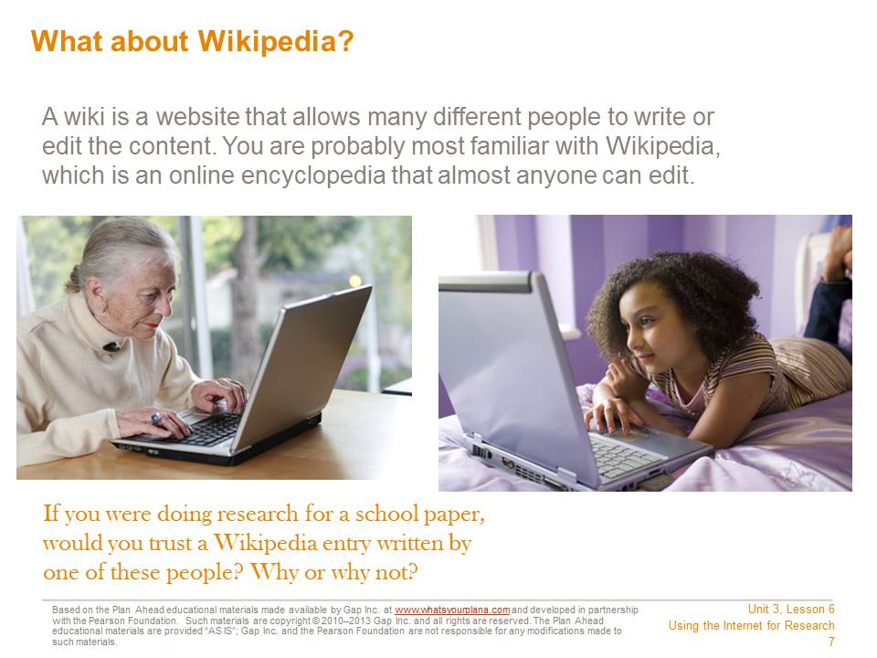  A wiki allows many different people to add content or edit it, so either of the people pictured above could edit the content of a Wikipedia entry. There are advantages and disadvantages to wikis. The advantage is that many different people can contribute. It’s interactive and it benefits from the wisdom and expertise of a wide range of contributors.  However, that can also be a disadvantage. Look at the photographs above. One of these people is younger than you are. She might not know enough about a topic to provide good information. The woman is much older than you are, and she probably does have knowledge and expertise on some topics. But you certainly wouldn’t expect her to know a lot about the latest techno band or the most popular TV show with high schoolers. So when you use a site like Wikipedia, you always need to remember that you might be reading something that a non-expert wrote. It could be incorrect. That’s why some teachers prefer that you not use Wikipedia as a source for assignments.  If you are allowed to use Wikipedia, make sure to double check the information against other sources. Some articles on the site are more accurate than others. | Presentation notes  Share your own personal viewpoint on using Wikipedia for research in this course.

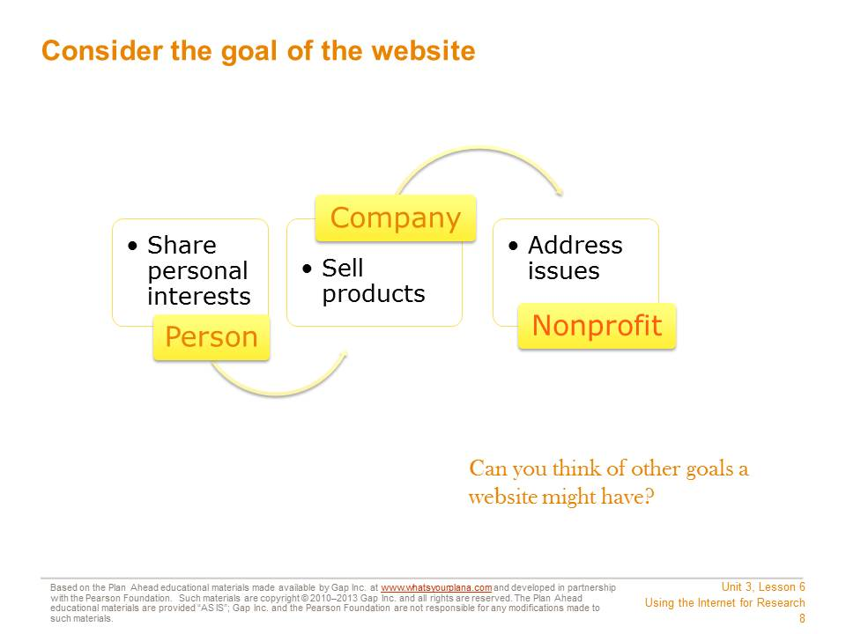  The site’s creators have a goal, a reason they built the site. See if you can identify what the goal is. Usually, a site is built to share information with the general public.  A person might make a site to share her personal interests.  A company usually makes a site to promote its business or products.  An organization, like a nonprofit group, might have a site to talk about the issue or cause the organization addresses.  If people or companies are selling something or just sharing their own opinions, their information may not be trustworthy. A school or a museum might be more reliable. But also keep in mind that there are some schools and museums that have very specific beliefs that most people don’t follow. So it’s important to continue to double check your information against sources you know are reliable, like your textbook. | Presentation notes  Discuss the question on the slide. Point out that sometimes a site will have a mixture of reliable and unreliable information. For example, a doctor might have a website with information about healthy eating. That information is probably reliable, because the doctor is an expert. But the website might also feature information about a special diet plan the doctor helped create, which you can sign up for today for only $49.95. That’s a sales pitch, and the information on that part of the site is probably not as reliable. So identifying the goal of a site can help you determine if it’s reliable, but you have to think carefully about the information you see, too.

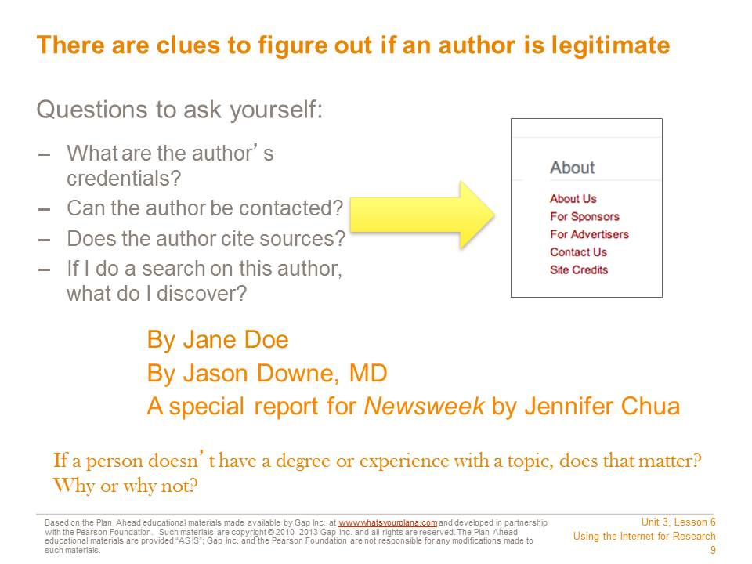  How do you know the author is a trustworthy source on this topic?  - A good source will include the author’s credentials. Is this person an expert on this subject—a college professor in this subject or someone with an important job in this field?  - If the author is a journalist, who is she writing for? If she writes for a reputable magazine or newspaper, then she had to prove that her facts were accurate.  - You can also do a separate search on the author to learn more about him or her.  - Is there a way to contact the author? Journalists and experts frequently include this information, so if people have questions about the article, they know whom to ask. | Presentation notes  Discuss the question posted on the slide (about whether or not it is important for an author to have a degree or experience with the topic). Guide students to recognize that checking for a degree or experience is one of the best ways to check the validity of the information. Also point out that journalists who write for well-respected magazines and newspapers may not be experts, but they usually have talked to experts before they write an article. Therefore, their work is probably a good source as well.  Give students time to add to their worksheets.

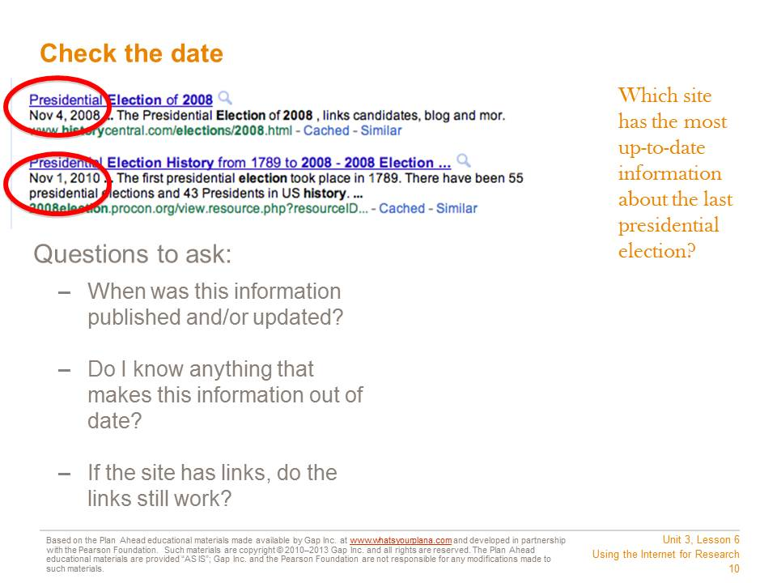  Look for the date when the information was published or updated. It may be at the very top of the page, or down at the bottom by a copyright statement.  Sometimes you will see “Published on” and “Updated on”—that means the information was published on one date and then added to or revised on another date. This often happens with news stories.  What is an acceptable date? In general, look for the newest information available.  If you are researching something that hasn’t changed very much, like a historical event, you can use older information and still feel confident that it’s reliable. For example, what we know about the Roman Empire hasn’t changed much in the last year or two.  But say you’re researching US politics using a website from 2007. That site would say that our country has never had an African American president. If no one has updated this website to include President Obama, then it’s probably not a reliable website. | Presentation notes  Discuss the question posted on the slide. Point out that the earlier date (in 2008) was actually the day when the election took place. So something written that day might not include the results of the election. The later information (from 2010) would include the results of the election, so it would be a better source to use.  After students add to their worksheets, ask: does anyone have a research paper they’re working on right now? If so, use that topic to discuss specifics about the date.  If not, use an example topic. What if you’re writing a paper on the latest cancer research? On the countries involved in World War II? Guide students to recognize that some topics need extremely up-to-date information, while other topics (like historical or literary topics) don’t change as quickly, so it’s possible to use slightly older sources and feel confident they are still accurate.

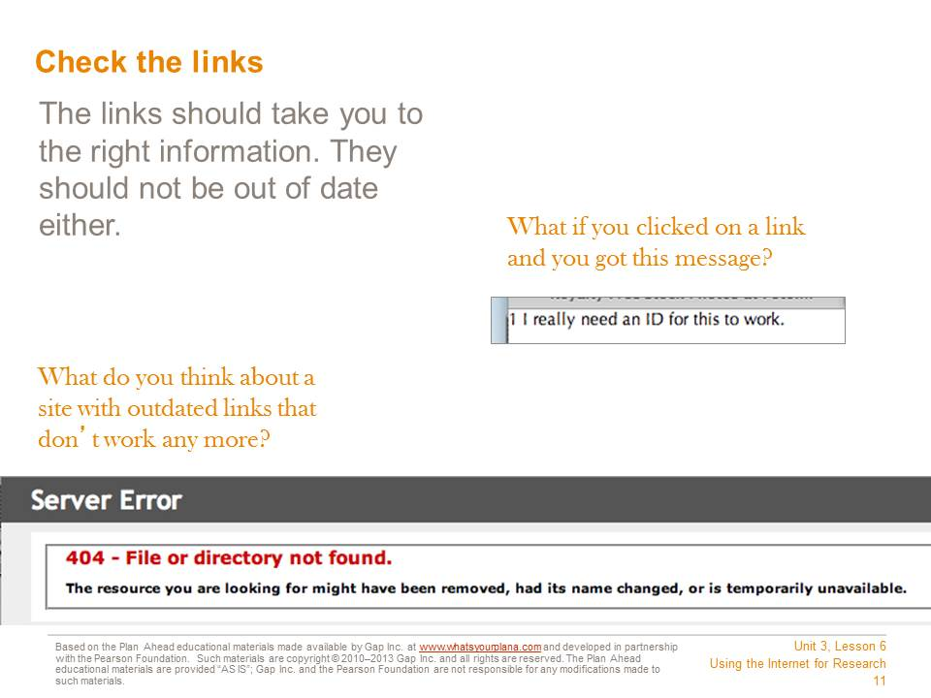  Many sites link to other websites that offer similar information. Try out the links—do they still connect you to the right information? If they don’t work, that is a warning sign. If the people who run the site don’t keep their links up to date, they probably aren’t making sure the rest of their information is up to date either. | Presentation notes

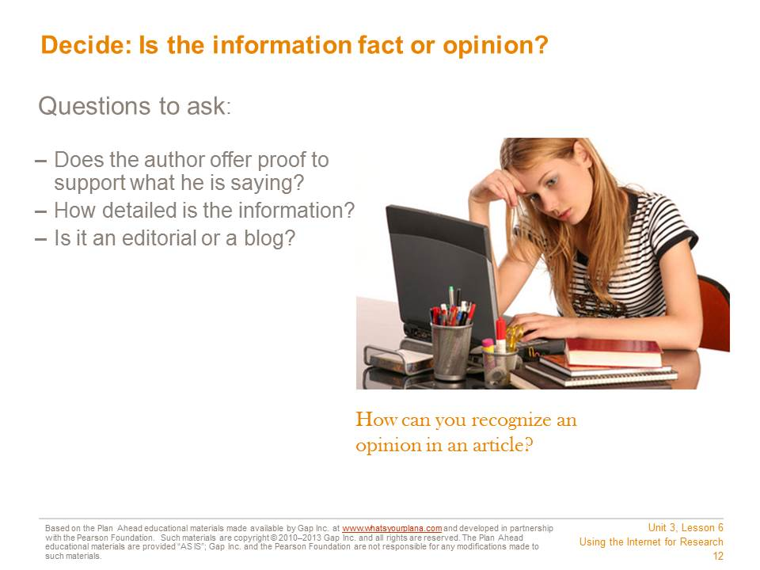  Is the information fact or opinion? If the article includes links to other reputable sites or quotes reputable sources, that’s a good sign. Even if the article you’re reading is an opinion, you can look up the facts being provided and use them for your research.  One sign that the website contains opinions and not facts is if it says things like, “Everyone knows….”  If the article says, “I think…” or “I believe…,” that’s a hint that you’re reading an opinion piece. Also, if the piece is labeled as an “editorial,” that’s another word for an opinion piece. Many blog entries are also opinion pieces, so be careful if you find something on a blog. If you can’t find supporting evidence, don’t use a blog as part of your research. | Presentation notes  Ask students if they can think of other ways to recognize an opinion piece. Review the following:  Some news sites or newspapers actually have a section called “Opinions” or “Viewpoints.” They may also put a disclaimer on the page, such as: “These views represent one person’s opinion and do not reflect the opinions of everyone at this organization.”  If the site makes extreme claims that don’t match up with the rest of your research, it’s probably someone’s opinion. For example, if you’re doing research for a history class paper on the Civil War and you find a site that claims that Abraham Lincoln was shot by aliens, that’s someone’s opinion—not a fact.  If you notice that the site is using—or not using—specific words that other sites commonly use, that can also be a clue that the site is biased. For example, some animal rights groups think calling an animal that lives in your home a “pet” is an insult. So if you find a site that talks a lot about “animal companions” and doesn’t use the word “pet,” that might be a hint that this site is put together by people with a very specific viewpoint.

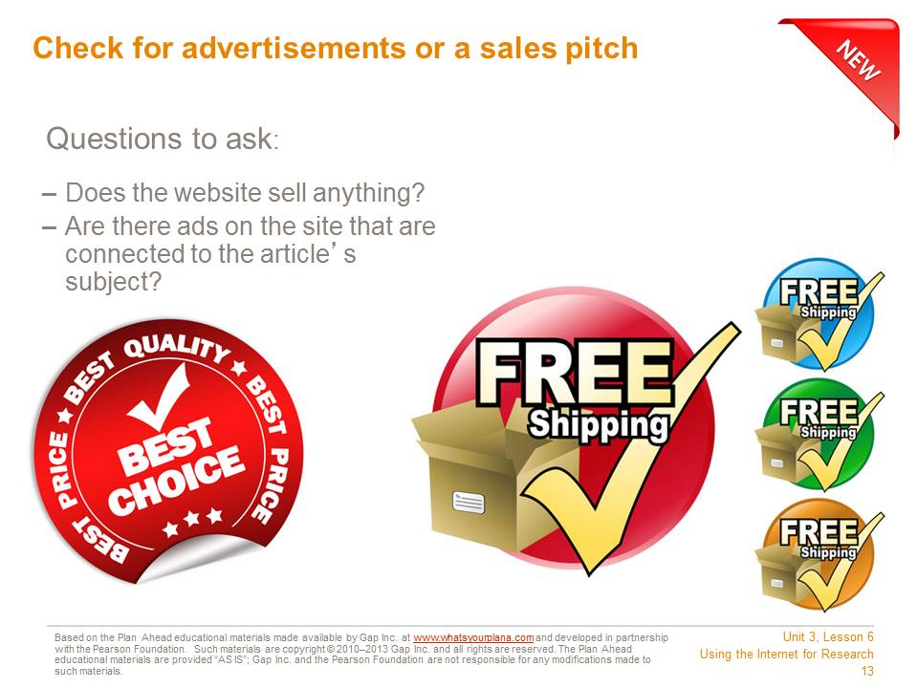  Does the website have ads? If the ads aren’t related to the topic, it just means that this is how the website is getting paid for. But if the ads are for the thing you’re researching, then it makes the whole site suspicious. For example, if you are researching why Vitamin B is a good thing, and the ads are for a company that sells Vitamin B, then you can’t be sure you’re getting the whole story.  If the website is selling something, that might influence what the article says. For example, a veterinarian’s office might have good information on cats. But if the site claims you should only feed your cat a specific type of cat food—which it sells—that’s a warning sign. | Presentation notes  Point out that many sites, as well as magazines and newspapers, include advertisements. So students should not try to avoid any website with any kind of ads on it.  Guide students to recognize that the problem happens when the factual content of a site and its ads overlap or contradict each other. For example, a visit to the San Francisco Chronicle’s website shows that it features ads. Usually the ads are for local tourist attractions like Pier 39 or weekend getaways in Monterey or the Wine Country. If the story you’re looking at is about the governor of California, then those ads aren’t a problem for you. But what if you went to their site and saw a big ad saying “Jerry Brown is the best governor ever!”? If you saw that, you might feel like the Chronicle’s website is not reliable when it comes to articles about the governor.  Also point out that most news organizations have specific guidelines about the types of ads they will take so that they can avoid the appearance of “conflict of interest.”

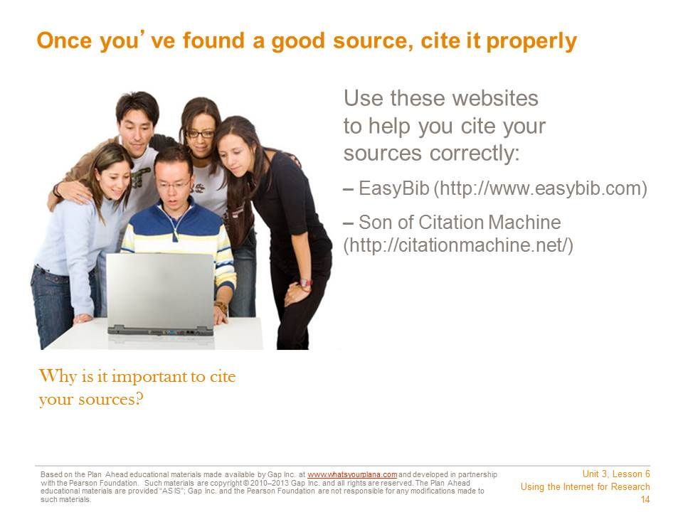  Citing your sources means telling people where you got your information. When you do research, you need to list the books, encyclopedias, and Internet sources you used.  It’s important to cite your sources. It lets your teacher know that you have used good information for your report. When experts do research, they cite their sources so that other people can do the same research if they want to. Any time you use someone else’s words or information, you must cite who and where you got it from.  It’s also illegal not to! You need to give credit to the people who wrote the information. Otherwise it seems as though you wrote it, and that’s called plagiarism.  For each Internet source you use, write down the following information:  - The name of the site and the author (Who made the website? A company? An organization? An individual?)  - The name of the article, if there was a specific article you used  - What day you found the information  - The web address or URL  - The date on which the information was published | Presentation notes  Demonstrate the citation form that you would prefer students use in your classroom (either by accessing EasyBib or Son of Citation Machine and demonstrating online, or by copying the appropriate format onto the board or a sheet of chart paper).

Teacher Resource 6.3
Quiz: Using the Internet for Research
Student Name:__________________________________________________Date:___________
Directions: Respond to the questions below in complete sentences.

- What are two ways to tell if a source is reliable?

- What’s the difference between a web address that ends in “.com” and one that ends in “.edu”?

- Why is it important to know who is responsible for publishing a website before you use it as a source?

- Why does it matter what the goal of a site is?

- When is it okay to use a blog or an editorial as a source?

- Why is it important to cite your sources?
Teacher Resource 6.4
Answer Key: Quiz on Using the Internet for Research
While student answers will vary, the following answer key contains the basic knowledge and concepts to be stated in their responses. Use your preferred scoring or point system to assess the quizzes.
- What are two ways to tell if a source is reliable? Check the web address; look for the author or publisher of the site; check the date; find out if the information is fact or opinion.
- What’s the difference between a web address that ends in “.com” and one that ends in “.edu”? Addresses ending in “.com” are from companies (including major newspapers and magazines) and “.edu” sites are educational institutions such as colleges and universities.
- Why is it important to know who is responsible for publishing a website before you use it as a source? It’s important to know what person, company, or organization is responsible for the site so that you can figure out what their reason is for publishing the information. If they have an opinion or are trying to promote or sell something, you probably shouldn’t use the website as a source.
- Why does it matter what the goal of a site is? The site’s goal will influence what information they present and how they present it. If a site is trying to sell something, for example, they may present biased or inaccurate information in order to make a sale.
- When is it okay to use a blog or an editorial as a source? It’s okay to use these sources if you present the information as opinion and not as fact, and if you can find supporting evidence from other reliable sources.
- Why is it important to cite your sources? It’s important to cite your sources so that people know where you got your information and so that the teacher knows you consulted reliable sources. It’s also important to give credit to the people who provided the information; otherwise it looks as though you came up with it yourself. Plagiarism, or acting as though someone else’s work is your own, is cheating and it is against the law.

Teacher Resource 6.5
Key Vocabulary: Conducting Effective Online Research
These are terms to be introduced or reinforced in this lesson.
Term | Definition
advanced search | A tool or a feature on most Internet search engines designed to help narrow search results.
blog | A contraction of the terms web and log, a type of website usually maintained by an individual with regular entries of commentary, descriptions of events, or other data such as graphics or video.
citation | A reference to a source of information.
citation generator | An interactive online tool designed to create reference citations for research papers. Son of Citation Machine and EasyBib are two common citation generators.
editorial | A piece of writing, usually published in a news source, intended to represent or promote an opinion or a perspective.
meta-search engine | Search engines, such as Cacti Search, that search the results of multiple search engines and can provide the results all at once.
plagiarism | Passing off someone else’s ideas, words, or work as your own; to use someone else’s work without crediting the source.
reputable | Honorable; having a good reputation. A reputable website contains information that you can trust.
search engine | A tool designed to find information on the Internet. Google, Yahoo!, Ask.com, Live, and Bing are popular search engines.
URL | Uniform resource locator, or web address.

Teacher Resource 6.6
Bibliography: Conducting Effective Online Research
The following sources were used in the preparation of this lesson and may be useful for your reference or as classroom resources. We check and update the URLs annually to ensure that they continue to be useful.
Print
Lapan, Richard T. Career Development Across the K-16 Years. Alexandria, VA: American Counseling Association, 2004.
Online
Dennis-Shaw, Sarah. “Wading Through the Web: Teaching Internet Research Strategies.” ReadWriteThink, http://www.readwritethink.org/classroom-resources/lesson-plans/wading-through-teaching-internet-983.html (accessed July 12, 2013).
Gorman, Andrew. “Middle School Lesson Plan: Validity on the Internet.” University of Colorado at Boulder School of Education and Department of Computer Science, http://l3d.cs.colorado.edu/~agorman/educ6804/validity/lesson2.htm (accessed July 12, 2013).

