Lesson 12
Job Applications and Interviews
Teacher Resources
Resource | Description
Teacher Resource 12.1 | Storyboard: Applying for a Job (separate PowerPoint file)
Teacher Resource 12.2 | Interactive Presentation Notes and Instructions: Applications, Interviews, Cover Letters, and Work Permits (includes separate PowerPoint file)
Teacher Resource 12.3 | Example: Pet Supply Store Job Ad  Make It Local | If you choose to replace the example with one based in your community, modify this ad; then remove this callout.
Teacher Resource 12.4 | Assessment Criteria: Resume
Teacher Resource 12.5 | Key Vocabulary: Job Applications and Interviews
Teacher Resource 12.6 | Bibliography: Job Applications and Interviews

Teacher Resource 12.2
Interactive Presentation Notes and Instructions: Applications, Interviews, Cover Letters, and Work Permits
Before you show this presentation, use the text accompanying each slide to develop presentation notes. Writing the notes yourself enables you to approach the subject matter in a way that is comfortable to you and engaging for your students. Note the ideas for fully engaging the students that are placed at key points in the “Notes” section.

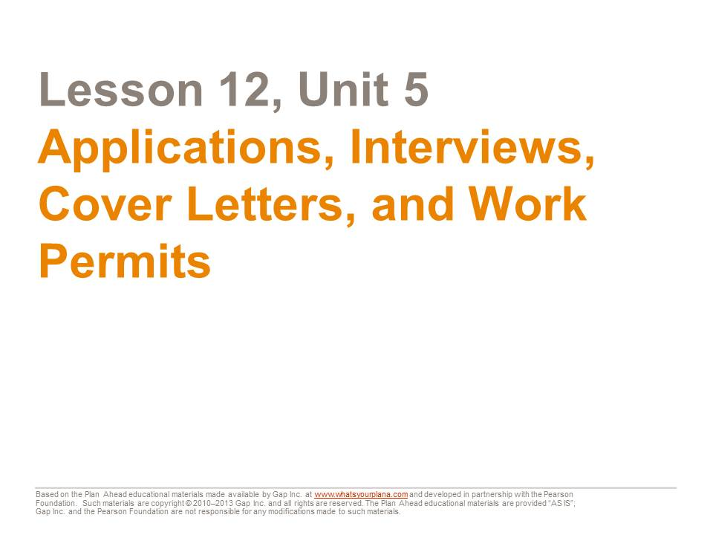  You already know about the power of excellent communication skills to make a good impression on others. Now, as you make plans for college and a future job, it’s also important to know how to present yourself on applications and in interviews. Much of the information and advice here will apply to college admissions. But our main focus is on the job application process. | Presentation notes

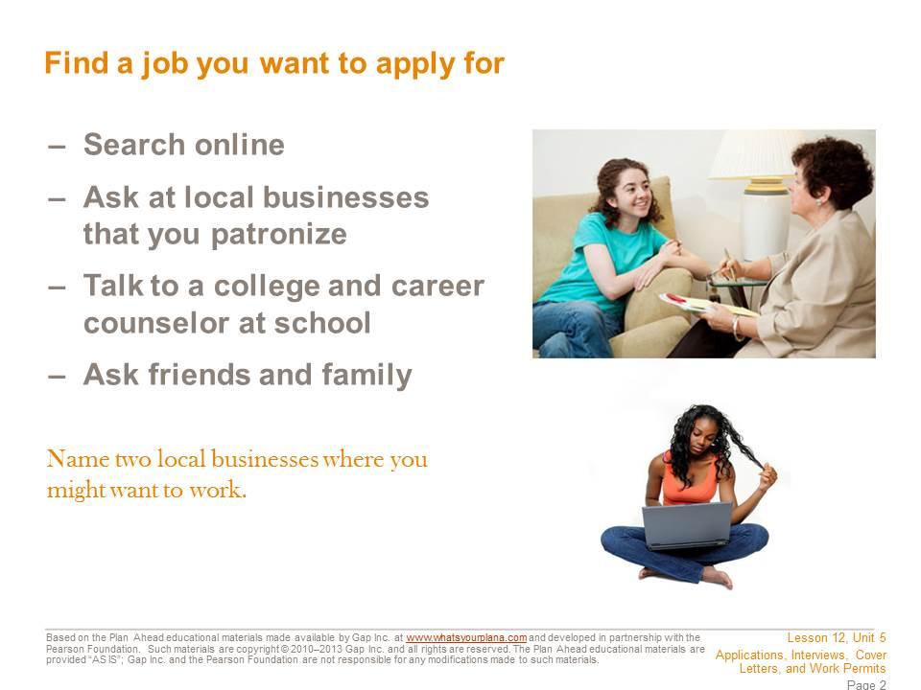  These days, most available jobs are posted online at websites. On a job search website, you can narrow your search geographically—for example, you can search for jobs specifically within a major city or even within a certain neighborhood. Craigslist also has a special section for part-time jobs.  Maybe you already have a potential employer in mind. Some big chains may have local stores in your area, such as coffee bars, grocery stores, or fast-food restaurants. Many of these employers may have applications online that you can fill out.  Many people find jobs by word of mouth. Ask your friends, family members, and neighbors if they know of any job openings. In the business world, this is called networking.  If you’re not sure how to get an application, go to the business and ask in person. Many businesses have applications available; you can take one home to complete and come back another day to return it. | Presentation notes  After students have read the slide, write the following on the board: Potential Good Local Employers. Ask students to brainstorm—what local businesses can they think of where they might be able to get a job? You may wish to supplement their suggestions with your own observations, based on your familiarity with local businesses or your knowledge of where students have worked in the past. Good options include: restaurants, supermarkets, coffee bars, and local shops (pet stores, clothing stores, book stores, sporting goods stores, game stores, etc.). Explain that these types of employers frequently hire high school students, so they may be better prepared to work around your school schedule and will probably be less concerned if you don’t have a lot of experience.

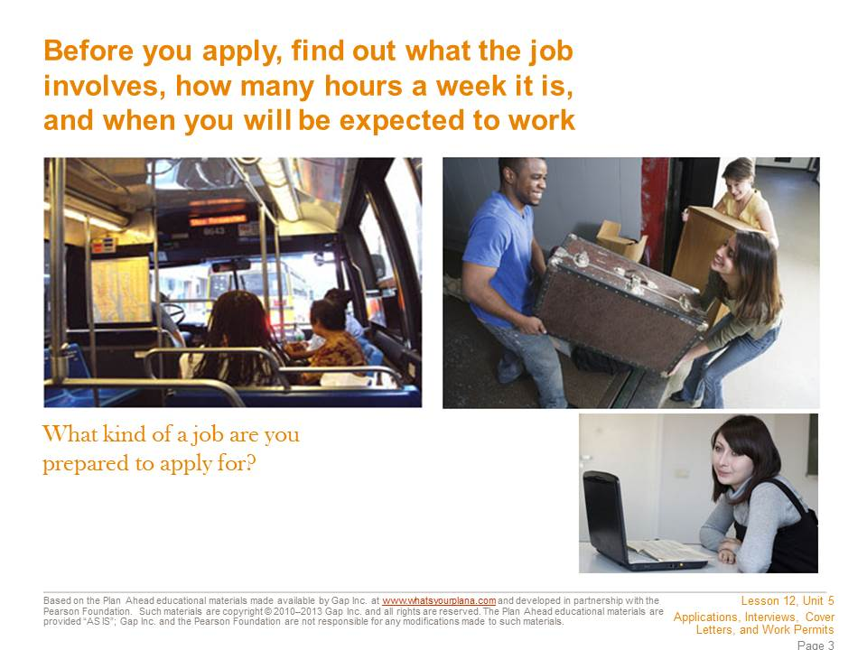  You need to find out some information about a job before you apply for it. Research the company on its website or talk to people who might know something about it. Try to find a job that suits your interests and make sure that you can handle the job requirements.  Do you need to be physically strong? Do you need to be able to use a computer? Will you be serving customers? Also think about scheduling. Can you work around your school schedule? You might want to work at a coffee bar, but if they need people to work the morning shift on weekdays, that job probably won’t work for you except in the summers. Also think about how you will get to work. It might be really fun to get a job at that cool store on the other side of town, but how long will it take you to get there?  As you look for a job, keep these practical considerations in mind. | Presentation notes  Point out that there are other jobs which high school students can get, depending on their qualifications. Some offices may be willing to hire a student as a summer intern, to do data entry in the computer, file papers, or answer phones. Students with the right kinds of experience can also work as a camp counselor or lifeguard.  Ask students to think about the careers they have researched in this course. What kind of summer job could they get that might connect directly to one of their potential careers? Invite a few volunteers to share their ideas.  Guide students to recognize that there are many ways in which a summer job can prepare you for a later career. For example, if you want to be a teacher, a job as a camp counselor or lifeguard could be great experience. You are supervising kids and demonstrating responsibility—two things that teachers need to be able to do.  Also remind students that a volunteer position could give them valuable experience. For example, some hospitals have teenaged volunteers who deliver messages, bring flowers to sick patients, etc. If you want to become a doctor or a nurse, spending that kind of time in a hospital could be very useful, even though you wouldn’t get paid.

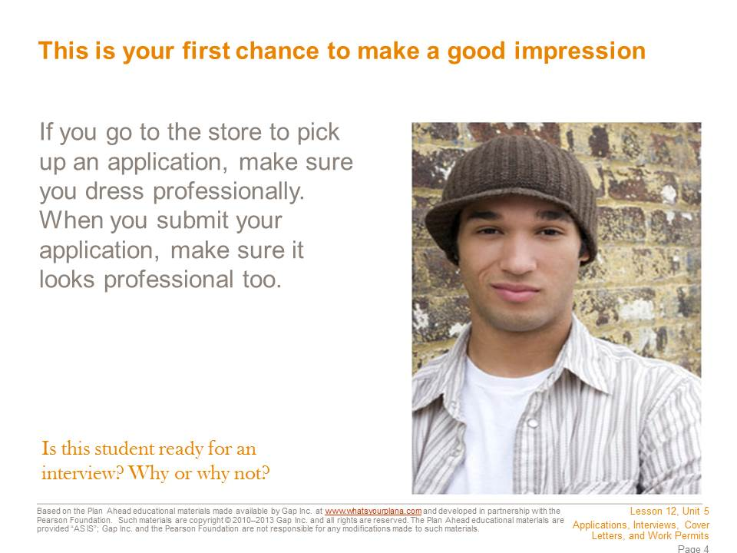  First impressions are very powerful. Even if you’re just submitting an application, you want to look professional. If you are going into a store to pick up an application, dress nicely. That doesn’t mean you need to wear a suit or fancy clothes, but you should wear clothes that will not offend people. For example, this is not the time to wear a t-shirt with profanity on it or a mini-skirt.  You also want your application to look professional. If you are filling out an application by hand, make sure to use blue or black ink. Bright colors and glitter pens are fun to take notes with at school, but they do not look professional on an application. Don’t draw on your application either—no smiley faces next to your signature or hearts dotting the i’s. Neatness is essential: do not turn in a wrinkled application or one that has crossed-out words, and use your easiest-to-read handwriting. Take your time filling it out. | Presentation notes  Ask students to think about what they are wearing right now. Would this be an acceptable outfit to wear if you went in to pick up an application? Why or why not?  Call on a few volunteers to stand up and say if they think their current outfit would be acceptable. Invite the rest of the class to comment: do they think the outfit is acceptable for picking up an application? Why or why not?  Remind students that this is not a question of personal taste, but of dressing appropriately for a business situation. This is another form of code-switching. No one is saying you can’t ever wear mini-skirts, let your pants sag down low, or wear t-shirts with profanity, if that’s something you want to do, but you need to choose when the appropriate time is to wear those things.

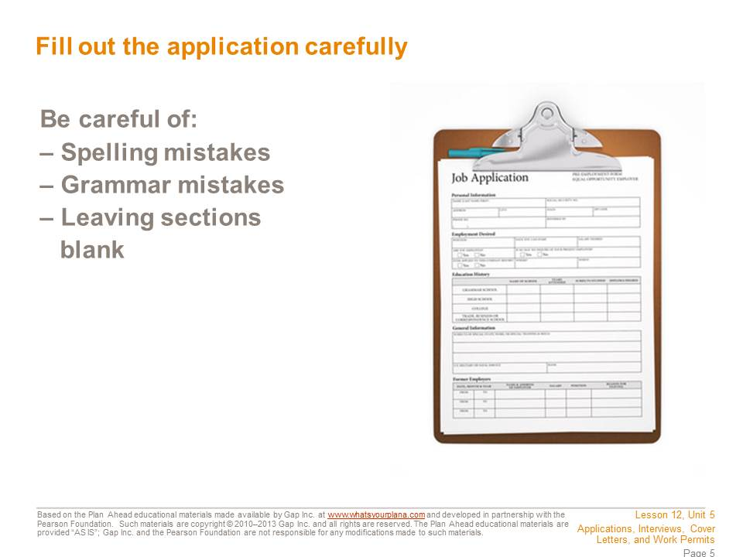  Do your best to avoid making spelling and grammar mistakes. If managers or store owners see a lot of mistakes on your application, they might think you will make mistakes when you’re working.  Don’t leave any sections blank; the manager might think that you didn’t finish the application. Of course there may be sections that you can’t fill out. If this is your first job, you won’t have any “previous employment” to list, and if the application asks about degrees, you don’t have one yet. However, instead of leaving the section blank, you should put “N/A,” which means “not applicable.” That way the manager will understand that you did read the whole application, but just don’t have anything to include in that section. Don’t worry about putting N/A down on a section if you need to; the manager can see that you are just starting out.  If possible, have someone read over your application for you before you turn it in, and make sure you read over the whole thing yourself at least twice. Read it carefully—you don’t want to lose out on a good job because of some careless mistakes.  Many job applications can be filled out online. Before you hit the Send button, however, have someone check your application for mistakes that you didn’t catch. Print a copy of the application to keep for yourself. It will make filling out future applications faster, because you’ve already collected all the information you need. | Presentation notes  Give students time to read the slide, and then ask them: what do you do if you’re filling out an application and there’s a section you can’t answer—like a section where it asks about a college degree?  The correct answer is to write “N/A,” or “not applicable.” It’s important to do that so the employer realizes you did review the entire application, but simply don’t have information to include in a particular section.  Let students know they will take a closer look at a job application later in this lesson.

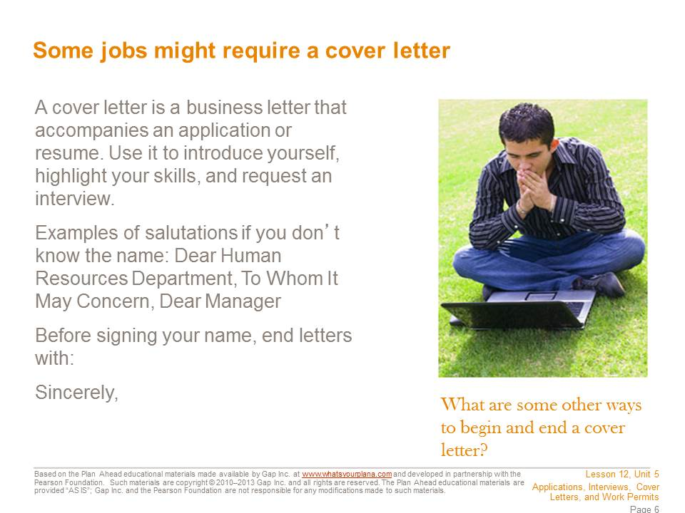  Some employers like to receive a cover letter to have another chance to learn about the potential employee. A cover letter gives you a chance to write about things that might not be on your application. It generally has three parts: an introduction, a summary of your key qualifications, and a request for future action.  In the first section, introduce yourself and explain why you are applying. For example, “I am interested in the position of part-time retail associate that I saw advertised on Jobsforteens.com.”  In the second section, point out why you are a good candidate. For example, “Your ad says that you want someone who is knowledgeable about sports and sports equipment. I have played baseball, lacrosse, and football, and last year I served as the equipment manager for the junior varsity football team at my school.” You also need to make it clear why you want to work at this company. Good reasons? You like its products, you want to have a career in that industry, or you know people who work there and you’ve heard it’s a good job. Bad reasons? It’s the only company hiring, or you think the company will pay you well.  In the third section, you request future action. This generally means that you are asking for an interview. You may want to say something like, “I hope we can discuss this position in the near future,” or “Thank you for considering my application. I look forward to hearing from you soon.” | Presentation notes

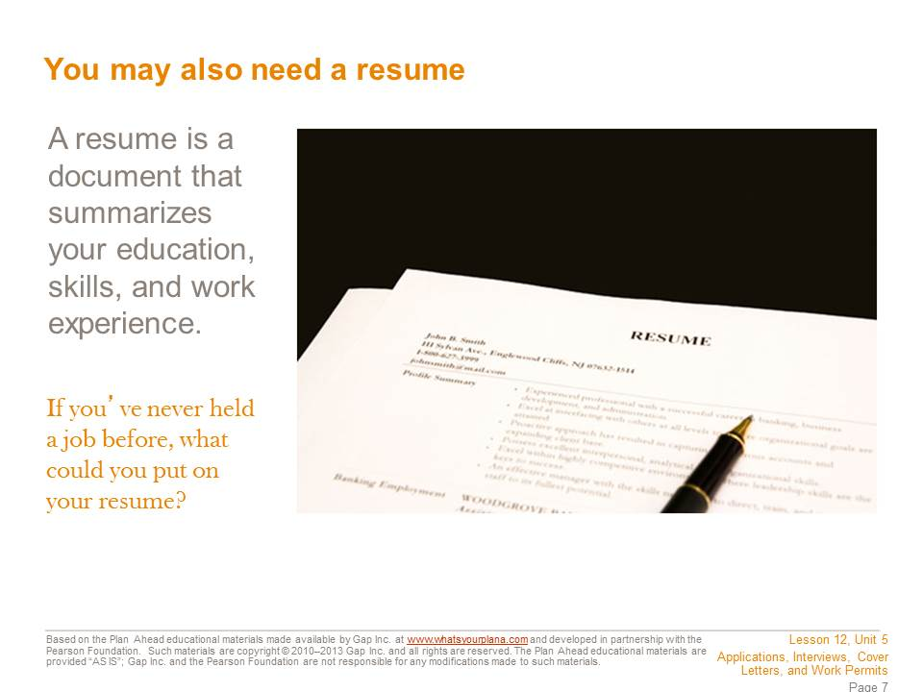  A resume is a written description of your education, skills, and work experience. For work experience, you generally write down the job title, the company you worked for, where it is, when you worked there, and what you did. For example:  - Barista/waiter, Main Street Coffee Company, San Francisco, CA, June–August 2011.  For many adults, the work experience section takes up most of the resume. But what if you’re applying for your first “real” job? First of all, any job you’ve done—babysitting, mowing lawns, or taking care of your neighbor’s cat—can be put on your resume. You might list it as:  - Babysitter, Private Employer, San Francisco, CA, 2008–present  You can also list volunteer experience you may have:  - Kennel Volunteer, San Francisco SPCA, San Francisco, CA 2009–2010  You should list your education, and if you have a good GPA, make sure to mention that. It shows that you are reliable and hardworking. List any awards you’ve received. You can also list extracurricular activities. Finally, you should include a “skills” section that identifies your ability to use the computer, any languages you speak in addition to English, and those all-important “soft skills.” You may wish to mention that you took this course! | Presentation notes

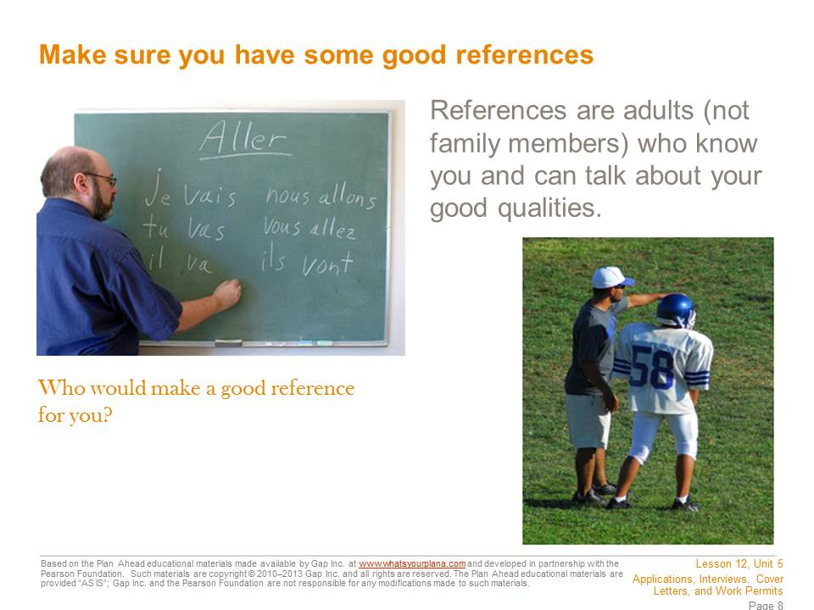  Most companies ask for references. These are people who can talk about what you are like and give potential employers more information about you. Not all employers will ask for references, but it’s good to be prepared.  Your references need to be adults and they can’t be family members. So who can you ask? If you’ve had a job, you can ask your previous employers. If you babysit for your neighbor, she can tell a potential employer if you’re reliable and trustworthy. But maybe you’ve never had a paying job. Don’t worry—for people your age, school has basically been your job. Your teachers can talk about whether or not you show up on time, are reliable, get homework done, etc. Choose one or two teachers you have a good relationship with.  You can also ask adults who work with you on school activities: coaches, band or drama directors, or club moderators. Just like teachers, these people know if you show up on time, do what is asked of you, and are reliable and trustworthy. That’s also true for scout leaders or coaches of local sports teams. If you are involved with a church, a temple, a mosque, or a religious organization, you may also be able to ask people there to vouch for you. And if you do volunteer work, your volunteer supervisor could be a good reference.  You should ask if it’s okay to use someone as a reference before you put that person’s name and information on an application, not after. Make sure you have all of the right information for contacting your reference, too. | Presentation notes  Ask students: who could you ask to be a reference? If possible, you may wish to share some of the people you asked to serve as references for one of your first jobs.  Invite volunteers to share one person they might ask to be a reference and why they think that person would be a good reference. For example:  - I would ask my soccer coach, because I worked really hard at soccer last year and I never missed a practice or a game.  - I would ask my downstairs neighbor because she always asks me to water her plants and pick up her mail when she’s traveling. She’s talked about how responsible I am.  Guide students to recognize that some references are an especially good fit based on the job you’re applying for. For example, if you’re looking to get a job that requires math skills, your math teacher would be a great reference. If you’re applying to be a camp counselor, your neighbor you babysit for you can speak directly to your ability to manage children, as well as general stuff like if you’re reliable or not.  Reassure students that it’s okay if they don’t have two or three “perfect fit” references for every job—that’s almost impossible. But if they can find one “perfect fit” reference, that might make them look like an even stronger candidate for the job.

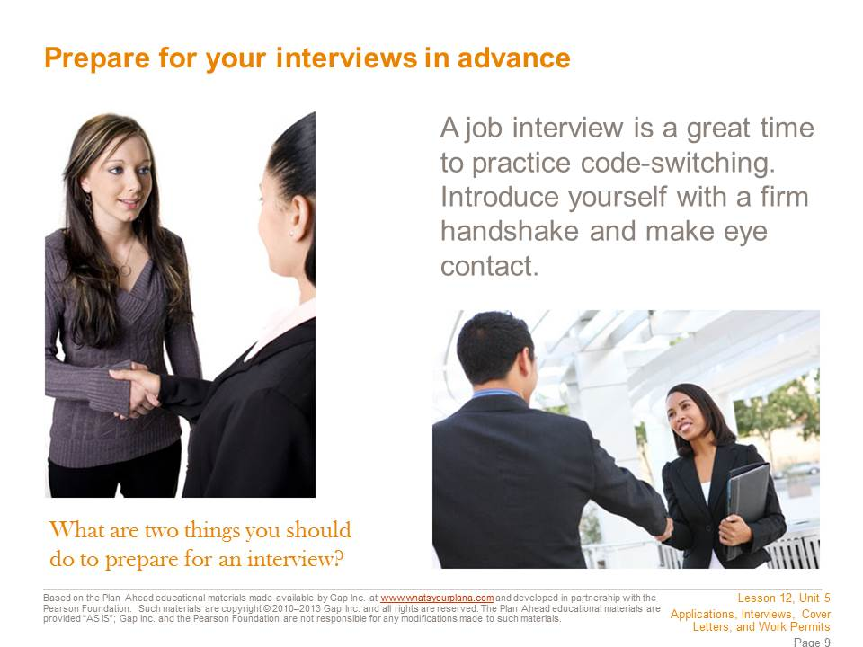  Know how to get to the interview and how long it will take to get there. Leave plenty of time. It’s better to be too early for an interview than to be late. Only a true emergency should cause you to miss an interview. You don’t want to have to say, “Well, my friend was going to give me a ride, but then he had to do something….” Have a back-up plan. Also keep in mind that you may be asked to come back more than once. The employer may want to see if you are reliable and can follow instructions.  If you are going to get a job in an office, wear your most professional-looking clothes. On the other hand, if you are going to work in a restaurant or a store, you probably don’t need to dress up quite as much. Your clothes need to be clean, with no wrinkles, not too baggy, short, or low cut, and nothing with sayings or pictures that might offend people. A nice shirt or blouse and nice pants (not jeans) would be a reasonable outfit. Don’t wear lots of make-up or perfume; some people are allergic to perfume. This is also not the time to have a really unusual hair style.  Bring a couple of pens in case there are other forms you need to fill out. Bring a note pad so you can jot down information. If you have submitted a resume or cover letter, bring copies. Also, be prepared to shake hands with the interviewer and to introduce yourself by your first and last name. To shake hands, extend your right hand (not just your fingertips), fully connect with the other person’s hand, and shake firmly yet gently. An appropriate hand shake only takes a second. | Presentation notes  After they read the slide, ask students to practice shaking hands with the person sitting next to them. Remind them that they should offer their whole hand (not just their fingertips) and shake gently but firmly. Also point out that this is not the time for a fist bump, high five, or other “creative” method of greeting. Again, this is a form of code-switching. If you meet up with your friend after the interview, you can use whatever non-traditional method of greeting you wish, but in the interview, a professional handshake is appropriate.

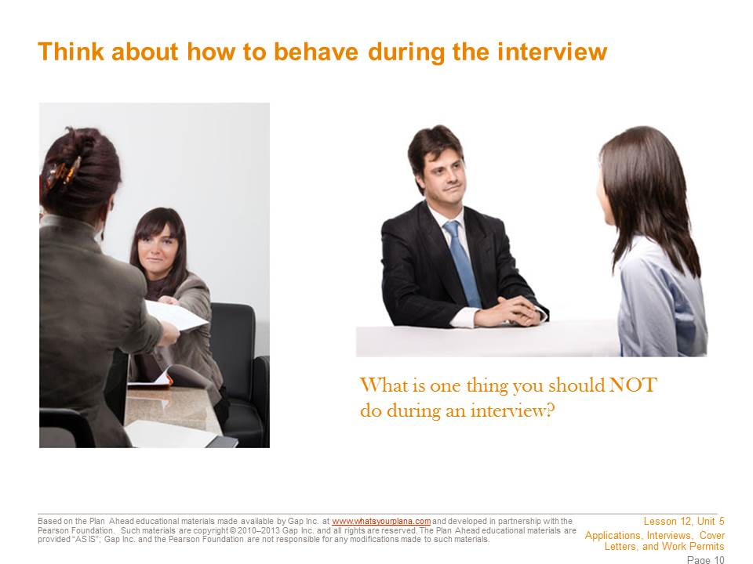  Before you go, think about how you might answer interview questions. Common questions are designed to get to know you, like: “Tell me about yourself,” “What’s your greatest strength? Your greatest weakness?” “Why do you want to work here?”  Practice saying your answers out loud with someone who can give you good feedback. If nobody is around, practice in the mirror.  If you sit down for the interview, sit up straight. Don’t chew gum, bring snacks or drinks with you, or yawn. You might be nervous, but try not to fidget. Listen carefully to the questions, without interrupting. Make sure you give good answers, but stay on topic and keep it brief. For example, if the interviewer asks if you are reliable, you can say that you get good grades or never missed a practice when you were on the volleyball team. Those are all good points. But you shouldn’t say that you get good grades even though you have this one teacher who’s mean or that not only do you show up to practice, but your team made it to state this year…those are not details the interviewer needs to know.  You can prepare some questions of your own; be sure to only ask ones that didn’t get answered already in the course of your conversation. Otherwise it will seem as if you don’t listen well. Remember to turn off your cell phone before the interview. | Presentation notes  Ask students: can you think of anything else you could do in advance to be prepared for the interview?  One big thing that is not mentioned on the slide is researching the company. If it’s a company you already know well—for example, a favorite store or a local restaurant where you eat all the time—you’re probably pretty familiar with its products. But if you don’t know the company that well, it’s important to do a little research.  See if the company has a website and read it. Eat at the restaurant or visit the store before the interview—and remember to dress and behave appropriately while you’re there! You can really impress the person interviewing you if you can say something like, “I think it’s great that you carry so many different types of athletic shoes” or “I was in here last weekend and things went so smoothly, even though the restaurant was really busy.” This shows the employer that you are really paying attention and committed to this job.

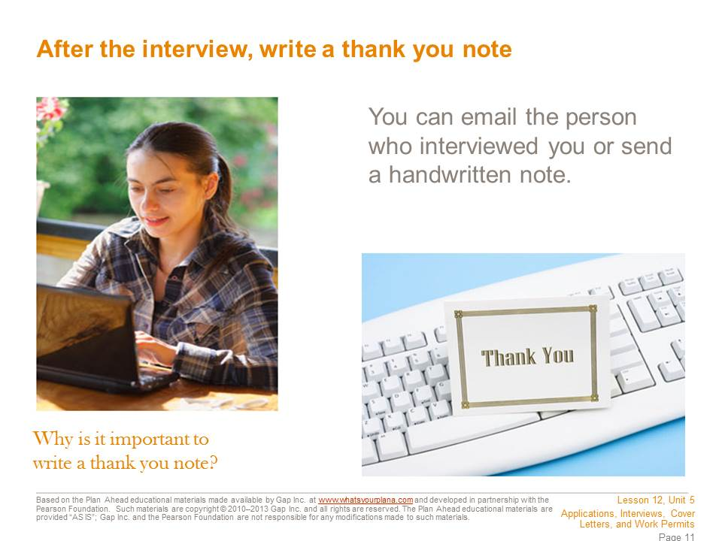  At the end of the interview look the interviewer in the eye, smile, and shake hands again if the interviewer extends his or her hand. Thank the interviewer for taking the time to meet with you. Then, after you get home, write a thank you note or email. If you have been communicating with the interviewer via email, you can send your thank you note that way. Otherwise, write a handwritten note and mail it or personally deliver it.  A thank you note is appropriate, because this person took time out of his or her day to talk to you. Even if the person doesn’t hire you for the job, he or she is helping you learn more about how to do an interview and giving you valuable experience. Sending a thank you note is a great way to impress the interviewer—and to remind the interviewer of what a good candidate you are for the job. | Presentation notes

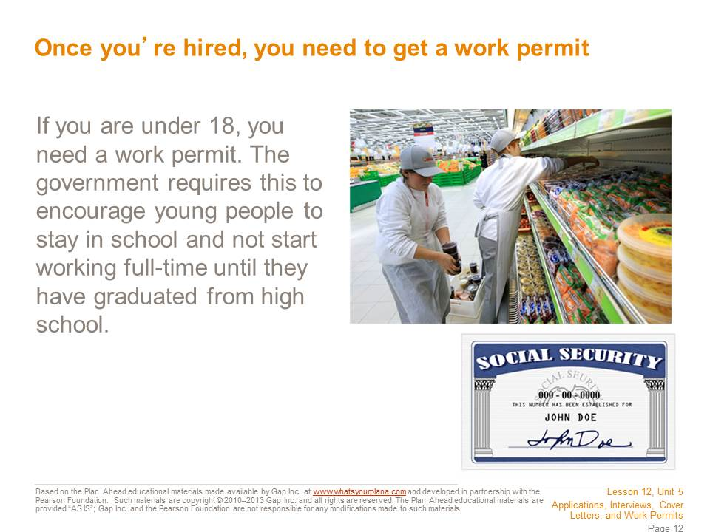  Once an employer agrees to hire you, you can apply for a work permit. You need one because state and federal laws are in place to protect young workers (until the age of 18) from overwork and unsafe conditions, and to ensure that they receive an education.  Your teacher can help you figure out how to obtain a work permit locally.  To obtain a permit, you need to provide the following: a completed application, a social security card, proof of your age (for example, a birth certificate), and proof of school attendance from your school office. | Presentation notes

  You now have the information you need to apply for a job, internship, or college admission.  If you’ve taken all these steps and you don’t get the job, it’s disappointing—but don’t be discouraged. Everyone has to go through this process more than once, and usually many times, before landing a job. Stay focused, patient, and persistent, and eventually your efforts will yield results. | Presentation notes  After students have read the slide, ask them: which of these tips do you think would also be good to keep in mind if you are applying to a college?  Guide students to recognize that the two situations have a lot in common. If you visit a college campus or are interviewed by someone at the college, you should dress appropriately. When you are filling out your application, you should try to make sure it is neat and presentable, just like a job application. And just like you might include a cover letter or resume with a job application, college applications frequently require additional documents. Colleges also usually request letters of recommendation, which are basically written documents from the same type of people you might use as references for a job—teachers, coaches, employers, etc. So when students are applying for a part-time or summer job, they’re also really getting a chance to practice some of the same skills they will need for applying to colleges.
Teacher Resource 12.3
Example: Pet Supply Store Job Ad
Make It Local | If you choose to replace the example with one based in your community, replace this ad; then remove this callout and re-save the file before distributing it to students. See the separate word file for the Example Application.

SF bay area craigslist > san francisco > jobs > retail/wholesale jobs

Neighborhood Pet Store (mission district)

Date: 2012-05-04, 12:49PM PDT
Reply to: job-nrffv-5551234567@craigslist.org ^{[Errors when replying to ads?]}

We are a friendly and busy pet supply store looking for someone that loves animals and is good with people, too. You must be able to lift 50 pounds on a regular basis. Job includes stocking, managing the register, helping customers and receiving deliveries. No experience necessary, good work ethic a must! Looking for approx. 20 hours/week. Evening and weekend availability a must!
The candidate must:
Be reliable and honest.
Retail/sales experience preferred, but willing to train the right person.
Be mature. Stable. No drama.
Be a self-starter with good time management skills.
Be chatty and friendly and happy.
Have knowledge of pet foods and needs (have worked in pet store or owned lots of animals).
Be confident and professional.
Be organized and able to multi-task daily ordering, sales, inventory, and research.
Be comfortable with a family-owned business.
Submit application (available on our website), as well as a cover letter and resume, in person between 12 pm and 3 pm every day or via email. No calls. Main Street Pet Supply is an Equal Opportunity Employer.
Thanks!
- Compensation: 10-12 DOE
- This is a part-time job.
- Principals only. Recruiters, please don't contact this job poster.
- Please, no phone calls about this job!
- Please do not contact job poster about other services, products or commercial interests.
PostingID: 5551234567
Teacher Resource 12.4
Assessment Criteria: Resume
Student Name:______________________________________________________________
Date:_______________________________________________________________________

Using the following criteria, assess whether students met each one.

 |  | Met | Partially Met | Didn’t Meet
The resume includes full contact information for the job applicant (full name, mailing address, phone number, email address). |  | □ | □ | □
The resume includes accurate information about the job applicant’s education and work experience. |  | □ | □ | □
The resume includes useful information about awards, extracurricular activities, or special skills that an employer might want to know. |  | □ | □ | □
The resume includes contact information for three references. |  | □ | □ | □
The resume is organized and formatted in a way that makes it easy to read and find information. |  | □ | □ | □
The resume is neat and uses proper spelling and grammar. |  | □ | □ | □

Additional Comments:
_____________________________________________________________________________
_____________________________________________________________________________
_____________________________________________________________________________
_____________________________________________________________________________

Teacher Resource 12.5
Key Vocabulary: Job Applications and Interviews
These are terms to be introduced or reinforced in this lesson.
Term | Definition
401(k) | A retirement savings plan that is funded by employee contributions and (often) matching contributions from the employer; usually listed as part of an employee benefits package.
administrative assistant | An individual who provides support to one or more executive or senior-level employees in a business; a secretary may also be called an administrative assistant.
application | In this context, a written or online form for employment or admissions to a postsecondary institution.
availability | When someone is available; in the context of a job ad, employers may specify that candidates need to be available during certain days/times of day.
background check | The process of authenticating the information supplied to a potential employer by a job applicant in his or her resume, application, and interviews. In most application processes, lying about background and credentials will keep the employer from hiring the applicant. Background checking ensures the employer that the candidate has the background and experience he or she claims. A background check may include verifying academic records, employment history, checking in with references, drug testing, checking the applicant’s credit and researching the applicant online.
barista | A person who works at a coffee bar (such as Starbucks or Peet’s), making drinks and serving food behind the counter.
benefits | Typically medical or dental coverage, retirement plans, paid vacation, etc. Most part-time jobs offer limited or no benefit packages.
busser | Someone who works in the restaurant and catering industry clearing dirty dishes, taking the dirty dishes to the dishwasher, setting tables, and otherwise assisting the waiting staff. Also known as busboy or busgirl.
clean DMV (or clean driving record) | A DMV record that is free of any (or serious) problems, such as tickets, accidents, drunk driving, racing, or suspended license. For jobs that require driving (for example, making deliveries), an employer may specify a clean driving record as a condition of employment.
compensation | The pay and other benefits provided to an employee for his/her work.
computer literate | Able to use a computer effectively; job ads may specify certain programs (for example, Microsoft Word) or may simply request a general comfort level with the use of computers. It’s important to be able to “prove” computer literacy based on training, experience, or listing programs you are familiar with in your resume/on your application.
cover letter | A letter sent with a job application to explain the applicant’s interest more fully. It also explains the applicant’s skills and experience that make him or her a qualified candidate.
customer service | Providing service to a customer before, during, and after a purchase; good customer service skills are an asset in almost any job, and job ads frequently specify a need for customer service skills. It’s important to be able to “prove” customer service skills based on training or experience—it’s not enough to just say “yes, I have good customer service skills.”
data entry | Entering information into a computer program, such as names, dates, costs, etc. Data entry jobs typically require good typing/computer skills and a familiarity with the program the information is being entered into. Data entry may be the sole focus of a job, or it may be part of an overall job description (for example, some receptionists or administrative assistants may do data entry as part of their job).
DOE (depending on experience) | Usually in reference to salary, means that a more experienced person will probably be higher on the salary scale than someone without experience. For example “$10-12/hour DOE” would suggest that someone without any experience might be offered $10, while someone with a lot of experience might be offered $12.
entry-level | Suitable for a beginner or first-time employee; some entry-level jobs are appropriate for part-time or summer employment for high school students, while other entry-level jobs are full-time and/or require additional education/training.
Equal Opportunity Employer (or EOE) | An employer which follows the principle of equal opportunity in regards to its hiring and promotion procedures. An equal opportunity employer is not allowed to discriminate based on items such as race or gender, and is required to give everyone an equal chance to earn the job.
exempt | An employee who is paid a salary rather than paid by the hour; exempt employees may work more or less than 40 hours/week. They are paid for their performance/achievements rather than paid by the hour. Most part-time employees are not exempt. Exempt employees do not earn overtime. Teachers frequently are exempt employees; their salary is based on their teaching assignments for the year. If they spend an additional 10–20 hours a week at home prepping assignments/grading papers, they do not receive additional compensation for that.
full-time | A work schedule of 40 hours/week or more.
hostess | A person who greets guests at a restaurant; may also be responsible for seating guests.
hourly | Paid by the hour. In other words, if the employee works 8 hours, he will be paid 8 times his hourly wage. Most entry-level and part-time jobs are paid hourly. Hourly employees may earn overtime if they work more than 40 hours/week.
interview | A formal meeting in person, especially one arranged for evaluating the qualifications of an applicant. Initial interviews are often conducted by phone.
inventory | A company or store’s contents; keeping track of inventory is an important part of retail sales work. Job ads may specify that sales clerks must help track inventory or maintain inventory records.
non-exempt | An employee who is paid hourly; non-exempt employees may earn overtime if they work more than 40 hours/week. Most entry-level positions and part-time jobs are non-exempt.
part-time | A work schedule that is less than full-time (less than 40 hours/week).
POS system | A computerized system that connects checkout terminals (cash registers) and allows a business to track sales, inventory, etc. Job ads may specify familiarity with a POS system as a requested skill for applicants.
receptionist | A person who answers phones and greets guests at an office.
reference | An adult (not a relative) who can speak to an applicant’s work or educational history, soft skills, work habits, etc. For high school students, teachers, coaches, neighbors, or previous employers can be good references. An applicant typically is expected to provide contact information for three references as part of the application process. In some cases, references may be asked to write a letter of recommendation as a way of sharing information about the applicant; this is common with college applications.
resume | A summary of one’s academic achievements, work history, and volunteer experience.
retail experience | Experience working at a store/making sales.
seasonal | Work that is available at a specific time of year. For example, many department stores take on seasonal workers during the Christmas holiday season, and some jobs, like lifeguard or camp counselor, are primarily available in the summers.
thank you note | In this context, a short handwritten or emailed message an applicant sends to thank a prospective employer for an interview.
work permit | A legal document that allows an employer to hire a minor. State and federal laws require work permits to protect young workers from overwork and unsafe conditions; the minimum age for obtaining a work permit is 14.
WPM | Abbreviation for “words per minute,” a measure of how quickly someone types. Keep in mind that a high WPM rate does not help if the typing is inaccurate; most typing tests evaluate WPM as well as accuracy.

Teacher Resource 12.6
Bibliography: Job Applications and Interviews
The following sources were used in the preparation of this lesson and may be useful for your reference or as classroom resources. We check and update the URLs annually to ensure that they continue to be useful.
Print
Downing, Skip. On Course: Strategies for Creating Success in College and in Life, 5th ed. Boston: Houghton Mifflin, 2008.
Lapan, Richard T. Career Development Across the K-16 Years. Alexandria, VA: American Counseling Association, 2004.
Packer, Alex J. The How Rude! Handbook of School Manners for Teens. Minneapolis, MN: Free Spirit Publishing, 2004.
Pestalozzi, Tina. Life Skills 101: A Practical Guide to Leaving Home and Living on Your Own. Cortland, OH: Stonewood Publications, 2009.
Online
Doyle, Alison. “Job Interview Tips for Teens.” About.com, http://video.about.com/jobsearch/Job-Interview-Tips-for-Teens.htm (accessed July 12, 2013).
Doyle, Alison. “Teen Interview Tips.” About.com, http://jobsearch.about.com/od/interviewsnetworking/a/teeninterview.htm (accessed July 12, 2013).
Hansen, Katharine, PhD. “Job Interview Strategies for Teens: Part I—Interview Preparation.” Quint Careers, http://www.quintcareers.com/teen_job_strategies.html (accessed July 12, 2013).
Hansen, Katharine, PhD. “Job Interview Strategies for Teens: Part II—During and After the Interview.” Quint Careers, http://www.quintcareers.com/more_teen_job_strategies.html (accessed July 12, 2013).

