|  |  |
| --- | --- |
| **Tech. Tool** | **Resource Information** |
| **Scoop.it** | URL: <http://www.scoop.it/> |
| My Username: |
| My Password: |
|  | |
| **Prezi** | URL: <http://prezi.com/your/> |
| My Username: |
| My Password: |
|  | |
| **Moodle** | URL: <https://moodle.everett.k12.wa.us/moodle/> |
| My Username: |
| My Password: |
|  | |
| **WOIS** | URL: <http://www.wois.org/> |
| My Username: |
| My Password: |
|  | |
| Career Ready 101 | URL: <http://www.careerready101.com> |
| My Username: |
| My Password: |
|  | |
| **NCRC** | URL: <https://rsp.act.org/1036553068> |
| My Username: |
| My Password: |

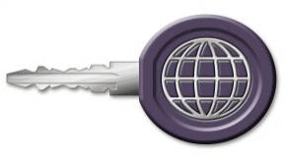

**Keys to Technology Resources**