Name:
ACT National Career Readiness Certificate (NCRC)
You have completed the WorkKeys assessments measure "real world" skills that employers believe are critical to job success. Test questions you answered were based on situations in the everyday work world. Your individual scores on the assessments in Applied Mathematics, Locating Information, and Reading for Information placed you at a particular level. Answer the questions below and upload the document with your name to your class Moodle Site.
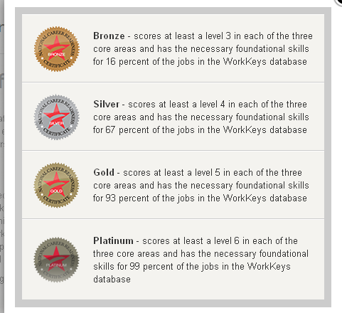 | Based on your scores, which level did you achieve on the NCRC?
 | Paste your screenshot/image of your score here.
Describe how you will use the results of the assessment in the future.
Describe how useful the assessment was for thinking about the future and career readiness.

