Getting to Your Online Class

Open an Internet Browser (IE, Firefox, etc.)
Go to http://moodle.everett.k12.wa.us/moodle /
Know – School, Teacher, Course, Enrollment Key and your Computer Login.

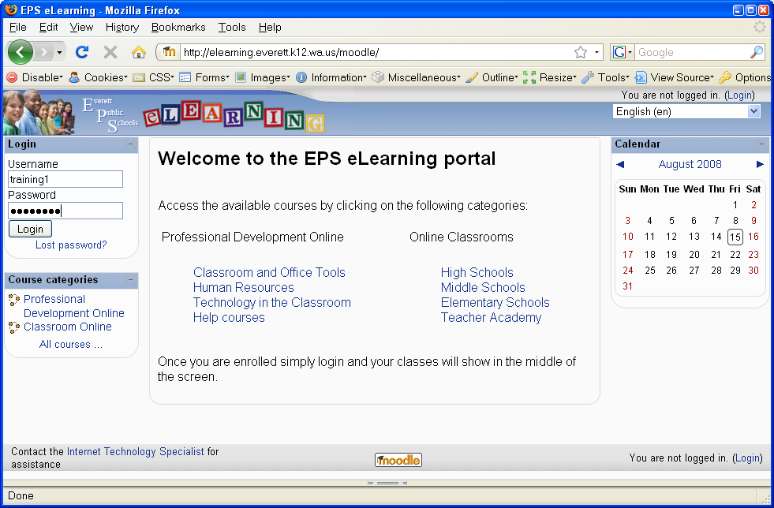
Use same login you use to log into a computer at school
Click Login
Now, whenever you login, your
course will be on the Home page.
If your name does not display Type it in.

Type in an email address even if you have to make one up.
Ex. eve@eps.com

Scroll to the bottom and click

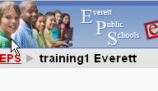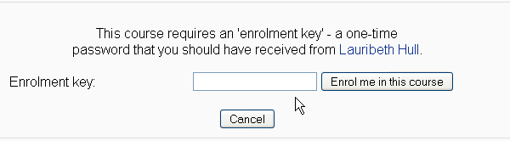
Enter Enrollment Key (your key)
Click Enrol me in this course

At the top of the page click EPS
Navigate to your course
(Category > School >Your Course)
