Name_______________________________________Date_______________________Period__

SPIES Visual Assignment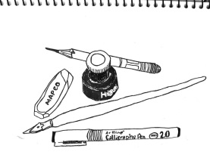

**Your Task:** Create a visual or schematic to illustrate and communicate your understanding of what Total health and Wellness looks like in each of the SPIES areas.

Final product must contain:

⃝ All 5 areas of total health (the SPIES) illustrated and represented

⃝ Image should communicate definition of area of total health

⃝NO Pencil and colored

Name_______________________________________Date_______________________Period__

SPIES Visual Assignment

**Your Task:** Create a visual or schematic to illustrate and communicate your understanding of what Total health and Wellness looks like in each of the SPIES areas.

Final product must contain:

⃝ All 5 areas of total health (the SPIES) illustrated and represented

⃝ Image should communicate definition of area of total health

⃝NO Pencil and colored