Identify the hazards that make the environment unsafe
Safe or Unsafe? |  | Safe or Unsafe?
Safe or Unsafe? | 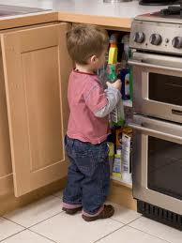 | Safe or Unsafe? | 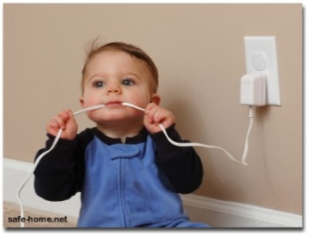
Safe or Unsafe? | 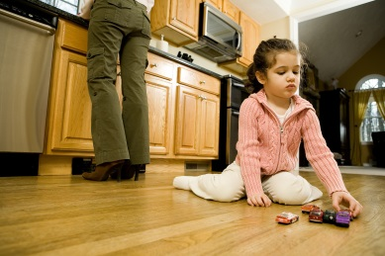 | Safe or Unsafe? | 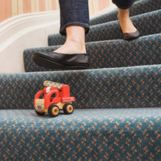
Safe or Unsafe? | 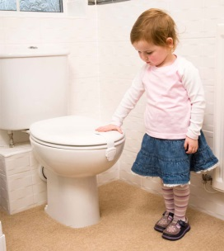 | Safe or Unsafe? | 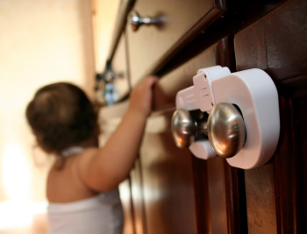
Safe or Unsafe? | 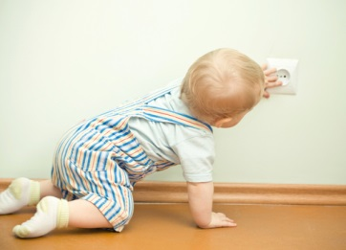 | Safe or Unsafe? | 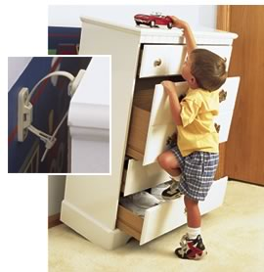
Safe or Unsafe? | 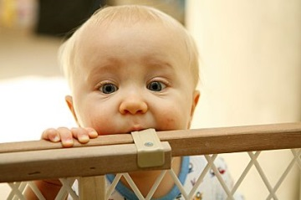 | Safe or Unsafe? | 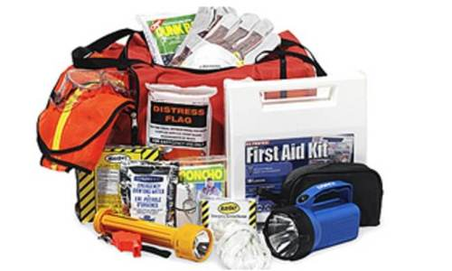
Safe or Unsafe? | 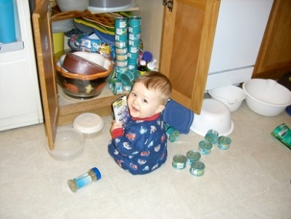 | Safe or Unsafe? | 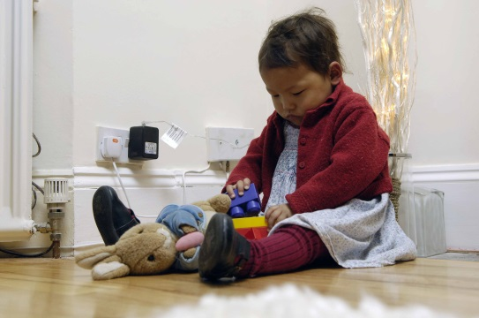

Identify the hazards
Teacher’s Key
Safe or Unsafe? |  | Safe or Unsafe?
Unsafe |  | Unsafe
Unsafe |  | Unsafe
Safe |  | Safe
Unsafe |  | Unsafe
Unsafe |  | Safe
Unsafe |  | Unsafe

