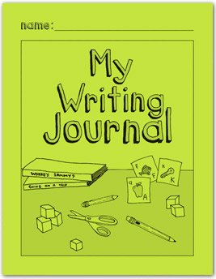

Supporting K Student

Work In My Writing Journal

*Getting Started*

* Designed for K students after use of My Pictures and Stories (Yellow Book)
* Move to the green book when the student is starting to make letter sound connections and has the writing structure in place (has topics, draws good picture detail and can “write” some letters below the line).
* All Kindergarteners should transition to the green book by winter break.
* Most effective when used *with* the teacher in small groups.
* Student proficiency in writing below the line is the primary focus.
* Student still orally tells the story before beginning any writing.
* Teacher confers with the student about what the *plan* will contain.
* The more detailed the plan, the more detailed the story will be.
* Direct instruction focuses on phonics, beginning, ending and medial sounds, sight words, generating word families, spaces, blends.
* As students understand the writing process, they can work more independently in the journal as teachers roam and provide support.
* Known words and word families are continually added to the first two pages for the student to reference during writing.
* Teacher continues to support fine motor needs of students when indicated.

*Student Writing Pages*

* Students have writing tools (yellow and green cards) available.
* The plan is now a sketch using pencil and no longer a picture with color.
* Only the *important details* go in the plan, it is not an illustration.
* Line out mistakes, no erasers. This allows teachers to see “trails of thought”.
* Plan is one part until the student is proficient at the 3rd quarter benchmark and then is instructed in making a two-part plan. The student then draws a vertical line in the unlined portion of the page and labels “B” for the beginning and “E” ending on each side.
* After the student draws the sketch and retells the oral story, teacher has child add any missing details to the plan that are critical part(s) of the story.
* The plan contain speech or thought bubbles with words or random letters.
* The student labels “me, mom, dad”- sight words copied from the yellow/green card.
* The student writes one and later two sentences below the line using random letter strings, phonetic spelling, beginning sounds, ending sounds, etc.
* Contains evidence that instruction by the teacher has occurred.

Monitoring Pages

* Initially, and periodically the teacher scores the level of the student work in an *assessment with no teacher help* and indicates the dates benchmark items are consistent in the student writing on the monitoring notes pages.
* Use the blank areas to monitor for other items as needed.