|  |  |  |  |  |
| --- | --- | --- | --- | --- |
| **Forest View Elementary – State of the School Review – 2017/2018** | | | | |
|  | **Data Analysis** | **ELA: Reach** | **STEM** | **Social/Emotional** |
| **What did I notice about the work of high performing teams?** |  |  |  |  |
| **What do I wonder about the work of high performing teams?** |  |  |  | Image |

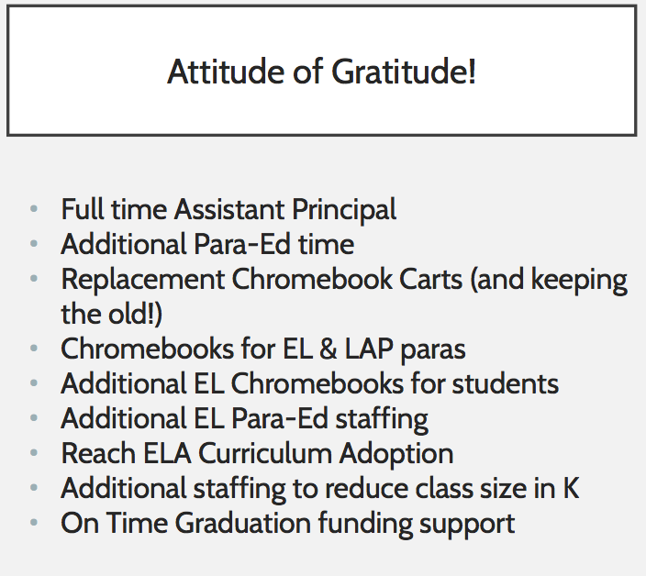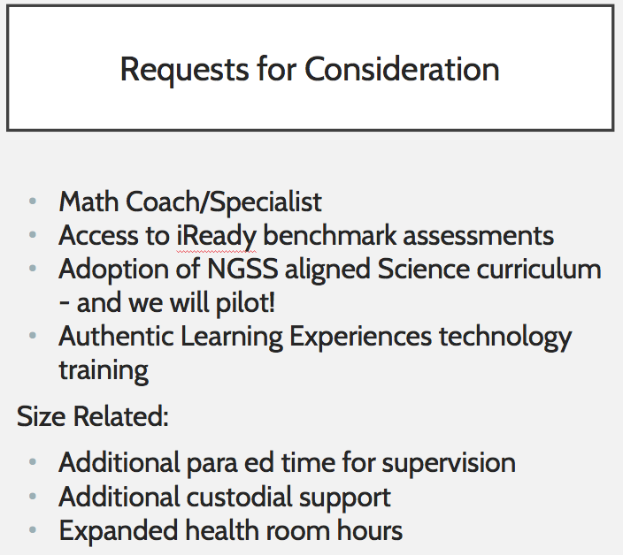

**Additional Notes:**