*Learning other languages and understanding the culture of the people who speak them is a 21st century skill that is vital to success in the global environment in which our students will live and work. For college and career readiness, our students need to be proficient in other languages, regardless of whether they choose to transition directly to the workforce or to post-secondary education.*

*--- The American Council on the Teaching of Foreign Languages (ACTFL) &*

*The Partnership for 21st Century Skills*

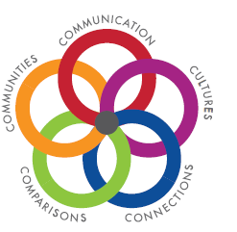Language and communication are at the heart of the human experience. The Everett Public Schools World Languages program strives to equip students linguistically and culturally to engage effectively with others in global communities at home and around the world.In world language courses, students learn about the language and cultures of nations and peoples in our community and around the world, as they learn the World-Readiness Standards for Language Learning, including Communication, Cultures, Connections, Comparisons, and Communities and 21st century skills.

**World Language Pathways**

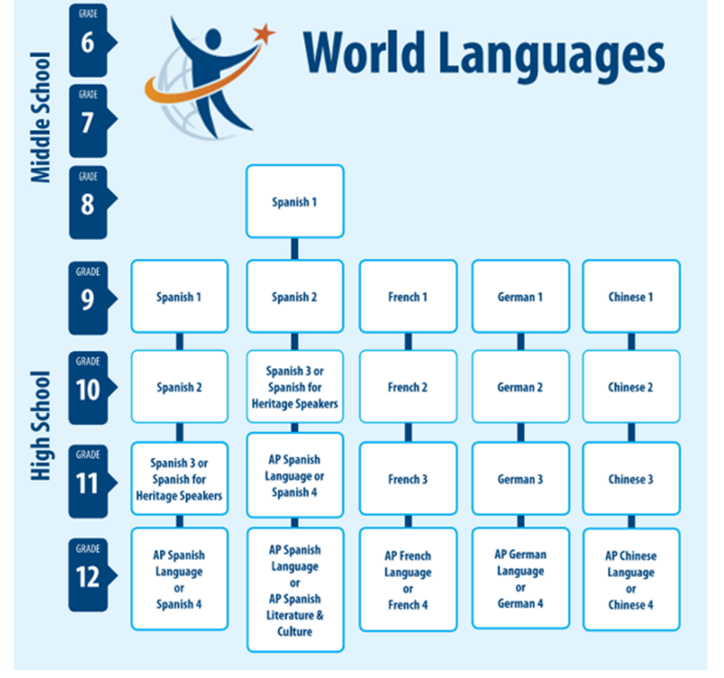Everett Public Schools World Languages program offers **Chinese**, **French** and **Spanish** at Cascade High School, Everett High School and H. M. Jackson High School. **German** is offered at Cascade HS and H. M. Jackson HS.

Spanish 1 is offered as an elective for 8th graders at all five **middle schools**.

**Advanced Placement (AP) Language and Culture** courses are offered for French, German, and Spanish at Cascade High School, Everett High School and H. M. Jackson High School. In 2018-19 AP Chinese Language and Culture will be offered at Everett High School.

**AP Spanish Literature and Culture** is also offered at Cascade High School, Everett High School and H. M. Jackson High School.

Please note that Heritage Speakers with higher levels of proficiency in Spanish may take **Spanish for Heritage Speakers** in Grade 9.

These pathways reflect course sequences most students follow; the recommended course sequence for language study is Level 1, Level 2, Level 3, and then the Advanced Placement course in that language.