**TIMECARD ONLINE will now be a new tab available  
through the EMPLOYEE ONLINE product.**



SAVE to revisit at a later date, and to calculate totals

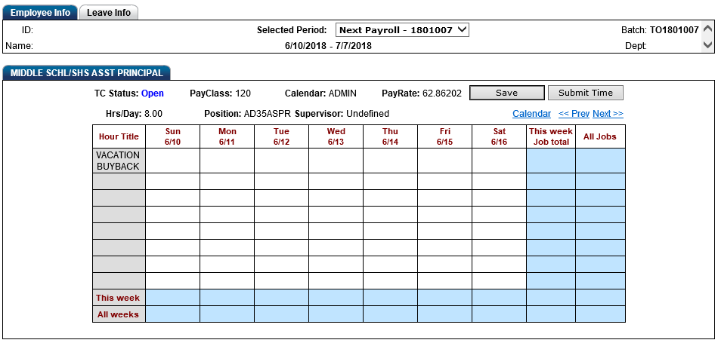STEP 1: Choose from the **JULY** open pay period

STEP 2: Use the “Next” link to move to the last day of the contract period: **Sat 6/30**

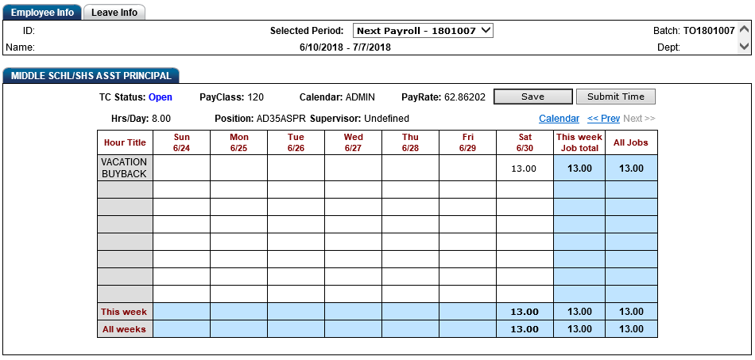

STEP 4: SUBMIT to send for approval

STEP 3: On 6/30, enter the number of **DAYS** you are requesting for buy back (no more than 13)



STEP 4: Before clicking on SUBMIT, be certain this is what you want. Once submitted, the records will route to the Payroll office and you will not be able to add or edit the records. If an error has been identified, you will need to contact the payroll office directly.

You will receive an email once your records have been received by the payroll office, completing the electronic approval process!