Directions on how to volunteer for an event

Go to the following URL.

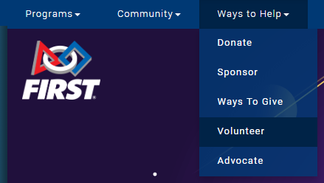<https://www.firstinspires.org/ways-to-help/volunteer>

Under the Community Menu select Volunteer

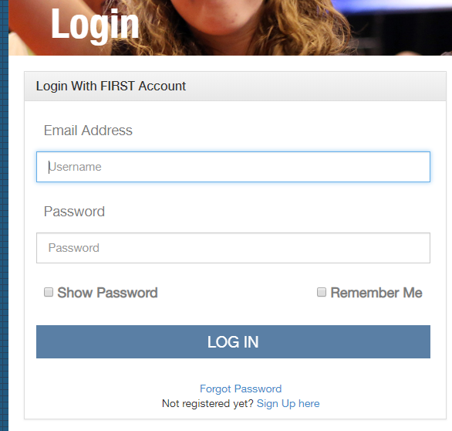The Volunteer menu will take you to the Login Page. If you already have an account then login, otherwise use the link Sign Up Here.

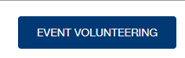

You will now see several buttons choose the Event Volunteering



Under the Event Filters click on the FTC button

In the Date Area From 12/15/2018

Now you will see 10 rectangles select the one that is called Pasteur Interleague with Event Location Henry Jackson High School, Mill Creek, WA (see pictue on page 2)

**FTC Event to Select You will now have to click on the following buttons.**

**EVENT DAY 12/15/2018**

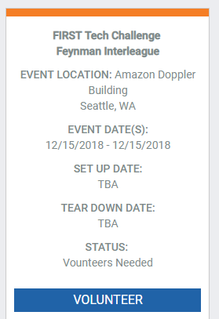

**Pasteur Interleague**

Henry Jackson

High School  
Mill Creek, WA

**Assign me as needed**

**Next**

**___________________________________________________________**

Put 2910 where it asks to Enter Team Number

 Then click complete