Choose *Class Notebook* tab:

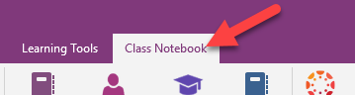

Click on the dropdown arrow for *Connections* and select *Map Class Notebook*:

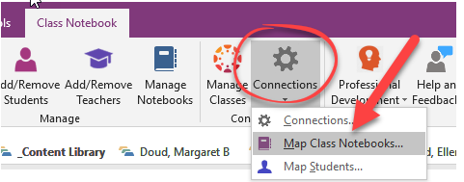

Match your current Class Notebook with the **second semester** Canvas course from the dropdown:

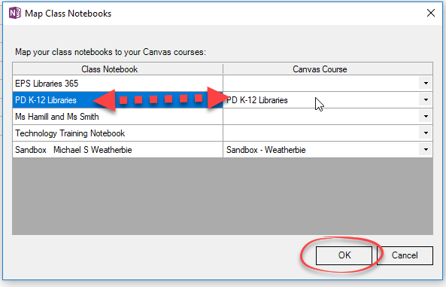

Click on the dropdown arrow for *Connections* and select *Map Students*:

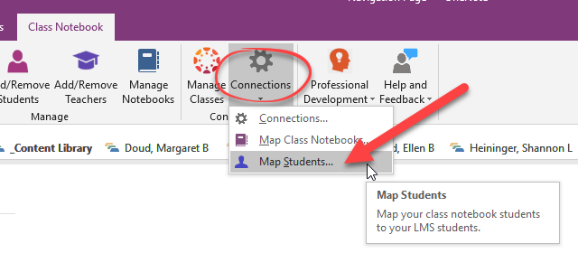

Select the notebook from the dropdown you want to map students:

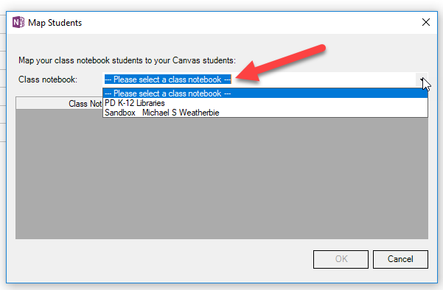

Match your students in the Class Notebook with the student in your Canvas course from the dropdown:

